# OpenGauss

* When the gs_checkperf tool is used to check system performance, which of the following can be viewed only by user root?

1. Host level
2. openGauss level
3. **SSD performance (Verificado)**
4. Session/process level

* [Fonte](https://docs.opengauss.org/en/docs/1.0.0/docs/Toolreference/gs_checkperf.html)
* Which of the following functions are supported by UGO?
* **Target database selection and specification recommendation (Verificado)**
* **Migration workload evaluation (Verificado)**
* **Target database compatibility analysis (Verificado)**
* **Source database profile (Verificado)**
* [Fonte](https://www.huaweicloud.com/intl/en-us/product/ugo.html)
* The operation result of a logical operator can be TRUE, FALSE or NULL. NULL indicates unknown

1. **True (Verificado)**
2. False

* [Fonte](https://docs.opengauss.org/en/docs/1.0.0/docs/Developerguide/logical-operators.html)
* Which of the following can be used to view partition information and system catalogs?
  1. pg_index
  2. pg_class
  3. **pg_partition (Verificado)**
* [Fonte](https://docs.opengauss.org/en/docs/3.1.1/docs/Developerguide/pg_partition.html)
* Which of the following statements is false about GTM-Lite technology?

1. The GTM-Lite technology eliminates the performance bottlenecks associated with single GTM and improves the transaction processing performance.
2. In GTM-Lite mode, distributed transactions are eventually consistent.
3. GTM-Lite is an innovation of global management of distributed transactions.
4. **In GTM-Lite mode, distributed transactions are strongly consistent.**

* In openGauss, which of the following is the result returned by the SQL statement SELECT trunc(timestamp ‘2001-02-16 20:11:11’);?

1. **36938**
2. 36938.83333333336
3. 36938.841099537036
4. Syntax Error

* Which of the following is a command-line database connection tool provided by openGauss?

1. **gsql**
2. gs_connect
3. psql
   1. gaussdb

* [Fonte](https://docs.opengauss.org/en/docs/1.0.0/docs/Developerguide/logical-operators.html)
* Which of the following commands can be used to collect OS and log information to locate faults when openGauss is faulty?

1. gs_checkperf
2. **gs_collector (Verificado)**
3. gs_restore
4. gs_check

* [Fonte](https://docs.opengauss.org/en/docs/1.0.0/docs/Toolreference/gs_collector.html)
* How often is the openGauss WDR snapshot executed by default?

1. 30 minutes
2. 120 minutes
3. **60 minutes (Verificado)**
4. 360 minutes

* [Fonte](https://docs.opengauss.org/en/docs/3.0.0/docs/CharacteristicDescription/workload-diagnosis-report-wdr.html)
* Which of the following system catalogs or views can be used to query table information in a database?

1. pg_database
2. **pg_tables**
3. **pg_class**
4. **information_schema.tables**

* Which of the following system catalogs or views can be used to query permission information in a database?

1. **information_schema.table_privileges**
2. **pg_authid**
3. **pg_user**
4. pg_shdepend

* In openGauss, which of the following commands are used to insert new data into a table?

1. **INSERT INTO SELECT (Verificado)**
2. **INSERT INTO (Verificado)**
3. DELETE
4. UPDATE

* Which of the following statements are true about schemas in openGauss?

1. By default, each database has a schema named "public".
2. Database objects with the same name can exist in different schemas of the same database without causing conflicts
3. When a user is created, the system automatically creates a schema with the same name as the user.
4. Schemas help multiple users operate the same database without interference

* After running the “install.sh” script to install openGauss, you can run the “ps” and “gs_ctl” commands to check whether the process is normal.

1. **True**
2. False

* In openGauss, the Sophon intelligent index optimization technology enables databases to adjust index policies based on workloads automatically. In this way, the query performance can be continuously optimized without manual intervention.

1. **True**
2. False

* The cluster manager (CM) manages and monitors the running status of each functional unit and physical resource in the openGauss database system, executes SQL commands sent by client, and processes data storage and query tasks.

1. True
2. **False**

* Which of the following statements are true about the openGauss import and export tools?

1. gs_dumpall needs to be executed by the root user, but gs_ dump does not need to be executed
2. **Both gs_dump and gs_ dumpall can export database object information**
3. **gs_restore can import the files exported by gs_ dump**
4. gs_dump can directly export the entire database and its data files.

* Which keywords or clauses are the main components of Data Query Language (DQL) in SQL?

1. **FROM**
2. **ORDER BY**
3. **WHERE**
4. UPDATE
5. **SELECT**
6. INSERT

* The “commit” command is used to commit a transaction to a database

1. **True**
2. False

* After the openGauss enterprise edition is installed, you can run the “gs_om -t start” command to start the database.

1. **True (Verificado)**
2. False

* Which of the following statements is false?

1. A user is a set of roles
2. **A role is a set of users (Verificado)**
3. In openGauss, users and roles use the same operation and maintenance methods
4. When creating a user, you can specify the validity period of the user.

* Compared with other open-source databases, openGauss has many new technical features. Which of the following statements is false?

1. lt provides the Sstore engine for frequent query scenarios
2. **It provides the Ustore for frequent update scenarios. (Verificado)**
3. **It adopts the Mulan Permissive Software License, allowing code to be freely modified, used, and referenced. (Verificado)**
4. **It provides Al-based parameter tuning and index recommendations and automatically recommends Al parameters. (Verificado)**

* Which of the following threads does not belong to openGauss?

1. BgWriter thread
2. Checkpoint thread
3. **Master thread (Todas as outras existem)**
4. WalWriter thread

* Which of the following openGauss commands is used to create a schema?

1. **CREATE SCHEMA (Verificado)**
2. GENERATE SCHEMA
3. NEW SCHEMA
4. ADD SCHEMA

* Which of the following statements is true about the openGauss database architecture?

1. **openGauss uses the single-process and multi-thread architecture. All database operations are performed in the same process as threads.**
2. openGauss uses the multi-process architecture. Each database connection corresponds to an independent process.
3. openGauss uses the client/server architecture. The client and server run in the same process
4. open Gauss uses the multi-process and multi-thread architecture

* Which of the following files is used to set the openGauss client authentication policy?

1. pg_ctl.conf
2. pg_ident.conf
3. **pg_hba.conf (Verificado)**
4. postgresql.conf

* openGauss uses the thread pool model to implement high concurrency. What is the number of concurrent connections in the default configuration?

1. 50000
2. **1000**
3. 10
4. 100

* Which of the following statements is true about openGauss column-store tables?

1. The physical data file size of both column-store and row-store tables is 8192 bytes.
2. Each column in a column-store table corresponds to a physical data file.
3. Data in a column-store table is stored in a physical data file.
4. The default data compression level of column-store tables is high.

* Which of the following components generates and maintains globally unique information such as global transaction, snapshots, timestamps and sequences
  1. DN
  2. CM
  3. CN
  4. **GTM (Verificado)**
* Assume that user A’s account has CNY100. At t1, user B transfers CNY200 to User A. At t2, User C transfers CNY300 to user A. User B terminates the transfer. At t4, User C, successfully completes the transfer. At t5, the banking system becomes faulty. (t1 < t2 < t3 < t4 < t5) after the banking system recovers, how much money will be in User A’s account?
  1. 300
  2. 100
  3. 400
  4. **600 (Verificado)**
* Which of the following commands can be used to roll back the current transaction
  1. end
  2. commit
  3. exit
  4. **rollback**
* Which of the following is NOT a characteristic of the OpenGauss transaction
  1. **Partition fault tolerance (Verificado)**
  2. Atomicity
  3. Durability
  4. Consistency
* In OpenGauss, which of the following gsql meta-commands can list all database roles?
  1. \dn
  2. **\du (Verificado)**
  3. dr
* Which of the following SQL languages is used to set or change the database transactions, authorize operations, and lock tables?
  1. DQL
  2. **DCL (Verificado)**
  3. DDL
  4. DML
* In OpenGauss, which of the following SQL statements is used to modify column attributes
  1. ALTER TABLE t ADD new_col;
  2. **ALTER TABLE t SET col1 to nvarchar(20); (Verificado)**
  3. ALTER TABLE t DROP col1;
  4. ALTER TABLE t rebuild col1 to col2;
* The existing sequence seq1 in openGauss is defined as follows:  
  CREATE SEQUENCE seq1 START WITH 8 MAXVALUE 11 INCREMENT BY 2 CYCLE;. Which of the following results is obtained after the SQL statement SELECT nextval(seq1) is executed for five times?
  1. 8, 10, 11, 2, 4
  2. 10, 1, 3, 5
  3. 8, 10, 12, 1, 3
  4. **8, 10, 11, 1, 3**
* Which of the following statements is true about the fully-encrypted equality query capability of the OpenGauss database?
  1. Data is encrypted during storage and decrypted using the dynamic key provided by the application during computing
  2. Data is encrypted during storage and computing and decrypted when it is returned to the client
  3. Data is encrypted during storage and decrypted during computing. Data is encrypted during transmission, storage and computing and cannot be decrypted
  4. **Data is encrypted during transmission, storage and computing and cannot be decrypted (Verificado)**
* Which of the following tools is used to check whether the environment meets the installation requirements before openGauss installation?
  1. gs_checkperf
  2. gs_collector
  3. gs_check
  4. **gs_checkos (Confia no pai)**
* Which of the following statements is false about the ACID feature of database transactions?
  1. **I refers to availability. The database system must provide the highest availability for database execution to ensure that most transactions can be successfully executed (Verificado)**
  2. A refers to atomicity. Operations in a transaction are either successful or all failed
  3. C refers to consistency. The system status can only be the status before the transaction or after the transaction is successful. No inconsistent status can occur
  4. D refers to durability. The status of a successful transaction can be maintained even if the machine is powered off
* Which of the following statements is true about the separation of duties of OpenGauss
  1. The responsibilities between databases instances, databases and tablespaces are separated
  2. **Database read, write, and management operations are performed by differents roles or users**
  3. Database administrators (DBAs) application developers and system administrators have the same permissions and responsibilities
  4. The responsibilities of database management, data security, and database audit log viewing and management are assigned to different roles or (..?)
* When you create or update a user account in OpenGauss, which of the following options can improve account security
  1. Allowing any IP address to log in
  2. Setting a simple password
  3. **Enabling SSL/TLS encrypted connection** **(Verificado)**
  4. Disabling password policy check
* Which of the following are the join operators of openGauss?

1. **Harshjoin** **(Verificado)**
2. **Mergejoin (Verificado)**
3. Union
4. **Nestloopjoin (Verificado)**

* [**Fonte**](https://docs.opengauss.org/en/docs/1.0.1/docs/Developerguide/join-operation-hints.html)
* Which of the following options are equivalent to OFFSET 3 LIMIT 10?

1. LIMIT3,10
2. LIMIT10,3
3. LIMIT 3 OFFSET 10
4. **LIMIT 10 OFFSET 3 (Verificado)**

* In the openGauss database architecture design, what are the advantages of the primary/standby mode compared to the standard mode

1. The maximum data loss duration (RPO) and the maximum system recovery duration (RTO) can be controlled
2. **Multiple failover and switchover modes are supported**
3. Damaged pages can be automatically repaired
4. **Maximum reliability, performance and availability can be achieved**

* Which of the following statements are true about the openGauss table design?

1. **COMMENT does not need to be added**
2. For Astores tables are frequently updated, a small fill factor needs to be specified
3. Planning the table structure design prevents the addition of columns and modification of column types or lengths
4. **Clustering or partial clustering is used to implement continuous storage of hot data and convert random I/Os into continuous I/Os**

* Which of the following statements are true about openGauss database auxiliary thread?

1. **WAL writer is responsible for writing permanent records of committed transactions to WAL files**
2. **Checkpointer is used to periodically check the points of flush dirty pages to disks to ensure database consistency**
3. AutoVacuum is used to collect statistics on objects. SQL statements sessions, and looks and store the statistics in the pgstat.stat file
4. Page writer is used for copying the dirty page data to the doublewrite area and flushing the data to disks

* In the openGauss fully-encrypted database, which of the following methods can be used to create an encrypted table?

1. Use the ALTER TABLE statement to specify the encryption algorithm and key.
2. **Use the CREATE TABLE statement to specify the encryption algorithm and key**
3. Use the CREATE TABLESṔACE statement to specify the encryption algorithm and key
4. Run the pg_dump command to back up the existing encrypted table and specify the encryption algorithm and key

* In openGauss the SMALLINT type occupies one byte:

1. Correto
2. **Error** ✅

* Indexes can improve the data retrieval speed. In openGauss, an index takes effect only for one column. If an index is created for multiple columns, the index takes effect only for the first column:

1. Correto
2. **Error** ✅

* If data in the base table changes, the data queried from the view changes accordingly:

1. **Correto** ✅
2. Erro

* You do not need to create an XML file before using the installation package to install openGauss.

1. Correto
2. **Erro (Verificado)**

* In primary/standby deployment mode, all database nodes share the postgresql.conf configuration file:

1. Correto
2. **Erro (Verificado)**

* Which of the following is a database connection tool provided by openGauss to run in the command line?

1. **gsql (Verificado)**
2. psql
3. zsql

* In the openGauss data types, how many bytes does the DATA type occupy?

1. 8
2. **4 (Verificado)**
3. 12
4. 16

* Which of the following components uses shards and replicas of GausDB (for openGauss)?

1. CM
2. GTM
3. CN
4. **DN**

* Assume the customer table exists in the tpcds schema. Which of the following commands CANNOT be used to delete the tpcds schema?

1. drop schema tpcds
2. drop table tpcds customer drop schema tpcds
3. **drop schema restrict**
4. drop schema tpcds cascade

* In openGauss, which of the following technologies can eliminate single points of failure (SPOF) through multi-layer redundancy?

1. **Backup and restoration**
2. Cluster HA
3. **Scale-out**
4. Distributed execution framework

* Which of the following is not a binary operator in openGauss?

1. **^**
2. #
3. |
4. ~

* ANALYZE supports only row-store tables:

1. Correto
2. **Erro** ✅

* Which of the following commands can be used to uninstall the openGauss database and delete the data directory?

1. ps_preinstall
2. gs_postuninstall
3. gs_uninstall
4. **gs_uninstall --delete-data (Verificado)**

* Which of the following tools is used to help users understand the database workload of openGauss?

1. **gs_checkperf (Verificado)**
2. gs_check
3. gs_checkos
4. gs_collector

* Which of the following statements is true about the logical replication of the openGauss database?

1. **It supports primary-primary deployment and table-level replication, and converts binary logs to logical SQL statements**
2. It supports primary-primary deployment and table-level replication
3. It converts binary logs to logical SQL statements and supports table-level replication
4. It supports primary-primary deployment and converts binary logs to logical SQL statements

* Which of the following drivers is used by the client connection tool Data Studio to communicate with the openGauss database?

1. ODBC
2. Libq
3. **JDBC (Verificado)**
4. Psycopg

* Which of the following tools and service-oriented capabilities are provided or supported by GaussDB(for openGauss)?

1. **Data Admin Server (DAS)**
2. **Database and Application Migration UGO**
3. **Data Replication Service (DRS)**
4. **Cloud Trace Service (CTS)**

* Which of the following statements can be used to recreate indexes in openGauss?

1. A reindex table tpcdsship_mode_11
2. **RENDER INDEX tpcds_ds_shop_mode_t1_index4**
3. **ALTER INDEX tpcds_ship_mode_t1_index2 REBUILD**
4. REBUILD INDEX tpcds_ship_mode_t1_index4

* Which of the following statements are true about the usage of the COPY command in openGauss?

1. **Export table data copy, table1 to ‘data/input/t1_output.txt’ delimiter ‘**^’
2. Import text data, copy from ‘data/input/t1_output.txt’ delimiter ‘^’
3. Export table data copy to table1 from ‘data/inputt1_output.text’ delimiter ‘^’
4. **Import text data copy values from “data/input/t1.txt delimiter**

* Which of the following are risky operations that you need to pay attention to during routine operations of openGauss?

1. **Manually modify the pg_xlog file**
2. **Directly modify the content of the pg_hba.conf file**
3. **Run the kill 9 command to terminate a job process**
4. **Open the configuration file and manually modify the port number**

* Which of the following methods can be used to view openGauss database parameters?

1. **postgresql.conf file**
2. **pg_settings view**
3. **gs_guc tool**
4. show command

* In which of the following situations a WDR cannot be generated?

1. A primary/standby switchover is performed between two snapchats
2. **DROP DATABASE operation is executed between snapshots**
3. A code restarts between two snapshots
4. TRUNCATE TABLE operation is executed between two snapshots

* Which of the following tools can be used to implement logical backup of the openGauss database?

1. **gs_dump**
2. PITR
3. LVM snapshot
4. **gs_dumpall**

* Which of the following statements are true about the openGauss database?

1. **openGauss primary/standby DNs: store service data (by row-store, or memory table), executes data query tasks, and returns execution results to the client driver.**
2. **CM: O&M management module provides management APIs and tools for routine cluster O&M and configuration management.**
3. **OM: cluster management module provides startup and stop, primary/standby switchover, and status query.**
4. **Clint driver: receives the access requests from applications and returns the execution results for the application.**

* Data Studio is an integrated developer environment. Which of the following are features of Data Studio?

1. **Executing SQL statements/scripts**
2. **Editing and executing PL/SQL statements**
3. Viewing WDRs
4. **Creating and managing database objects**

* System catalogs store the structured metadata of openGauss. They are the source of information used by openGauss to control system running and are component of the database system.

1. **True (Verificado)**
2. False

* When a large number of update or deletion operators are performed in the database, you can run the VACUUM statement to restore disk page fragments and return them to the OS

1. **True (Verificado)**
2. False

* Column-store tables support updates with uncertain results. No error is reported when you attempt to update a row with multiple rows of data in a column-store table.

1. **True**
2. False

* In openGauss, you must have the super administrator permission to create a schema (CREATE SCHEMA)

1. True
2. **False (Verificado)**

* [**Fonte**](https://docs.opengauss.org/en/docs/latest/docs/SQLReference/create-schema.html)
* The operation result of the logical operator can be TRUE, FALSE or NULL. NULL indicates unknown.

1. **True (Verificado)**
2. False

* [Fonte](https://docs.opengauss.org/en/docs/latest/docs/SQLReference/boolean-types.html)
* DRS provides backup migration without exposing source databases. It is applicable to scenarios where you do not want to expose IP addresses to the public network. Which of the following is not a step in the backup migration process?

1. **Use DRS to restore backup data from OBS to a target database.**
2. Use DRS to connect source and target databases.
3. Upload the source database backup file to OBS
4. Export data fron the source database as a backup file

* In openGauss, which of the following technologies implements node scaling

1. GTM-like
2. Cluster HA
3. **Scale-out**
4. NUMA-Aware

* Which of the following is false about the maximum values of the specifications in openGauss?

1. Number of concurrent connections: 10000
2. Size of single table: 32 TB
3. **Number of columns in composite index: 64 (Verificado)**
4. Size of data in a single row: 1 GB

* In openGauss, which of the following can be used to calculate the center of a rectangle?

1. lseg(box)
2. line(box)
3. **center(box)**
4. point(box)

* In openGauss, which of the following is a default folder for WALs?

1. pg_audit
2. pg_log
3. global
4. **pg_xlog (Verificado no quiz)**

* Which of the following system views can display information about database parameters at run time?

1. **PG_SETTINGS**
2. PG_RULES
3. PG_SETTING
4. PG_RUSE

* [Fonte](https://docs.opengauss.org/en/docs/1.1.0/docs/Developerguide/pg_settings.html)
* Which of the following is a character processing function in openGauss?

1. **Ipad (Verificado)**
2. path
3. bitand
4. age

* [Fonte](https://docs.opengauss.org/en/docs/1.1.0/docs/Developerguide/character-processing-functions-and-operators.html)
* Which of the following statements is true about the fully encrypted equality capability of the openGauss database?

1. Data is encrypted during storage and decrypted using the dynamic key provided by the application during computing
2. **Data is encrypted during transmission, storage and computing and cannot be decrypted (Verificado)**
3. Data is encrypted during storage and computing and decrypted when it returned to the client
4. Data is encrypted during storage and decrypted during computing

* What open-source protocol does openGauss use?

1. BSD License
2. **Mulan PSL (Verificado)**
3. GNU General Public License
4. MIT License

* [Fonte](https://opengauss.org/en/)
* Row and column-store models have their own advantages and disadvantages. They are usually used for transactional processing databases. By default, the column-store model is used.

1. True
2. **False**

* In openGauss, which of the following system views are related to audit information?

1. **GS_AUDITING_ACCESS (Verificado no Quiz)**
2. **GS_AUDITING_PRIVILEGE (Verificado no Quiz)**
3. GS_MARKING
4. **GS_AUDITING (Verificado no Quiz)**

* Which of the following statements can be used to delete data from a table in openGauss?

1. **DELETE FROM (Confia no pai)**
2. DROP TABLE
3. DUMP TABLE
4. **TRUNCATE TABLE (Confia no pai)**

* Which of the following statements are true about DRS?

1. **DRS real time migration allows you to directly migrate data from the source database to the target database if they are connected, and if the sourcer database instances, target database instances, and migration objects are configured. (Verificado)**
2. **DRS real-time synchronization is different from real-time migration. Migration means moving your whole database from one platform to another. Synchronization refers to the continuous flow of data between different services. It applies to scenarios such as real-time analysis, report system, and data warehouse environment. (Verificado)**
3. **Using DRS backup migration, you can migrate data without exposing your source databases to the internet. (Verificado)**
4. **Data Replication Service (DRS) is a cloud service used for real-time database migration and synchronization (Verificado)**

* In the openGauss data types, how many bytes does the DATE type occupy?
  1. 8
  2. **4 (Verificado)**
  3. 12
  4. 16
* [Fonte](https://docs.opengauss.org/en/docs/5.0.0/docs/SQLReference/date-time-types.html)
* In openGauss, system catalogs and all built-in data types, functions, and operators belong to which of the following schemas?

1. **pg_catalog (Verificado)**
2. pg_temp
3. information_schema
4. public

* To prevent disclosure of user passwords, openGauss encrypts and stores them in which of the following system catalogs?

1. pg_directory
2. **pg_authid (Verificado)**
3. pg_password
4. pg_proc

* Which of the following statements about the second normal form (2NF) of the database is false?

1. **If a composite primary key exists in a table, other non-primary key columns can partially depend on the column in the composite key (Verificado)**
2. 2NF is established on the basis of 1NF, that is, 1NF must be met before 2NF can be
3. 2NF requires that each instance or row in a database table be uniquely distinguishable
4. 2NF emphasizes full functional dependency

* Which of the following functions is provided by the CM module of a database cluster?

1. **It manages and monitors the running status of functional units and physical resources in a distributed system, ensuring stable operation of the entire system. (Verificado)**
2. It provides management interfaces and tools for routine maintenance and configuration management of the cluster
3. It generates and maintains globally unique information such as global transaction IDs, transaction snapshots, timestamps, and sequences.
4. It receives access requests from the application layer, and returns the execution result to the client. It breaks down tasks and distributes task fragments to different DNs for parallel processing.

* Which of the following data types is aliased INT4?

1. TINYINT
2. SMALLINT
3. **INTEGER (Verificado)**
4. BIGINT

* An application can set appropriate parameters by calling gs_guc. Which of the following is the meaning of -N all?

1. **All hosts in openGauss. (Verificado)**
2. All instances of the host.
3. client can connect to any database.
4. Statements that need to be added in the pg_hba.conf file.

* Which of the following statements about the deployment modes supported by openGauss is true?

1. Only standalone deployment is supported.
2. Only primary/standby deployment is supported.
3. **Both standalone deployment and primary/standby deployment are supported. (Verificado)**
4. Only distributed deployment is supported.

* Write-ahead logs (WALs) are important in the openGauss database and may be used for operation restoration when the system crashes. Which of the following is the default folder for WALs?

1. pg_log
2. **pg_xlog (Verificado)**
3. pg_audit
4. global

* Which of the following keywords indicates that a data source cannot be deleted as objects that depend on it currently exist?

1. src_name
2. CASCADE
3. **RESTRICT (Verificado)**
4. IF EXISTS

* After separation of duties in GaussDB (for openGauss) is enabled, which of the following administrators can view audit logs?

1. Security administrator
2. Storage administrator
3. **Audit administrator (Verificado)**
4. System administrator

* Which of the following type conversion functions is used to convert x to the type specified by y?

1. hextoraw(string)
2. **cast(x as y) (Verificado)**
3. pg_systimestamp()
4. to_bigint(varchar)

* Anomaly_detection is a tool integrated into openGauss and can be used to collect and predict database indicators, as well as monitor and diagnose exceptions. Which of the following statements about anomaly_detection is false?

1. Anomaly_detection can monitor multiple indicators at the same time and predict the trends for each indicator.
2. Anomaly_detection consists of an agent and a detector.
3. **The agent module of anomaly_detection and the openGauss database can be deployed on different servers. (Verificado)**
4. The detector module of anomaly_detection communicates with the agent module over HTTP or HTTPS.

* Which of the following tools can be used to start or stop openGauss and generate or update the configuration file?

1. gs_collector
2. gs_ssh
3. **gs_om (Verificado)**
4. gs_dumpall

* One-click diagnosis information collection helps administrators quickly obtain collected information. Which of the following statements about one-click diagnosis information collection is false?

1. It provides multiple suites to capture, collect, and analyze diagnosis data, enabling fault diagnosis and accelerating the diagnosis process.
2. It extracts necessary database logs, cluster management logs, and stack information from the environment based on the requirements of development and fault locating personnel. Administrators demarcate and locate faults based on the obtained information.
3. The one-click collection tool obtains different information from the production environment depending on the actual faults, improving the fault locating and demarcation efficiency.
4. **Administrators can collect the required information without modifying the configuration file. (Verificado)**

* Which of the following geometry types supported by openGauss represents a rectangle?

1. point
2. lseg
3. **box (Verificado)**
4. polygon

* Which of the following statements about the validity period of a user account is false?

1. The validity period of a user account is set to limit the operation period of the user.
2. new validity period is set to enable a user not within the validity period to use its account.
3. An operation period includes the validity start time and validity end time.
4. **If the start and end times of the validity period are not specified, the default validity period is used. (Verificado)**

* Which of the following commands cannot be used to view user information?

1. \d pg_authid
2. select * from pg_authid;
3. select * from pg_user;
4. **select * from dba_user; (Verificado)**

* By default, all users and roles in openGauss have which of the following permissions?

1. admin
2. dba
3. **PUBLIC (Verificado)**
4. administrator

* Compared with the column-store model, which of the following are advantages of the row-store model?

1. Only the selected columns are read.
2. **The insert/update operation is easier.** (**Verificado)**
3. The projection is efficient.
4. **The data is stored together. (Verificado)**

* Which of the following statements about the openGauss feature of binding threads to cores based on NUMA are true?

1. **This feature is used to avoid the switchover time of corresponding threads on different CPU cores. (Verificado)**
2. **This feature reduces resource contention for corresponding threads. (Verificado)**
3. **If this feature is not used, the corresponding thread queue waits for a time slice to be allocated. (Verificado)**
4. **Threads are bound to cores to avoid thread offset between cores. (Verificado)**

* Which of the following operations on tables are DDL operations?

1. **CREATE TABLE (Verificado)**
2. UPDATE TABLE
3. **ALTER TABLE (Verificado)**
4. **DROP TABLE (Verificado)**

* openGauss supports database audit. Which of the following system views are related to audit information?

1. **GS_AUDITING (Verificado)**
2. GS_MASKING
3. **GS_AUDITING_ACCESS (Verificado)**
4. **GS_AUDITING_PRIVILEGE (Verificado)**

* Which of the following are common logical operators?

1. **and (Verificado)**
2. but
3. **or (Verificado)**
4. **not (Verificado)**

* Which of the following capabilities belong to DB4AI of the openGauss database?

1. **Predictor (Verificado)**
2. X-Tuner
3. **DeepSQL (Verificado)**
4. SQLdiag

* Which of the following statements are true about the features of the real-time migration function in DRS?

1. Only table data can be migrated.
2. **During migration, it allows services to continue to be used externally as much as possible. (Verificado)**
3. **It effectively minimizes the impact on services. (Verificado)**
4. **It is used to smoothly migrate databases to the cloud. (Verificado)**

* Which types of network addresses can be stored among the data types provided by openGauss?

1. **IPv4 (Verificado)**
2. **IPv6 (Verificado)**
3. IPv8
4. **MAC (Verificado)**

* Which of the following statements about the memory-optimized table (MOT) storage engine are true?

1. MOT is the most advanced production-level feature of openGauss databases. It performs better for transactional workloads. (Verificado)
2. MOT supports a complete set of database features, such as stored procedures and user-defined functions. (Verificado)
3. MOT fully supports ACID features and includes strict persistence and high availability support. (Verificado)
4. MOT’s near-lock-free design and highly tuned implementation enable superior near-linear throughput scaling on multi-core servers. (Verificado)

* Administrators use gs_dumpall to export data. Which of the following statements about the gs_dumpall command are true?

1. **gs_dumpall is executed by the OS user omm. (Verificado)**
2. Other users cannot access the openGauss database when gs_dumpall is used to export data.
3. During an export, gs_dumpall reads all the tables in a database, so you need to connect to the database as an openGauss administrator to export a complete file. (Verificado)
4. **The result exported from gs_dumpall is an SQL script file in plain text format. (Verificado)**

* Which of the following are common database management systems?

1. **Oracle (Verificado)**
2. Windows
3. **MySQL (Verificado)**
4. Linux

* Which of the following SQL statements return an output result of “03:00:00”?

1. SELECT time ‘05:00’ - interval ‘2 minutes’ AS RESULT;
2. **SELECT time ‘05:00’ - interval ‘2 hours’ AS RESULT; (Verificado)**
3. SELECT time ‘04:00’ - interval ‘1 minutes’ AS RESULT;
4. **SELECT time ‘04:00’ - interval ‘1 hours’ AS RESULT; (Verificado)**

* Which of the following are part of the three-layer key management mechanism in the openGauss fully-encrypted equality query process?

1. **Root key (Verificado)**
2. **Master key (Verificado)**
3. Row encryption key
4. **Column encryption key (Verificado)**

* Which of the following statements about tablespaces controlling the layout of database disks are true?

1. Tablespaces can be used to arrange storage locations for database objects as needed, improving database performance. (Verificado)
2. When a partition is shared with other data, tablespaces will not occupy excessive space in the partition. (Verificado)
3. When the usage of the disk where tablespace resides reaches 60%, the tablespace can set the database to read-only mode.
4. If the disk partition or volume allocated to the initialized database is full and the space cannot be logically increased, you can create and use tablespaces in other partitions until the space is reconfigured. (Verificado)

* Service data flows in a fully-encrypted database exist in ciphertext form during data processing. Which of the following statements about equality query in a fully-encrypted database are true?

1. The fully-encrypted database protects data privacy and security throughout the lifecycle on the cloud. Attackers cannot obtain valid information from the database server regardless of the data status. (Verificado)
2. The fully-encrypted database helios cloud service providers gain third-party trust. Users can keep keys for themselves, preventing high-privilege users from obtaining valid data information. (Verificado)
3. With the help of full encryption capabilities, the fully-encrypted database enables cloud databases to better comply with personal privacy protection laws and regulations. (Verificado)
4. Data is stored in ciphertext and therefore does not need to be protected by firewalls.

* Which of the following statements about system catalogs and system views are true?

1. System catalogs store openGauss structural metadata. They are the source of information used by openGauss to control system operations. (Verificado)
2. The system view provides methods to query system catalogs and the internal state of the database. (Verificado)
3. System catalogs and views are visible only to administrators.
4. In normal cases, users should not manually modify system catalogs or views. (Verificado)

* The accuracy of the statistics may affect the database’s ability to generate a valid execution plan. Which of the following describes situations in which you should consider recollecting statistics to ensure they are accurate?

1. Numerous inserts or deletes are performed on a table. (Verificado)
2. The intermediate table is generated in the batch processing script or stored procedure. (Verificado)
3. If multiple columns in a table are related to each other and the query has conditions or grouping operations based on those columns, you can attempt to collect multi-column statistics. (Verificado)
4. Numerous update operations are performed on a table.

* Which of the following statements about hash distribution are true?

1. It applies to user tables with a small amount of data.
2. It calculates the hash value of a single or multiple distribution columns specified by users. (Verificado)
3. Data from the same user table is stored in different shards. (Verificado)
4. It increases the total amount of data supported by the database. (Verificado)

* Which of the following functions can be implemented by the system administrator by restricting the permission to execute a stored procedure?

1. Restrict access to all data in the database.
2. Restrict access to corresponding data. (Verificado)
3. Prevent unauthorized users from accessing data. (Verificado)
4. Ensure data security. (Verificado)

* Database security administrators can use audit logs to reproduce a series of events that caused a fault in the database or to identify unauthorized users, unauthorized operations, and the time when these operations were performed.

1. **True (Verificado)**
2. False

* In the logical structure of a database, one tablespace can correspond to multiple databases.

1. True (Verificado)
2. False

* Developed based on the Kunpeng ecosystem, GaussDB(for openGauss) continuously optimizes its performance to meet ever-increasing demands across a wide range of scenarios.

1. **True (Verificado)**
2. False

* openGauss does not support CBO. The optimization capability in complex scenarios is average.

1. True
2. **False (Verificado)**

* With GaussDB(for openGauss) parallel data import, the system can quickly import external data of a specific format (CSV/TEXT/FIXED) to databases.

1. **True (Verificado)**
2. False

* In standalone mode, multiple database instances are deployed on a single host for data security purposes.

1. True
2. **False (Verificado)**

* openGauss is a relational database. It uses a client/server, single-process multi-thread architecture and supports standalone and one-primary multi-standby deployment. When primary/standby deployment is used, the standby node can be read too, and HA and read expansion are supported.

1. **True (Verificado)**
2. False

* You are not allowed to rename a database in use. To rename it, connect to another database.

1. **True (Verificado)**
2. False

* A hint specified for a query plan does not apply to its subquery plans. To specify a hint for a subquery, add the hint following the SELECT of this subquery.

1. True (Verificado)
2. False

* RTO refers to the maximum amount of data loss that can be tolerated, that is, the time point corresponding to the data after service recovery.

1. True
2. **False (Verificado)**

* If the disk partition or volume allocated to the initialized database is full, you can create and use tablespaces in other partitions until the space is reconfigured.

1. **True (Verificado)**
2. False

* Bit strings are strings of 1’s and 0’s. The bit type data must match the length n. An error is reported if short or long data is stored.

1. **True (Verificado)**
2. False

* A transaction is a logical unit of program execution, consisting of a series of operators for accessing or updating data in the system.

1. **True (Verificado)**
2. False

* Currently, a SERIAL column can be specified when you create a table and can be inserted in an existing table.

1. True
2. **False (Verificado)**

* You can set multiple IP addresses for each of the backIp, sshIp, and listenIp parameters in a configuration file.

1. True
2. **False (Verificado)**

* PG_STATS displays the single-column statistics stored in the PG_STATISTIC table.

1. **True (Verificado)**
2. False

* GaussDB(for openGauss) provides logical backup capabilities, but can only back up data in user tables to local disk files and OBS in text format.

1. True
2. **False (Verificado)**

* Standalone deployment is special. There is only one data copy. Once data is damaged or lost, only physical backups can be used to restore data.

1. True (Verificado)
2. False

* If the time format of another database is different to that of openGauss, you can change the value of () to ensure consistency.

1. **datestyle (Verificado)**

* A company uses the openGauss primary/standby deployment mode to deploy the system. When the primary database is abnormal, the administrator uses () to promote the standby database to the primary database to continue supporting services.

1. **failover (Verificado)**

* If you specify the () parameter when running the CREATE TABLE statement, data in the table will be partitioned.

1. **PARTITION (Verificado)**

* In SQL statements, the common logical operators are AND, OR and ().

1. **NOT (Verificado)**

* In the MOT statement for creating or deleting a memory-optimized table, the () keyword can be used to reference the MOT.

1. **FOREIGN (Verificado)**

* Which of the following is not a component of a database system?

1. Database
2. DBMS
3. Database application
4. **Database storage medium (Verificado)**

* Which of the following statements about the ACID feature of database transactions is incorrect?

1. A indicates atomicity, whereby operations in a transaction are either all successful or all failed.
2. C refers to consistency, whereby the system status can only be the status before the transaction or after the transaction is successful. No inconsistent intermediate status can occur.
3. **I refers to availability, whereby the database system must provide the highest availability possible for transaction execution in order to ensure as many successfully executed transactions as possible. (Verificado)**
4. D refers to durability, whereby the status of a successful transaction can be maintained, even if the machine is powered off.

* Which of the following phases are involved in the development of data management technologies?

1. **Manual management (Verificado)**
2. **File system (Verificado)**
3. **DBS (Verificado)**
4. AI management

* Which of the following is not an openGauss server tool?

1. gs_check
2. gs_guc
3. **gsql (Verificado)**
4. gs_collector

* When the gs_checkperf tool is used to check system performance, which of the following can be viewed only by user root?

1. openGauss level
2. Host level
3. Session/Process level
4. **SSD Performance (Verificado)**

* Which of the following are the prerequisites for installing openGauss on a single node?

1. **User groups and common users have been created, and the operating systems and networks of all servers are running properly.**
2. **Common users must have the read, write, and execute permissions on the database package decompression directory and installation directory, and the installation directory must be empty.**
3. **A common user has the execution permission on the downloaded openGauss package.**
4. **Before the installation, check whether the specified openGauss port is occupied. If the port is occupied, change the port number or stop the process that uses the port.**

* Which of the following are the openGauss deployment modes?

1. **Standalone deployment (Verificado)**
2. **Primary/Standby (Verificado)**
3. **One primary and multiple standbys deployment (Verificado)**
4. Primary-primary deployment

* What are the two components of the openGauss AI feature? What are the features of each component?

Resposta: DB4AI, AI4DB

* Users and roles have the same syntax in the openGauss database. Therefore, they are fully equivalent.

1. True
2. **False (Verificado)**

* Which of the following commands can be used to export partial data from the student table?

1. gs_dump
2. gs_dumpall
3. **copy Conditional Statement (gs_dump e gs_dumpall não exportam parcial - Verificado)**
4. gs_backup

* Which of the following statements about row-store tables and column-store tables are true?

1. **Row-store tables are used in scenarios where INSERT and UPDATE operations are frequently performed.**
2. **Row-store tables are applicable to point queries, that is, simple index-based queries that return a small number of records.**
3. Column-store tables are more efficient in compression and projection.
4. Row-store tables are used in scenarios where there are a large number of queries for statistical analysis.

* BIGINT occupies four bytes.

1. True
2. **False (Verificado)**

* CLOB is used to store large object data of the TEXT type.

1. **True (Verificado)**
2. False

* Which of the following logical expressions is used to search for records whose position is an engineer and salary is greater than 6000?

1. Position = 'Engineer' OR Salary > 6000
2. Position = Engineer AND Salary > 6000
3. Position = Engineer OR Salary > 6000
4. **Position = 'Engineer' AND Salary > 6000 (Verificado)**

* In a WHERE clause, the expression "age between 20 and 30" is equivalent to.

1. **age >= 20 and age <= 30 (Verificado)**
2. age >= 20 or age <=30
3. age > 20 and age < 30
4. age > 20 and age < 30

* Assume that you want to query student names, ages, and scores from the student table, and want the results sorted in descending order by age. If there are students of the same age, they are sorted in ascending order by score instead. Which of the following SQL statements can be used?

1. **SELECT name, age, score FROM student order by age desc, score; (Verificado)**
2. SELECT name, age, score FROM student order by age, score asc;
3. **SELECT name, age, score FROM student order by 2 desc, 3 asc; (Verificado)**
4. SELECT name, age, score FROM student order by 1 desc, 2;

* Which of the following SQL commands can be used to increase the value of the AGE column in the STAFFS table by five years?

1. UPDATE SET AGE WITH AGE+5
2. UPDATE AGE WITH AGE+5
3. **UPDATE STAFFS SET AGE = AGE+5 (Verificado)**
4. UPDATE STAFFS AGE WITH AGE+5

* Which of the following four groups of SQL commands belong to the DML commands?

1. CREATE, DROP, UPDATE
2. **INSERT, UPDATE, DELETE (Verificado)**
3. INSERT, DROP, ALTER
4. UPDATE, DELETE, ALTER

* Which of the following SQL statements will delete records for all students whose class ID (specified by cid) is 6 from the student table?

1. **delete FROM student where cid = 6; (Verificado)**
2. delete * FROM student where cid = 6;
3. delete FROM student on cid = 6;
4. delete * FROM student on cid = 6;

* When an index is created for a table, the corresponding base table is deleted if the index is canceled.

1. True
2. **False (Verificado)**

* SQL integrates data query, data manipulation, data definition, and data control. Which of the following functions is implemented by the CREATE, DROP, and ALTER statements?

1. Data Query
2. Data manipulation
3. **Data definition (Verificado)**
4. Data control

* Create a decremental sequence named seq_1. The starting value is 400, the step is –4, and the minimum value is 100. When the sequence reaches the minimum value, it can be cyclically executed. Which of the following statements are correct?

1. CREATE SEQUENCE seq_1 START WITH 400 MAXVALUE 100 INCREMENT BY -4 CYCLE;
2. **CREATE SEQUENCE seq_1 MAXVALUE 400 MINVALUE 100 INCREMENT BY -4 CYCLE; (Verificado)**
3. CREATE SEQUENCE seq_1 START WITH 400 MINVALUE 100 INCREMENT BY -4 CYCLE;
4. **CREATE SEQUENCE seq_1 START WITH 400 MINVALUE 100 MAXVALUE 400 INCREMENT BY -4 CYCLE; (Verificado)**

* What is the result returned by the SQL statement SELECT date '2021-4-28' + integer '7' AS RESULT;?

1. 2021-05-05 (Verificado)
2. 2021-05-05 01:00:00
3. **2021-05-05 00:00:00 (Verificado)**
4. 00:00:00

* Which of the following are arithmetic functions?

1. length(str)
2. **sin(n) (Verificado)**
3. **round(v numeric, s int) (Verificado)**
4. hex(p1)

* Which of the following are logical operators?

1. **and (Verificado)**
2. **or (Verificado)**
3. **not (Verificado)**
4. not or

* Which three separate approaches to pattern matching are provided by a database?

1. **LIKE (Verificado)**
2. Same
3. **SIMILAR TO (Verificado)**
4. **POSIX regular expressions (Verificado)**

* In the GaussDB distributed architecture, which of the following components is used for sharing configuration and service discovery (service registration and search)?

1. CN
2. DN
3. GTM
4. **ETCD (Verificado)**

* What are the core functions of UGO for database and application migration?
  + **With the functions of database evaluation, object migration, and automatic syntax conversion, UGO can help you evaluate your reconstruction workload in advance, improve the conversion rate, and minimize the costs of database migration.**

# OpenEuler

* Which of the following statements are true about runlevels?

1. Runlevel 6 corresponds to graphical target, indicating that the system enters graphical interface mode
2. **Runlevel 0 corresponds to power off target, indicating that the system will shut down.**
3. **Runlevels 2, 3, and 4 correspond to multi-user.target, indicating that the system enters multi-user mode, which allows multiple users to log in but provides no graphical interface**
4. **Runlevel 1 (single-user mode) corresponds to rescue.target, indicating that the system enters rescue mode where only the "root" user can log in.**

* Which of the following statements are true about special shell variables?

1. **"$?" indicates the exit status of the previous command, or the return value of a function.**
2. **"$#" indicates the number of arguments passed to a script or function**
3. "$$" indicates all arguments passed to the script or function.
4. **"$0" indicates the file name of the current script.**

* In openEuler, which of the following options can be used to adjust process priority?

1. **renice**
2. pS
3. top
4. nice

* Which of the following statements are true about switching to the "root" user?

1. The "SU command only switches the user identity to "root", but the shell environment remains that of the common user.
2. The "sudo" command allows common users to execute commands that only the "root" user can execute.
3. **When the "su" command is used, both the user identity and shell environment are switched to the "root" user.**
4. Configuring "NOPASSWD" in "/etc/sudoers" allows the "sudo" command to bypass the "root" password prompt.

* In openEuler, which of the following commands can be used to view network device configurations?

1. **ifconfig -a**
2. **ip link show**
3. **ip addr**
4. **nmcli device status**

* Which of the following statements are true about task management in openEuler?

1. **The "at" command can specify a specific time for the system to run a script.**
2. Cron checks every minute for commands that need to be run, which consumes a lot of resources.
3. The "at". command must specify both the date and time.
4. **Cron is suitable for periodic execution of commands.**

* Which of the following statements are true about Linux commands?

1. **“fdisk -l" displays drive partition details**
2. **“umount” is used to unmount devices.**
3. **“mount” is used to mount devices.**
4. **“du” displays the drive usage of a specified directory.**

* Which of the following software package installation methods are available in openEuler?

1. **"yum" or "dnf**
2. **Directly executing binary installation files**
3. **“rpm”**
4. **Source code compilation**

* In openEuler, which of the following commands are used to manage system routes?

1. **ip**
2. **route**
3. network
4. ifconfig

* In openEuler, Vim is in normal mode and the cursor is at line 5 of a file. Which of the following commands move the cursor to the first line?

1. **gg**
2. **1G**
3. 4K
4. G

* A user is trying to port programs written in C C++ and Go from the x86 architecture to Kunpeng. Which of the following statements are true about this process?

1. **Source code needs to be converted into machine instructions by a compiler and an assembler**
2. Machine language programs can run directly on any processor without additional processing
3. The generated machine language programs can directly load instructions and data into the CPU cache at runtime.
4. **Programs written in compiled languages need to be recompiled to adapt to the instruction set of Kunpeng processors.**

* Which of the following statements are true about the specifications of the Huawei Kunpeng 920 processor?

1. The Kunpeng 920 processor integrates eight DDR5 controllers, supports data transfer rates up to 2933 MT/s, and is compatible with PCIe 4.0 and earlier versions
2. **The instruction set of the Kunpeng 920 processor is compatible with ARMv8.2, with a maximum operating frequency of 2.6 GHz, and is equipped with a multi-level cache structure.**
3. **The Kunpeng 920 processor can integrate up to 64 self-developed cores and supports multiple core configurations, such as 64-core, 48-core, and 32-core**
4. **The Kunpeng 920 processor provides rich I/O interface support, including PCIe, SAS/SATA 3.0 controllers, and high-speed network interfaces such as 2 × 100G RoCE and various Ethernet standards.**

* Which of the following statements are true about the openEuler operating system?

1. openEuler does not support containerized application deployment and is mainly oriented towards traditional virtualization environments.
2. **openEuler provides kernel self-optimization capabilities, which can automatically adjust system performance based on application scenarios.**
3. **A long-term support (LTS) community version is released every two years**
4. openEuler supports only the x86 and MIPS architectures.

* Which of the following statements are true about common performance testing methods?

1. Reliability testing is to load a certain service pressure and run continuously for a period of time to test whether the system can run stably, focusing on the instantaneous pressure capacity of the system.
2. Benchmark testing is to quantitatively and comparatively test a performance r metric of a test object by designing scientific test methods, test tools, and test systems.
3. Load testing is to measure the capacity of a system by continuously increasing the load until the system performance bottlenecks or resources are saturated.
4. Stress testing is to test the processing capacity of the system under a certain saturated state, usually set to a high CPU and memory usage rate to test the stability of the system.

* The Kunpeng community provides developers with a comprehensive support platform, including software porting guides, performance tuning tools, technical support, and open source collaboration opportunities. These resources empower developers to smoothly port and optimize existing applications on Kunpeng processor-based platforms and participate in the development of the Kunpeng ecosystem, jointly driving technological advancements. However, all resources and services offered by the Kunpeng community are limited to software-level support and do not extend to hardware-level technical support.

1. **True**
2. False

* PXE booting or virtual CD-ROM drives are common methods for batch installation of openEuler.

1. **True**
2. False

* The "ls -a" command displays all files and directories, including hidden ones beginning with a period.

1. **True**
2. False

* To define custom software source repositories, you can add one or more "repository" entries in the "/etc/dnf/dnf.conf file, or create .repo files within the "/etc/yum.repos.d/ directory.

1. **True**
2. False

* Cron scheduled tasks usually include ">/dev/null 2>&1" at the end.

1. **True**
2. False

* Virtualization is a resource management technique that abstracts and transforms physical resources like processors, memory, storage, and NICs. The virtualized resources can be divided O combined into one or more virtual computing environments.

1. **True**
2. False

* In openEuler, the “at” command can be used to schedule a task for periodic execution.

1. True
2. **False**

* In openEuler, the “cron” command can be used to schedule a task for periodic execution.

1. **True**
2. False

* In openEuler, the file permission string “rwxr-xr-x” represents three user roles: the file owner, the owner group, and other users.

1. **True**
2. False

* In Vim normal mode of Vim in openEuler, pasting content copied by pressing “yy” will insert the content below the current line.

1. **True**
2. False

* The Kunpeng 920 processor features a powerful 64-core design and integrates eight advanced DDR4 memory controllers, enabling support for up to eight DDR4 memory slots to meet high-performance computing demands.

1. **True**
2. False

* A virtual machine (VM) has 2 GB of memory. What is the recommended swap partition size when openEuler is installed on the VM?

1. 1GB
2. 512 MB
3. **4GB**
4. 2GB

* When you log in to open Euler using the CLI, the system automatically loads a series of configuration files. Which of the following is the correct loading order of these files?

1. ~/.profile > /etc/profile > ~/.bash_profile >~1.bash_login
2. ~.profile > ~/.bash_login > ~/.bashra > /etc/profile
3. /etc/profile > ~/.profile > ~/.bash_profile > ~/.bash_login
4. **/etc/profile > ~/.bash_profile -> ~/.bash_login > ~/.profile**

* In openEuler, how can you schedule a command to run every Monday at 8:00 a.m.using cron?

1. 00 8 ** M commands
2. 08 00 * * 1 commands
3. 00 08 ** 0 commands
4. **00 08 ** 1 commands**

* In openEuler, if the umask is 023, what are the default permissions on newly created files and directories, respectively?

1. **644 754**
2. 666 777
3. 643 743
4. 643 643

* In openEuler, which "rpm" command is used to install application software?

1. rpm -e xxx.rpm
2. rpm -qi xxx.rpm
3. **rpm -ivh xxx.rpm**
4. rpm -ql xxx.rpm

* For the C or C++ source code "c = a+ b;", which of the following statements is true about the difference in assembly code between the Kunpeng processor and the x86 processor?

1. **The Kunpeng processor uses two "ldr" instructions to load data, one "add" instruction for addition, and one "str" instruction to save the result. The x86 processor uses two "mov" instructions to load data, one "add" instruction for addition, and one "mov" instruction to save the result.**
2. Both use two "mov" instructions to load data, one "add" instruction for addition, and one "mov" instruction to save the result.
3. The Kunpeng processor uses two "moy" instructions to load data, one "add" instruction for addition, and one "str" instruction to save the result. The x86 processor uses two "ldr" instructions to load data, one "add" instruction for addition, and one "mov" instruction to save the result.
4. Both use two "ldr" instructions to load data, one "add" instruction for addition, and one "Str" instruction to save the result.

* The Kunpeng Porting Advisor encompasses multiple features to facilitate smooth application porting to Kunpeng processors. Among these features, which one provides not only in-depth static analysis of source code but also the ability to identify and resolve potential performance bottlenecks and compatibility issues stemming from fundamental differences in processor architectures?

1. Software package dependency analysis and replacement suggestions
2. **Architecture adaptability analysis for source code, performance bottleneck identification, and optimization strategy provision**
3. One-click conversion of software package formats and immediate execution support
4. System software inventory audit and porting guide

* After successfully x86-based software is ported to the Kunpeng architecture, a series of tests is required to ensure that the ported software meets expectations in terms of performance, stability, and compatibility. In this context, which of the following Statements IS the most inaccurate about the core objective of the post- porting performance testing or the characteristics of the tools and methods employed during its execution?

1. Advanced performance testing tools, such as LoadRunner, can simulate large-scale concurrent user activity to accurately evaluate the performance of ported software under high pressure on the Kunpeng architecture, thereby identifying potential bottlenecks
2. **The core objective of performance testing is to ensure comprehensive functional coverage of the ported software and verify that each function point executes without errors on the Kunpeng architecture, guaranteeing the completeness and correctness of the software functions.**
3. Employing standardized models like PTGM and GAME(A) during performance testing helps systematically plan, execute, and effectively analyze the test results, providing guidance for performance optimization.
4. The core of performance testing lies in measuring the response time, throughput, and stability of the ported software under high load or peak usage scenarios on the Kunpeng architecture to ensure it meets the demands of real-world application scenarios.

* When you build open source software for the Kunpeng platform using Maven repositories, which of the following statements is false?

1. When the required components are not present in the local repository, Maven downloads them from remote repositories
2. The local Maven repository is first queried
3. Maven repositories can be configured with proxy settings to accelerate dependency downloads from remote repositories
4. **Maven repositories provide all external dependency libraries, including versions specifically optimized for the Kunpeng platform**

* In the field of integrated circuits (C), "die" refers to a single, unpackaged integrated circuit chip. In the Huawei-designed kunpeng 920 processor, what is the maximum number of cores that can be integrated into a single CPU die?

1. 32
2. 16
3. 48
4. **64**

* Which statement is false about symbolic links?

1. They exist in the form of paths
2. A link becomes invalid after the source file is deleted.
3. They can link to directories
4. **They cannot link across file systems**.

* In openEuler, what is the maximum number of primary partitions allowed on a drive?

1. One
2. Unlimited
3. Three
4. **Four**

* Which command upgrades a package only if the old package exists?

1. rpm -qa
2. **rpm -Uvh**
3. rpm -Fvh
4. rpm -ivh

* Which statement is false about single quotes in shell scripting?

1. Any character within single quotes will be output as is.
2. Variables within single quotes are invalid.
3. SIngle quotes escaped with a backslash can appear within single quotes.
4. Single quotes cannot appear within single quotes

* Which command is used to view open files in openEuler?

1. ls
2. mount
3. find
4. **lsof**

* Which command cannot be used to reboot openEuler?

1. **systemctl reboot**
2. reboot -w
3. **init 6**
4. **shutdown -r**

* Which of the following commands can be used to display running services?
  1. systemctl list units –type service
  2. systemctl list-units -type service
  3. **systemctl list-units –type service –all (Verificado)**
  4. systemctl list-units -type service -all
* Which of the following can’t be used for flow control of loops in shell scripts
  1. **go (Verificado)**
  2. until
  3. while
  4. for
* Which of the following configuration files needs to be modified to automatically mount sdd2 partition to the /mnt/file directory upon system startup
  1. /etc/fstba
  2. /etc/fstab.conf
  3. /etc/fstba.conf
  4. **/etc/fstab (Verificado)**
* which of the following is the maximum partition capacity supported by MBR
  1. 1T
  2. 4T
  3. 3T
  4. **2T (Verificado)**
* Which of the following is not a characteristic of linux processes
  1. **continuity (Verificado)**
  2. concurrency
  3. independence
  4. dynamics
* Which of the following is the default port of the OpenSSH service

1. 20
2. **22 (Verificado)**
3. 21

* Which of the following is not a table of iptables

1. filter
2. **INPUT (Verificado)**
3. mangle
4. NAT

* Which of the following commands can be used to view the background tasks of the current shell

1. cat
2. **jobs (Verificado)**
3. bg
4. vim

* Permissions of a file in linux consist of four parts. which of the following is represented by the third part

1. **permissions of other users (Verificado)**
2. file type
3. permissions of the group to which the file owner belongs
4. permissions of the file owner

* Which of the following is not an SSH client tool

1. scp
2. **rsync (Verificado)**
3. sftp
4. ssh

* Which of the following statements about periodic tasks is correct

1. the at command can be used to set periodic tasks
2. the job command can be used to set periodic tasks
3. **the crontab command can be used to set periodic tasks (Verificado)**
4. the kill command cannot be used to kill periodic tasks

* The openEuler administrator needs to set the permissions on a file as follows: the file owner has all permissions, the user group the file owner has read and write permissions, and other users have read permissions. which of the following is the correct permission value

1. 467
2. 674
3. 476
4. **764 (Verificado)**

* What are the minimum hardware requirements to install and use openEuler
* **4GB memory (Verificado)**
* **Arch64 or x86_64 architecture (Verificado)**
* 32GB drive size
* Two CPUs
* Which of the following statements are true about memory paging in openEuler
* The smaller the page the less time required for I/O
* **small pages are required to reduce internal fragments (Verificado)**
* the larger the page the better
* **the page size is always a power of 2 (Verificado)**
* A StratoVirt VM is an independent process in Linux. Which of the following threads are included in the process
* **I/O thread (Verificado)**
* **main thread (Verificado)**
* Secondary thread
* **vCPU thread (Verificado)**
* Which of the following are layers of A-Tune’s core technical architecture?
* Data platform layer
* **Intelligent decision making layer (Verificado)**
* **System profile layer (Verificado)**
* **System interaction layer (Verificado)**
* [Fonte](https://www.openeuler.org/en/other/projects/atune/)
* Feedback-directed optimization is an important part of compilation optimization. Feedback-directed optimization technologies include PGO and AutoFDO. Which of the following options enabled these technologies?
* fipa-cp
* **fprofile-generate (Verificado)**
* fauto-profile
* **fprofile-use (Verificado)**
* [Fonte](https://docs.openeuler.org/en/docs/22.03_LTS_SP4/docs/GCC/GCC_user_guide.html)
* Which of the following statements are true about ODBC?
* **Driver managers on Unix or Linux include unicODBC and ODBC**
* Currently, openGauss supports only ODBC 3.0
* **Applications can interact with the database through the APIs provided by ODBC, which enhances their portability and scalability**
* ODBC is an API proposed by Google based on X/OPEN CLI for accessing databases
* [Fonte](https://docs.opengauss.org/en/docs/5.1.0/docs/GettingStarted/odbc.html)
* Which of the following are health check scenarios?

1. **Check before openGauss installation (Fonte: voz da minha cabeça)**
2. **Pre upgrade check (Verificado)**
3. **Check before important operations (Fonte: voz da minha cabeça)**
4. Setting automatic WAL checkpoints

* [Fonte](https://docs.openeuler.org/en/docs/20.03_LTS_SP1/docs/x2openEuler/FeatureGuide.html)
* Which of the following options can be configured on the openEuler installation page?
* **Software selection (Verificado)**
* **Time and date (Verificado)**
* **Network and host name (Verificado)**
* User environment variables
* [Fonte](https://docs.openeuler.org/en/docs/22.03_LTS_SP1/docs/Installation/installation-guideline.html)
* Which of the following statements about built-in variables in openEuler are true?
* **$# indicates the number of positional parameters of the shell program (Verificado)**
* **$n ranges from 1 to 9 and indicates the value of the nth positional parameter of the shell program (on process) (Verificado)**
* **$* indicates a character string consisting of all positional parameters of the shell program (Verificado)**
* $0 indicates all shell parameters
* Fonte: Testei no OpenEuler cada variável
* Which of the following local file systems are supported by openEuler?

1. nfw
2. **btrts (Verificado)**
3. **ext4 (Verificado)**
4. **xfs (Verificado)**

* [Fonte](https://forum.huawei.com/enterprise/intl/en/thread/exploring-openeuler-an-open-source-linux-distribution-for-diverse-architectures/724396404039892992?blogId=724396404039892992)
* Which of the following are the functions of the systemctl command?

1. **Enabling a service to run at system startup (Verificado)**
2. **Starting,restarting and stopping services (Verificado)**
3. **Restarting and shutting down the system (Verificado)**
4. Collecting serial port information of the SO

* Fonte: o item d é muito absurdo
* Which of the following statements about the /etc/fstab configuration file are incorrect?

1. The file used to manage file system information
2. **The file is automatically generated after the system is started (Confia)**
3. **The file is used to naming rules and determines whether the tab characters can be used to name a file (Confia)**
4. **The file holds hardware information (Confia)**

* When you use an ISO image to install openEuler, the installation source can only be the local media:

1. Correct
2. **False (Verificado)**

* [**Fonte**](https://docs.openeuler.org/en/docs/22.03_LTS_SP1/docs/Installation/installation-guideline.html)
* For embedded devices with small memory openEuler provides the SLOB allocator as an alternative to the SLAB allocator:

1. **Correto (Verificado)**
2. Erro

* [Fonte](https://en.wikipedia.org/wiki/SLOB)
* Which of the following statements about judgment expressions is incorrect?

1. [-x $file] checks whether the file named after the value of $file variable exists and is executable
2. [-r $file] checks whether the file named after the value of the $file variable exists and is readable
3. **[-f $file] checks whether the $file directory exists (Verificado)**
4. [-w $file] checks whether the file named after the value of the $file variable existsand is writable

* [Fonte](https://unix.stackexchange.com/questions/453502/what-does-f-mean-in-an-if-statement-in-a-bash-script)
* In openEuler, which of the following characters is used to start a background process?

1. **& (Verificado)**
2. |
3. $
4. @

* [Fonte](https://www.scaler.com/topics/how-to-run-process-in-background-linux/)
* Which of the following is not a necessary component of the default SSH service of openEuler?

1. openssh
2. openssh-clients
3. **openssh-askpass (Verificado)**
4. openssh-server

* Which of the following is the first step of the openEuler startup process?

1. System boot
2. System initialization
3. Kernel start
4. **Hardware self-check (Verificado)**

* [Fonte](https://www.freecodecamp.org/news/the-linux-booting-process-6-steps-described-in-detail/)
* Which of the following computing architectures are supported by openEuler?

1. Sunway
2. LoongArch
3. **ARM (Verificado)**
4. **x86 (Verificado)**

* [Fonte](https://www.openeuler.org/whitepaper/en/openEuler-22.09%20Technical%20White%20Paper.pdf)
* In openEuler, permissions on a file are -rw-w-r--. Which of the following statements about this file are true?

1. **The file owner can read and write the file (Verificado)**
2. Other users can read and write the file
3. This is a directory file
4. The user group of the file owner can read and write the fix

* Which of the following statements are true about memory paging?

1. **The pages can be read-only (Verificado)**
2. **Page tables are stored in memory (Verificado)**
3. **Each process has it own page table (Verificado)**
4. Physical pages are allocated when a table is created (Não tenho certeza se está errada)

* [Fonte](https://stackoverflow.com/questions/56619431/where-is-page-table-located)
* [Fonte](https://manybutfinite.com/post/how-the-kernel-manages-your-memory/)
* What are the features of kmalloc in openEuler?

1. **Retains the original data in the obtained memory space (Verificado)**
2. Clears the memory space after obtaining it
3. **Allows kfree to relate the applied memory (Verificado)**
4. **Allocates contiguous space in the physical memory (Verificado)**

* [Fonte](https://litux.nl/mirror/kerneldevelopment/0672327201/ch11lev1sec4.html)
* [Fonte](https://www.oreilly.com/library/view/linux-device-drivers/0596005903/ch08.html)
* What experiences can openEuler Devkit improve for developers?

1. A community support
2. Development
3. O&M
4. **Deployment**

* What capabilities does x2openEuler provide to help users port applications?

1. **Hardware assessment (Verificado)**
2. **Configuration assessment (Verificado)**
3. **Software assessment (Verificado)**
4. Code modification

* [Fonte](https://docs.openeuler.org/en/docs/20.03_LTS_SP1/docs/thirdparty_migration/x2openEuleruserguide.html)
* Which of the following commands cannot be used to format /dev/hdb6 partition?
* mkfs -t ext4 /dev/hdb6
* **mount -t ext4 /dev/hdb6 (Verificado)**
* **makefile -t ext4 /dev/hdb6 (Verificado)**
* **format -t ext4 /dev/hdb6 (Verificado)**
* Which of the following are configuration files of the SSH client?
* **etc/ssh/sshd_config (Verificado)**
* ~/.ssh/config
* **/etc/ssh/ssh_config (Verificado)**
* /etc/ssh/ssh_config.d/openeuler.conf
* Which of the following statements about the commands are correct?

1. **The cat etc/os-release command is used to view the OS version (Verificado)**
2. **The lspci command is used to view system hardware information (Verificado)**
3. The cat/etc/fstab command is used to check the memory usage
4. **The lscpu command is used to view the CPU model, quantity and frequency (Verificado)**

* The crontab command is used to install, edit, remove, list and perform other operations on crontab files. All users share the same crontab file and can add commands they want to run to the file.

1. True
2. **False (Verificado)**

* [Fonte](https://linux.die.net/man/1/crontab)
* In openEuler, virtual memory expands the physical memory of the machine

1. **True (Verificado)**
2. False

* For a directory file the x permission indicates that specified users can execute the file.

1. True
2. **False (Verificado)**

* The architecture of StratoVirt supports VM, container and serverless scenarios.

1. **True**
2. False

* [Fonte](https://forum.huawei.com/enterprise/intl/en/thread/server-side-attack/697991275204198400?blogId=697991275204198400)
* A-Tune implements semi-automatic performance tuning.

1. True
2. **False**

* [Fonte](https://www.openeuler.org/en/other/projects/atune/)
* A-Tune was first introduced in openEuler 20.09, and later ported to openEuler 20.03 LTS SP2.

1. True
2. **False (Verificado)**

* [Fonte](https://www.openeuler.org/en/other/projects/atune/)
* The anable_hypo_index parameter specifies whether to enable the virtual index function

1. **True (Verificado)**
2. False

* [Fonte](https://docs.opengauss.org/en/docs/2.0.0/docs/Developerguide/virtual-index.html)
* When the CPU usage is high in openEuler, which of the following commands can be used together with the top command to locate the fault caused by high wa value?

1. free
2. **iotop (Verificado)**
3. ps aux
4. sar

* [Fonte](https://stackoverflow.com/questions/488826/what-process-is-using-all-of-my-disk-io)
* After an application is started in openEuler, which of the following commands can be used to set a priority for the corresponding process?

1. **renice (Verificado)**
2. priority
3. setpri
4. nice

* [Fonte](https://medium.com/@The_Anshuman/how-to-change-linux-process-priority-af55d074bf3d)
* Which of the following directories or files determines the boot mode of openEuler?

1. /boot/efi/EFI/openEuler/
2. **/sys/firmware/efi (Verificado)**
3. /etc/default/grub
4. /etc/grub2

* [Fonte](https://askubuntu.com/questions/162564/how-can-i-tell-if-my-system-was-booted-as-efi-uefi-or-bios)
* When creating a user in openEuler, which of the following options can be used to specify the home directory for the user?

1. -u
2. **-d (Verificado)**
3. -c
4. -p

* [Fonte](https://linux.die.net/man/8/useradd)
* What are the three core components of a computer?
* Power supply
* **I/O**
* **CPU**
* **Memory**
* Which of the following statements about memory allocation functions are correct?
* vmalloc allocates memory faster than kmalloc
* **Unlike kmalloc, vmalloc can generally allocate larger memory space (Verificado por IA)**
* **kmalloc and vmalloc allocate kernel-mode memory, while malloc allocates user-mode memory (Verificado)**
* **Memory allocated by kmalloc is physically continuous. Memory allocated and vmalloc is continuous only in the virtual address space. (Verificado)**
* What hardware architectures does StratoVirt support?

1. AArch64
2. **x86 (Verificado)**
3. sw_64
4. RISC-V

* [Fonte](https://www.openeuler.org/en/blog/wangzhigang/2020-09-25-stratovirt-intro.html)
* Which of the following statements about compilation options in openEuler are correct?
* **-finline-functions enables function inlining (Verificado)**
* **-ftree-vectorize enables loop and SLP vectorization (Verificado)**
* **-fprefetch-loop-arrays enables prefetching (Verificado)**
* **-funroll-loops enables loop unrolling (Verificado)**
* [Fonte](https://patchwork.ozlabs.org/project/gcc/patch/CAAkRFZJzPkDJe=y2RqDwXsegN1So-u8mvUM2Cc2=4yZm29ip5g@mail.gmail.com/#618852)
* [Fonte](https://man7.org/linux/man-pages/man1/gcc.1.html)
* Which of the following are NOT characteristics of the sharednothing architecture?

1. Nodes are independent of each other, process their own data, and return their one result to applicatsudo ions.
2. Each processing unit has its own private memory, CPU and hard disk.
3. A shared-nothing system usually needs to distribute its data in different databases of multiple nodes
4. **A shared-nothing architecture is vertically partitioned (Sem fontes para verificar, mas é a mais provável)**

* Which of the following are not the functions of the chgrp command?
* **Configuring file permissions (Verificado)**
* **Changing the owner of a file (Verificado)**
* **Configuring the user file-creation mode mask (umask) (Verificado)**
* Changing the group to which a file or directory belongs
* Which of the following are correct usage examples of the route command in openEuler?

1. **route add default gw 192.168.1.1 (Verificado)**
2. route del -net 192.168.0.1 netmask 255.255.255.0
3. route print
4. **route (Verificado)**

* Fonte: Testei no meu terminal
* In openEuler, memory protection is implemented solely by the operating system to prevent unauthorized access to process space

1. True
2. **False**

* The operation result of a logical operator can be TRUE, FALSE or NULL. NULL indicates unknown

1. **True (Verificado)**
2. False

* [Fonte](https://docs.opengauss.org/en/docs/1.0.0/docs/Developerguide/logical-operators.html)
* Which of the following can be used to view partition information and system catalogs?
  1. pg_index
  2. pg_class
  3. **pg_partition (Verificado)**
* [Fonte](https://docs.opengauss.org/en/docs/3.1.1/docs/Developerguide/pg_partition.html)
* Which of the following statements is false about GTM-Lite technology?

1. The GTM-Lite technology eliminates the performance bottlenecks associated with single GTM and improves the transaction processing performance.
2. In GTM-Lite mode, distributed transactions are eventually consistent.
3. GTM-Lite is an innovation of global management of distributed transactions.
4. **In GTM-Lite mode, distributed transactions are strongly consistent.**

* In openGauss, which of the following is the result returned by the SQL statement SELECT trunc(timestamp ‘2001-02-16 20:11:11’);?

1. **36938**
2. 36938.83333333336
3. 36938.841099537036
4. Syntax Error

* Which of the following is a command-line database connection tool provided by openGauss?

1. **gsql**
2. gs_connect
3. psql
   1. gaussdb

* [Fonte](https://docs.opengauss.org/en/docs/1.0.0/docs/Developerguide/logical-operators.html)
* Which of the following commands can be used to collect OS and log information to locate faults when openGauss is faulty?

1. gs_checkperf
2. **gs_collector (Verificado)**
3. gs_restore
4. gs_check

* [Fonte](https://docs.opengauss.org/en/docs/1.0.0/docs/Toolreference/gs_collector.html)
* How often is the openGauss WDR snapshot executed by default?

1. 30 minutes
2. 120 minutes
3. **60 minutes (Verificado)**
4. 360 minutes

* [Fonte](https://docs.opengauss.org/en/docs/3.0.0/docs/CharacteristicDescription/workload-diagnosis-report-wdr.html)
* Which of the following are the main purposes of memory management?

1. **Storage protection**
2. **Memory allocation and reclamation**
3. **Address translation**
4. CPU utilization improvement

* You do not need to specify the password of the root user during the openEuler OS installation. However, you must specify the password of the root user when logging in to the OS after the installation

1. **True**
2. False

* Which of the following keys can be used to quickly supplement commands and parameters?

1. Ctrl + L
2. ↑ and ↓
3. **tab (Verificado)**
4. space

* When a user wants to use the mv command to overwrite the target file at the destination after obtaining his consent, he should add the “-i” option into the command.

1. **True**
2. False

* [Fonte](https://www.ibm.com/docs/ssw_aix_71/osmanagement/HT_move_rename_files.html)
* How many lines of a file are displayed by default when using the head command?

1. 5
2. **10 (Verificado)**
3. 15
4. 20

* On openEuler, which of the following UIDs belongs to a common user by default?

1. **0**
2. 200
3. 800
4. 1200

* Fonte: O UID 0 pertence ao usuário root.
* Which of the following commands can be used to view information in files associated with users and groups?
* **cat (Verificado)**
* chmod
* clear
* **chage (Verificado)**
* Which of the following commands is not a Linux file operating command?

1. cat
2. chmod
3. **clear (Verificado)**
4. more

* Which of the following commands can be used to format the /dev/hdb6 partition?

1. **mkfs -t ext4 /dev/hdb6 (Verificado)**
2. format -t ext4 /dev/hdb6
3. format /dev/hdb6
4. makefile -t ext4 /dev/hdb6

* Because reducing LV capacity is risky, you need to unmount and forcibly check the file system.

1. **True**
2. False

* [Fonte](https://www.tecmint.com/extend-and-reduce-lvms-in-linux/)
* Which of the following commands can dynamically check host resource usage?

1. ps
2. **top (Verificado)**
3. free
4. lscpu

* The route command can view or configure host route information. Configured route information will remain valid permanently.

1. True
2. **False**

* Which one in the following commands can work successfully?

1. 1myname=openEuler1
2. myname = openEuler
3. **myname=openEuler (Verificado)**
4. myname =openEuler

* To configure the Samba file sharing server, which software needs to be installed?

1. **samba**
2. **samba-common**
3. samba-client
4. samba-user

* Samba’s main configuration file is smb.conf

1. **True (Verificado)**
2. False

* [Fonte](https://ubuntu.com/server/docs/samba-as-a-file-server)
* What is the kernel version of openEuler 20.03 LTS?

1. 3.1
2. 4.1
3. 3.19
4. **4.19**

* When the cp command is used to copy a file, which directory is the file to be copied in by default?

1. Home directory of the user
2. ./home
3. /root
4. **Current directory**

* Which of the following vi commands can be used to replace "abc" in lines 5 to 20 with "cba"?

1. 1,Ss/abc/cba/g
2. 5,20/abc/cba/g
3. 5-20s/abc/cba/g
4. **5,20s/abc/cha/g**

* Which of the following commands can be used to decompress the rr.tar.gz file?

1. **tar**
2. unzip
3. gzip
4. bunzip2

* If you run the useradd jerry command to add a user, what is the home directory of the user?

1. /etc/jerry
2. /var/jerry
3. **/home/jerry**
4. /root/jerry

* Which of the following commands is used to delete a user and the home directory of the user?

1. muser-r
2. deluser-f
3. **userdel-r**
4. usermgr-r

* When you run the ping command on a host in a LAN to test the network connection, it is discovered that the host can connect to all the hosts in the LAN but cannot connect to the public network: Which of the following is a possible cause?

1. The host IP address is incorrect
2. The gateway to the LAN is not set
3. **The gateway of the LAN or the gateway of the host is incorrect**
4. The DNS server of the LAN is incorrect

* There are four methods for assigning values to variables in the shell. What is the name 12 method called?

1. **Assign a value directly**
2. Assign a value through the read command
3. Use a postional parameter
4. Use the command output

* What is the command for displaying the home directory of a user?

1. **echo SHOME**
2. echo $USERDIR
3. echo SENV
4. echo SECHO

* Which of the following files can be modified to change the home directory of a user when the user is created?

1. letc/passwd
2. **Jetc/default/useradd**
3. /etc/profile
4. etc/stab

* What is the function of the set PS1="[\u\w\t]\\$"; export PS1 command?

1. Change the error message.
2. **Change the command prompt.**
3. Change some terminal parameters.
4. Change the auxiliary command prompt.

* What is the function of the export command in bash?

1. Runs commands in a subshell
2. Enables the command history to be used in the subshell.
3. **Sets environment variables for other applications.**
4. Provides the NFS partition to other systems on the network.

* Which of the following permissions is not required for running a script?

1. Read
2. **Write**
3. Execute
4. Directory browsing

* What is the first line of a bash shell script?

1. **#!/bin/bash**
2. #/bin/bash
3. #/bin/csh
4. /bin/bash

* Which of the following commands is used to define the global shell variables?

1. exportfs
2. alias
3. exports
4. **export**

* What is the function of the cron daemon?

1. Shares files on the network
2. Manages the printing subsystem
3. Traces and manages system information and errors.
4. **Manages the scheduling of routine tasks.**

* Which of the following commands can be used to list all tasks that are defined to be executed at a specified time in the future?

1. **atq**
2. cron
3. batch
4. at

* Which of the following crontab entries can be used to run the mybackup program at 1:00 pm and 8:00 pm. tom Monday to Friday?

1. 0.13.20 1,5 mybackup
2. **13,201,2,3,4,5 mybackup**
3. 13201,2,3,4,5 mybackup
4. 013 2015 mybackup

* The domain name system (DNS) is responsible for resolving host names and ()

1. **IP addresses**
2. MAC addresses
3. Network addresses
4. Host aliases

* The network address range of the LAN is 192.168.1.0/24, and the gateway address for the LAN to connect to other networks is 192.168.1.1. When the host 192.168.1.20 accesses the network 172.16.1.0/24, which of the following route settings is correct?

1. route add-net 192.168.1.0 gw 192.168.1.1 netmask 255.255.255.0 metric 1
2. **route add-net 172.16.1.0 gw 192.168.1.1 netmask 255.255.255.255 metric 1**
3. route add-net 172.16.1.0 gw 172.16.1.1 netmask 255.255.255.0 metric 1
4. route add default 192.168.1.0 netmask 172.168.1.1 metric 1

* Which of the following commands can be used to find the software package to which the /etc/my.conf file belongs?

1. rpm -q/etc/my.conf
2. rpm-requires /etc/my.conf
3. **rpm-qf/etc/my.cont**
4. rpm -q

* Which of the following characters is used to separate multiple commands in a line?

1. @
2. $
3. **;**
4. *

* Which of the following commands is used to determine the type of the myfile file?

1. whatis myfile
2. **file myfile**
3. type myfile
4. type -q myfile

* Which of the following command combinations can be used to count the number of users who log in to the system?

1. who
2. wc-w
3. **whoami**
4. wc-1

* Which of the following commands is used to delete a non-empty directory?

1. mkdir
2. rmdir
3. mv
4. **rm**

* On openEuler, which of the following is the default start UID of a common user?

1. 500
2. 501
3. **1000**
4. 1001

* Which of the following commands can be used to change the permissions on a file?

1. attrib
2. **chmod**
3. change
4. file

* If the umask value is 022, what is the default permission of a newly created file?

1. l--w--w-
2. I-w--w–
3. 1г-х г-х -
4. **\ г-гーパー**

* Assume that the current directory of the root user is /usr/local. After you run the cd command, which of the following directories is the current directory of the user?

1. /home
2. **/root**
3. /home/root
4. /usr/local

* Which of the following commands is used to change the owner of a file?

1. chmod
2. touch
3. **chown**
4. chgrp

* Which of the following Linux commands can be used to display contents one page at a time?

1. pause
2. cat
3. **more**
4. grep

* Linux has three commands for viewing files. To view the file content line by line by moving the cursor, which of the following commands should be used?

1. cat
2. more
3. **less**
4. me

* Which of the following commands is used to paste the content in the buffer before the cursor?

1. a
2. i
3. p
4. **P**

* Which command can be used to extract content from specified columns of each line of a text file?

1. cp
2. dd
3. fmt
4. **cut**

* Which of the following command is used to search a file for a character string that matches a specific pattern or search a directory for a specific file?

1. grep
2. gzip
3. **find**
4. look

* Which of the following is the super administrator on Linux?

1. Administrator
2. **root**
3. user
4. Anonymous user

* The files of Linux file systems are stored in different directories according to their functions. Which of the following directories stores files of external devices?

1. /bin
2. /etc
3. **/dev**
4. lib

* The files of Linux file systems are stored in different directories according to their functions. Which of the following directories stores files of external devices?

1. /bin
2. /etc
3. **/dev**
4. lib

* Which of the following statements about links is incorrect?

1. A hard link points the inode number of the link file to the inode of the linked file.
2. **Both the hard link and symbolic link generate new inodes.**
3. Links include hard links and symbolic links.
4. Hard links cannot point to directories.

* Which of the following commands can be used to list all files in a directory?

1. ls 4
2. ls
3. **ls -a**
4. ls -d

* Which of the following commands is used to list the files in the /home directory and its subdirectories?

1. **Is-R/home**
2. Is-d/home
3. Is-a/home
4. Is -1/home

* On openEuler, which of the following commands can be used to view the OS version information?

1. uname
2. lscpu
3. free
4. **cat /etc/os-release**

* How often is a version of openEuler released?

1. Every 3 months
2. **Every 6 months**
3. Every year
4. Every 2 years

* How often is an LTS version of openEuler released?

1. Every 3 months
2. Every 6 months
3. Every year
4. **Every 2 years**

* Which of the following keys can be pressed to stop the current running command?

1. **Ctrl+C**
2. Ctrl+F
3. Ctrl+B
4. Ctrl+D

* To restart the Linux system while writing memory data to the drive, which of the following commands should be used?

1. reboot
2. half
3. reboot-f
4. **shutdown -r now**

* In the Yum repository configuration file of openEuler, what does it mean when the "enable" configuration item is set to "1"?

1. The repository is not enabled
2. The repository cannot be deleted.
3. **The repository is enabled**
4. The repository cannot be modified.

* A virtual machine (VM) has 2 GB of memory. What is the recommended swap partition size when openEuler is installed on the VM?

A. 1 GB

**B. 4 GB**

C. 512 MB

D. 2 GB

* After the "netstat -a" command is executed, the system does not respond for a long time. Which of the following configurations is the possible cause?

A. DNS

B. NIS

C.iptables

D. Routing

* In Linux, which of the following statements is true about the function of the "chown" command?

A. Modifies the read, write, and execute permissions on a file or directory.

B. Modifies the default home directory of a-user.

C. Modifies the user and user group to which a file or directory belongs.

D. Modifies the link attributes of a file or directory, specifying if it is a hard or soft link.

* When you log in to openEuler using the CLI, the system automatically loads a series of configuration files. Which of the following is the correct loading order of these files?

A. letc/profile > ~/.profile > ~/.bash_profile > ~/.bash_login

B. ~/.profile > ~/.bash_login > /.bashrc.> /etc/profile

C. ~1.profile > /etc/profile > ~/.bash_profile > ~/.bash_login

**D. /etc/profile > ~/.bash_profile > ~/.bash _gin > ~/.profile**

* Which of the following files is used to set the openGauss client authentication policy?

A.pg_hba.conf

B. pg_ctl.conf

C.postgresql.conf

D. pg_ident.conf

* In distributed GaussDB, which of the following components is connected to services or applications?

A. CM

B. GTM

C. **CN**

D. DN

* While you edit a text file using Vim in openEuler, which command can be used in normal mode to forcibly save and exit the file?

A. :wq-f

B. :wq!

C.:wq.force

D. :wq

* In openEuler, which command can be used to partition a newly added drive?

A. du

B. Isblk

C. fdisk

D. Is

* In openEuler, which "rpm" command is used to install application software?

A. rpm -e xxx.rpm

B. rpm -qi xxx.rpm

C. rpm -ql xxx.rpm

D. rpm -ivh xxx.rpm

* In a development environment consisting of the Kunpeng 920 processor and openEuler, which of the following steps is performed by the Fortran compiler?

A. Interpreting and executing assembly language code

B. Directly executing Fortran source code

**C. Converting Fortran source code to assembly language**

D. Translating machine code back to Fortran source code

* When evaluating the performance of the Kunpeng 920 processor, a company noticed that the processor incorporates various acceleration engines to enhance the processing efficiency of specific tasks. According to the technical specifications of Kunpeng 920, which of the following options is not a built-in acceleration engine?

A. SSL acceleration engine

**B. Graphics and image rendering acceleration engine**

C. Compression acceleration engine

D. Encryption algorithm acceleration engine

* When you build open source software for the Kunpeng platform using Maven repositories, which of the following statements is false?

A. When the required components are not present in the local repository, Maven downloads them from remote repositories.

B. Maven repositories can be configured with proxy settings to accelerate dependency downloads from remote repositories.

C. The local Maven repository is first queried.

**D. Maven repositories provide all external Dependency libraries, including versions specifically optimized for the Kunpeng platform.**

* During software porting to the Kunpeng platform, which of the following activities does not belong to the functional verification phase?

**A. Performing comprehensive performance testing and tuning to achieve optimal performance**

B. Performing comprehensive functional testing to ensure all features operate correctly

C. Adapting delivery tools to ensure compatibility with the new platform

D. Writing and compiling code to adapt to architectural requirements of the new platform

* In the field of integrated circuits (IC), "die" refers to a single, unpackaged integrated circuit chip. In the Huawei-designed Kunpeng 920 processor, what is the maximum number of cores that can be integrated into a single CPU die?

A 32

B. 48

C. 16

**D. 64**

* Which of the following statements is false about the openGauss database management system?

A. OpenGauss supports multiple character sets, such as GBK, GB18030, and UTF-8.

B. openGauss provides security management functions, including SSL security network connection and user permission management.

C. The storage location specified when a tablespace is created in openGauss must be the same as the storage location of the default tablespace.

D. openGauss provides primary and stancy nodes to ensure data synchronization and failover.

* Which of the following statements is true about the openGauss database architecture?

A. openGauss uses the client/server architecture. The client and server run in the same process.

B. openGauss uses the multi-process architecture. Each database connection corresponds to an independent process.

C. open Gauss uses the single-process and multi-thread architecture. Al database operations are performed in the same process as threads.

D. openGauss uses the multi-process and multi-thread architecture.

* Which of the following statements is false about the "pg_hba.conf" file?

A. 3 the e "pg_hba.conf" file, each record occupies one row and specifies an authentication rule. An empty row or a row started with a number sign (#) is neglected.

B. The server checks the configuration file-based on the client IP address, username, and database to be accessed to determine whether the user passes authentication.

‣ C. The output format of the host information in the "pg_hba.conf" file is not strict. You can use any symbol to replace the space. If the format is incorrect, you cannot log in to the host.

D. Before a host remotely connects to a afabase, you must add the host information to the database configuration file and set client authentication.

* Compared with other open-source databases, openGauss has many new technical features. Which of the following statements is false?

A.It provides the Ustore for frequent update scenarios.

B. It provides Al-based parameter tuning and index recommendations and automatically recommends Al parameters.

C. It provides the Sstore engine for frequent query scenarios.

D. Ilt adopts the Mulan Permissive Softwar License, allowing code to be freely modified, used, and referenced

* Which of the following threads does not belong to openGauss?

A. BgWriter thread

B. WalWriter thread

C. Checkpoint thread

D. Master thread

* Which of the following openGauss commands is used to delete rows from a table?

A. DROP

B. TRUNCATE

C. UPDATE

D. DELETE

* During openEuler installation, what is the function of the "Troubleshooting" option?

A. Checking software packages and installing the OS

B. Entering debug mode

C. Directly installing the OS

D. Handling faults and errors

* Which statement is false about symbolic links?

A. They exist in the form of paths.

B. A link becomes invalid after the source file is deleted.

C. They cannot link across file systems.

D. They can link to directories.

* Which command upgrades a package only if the old package exists?

A. rpm -qa

B. rpm -ivh

C.rpm-Uvh

D. rpm -Fvh

* Which command cannot be used to reboot openEuler?

A. shutdown -r

B. systemctl reboot

C. init 6 )

D. reboot -w

* The Linux kernel can be divided into subsystems responsible for managing processes, memory, 1/O, files, and hardware.

True

False

* ln Linux, processes with higher priority are executed preferentially. A higher PRI value indicates a higher process priority.

True

Fase

* You can use the "route" command to add routing configurations. The added routing configurations are stored in the memory and remain valid after a reboot.

True

False

* The "commit" command is used to commit a transaction to a database.

True

False

* Programs developed with compiled languages can be ported to Kunpeng processors without recompilation. However, if the programs rely on compiled libraries (such as libraries) specific to a particular platform, these libraries need to be ported and recompiled.

**True**

False

* ln openGauss, the Sophon intelligent index optimization technology enables databases to adjust index policies based on workloads automatically. In this way, the query performance can be continuously optimized without manual intervention.

True

False

* The Kunpeng community provides developers with a comprehensive support platform, including software porting guides, performance tuning tools, technical support, and open source collaboration opportunities. These resources empower developers to smoothly port and optimize existing applications on Kunpeng processor- based platforms and participate in the development of the Kunpeng ecosystem, jointly driving technological advancements. However, all resources and services offered by the Kunpeng community are limited to software-level support and do not extend to hardware-level technical support:

True

**False**

* After running the "install.sh" script to install openGauss, you can run the "ps" and "gs_ct!" commands to check whether the process is normal.

True

False

* In the openGauss database, when the GRANT statement is used to grant permissions, the granted user can immediately grant the obtained permissions to other users, provided that "WITH GRANT OPTION" is specified during the authorization.

True

False

* The cluster manager (CM) manages and monitors the running status of each functional unit and physical resource in the openGauss database system, executes SQL commands sent by a client, and processes data storage and query tasks.

True

False

* PXE booting or virtual CD-ROM drives are common methods for batch installation of openEuler.

True

False

* The "ls -a" command displays all files and directories, including hidden ones beginning with a period.

True

False

* A user group can have multiple users, but a user can only belong to a single user group.

True

False

* To define custom software source repositories, you can add one or more "repository" entries in the "/etc/dnfidnf.conf" file, or create .repo files within the "/letc/yum.repos.d/" directory.

True

False

* The"pvcreate' command is used to create logical volumes of Logical Volume Manager (LVM). Logical volumes are built on top of volume groups

True

False

* In openEuler, which of the following commands can be used to update installed RPM packages?

A. rpm -e *.rpm

B. dnf upgrade *.rpm

C. rpm -F *.rpm

D. rpm -U *.rpm

* Which of the following statements are true about the Samba file sharing service?

A. A Samba server can serve as a file sharing server and a Samba client

B. Samba is a piece of software that enables Linux to use the Server Message-Block (SMB) network communication protocol.

C. Samba can be used for file sharing between Linux and Windows systems, as well as between Linux systems.

D. On Windows, Samba uses the NetBIOS protocol.

* Which keywords or clauses are the main components of Data Query Language (DQL) in SQL?

A. INSERT

B, SELECT

C. UPDATE

D. FROM

E.WHERE

F.ORDER BY

* Which of the following openGauss tools can export data from the database?

A. gs_check

B. gs_dumpall

C.gs_restore

D.gs_dump

* Virtualization includes full virtualization, paravirtualization, and hardware-assisted virtualization. Which of the following technologies are hardware-assisted virtualization?

A. AMD-V

B. lntel VT-x

C. ARM Virtualization Extensions

D. SR-1OV

* Which of the following modes are supported by Linux Virtual Server (LVS)?

A. KONG mode

B. NAT mode

C.DR mode

D. TUN mode

* In openEuler, which of the following commands display file contents?

A. more

B. cat

C.IS

D. cd

* In openEuler, the permissions on a file are "-rw-rw-r--". Which of the following statements are true about this file?

A. It is a directory file

B. The file owner can read and write the file

C. Other users can read and write the file

D. The user group of the file owner can read and write the file

* Which of the following statements are true about the specifications of the Huawei Kunpeng 920 processor?

A. The Kunpeng 920 processor provides rich VO interface support, including PCle, SAS/SATA 3.0 controllers, and high-speed network interfaces such as 2100G RoCE v2 and various Ethernet standards.

B. The instruction set of the Kunpeng 920 processor is compatible with ARMv8. 2, with a maximum operating frequency of 2.6 GHZ, and is equipped with a multi-level cache structure.

C.The Kunpeng 920 processor integrates eight DDR5 controllers, supports data transfer rates up to 2933 MT/s, and is compatible with PCle 4.0 and earlier versions.

D. The Kunpeng 920 processor can integrate up to 64 self-developed cores and supports multiple core configurations, such as 64-core, 48-core, and 32-core.

* The "-march" option plays a crucial role for the GCC compiler on the Kunpeng platform (based on ARM architecture). Which of the following are functions of the "- march" option?

A. Specifies the architecture version of the target processor.

B. Defines the range of instructions that the compiler should generate.

C. Determines whether to generate address-independent code.

D. Optimizes the code to match the features of a specific processor.

* Which of the following statements are true about the openEuler operating system?

A. OpenEuler does not support containerized application deployment and is mainly oriented towards traditional virtualization environments.

B. openEuler provides kernel self-optimization capabilities, which can automatically adjust system performance based on application scenarios.

C. openEuler supports only the x86 and MIPS architectures

D. A long-term support (LTS) community version is released every two years.

* In drive MO subsystem tuning, which of the following options are key tuning strategies?

A. File system and block device management; Choose a high-performance file system and adjust block device parameters to improve 1/0 efficiency.

B. Memory and cache optimization: Reasonably allocate memory for caching to reduce drive access frequency.

C. I/O scheduling and prefetch strategy: Choose an appropriate 1O scheduling algorithm and implement a file prefetch strategy to improve drive access order and efficiency.

D. Network storage configuration: Optimize network storage configurations such as the number of connections and bandwidth allocation to improve remote data access speed.

* Which of the following system catalogs or views can be used to query table information in a database?

A. pg database

B.pg_tables

C. information_schema.tables

D. pg_class

* Which of the following system catalogs or views can be used to query permission information in a database?

A.pg_user

B. pg_shdepend

C. pg_authid

D. information_schema.table_privileges

* Which of the following statements are true about the database backup tools gs_ dump and gs _basebackup?

A. If you use gs_basebackup on one host to remotely back up data from another host, you do not need to be a system administrator as long as you have the necessary permissions to back up those objects.

B. When gs_dumpall is running, gs_ dump is called internally.

C. gS dumpall IS used to back up all data in an openGauss database instance.

D. Using gs_ dump to export database data is a logical backup.

* Which of the following statements are true about the advantages of tablespaces?

A. Tablespaces enable administrators to arrange storage locations based on object usage modes, optimizing performance. For example, frequently used indexes or tables are stored in SSDs, whereas less frequently used or lower-performance tables are stored in HDDs.

B. A tablespace corresponds to a file system directory; you must have the read and write permissions on an empty directory.

lf the partition or volume where the database S located is full and cannot be scaled out, you can create tablespaces in other

partitions until the system space is reconfigured.

D. Any table in the database can have multiple tablespaces. YoU can: specify the tablespaces to be used.

* Which of the following statements are true about runlevels?

A. Runlevel 6 corresponds to graphical.target, indicating that the system enters graphical interface mode

B. Runlevel 0 corresponds to poweroff.target, indicating. that the system will shut down

C. Runlevel 1 (single-user mode) corresponds to rescue.target, indicating that the system enters rescue mode where only the "root" user can log in.

D. Runlevels 2, 3, and 4 correspond to multi-user.target, indicating that the system enters multi-user mode, which allows multiple users to log in but provides no graphical interface.

* Which of the following statements are true about special shell variables?

A. ""SO" indicates the file name of the current script

B. "S#" indicates the number of arguments passed to a script or function.

C. "$$" indicates all arguments passed to the script or function.

D."S?" indicates the exit status of the previous command, or the return value of a function

* Which of the following statements are true about switching to the "root" user?

A. The "sudo" command allows common users to execute commands that only the "root" user can execute.

B. Configuring "NOPASSWD" in "/etc/sudoers" allows the "sudo" command to bypass the "root" password prompt.

C. When the "su" command is used, both the user identity and shell environment are switched to the "root" user.

D. The "SU -" command only switches the user identity to "root", but the shell environment remains that of the common user.

* Which of the following statements are true about task management in openEuler?

A. The "at" command must specify both the date and time.

B. The "at" command can specify a specific time for the system to run a script.

C. Cron is suitable for periodic execution of commands

D. Cron checks every minute for commands that need to be run. which consumes a lot of resources

* Which of the following statements is true about openGauss column-store tables?

A. The default data compression level of column-store tables is high.

B. Data in a column-store table is stored in a physical data file.

C. Each column in a column-store table corresponds to a physical data file.

D. The physical data file size of both column-store and row-store tables is 8192 bytes.

* Which user has permission to run the "gs_install" command during openGauss database installation?

A. administrator

B. root

C. omm or database installation user

D. OS user

* If a database administrator wants to interrupt a query that has been running for a long time, which of the following views can be used to obtain the process ID of the session to help the database administrator perform this operation?

A. PG_STAT_ACTIVITY

B. PG_STATS

C. PG_STAT_USER

D. PG_USER

* While you edit a text file using Vim in openEuler, which command can be used in normal mode to forcibly save and exit the file?

A. wq.force

B. wql

C. wq-f

D. wq

* In openEuler, which command can be used to partition a newly added drive?

A. lsblk

B. fdisk

C. du

D. ls

* In openEuler, if the umask is 023, what are the default permissions on newly created files and directories, respectively?

A. 643 743

B. 644 754

C. 666 777

D. 643 643

* In a development environment consisting of the Kunpeng 920 processor and openEuler, which of the following steps is performed by the Fortran compiler?

A. Translating machine code back to Fortran source code

B. Interpreting and executing assembly language code

C. Converting Fortran source code to assembly language

D. Directly executing Fortran source code

* When you build open source software for the Kunpeng platform using Maven repositories, which of the following statements is false?

A. The local Maven repository is first queried.

B. When the required components are not present in the local repository, Maven downloads them from remote repositories.

C. Maven repositories provide all external dependency libraries, including versions specifically optimized for the Kunpeng platform.

D. Maven repositories can be configured with proxy settings to accelerate dependency downloads from remote repositories.

* During software porting to the Kunpeng platform, which of the following activities does not belong to the functional verification phase?

A. Adapting delivery tools to ensure compatibility with the new platform.

B. Writing and compiling code to adapt to architectural requirements of the new platform.

C. Performing comprehensive functional testing to ensure all features operate correctly.

D. Performing comprehensive performance testing and tuning to achieve optimal performance.

* Kunpeng processors are based on the ARM architecture, leveraging the high performance and low power consumption characteristics of its instruction set. Widely used in servers and enterprise-level applications, they support 64-bit computing, enhancing computing power and energy efficiency. Which instruction set does the Kunpeng processor utilize?

A. ARMv7

**B. ARMv8**

C. ARMv6

D. ARMv9

* In the field of integrated circuits (IC), "die" refers to a single, unpackaged integrated circuit chip. In the Huawei-designed Kunpeng 920 processor, what is the maximum number of cores that can be integrated into a single CPU die?

**A. 64**

B. 48

C. 16

D. 32

* Which of the following statements is false about the openGauss database management system?

A. openGauss supports multiple character sets, such as GBK, GB18030, and UTF-8.

B. openGauss provides primary and standby nodes to ensure data synchronization and failover.

C. openGauss provides security management functions, including SSL security network connection and user permission management.

D. The storage location specified when a tablespace is created in openGauss must be the same as the storage location of the default tablespace.

* Which of the following statements is true about the openGauss database architecture?

A. openGauss uses the multi-process architecture. Each database connection corresponds to an independent process.

B. openGauss uses the client/server architecture. The client and server run in the same process.

C. openGauss uses the single-process and multi-thread architecture. All database operations are performed in the same process as threads.

D. openGauss uses the multi-process and multi-thread architecture.

* Which of the following statements is false?

A. In openGauss, users and roles use the same operation and maintenance methods.

B. When creating a user, you can specify the validity period of the user.

C. A user is a set of roles.

D. A role is a set of users.

* Which of the following statements is false about the "pg_hba.conf" file?

A. The output format of the host information in the "pg_hba.conf" file is not strict. You can use any symbol to replace the space. If the format is incorrect, you cannot log in to the host.

B. Before a host remotely connects to a database, you must add the host information to the database configuration file and set client authentication.

C. The server checks the configuration file based on the client IP address, username, and database to be accessed to determine whether the user passes authentication.

D. In the "pg_hba.conf" file, each record occupies one row and specifies an authentication rule. An empty row or a row started with a number sign (#) is neglected.

* Which of the following threads does not belong to openGauss?

A. Master thread

B. Checkpoint thread

C. BgWriter thread

D. WalWriter thread

* Which of the following statements is false about the commands?

A. "rm" deletes files or directories.

B. "cp" copies files or directories.

C. "touch" creates files or directories.

D. "mv" moves files or directories.

* Which of the following statements is false about basic Vim operations?

A. "u" undoes all changes made to the current line since the cursor was placed on it.

B. "G" moves the cursor to the end of the file.

C. ":1,5s/word1/word2/g" replaces all occurrences of "word1" with "word2" from lines 1 to 5 in the file.

D. "set nu" displays line numbers.

* During openEuler installation, what is the function of the "Troubleshooting" option?

A. Handling faults and errors

B. Checking software packages and installing the OS

C. Directly installing the OS

D. Entering debug mode

* Which statement is false about symbolic links?

A. They cannot link across file systems.

B. A link becomes invalid after the source file is deleted.

C. They exist in the form of paths.

D. They can link to directories.

* Which statement is false about the "kill" command?

A. "kill -19" pauses the process.

B. "kill -1" suspends the process.

C. "kill -15" unconditionally stops the process without terminating it.

D. "kill -9" forcibly terminates the process.

* In openEuler, what is the maximum number of primary partitions allowed on a drive?

A. Three

B. Four

C. One

D. Unlimited

* Which command upgrades a package only if the old package exists?

A. rpm -ivh

B. rpm -qa

C. rpm -Fvh

D. rpm -Uvh

* Which statement is false about single quotes in shell scripting?

A. Variables within single quotes are invalid.

B. Any character within single quotes will be output as is.

C. Single quotes escaped with a backslash can appear within single quotes.

D. Single quotes cannot appear within single quotes.

* Which command cannot be used to reboot openEuler?

A. init 6

B. reboot-w

C. shutdown -r

D. systemctl reboot

* The Linux kernel can be divided into subsystems responsible for managing processes, memory, I/O, files, and hardware.

True

False

* In Linux, processes with higher priority are executed preferentially. A higher PRI value indicates a higher process priority.

True

False

* The SELECT statement can query the required information from a database table and change the data in the database table.

True

False

* In the character type VARCHAR(n), "n" indicates the number of bytes instead of characters.

True

False

* After the openGauss enterprise edition is installed, you can run the "gs_om -t start" command to start the database.

True

False

* In openEuler, the "at" command can be used to schedule a task for periodic execution.

True

False

* In openEuler, the file permission string "rwxr-xr-x" represents three user roles: the file owner, the owner group, and other users.

True

False

* In openEuler, the "ps -ef | grep xxx" command can be used to find processes that contain "xxx" within their process information.

True

False

* The Kunpeng 920 processor features a powerful 64-core design and integrates eight advanced DDR4 memory controllers, enabling support for up to eight DDR4 memory slots to meet high-performance computing demands.

True

False

* In openGauss, the Sophon intelligent index optimization technology enables databases to adjust index policies based on workloads automatically. In this way, the query performance can be continuously optimized without manual intervention.

True

False

* The Kunpeng community provides developers with a comprehensive support platform, including software porting guides, performance tuning tools, technical support, and open source collaboration opportunities. These resources empower developers to smoothly port and optimize existing applications on Kunpeng processor-based platforms and participate in the development of the Kunpeng ecosystem, jointly driving technological advancements. However, all resources and services offered by the Kunpeng community are limited to software-level support and do not extend to hardware-level technical support.

True

False

* The cluster manager (CM) manages and monitors the running status of each functional unit and physical resource in the openGauss database system, executes SQL commands sent by a client, and processes data storage and query tasks.

True

False

* The openEuler kernel, derived from Linux, supports Kunpeng and various other processors, maximizing their computational potential. openEuler is a high-performance, stable, and secure open source OS built by a global community and suitable for databases, big data, cloud computing, and AI.

True

False

* The "ls -a" command displays all files and directories, including hidden ones beginning with a period.

True

False

* A user group can have multiple users, but a user can only belong to a single user group.

True

False

* Which of the following statements are true about the "touch" command?

A. The "touch" command can be used to create empty files.

B. The "touch" command can be used to modify file timestamps.

C. The "touch" command can be used to clear file contents.

D. The "touch" command can be used to modify the file inodes.

* Which of the following statements are true about file access control lists (ACLs)?

A. The "getfacl" command is used to retrieve the ACL of a file.

B. The "setfacl" command is used to set the ACL of a file.

C. ACLs can be used to manage permissions of a file for specific users and user groups.

D. The "chacl" command is used to modify the ACL of a file.

* Which of the following statements are true about special shell variables?

A. "$$" indicates all arguments passed to the script or function.

B. "0" indicates the file name of the current script.

D. "$?" indicates the exit status of the previous command, or the return value of a function.

* Which of the following statements are true about switching to the "root" user?

A. Configuring "NOPASSWD" in "/etc/sudoers" allows the "sudo" command to bypass the "root" password prompt.

B. The "su-" command only switches the user identity to "root", but the shell environment remains that of the common user.

C. When the "su" command is used, both the user identity and shell environment are switched to the "root" user.

D. The "sudo" command allows common users to execute commands that only the "root" user can execute.

* In openEuler, which of the following commands can be used to view network device configurations?

A. nmcli device status

B. ip addr

C. ip link show

D. ifconfig -a

* Which of the following statements are true about task management in openEuler?

A. Cron checks every minute for commands that need to be run, which consumes a lot of resources.

B. Cron is suitable for periodic execution of commands.

C. The "at" command must specify both the date and time.

D. The "at" command can specify a specific time for the system to run a script.

* Which of the following statements are true about the openGauss import and export tools?

A. gs_dumpall needs to be executed by the root user, but gs_dump does not need to be executed.

B. Both gs_dump and gs_dumpall can export database object information.

C. gs_restore can import the files exported by gs_dump.

D. gs_dump can directly export the entire database and its data files.

* Which of the following statements are true about the single-node database architecture?

A. The single-node architecture is not scalable and cannot cope with increasing service requirements.

B. If the single-node architecture is faulty, data loss may occur.

C. In the single-node architecture, applications may preempt database resources, which cannot be resolved.

D. The single-node architecture has performance bottlenecks.

* Which of the following statements are true about gs_postuninstall?

A. gs_postuninstall can run successfully even if openGauss is not uninstalled successfully.

B. gs_postuninstall clears the settings made by the gs_preinstall script.

C. You can run gs_postuninstall as the OS user who installs the database.

D. Only user "root" can run gs_postuninstall.

* In openEuler, which of the following commands are used to manage system routes?

A. ifconfig

B. route

C. network

D. ip

* A software developer needs to port an application from an existing server to a new server powered by the Huawei Kunpeng processor. He intends to use the Kunpeng Porting Advisor to assist with the process. However, his development environment includes an older test machine with a CPU architecture incompatible with the Kunpeng Porting Advisor. Which of the following CPU architectures would prevent the installation of the Kunpeng Porting Advisor on the test machine?

A. x86

B. ARM

C. MIPS

D. Power

* Which of the following statements are true about the database backup tools gs_dump and gs_basebackup?

A. When gs_dumpall is running, gs_dump is called internally.

B. If you use gs_basebackup on one host to remotely back up data from another host, you do not need to be a system administrator as long as you have the necessary permissions to back up those objects.

C. Using gs_dump to export database data is a logical backup.

D. gs_dumpall is used to back up all data in an openGauss database instance.

* A user is trying to port programs written in C, C++, and Go from the x86 architecture to Kunpeng. Which of the following statements are true about this process?

A. Source code needs to be converted into machine instructions by a compiler and an assembler.

B. The generated machine language programs can directly load instructions and data into the CPU cache at runtime.

C. Machine language programs can run directly on any processor without additional processing.

D. Programs written in compiled languages need to be recompiled to adapt to the instruction set of Kunpeng processors.

* In drive I/O subsystem tuning, which of the following options are key tuning strategies?

A. I/O scheduling and prefetch strategy: Choose an appropriate I/O scheduling algorithm and implement a file prefetch strategy to improve drive access order and efficiency.

B. Memory and cache optimization: Reasonably allocate memory for caching to reduce drive access frequency.

C. Network storage configuration: Optimize network storage configurations such as the number of connections and bandwidth allocation to improve remote data access speed.

D. File system and block device management: Choose a high-performance file system and adjust block device parameters to improve performance.

* **Atlas 500 uses the ( ) technology for heat dissipation.**

A. Liquid cooling

**B. Air cooling**

C. Thermo-electric cooling (TEC)

D. Hybrid liquid cooling

* + **Explicação:** O **Atlas 500** é um dispositivo de computação de borda da Huawei que utiliza **resfriamento a ar (Air Cooling)** para dissipação de calor, garantindo operação eficiente sem a necessidade de soluções líquidas ou híbridas.
* **A physical partition is of the CPU core level.**Falso
  + **Explicação:** Uma **partição física** geralmente opera no nível do **soquete do processador** e não no nível do núcleo individual. O isolamento no nível do **núcleo** pode ser obtido através de tecnologias como **affinity scheduling** ou **pinning de CPU**, mas não é considerado uma partição física.
* **The TaiShan distributed storage solution uses Ceph and FusionStorage as its storage software.**Verdadeiro
  + **Explicação:** A solução de armazenamento distribuído **TaiShan**, baseada na arquitetura **ARM**, utiliza **Ceph** (popular no armazenamento distribuído open-source) e **FusionStorage** (solução proprietária da Huawei) para oferecer **alto desempenho e escalabilidade** em armazenamento distribuído.
* **Which of the following items is not included in the site survey process?**

A. On-site preparation coordination meeting

B. Survey report preparation

C. Site survey preparation

**D. Software installation planning**

* + **Explicação:** O **processo de levantamento do local (site survey)** envolve a preparação do site, reuniões de coordenação e elaboração de relatórios. **O planejamento da instalação de software não faz parte desse processo**, pois está relacionado à configuração do sistema após a instalação física do hardware.
* **Which of the following requirements must be met to ensure the reliability of installation preparations?**

A. Transportation reliability

B. Installation reliability

C. Heat dissipation reliability

**D. Environment reliability**

* + **Explicação:** A **confiabilidade do ambiente (environment reliability)** é um fator crítico para garantir que as condições **físicas e ambientais** (como temperatura, umidade e qualidade da energia elétrica) sejam adequadas para a instalação e operação dos equipamentos.

**PROVA FASE PRELIMINAR - HCIA**

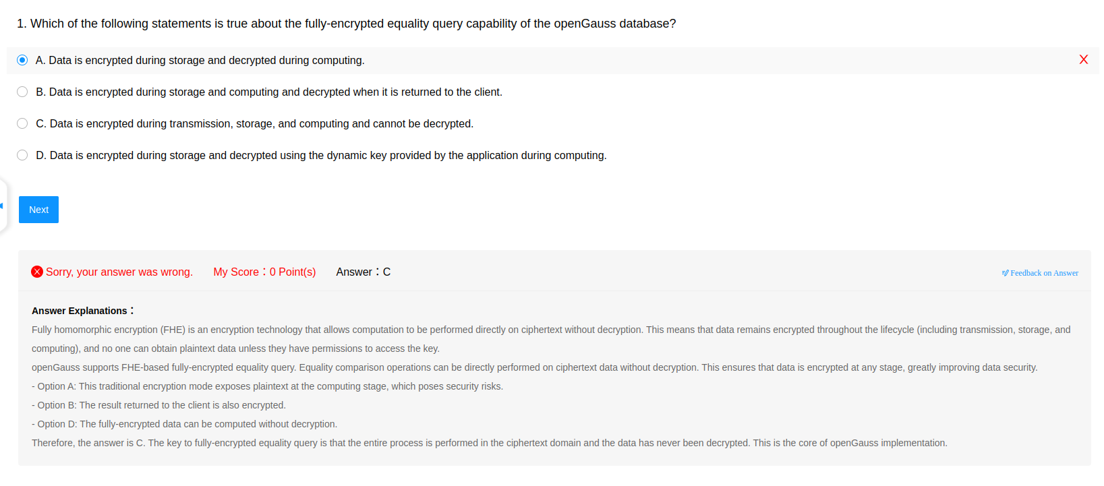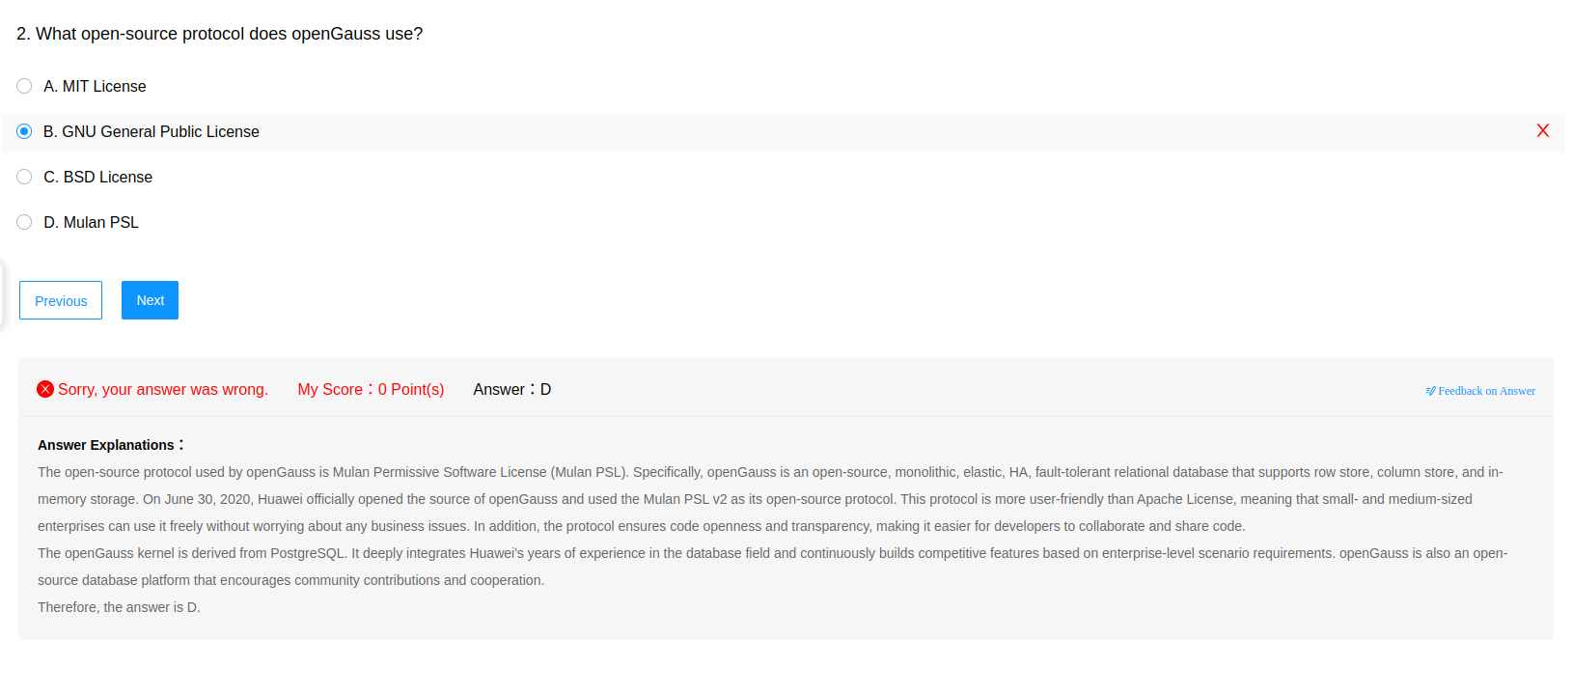

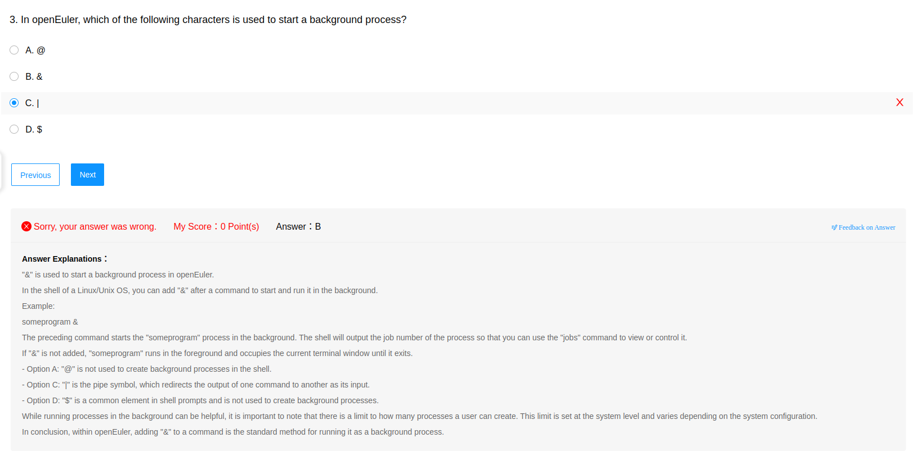

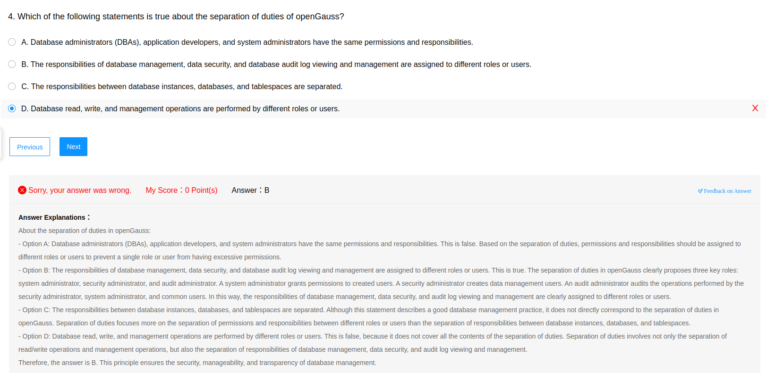

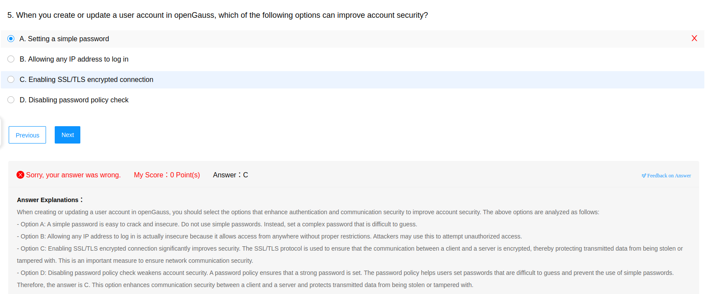

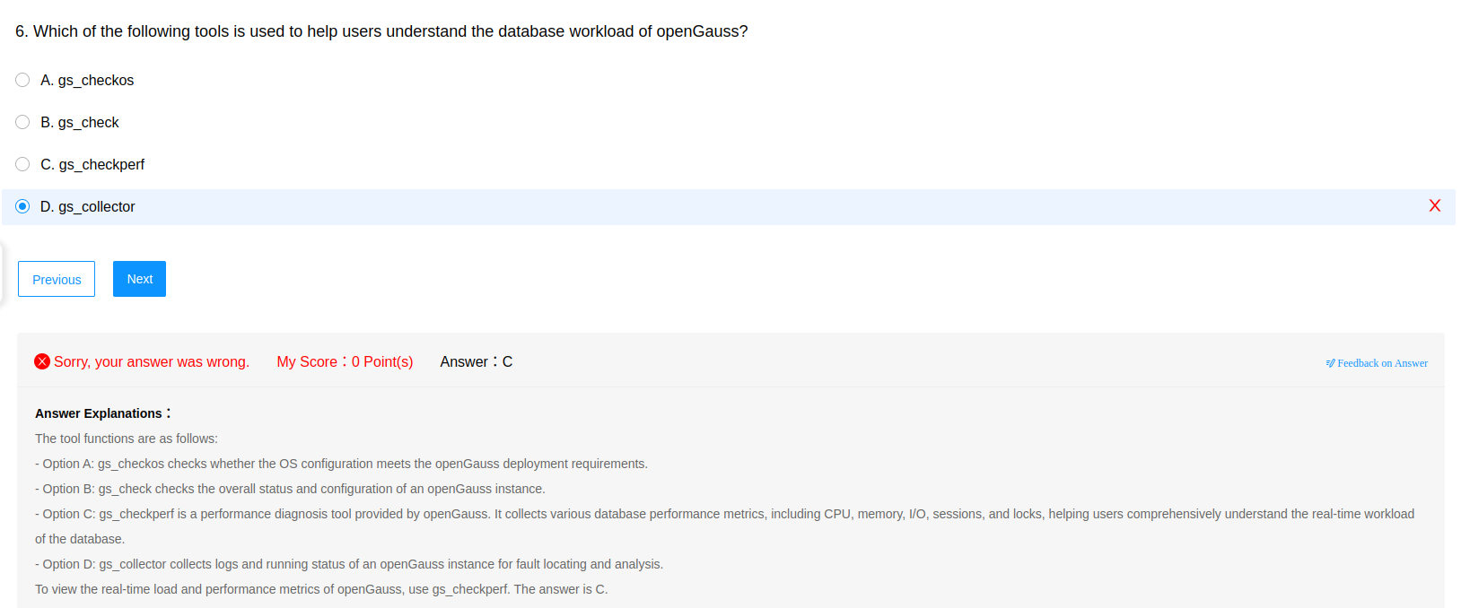

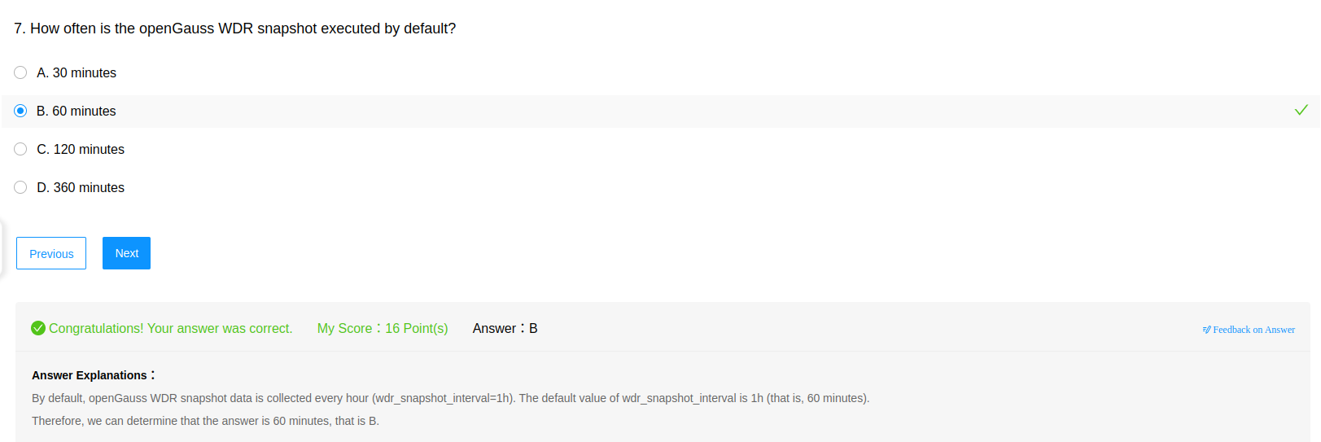

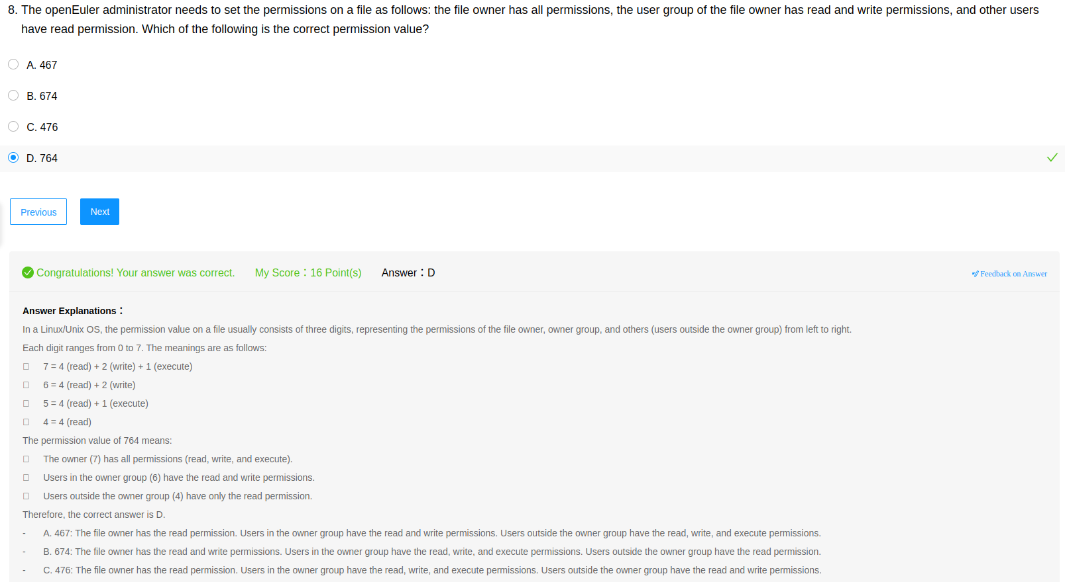

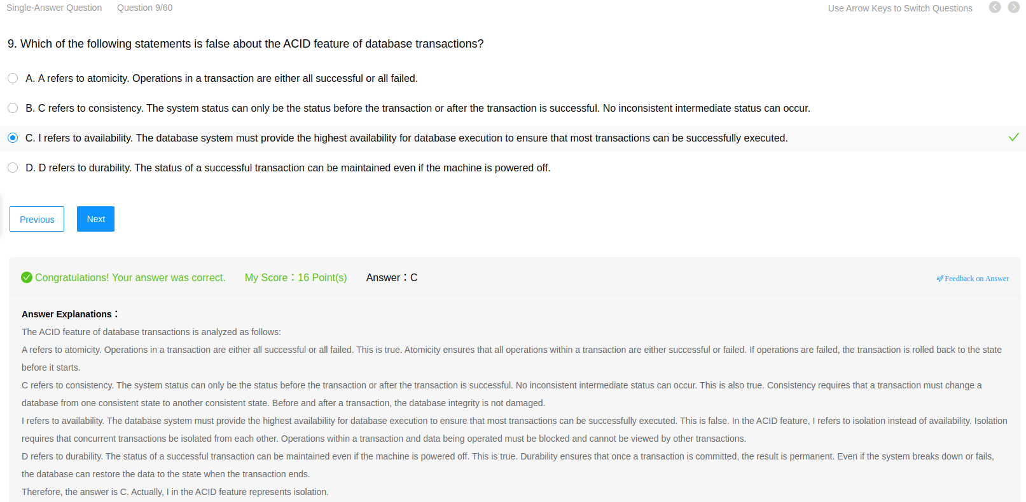

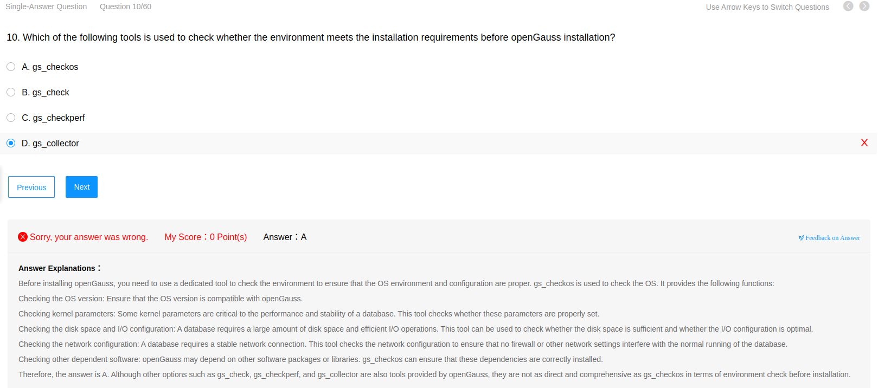

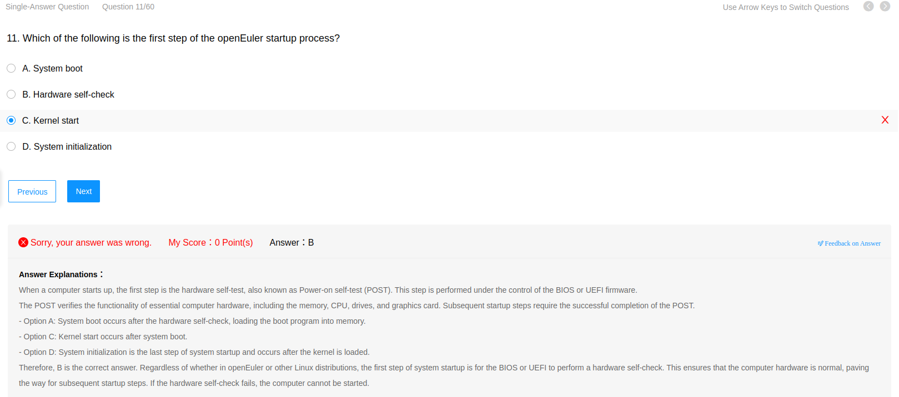

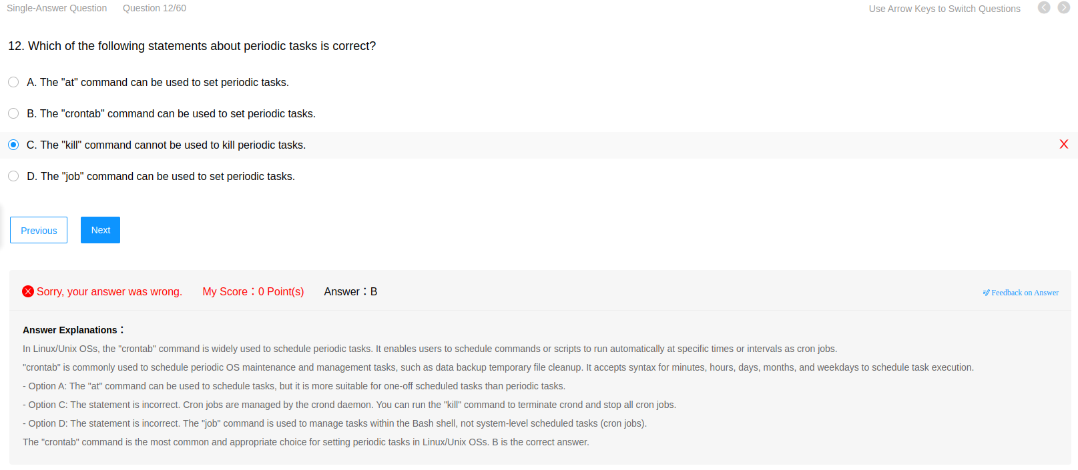

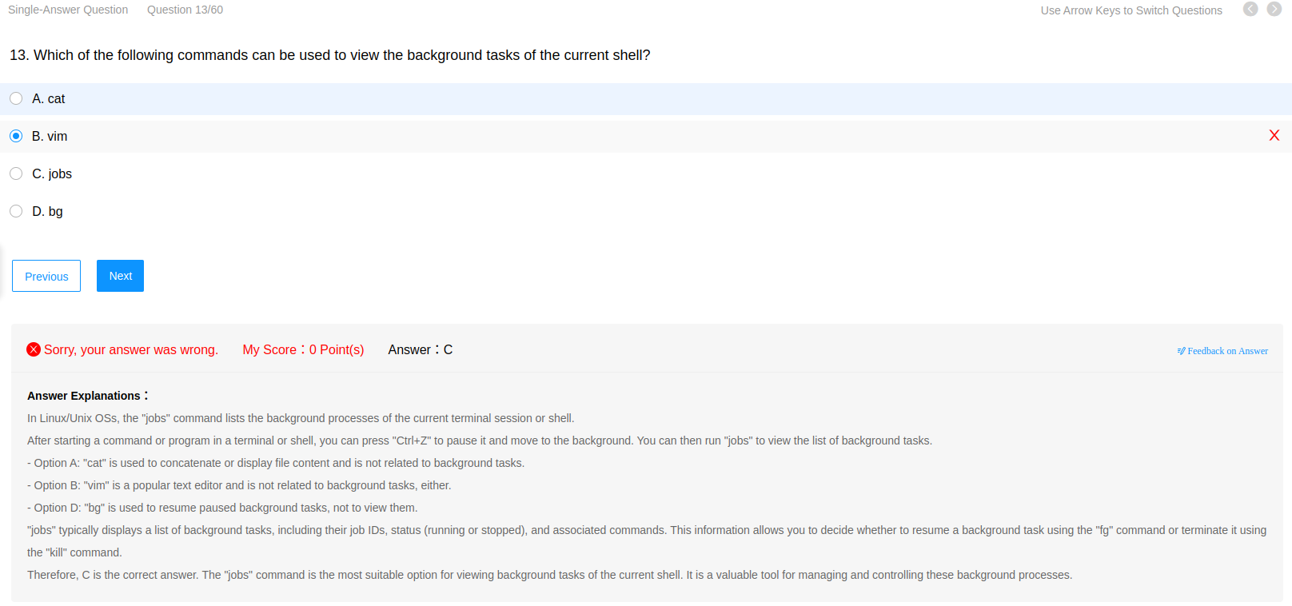

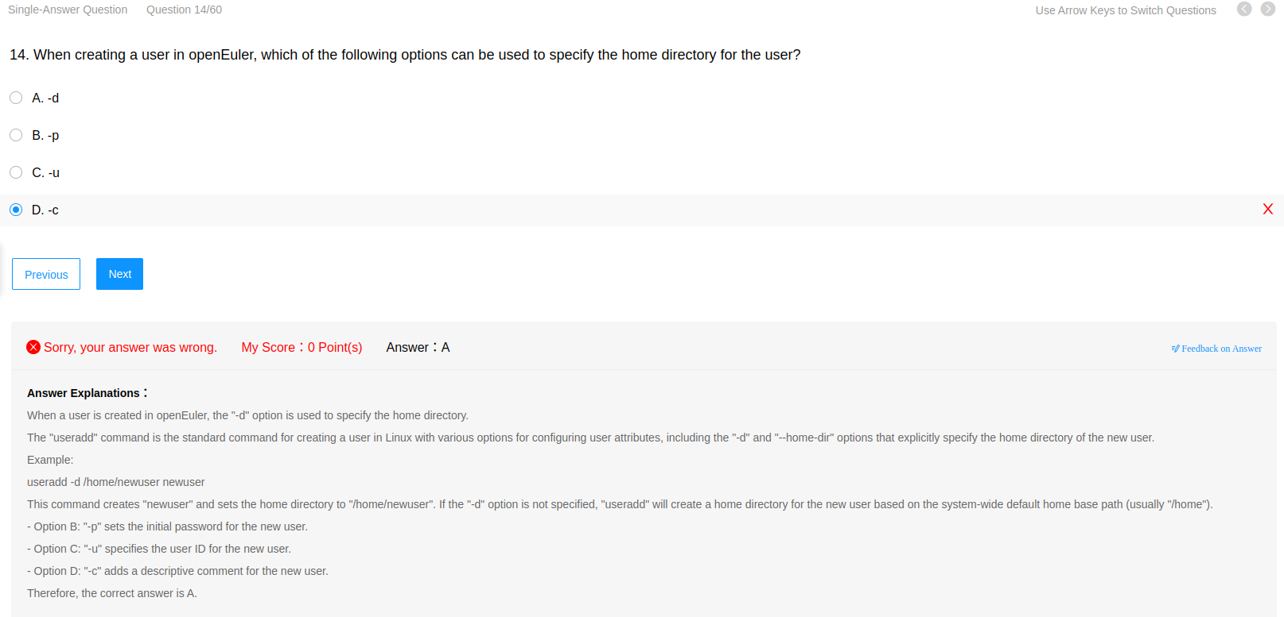

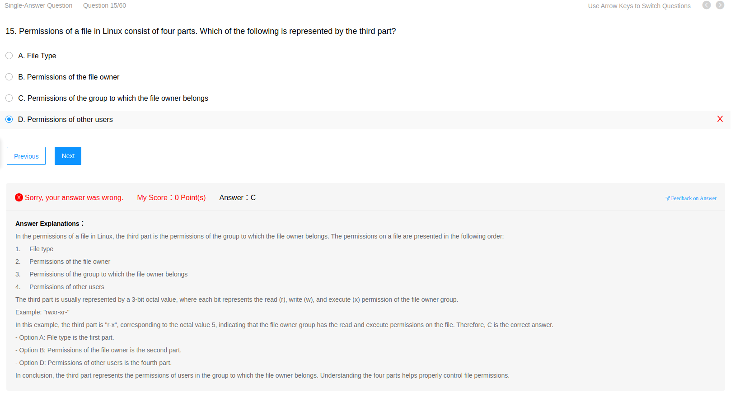

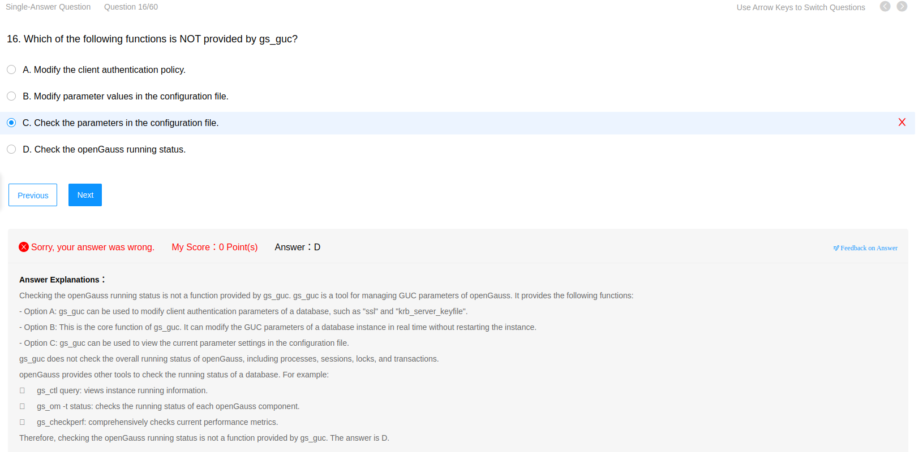

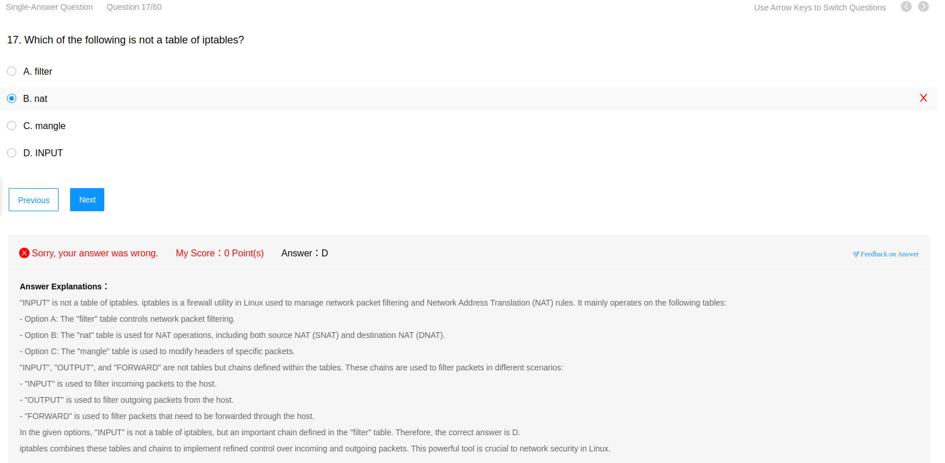

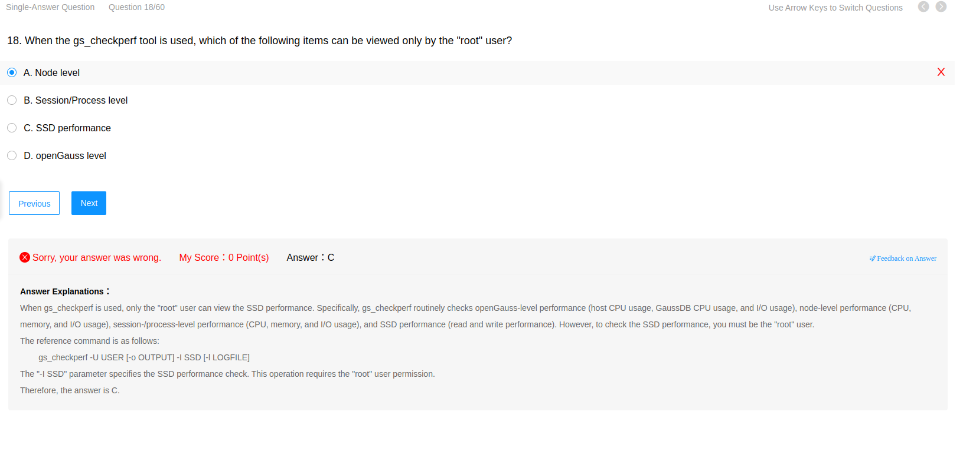

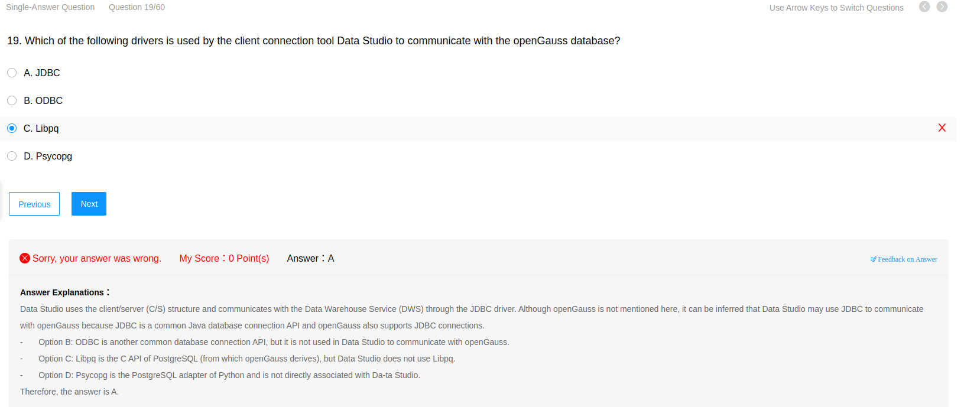

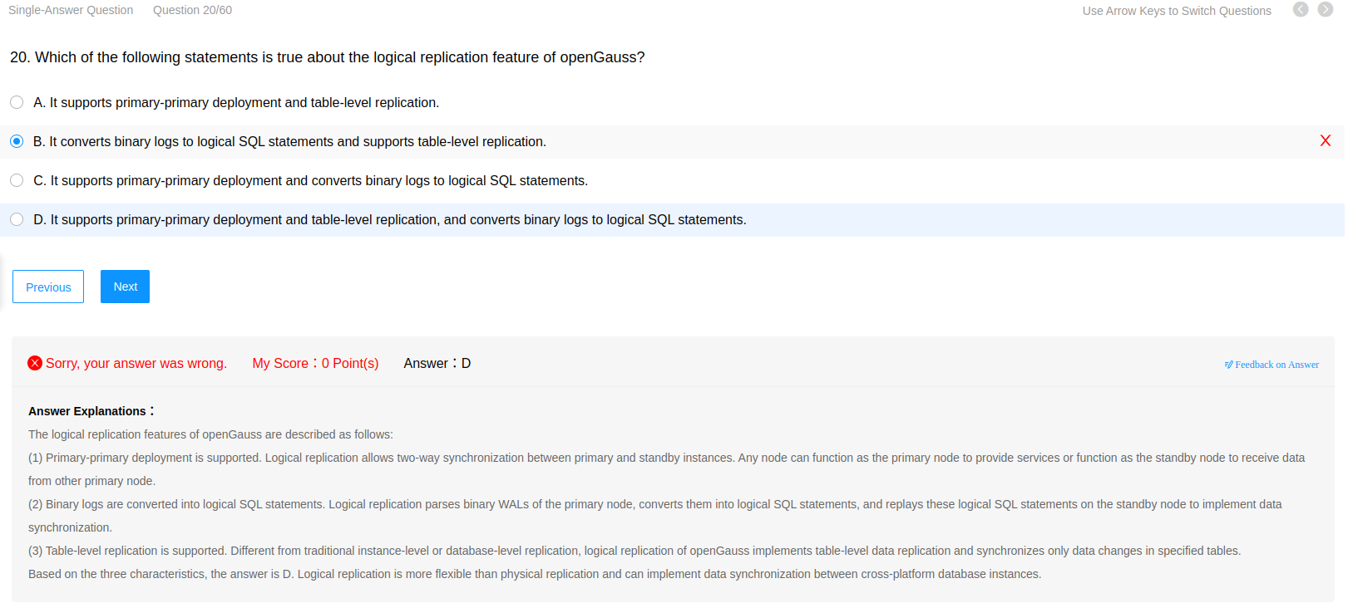

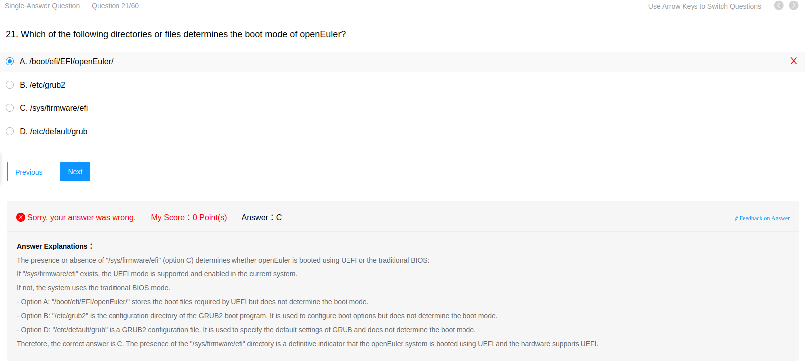

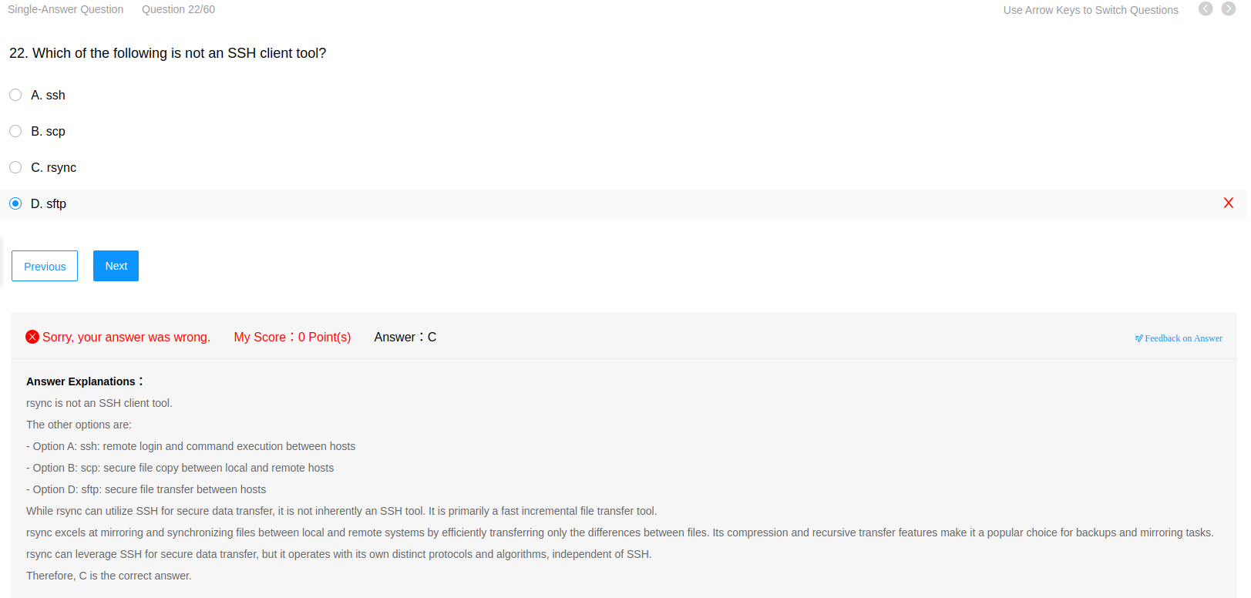

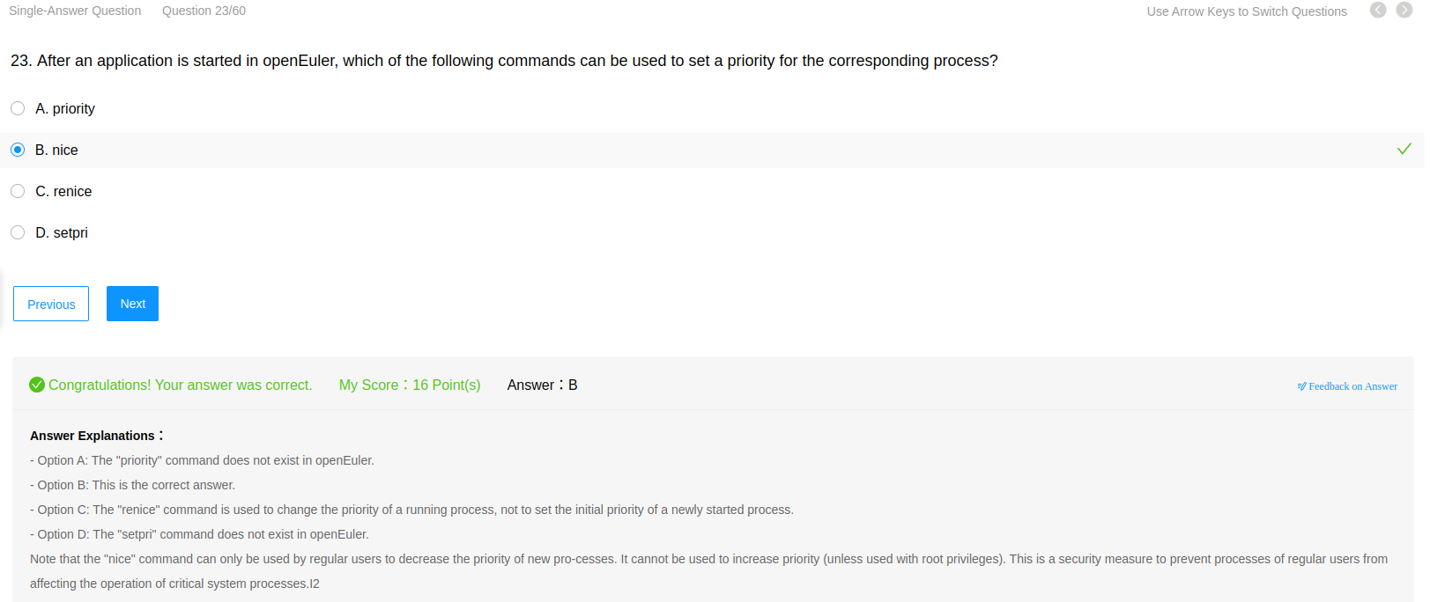

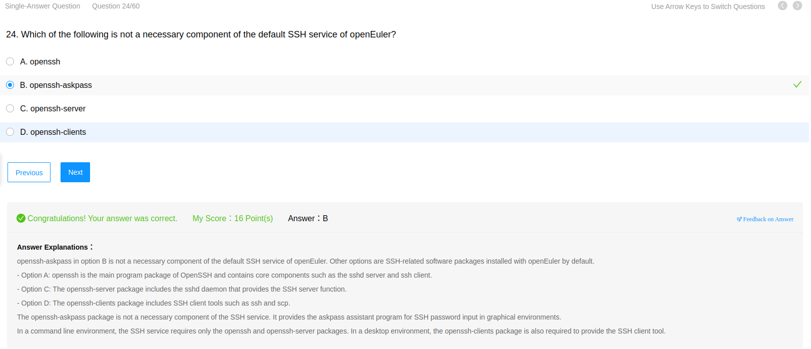

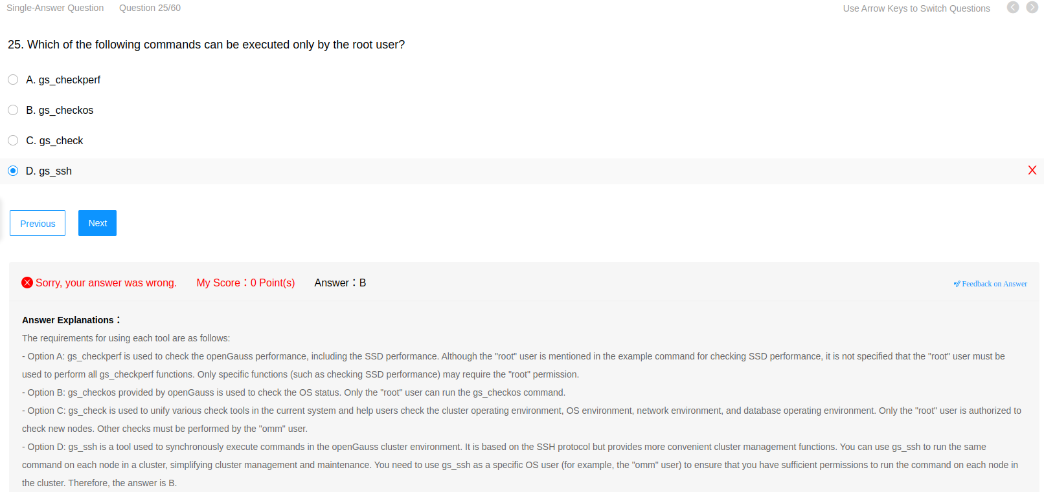

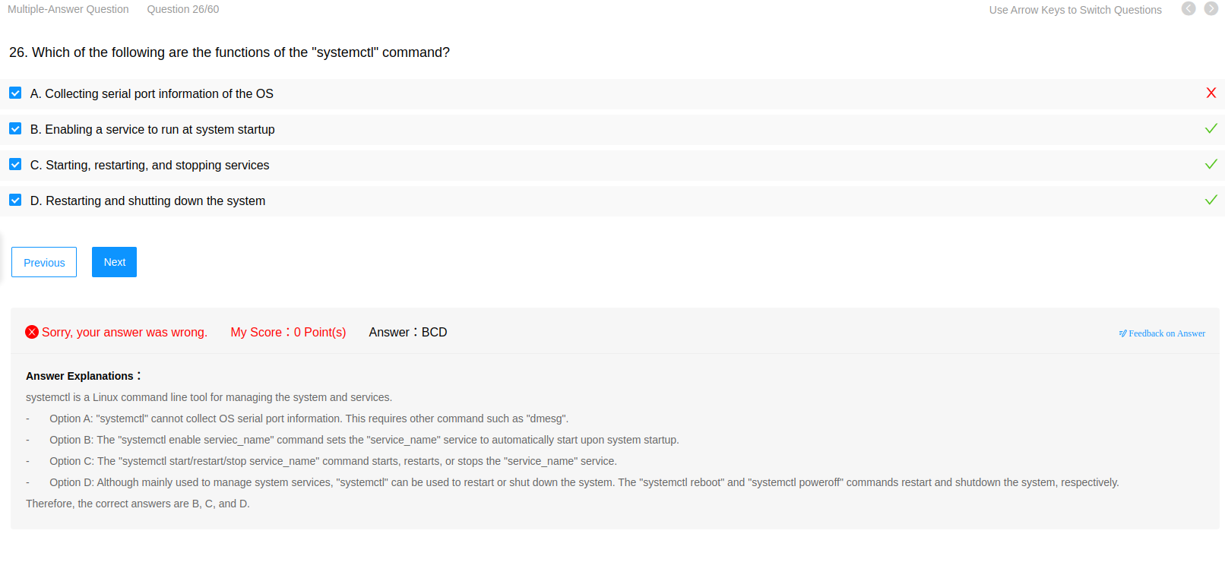

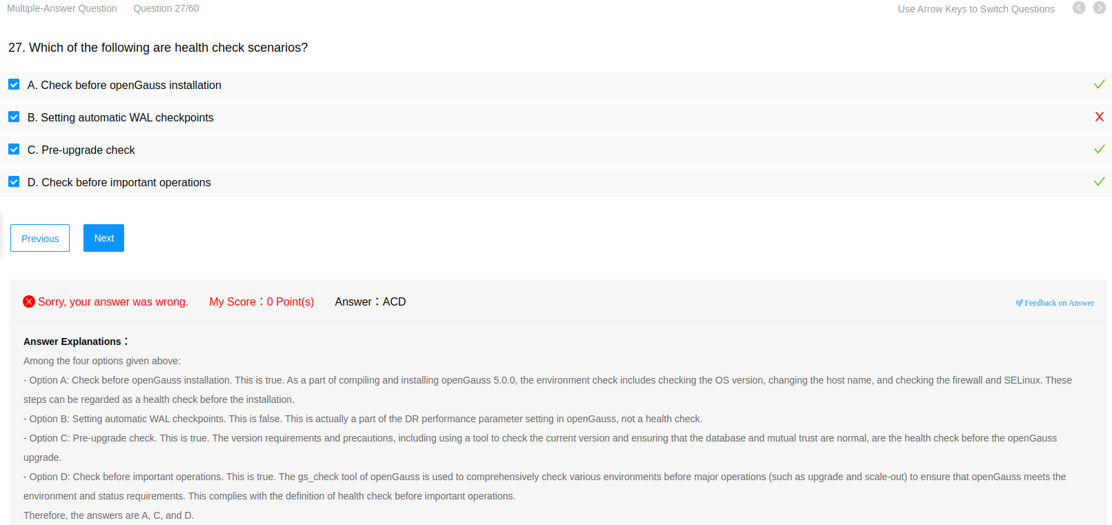

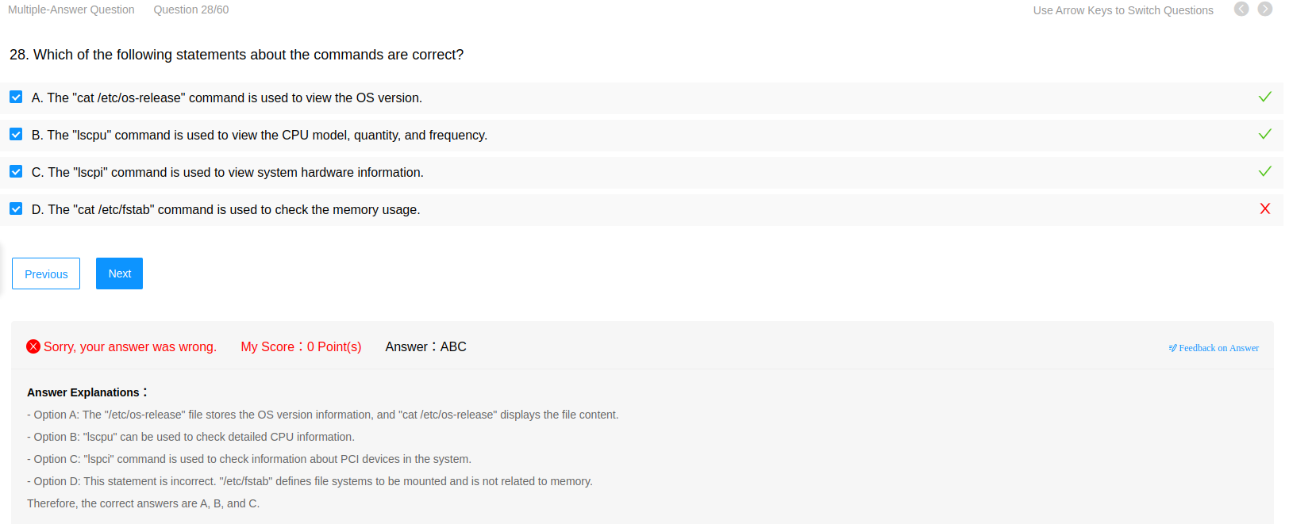

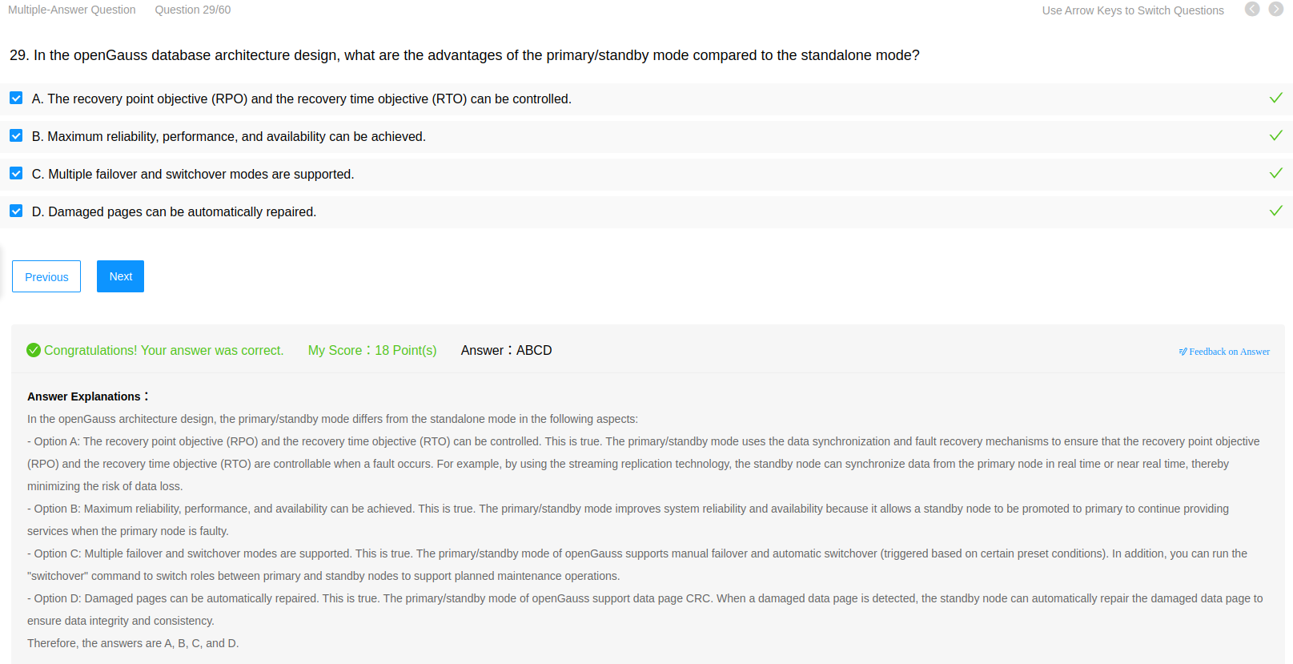

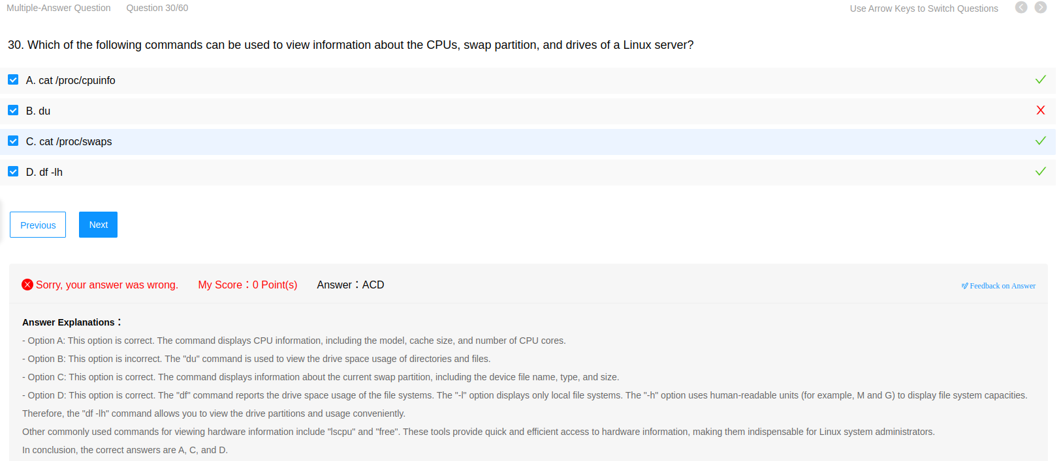

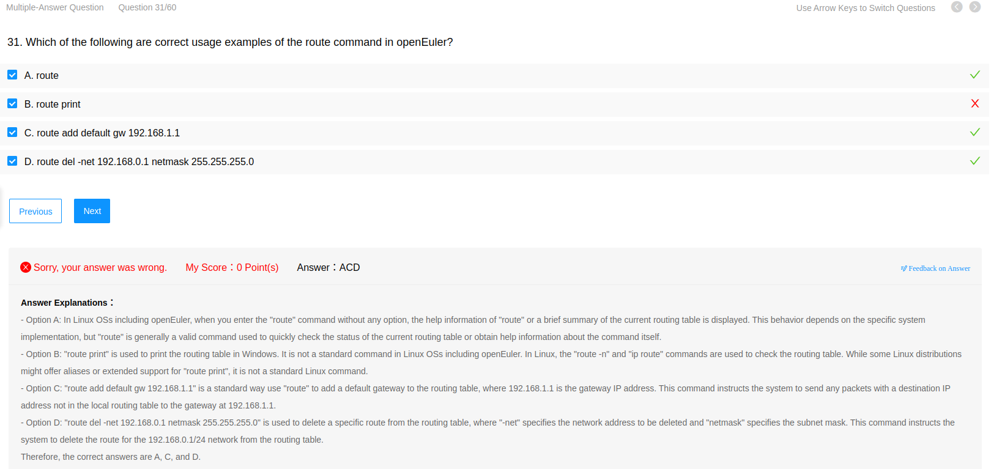

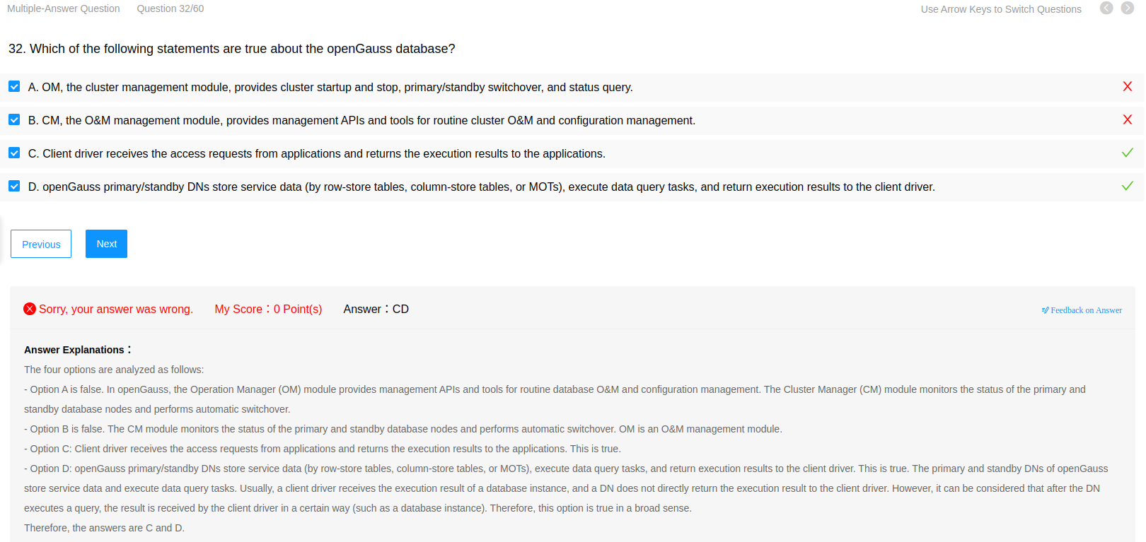

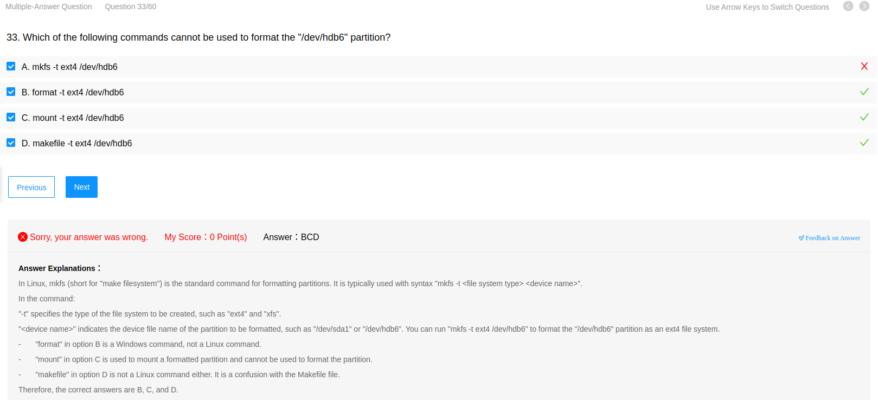

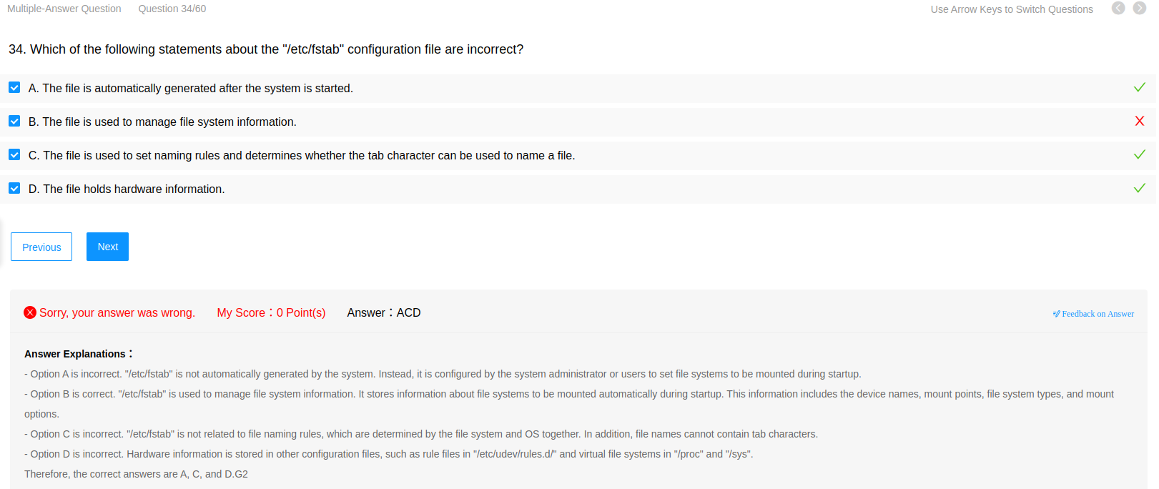

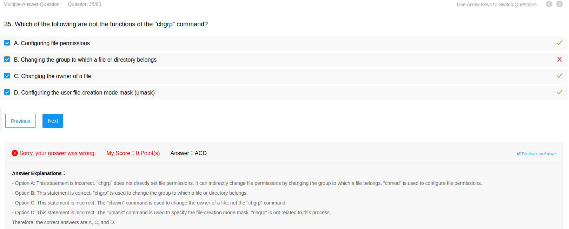

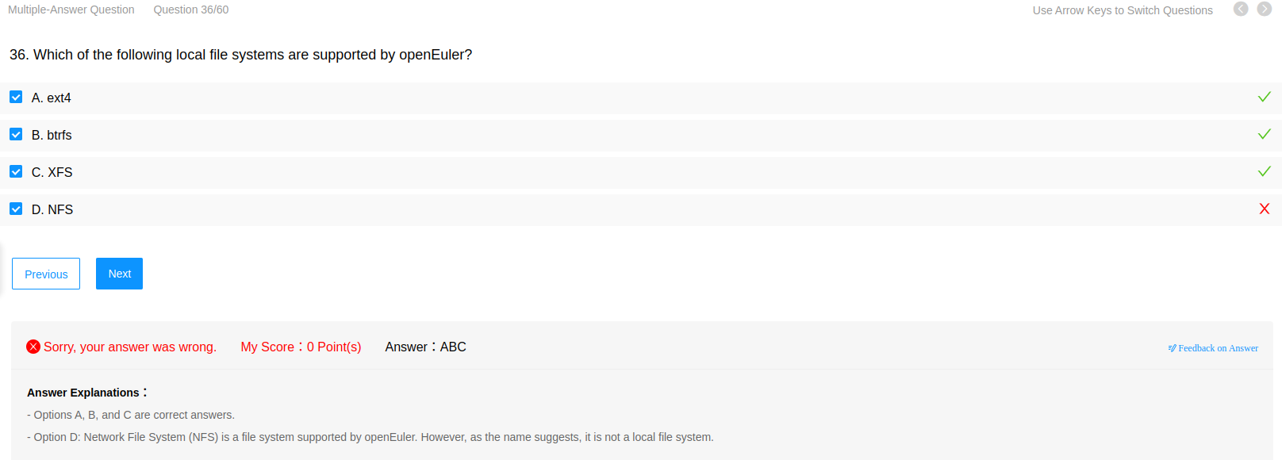

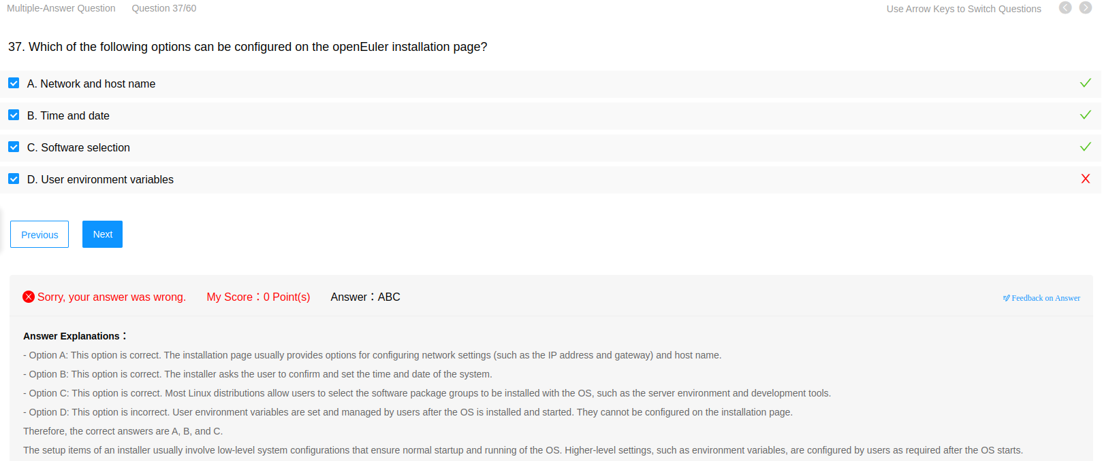

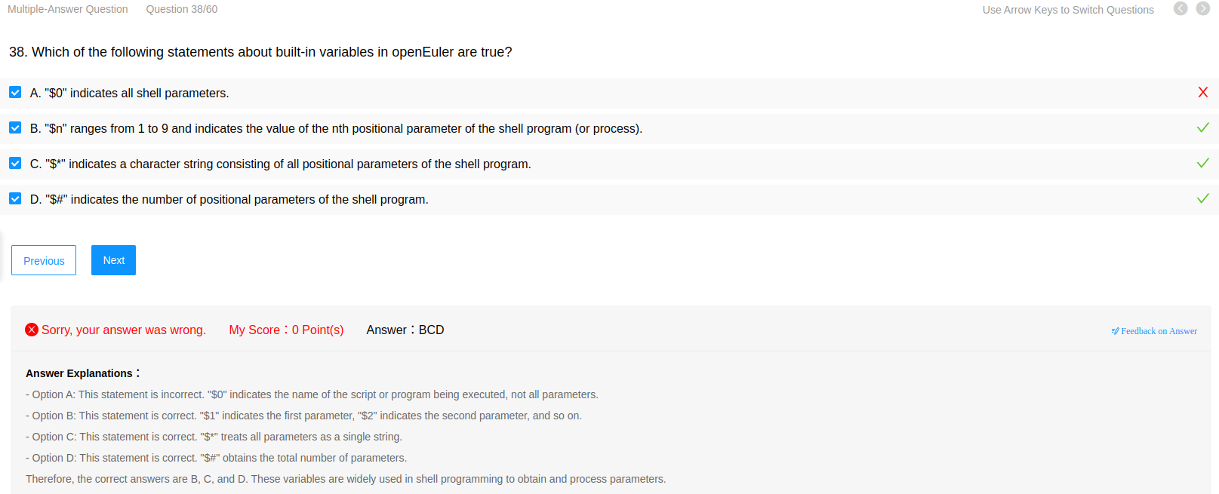

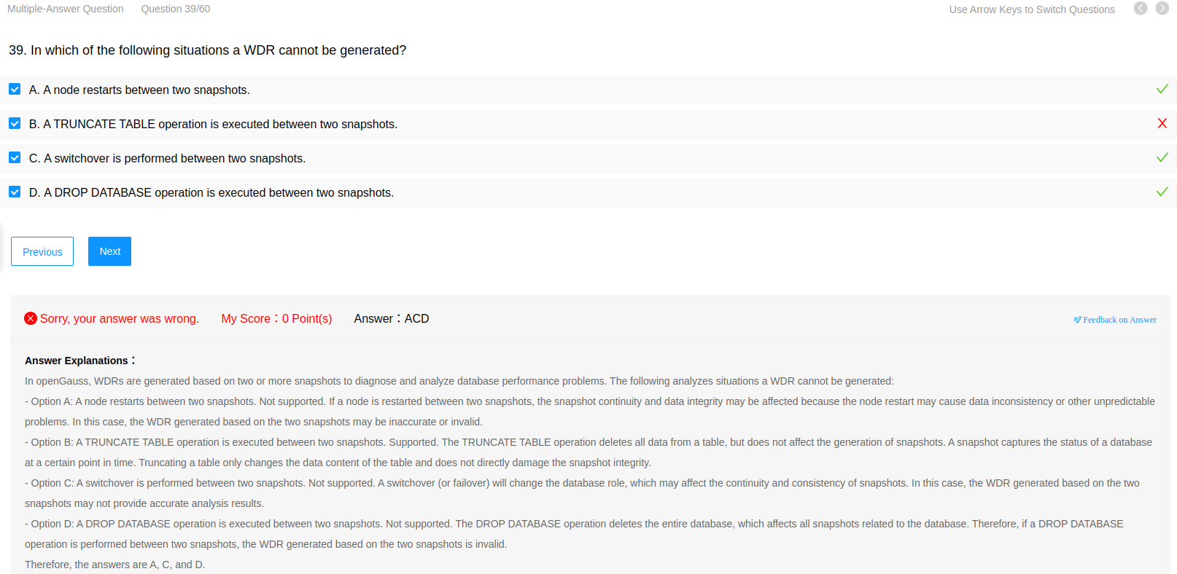

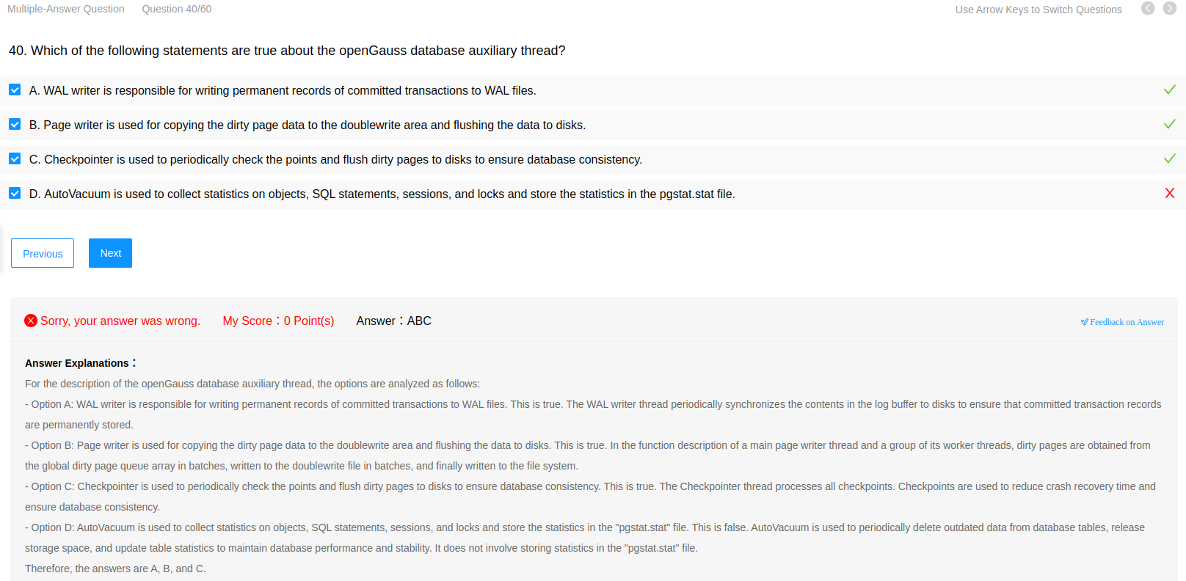

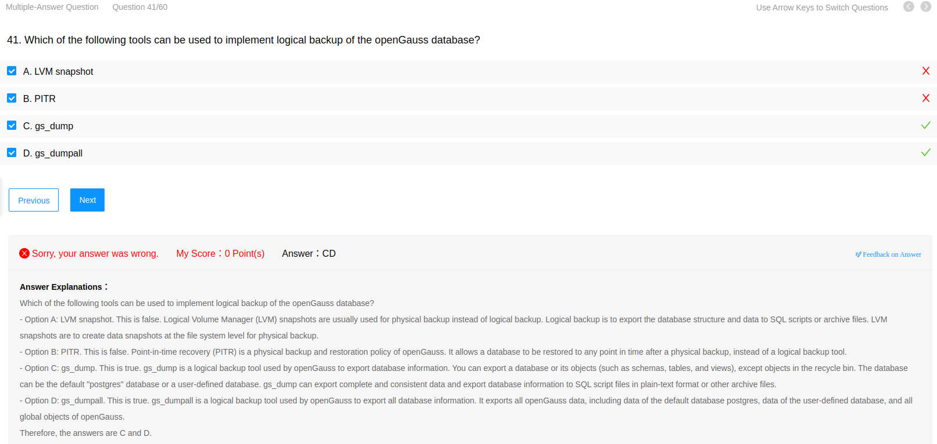

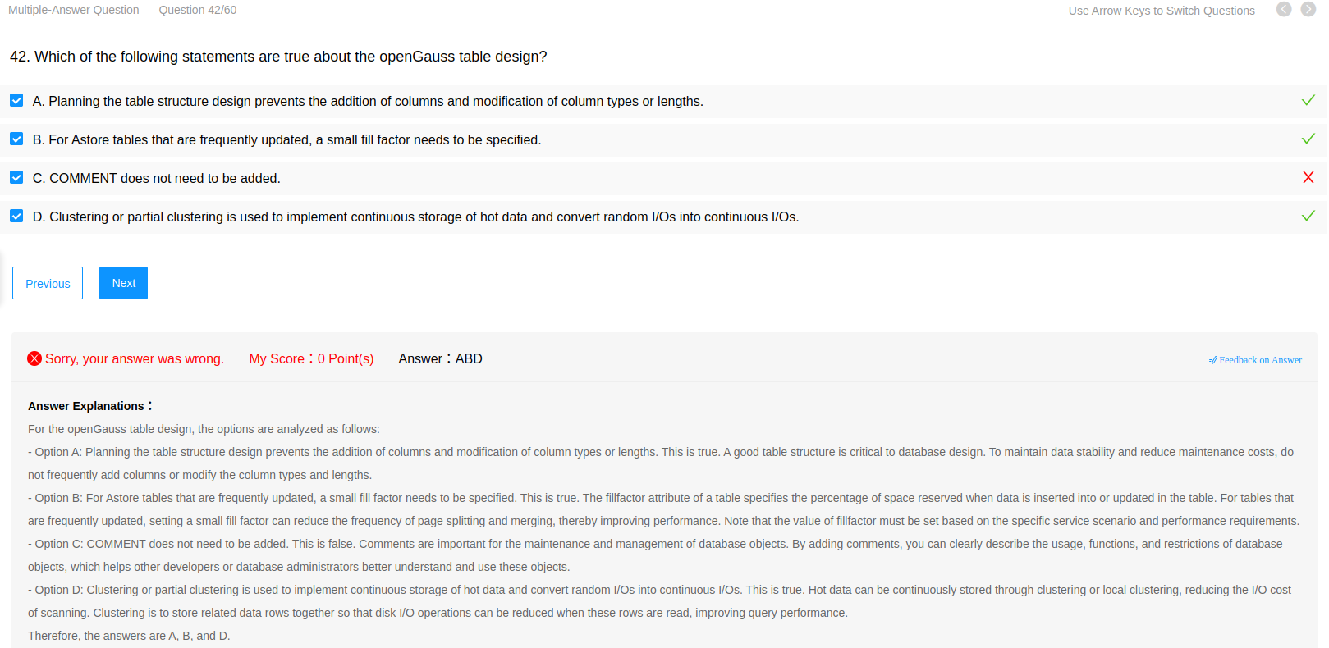

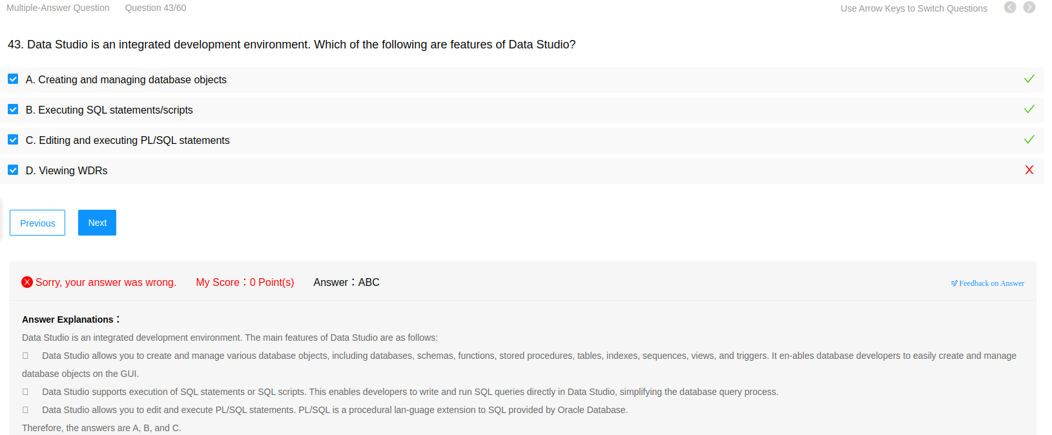

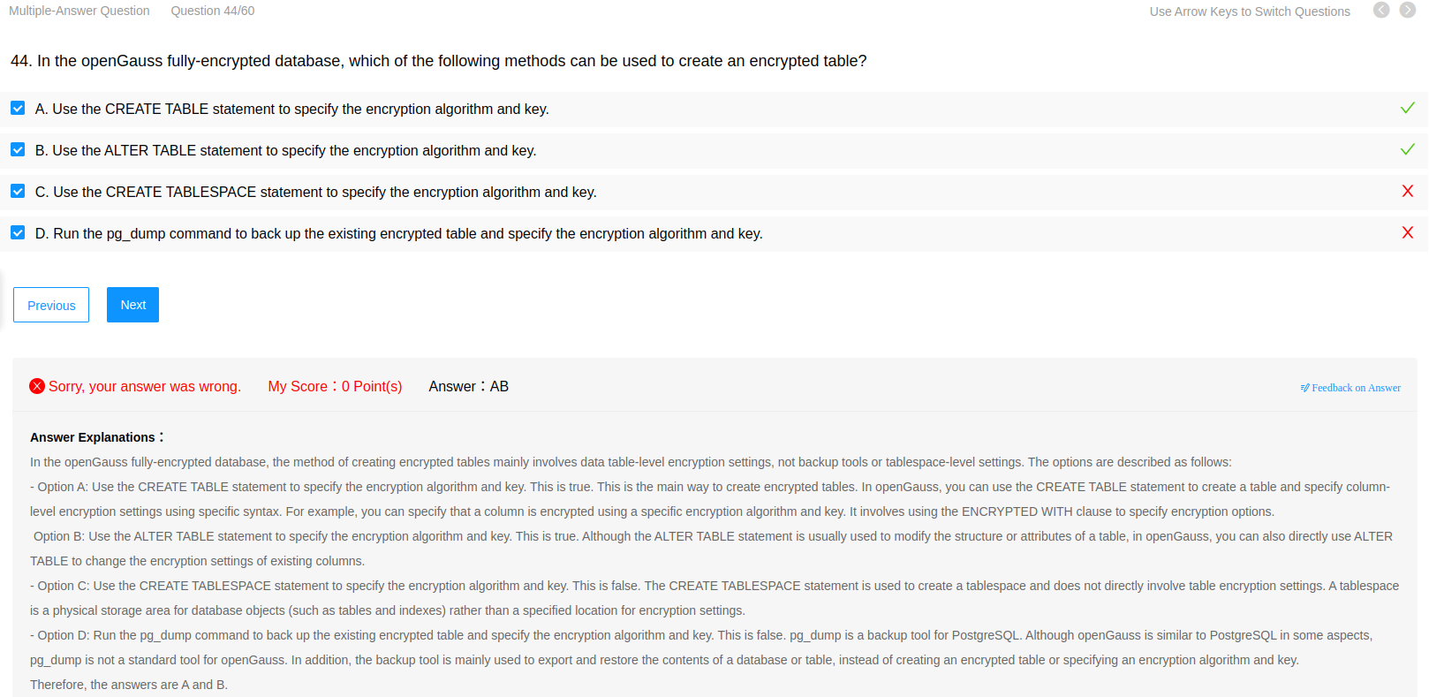

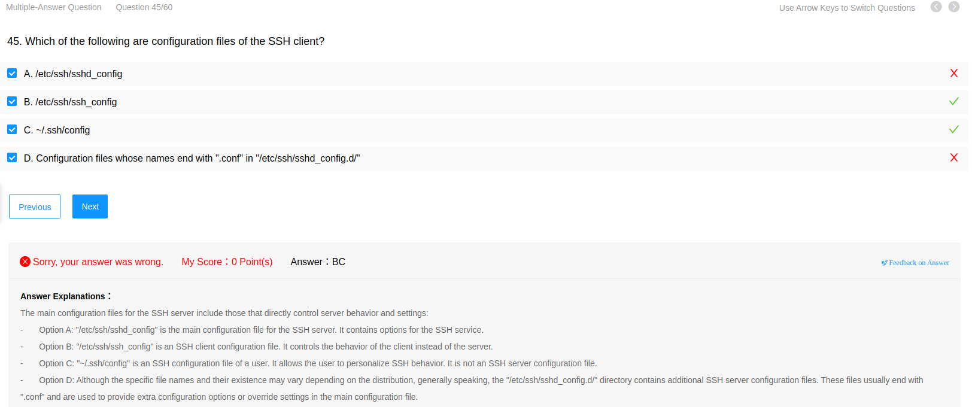

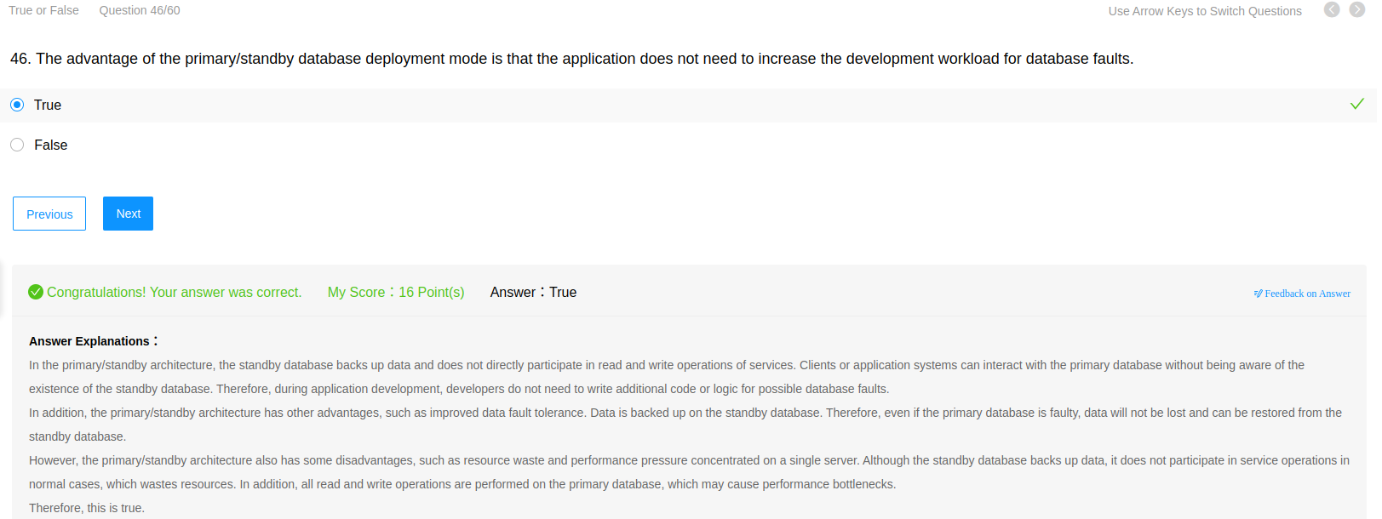

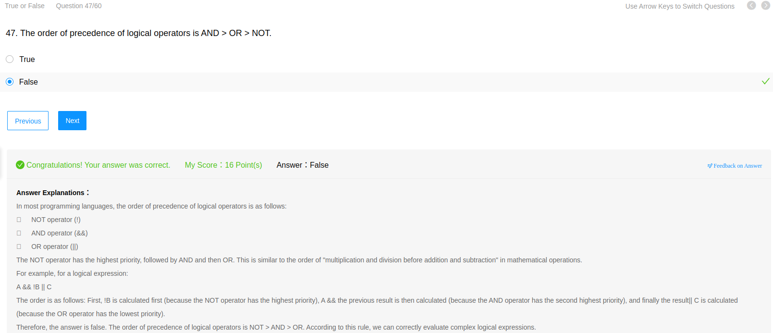

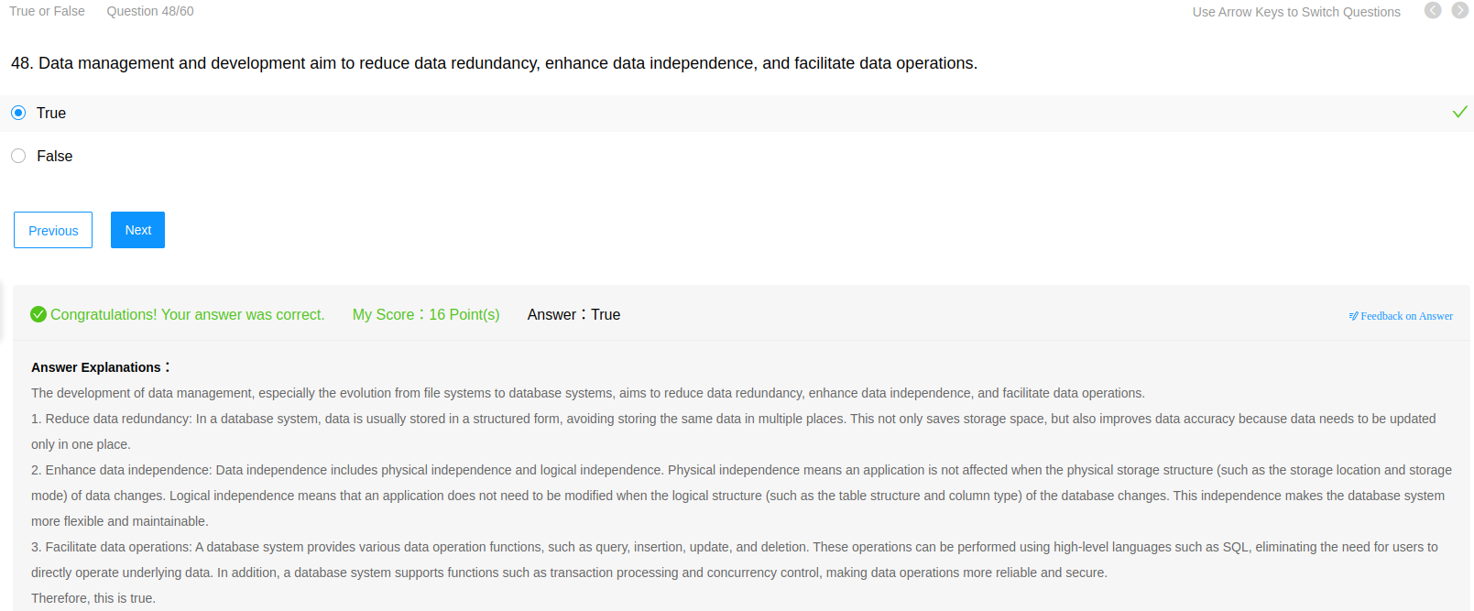

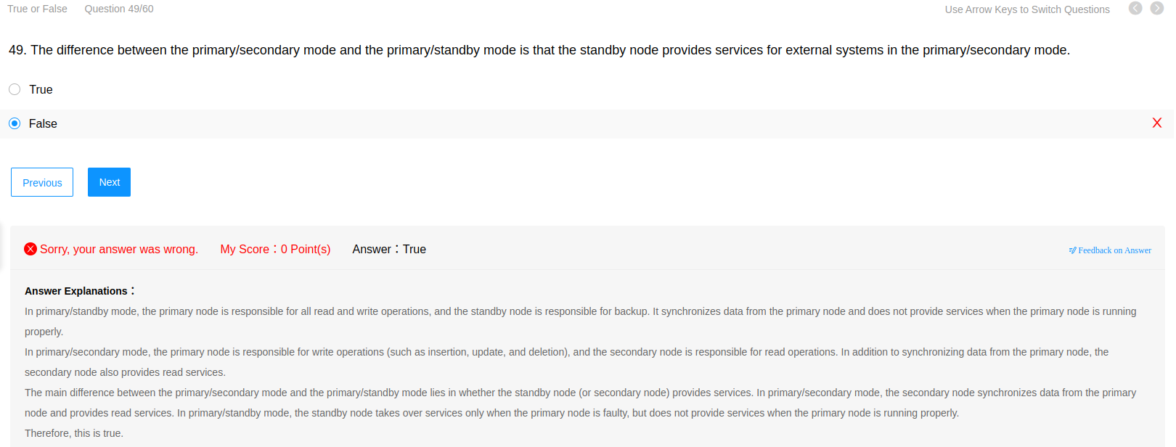

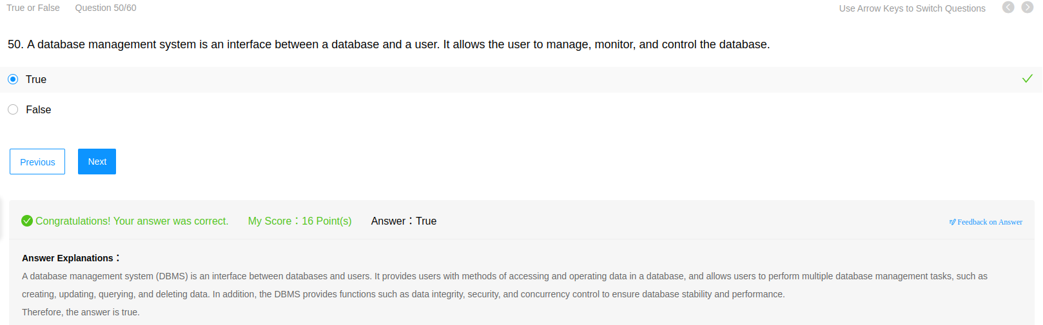

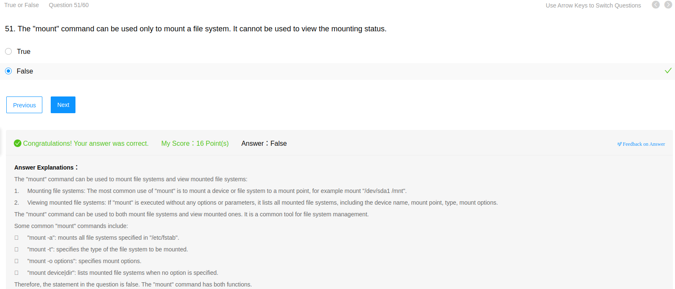

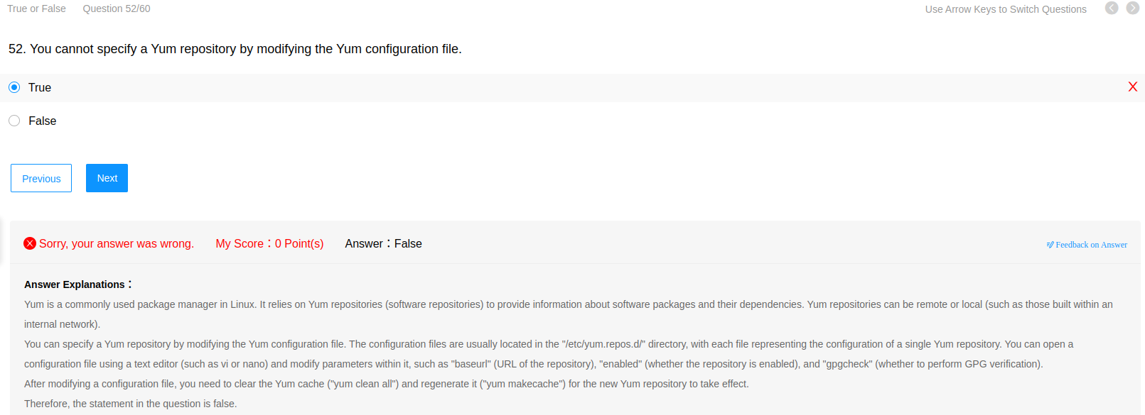

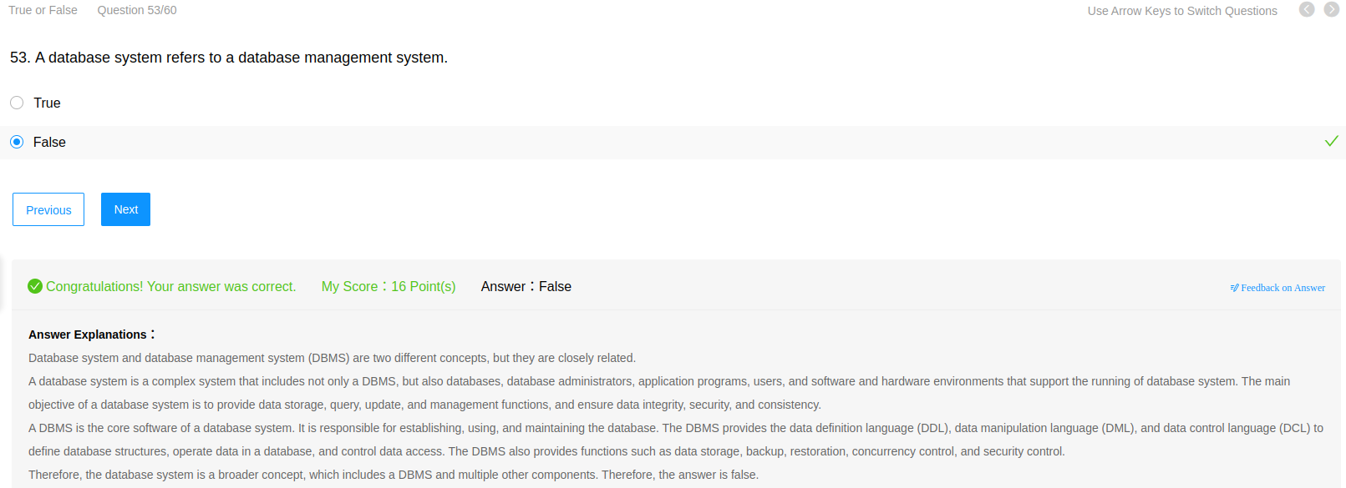

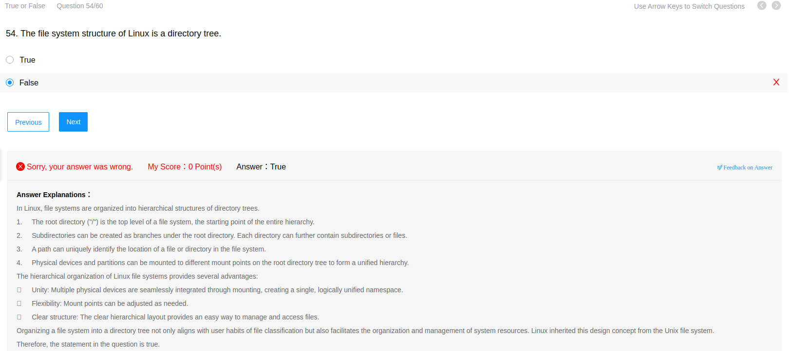

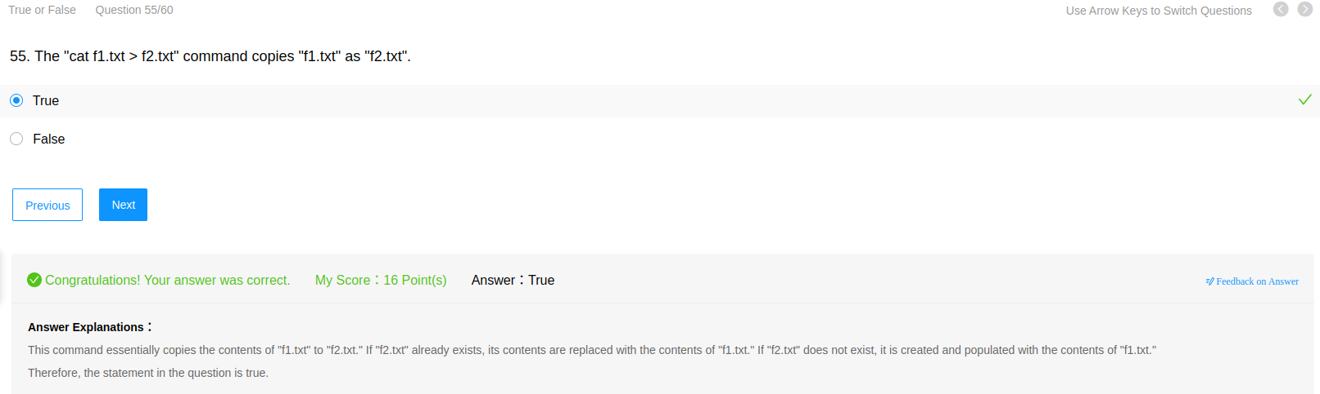

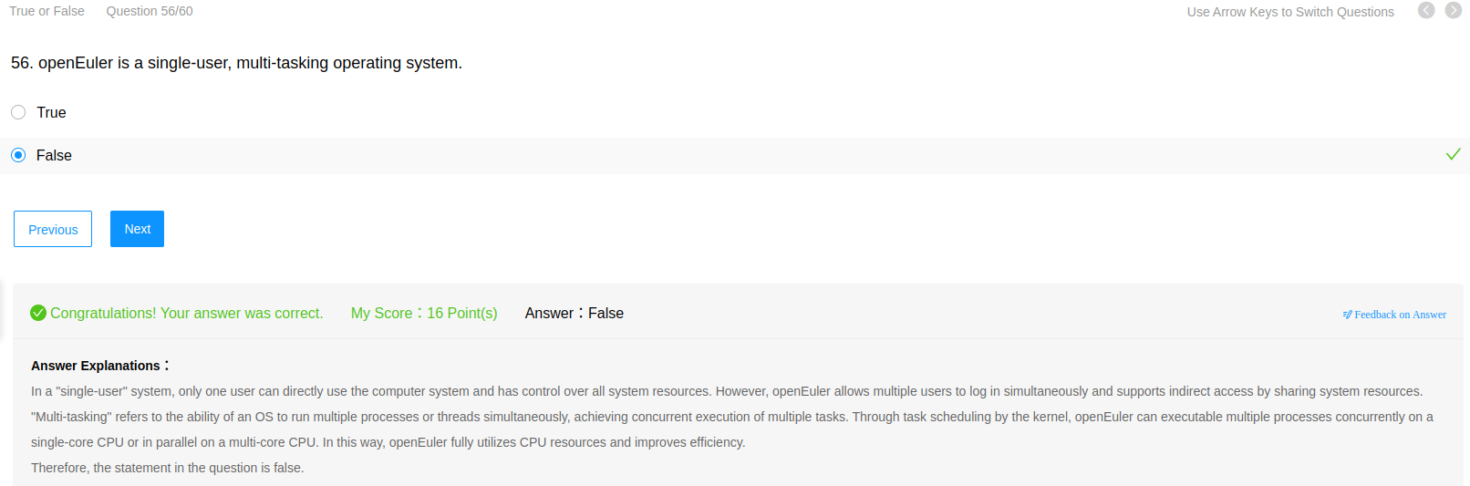

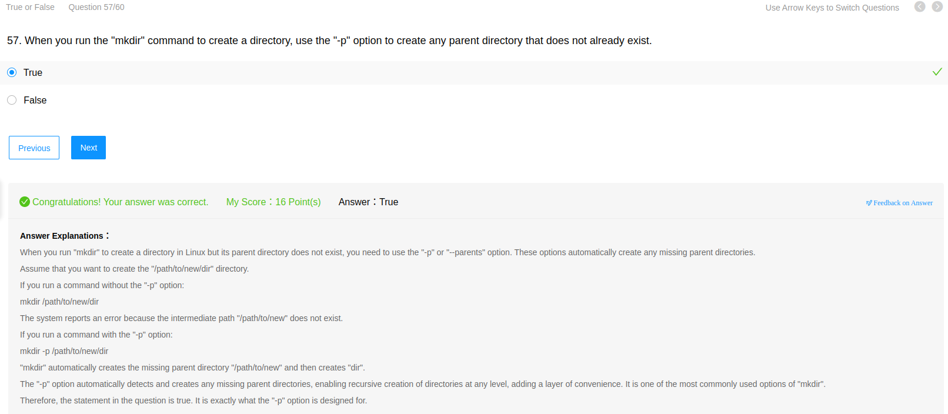

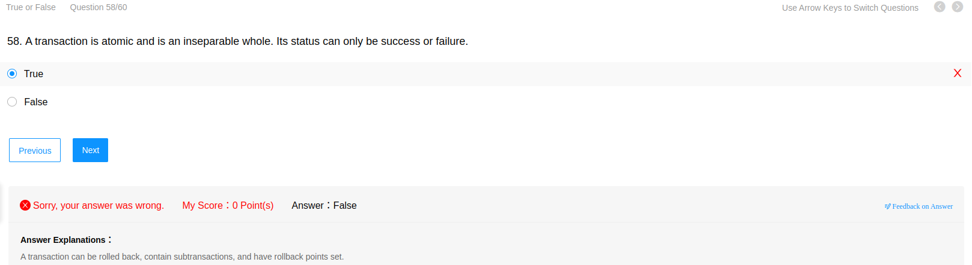

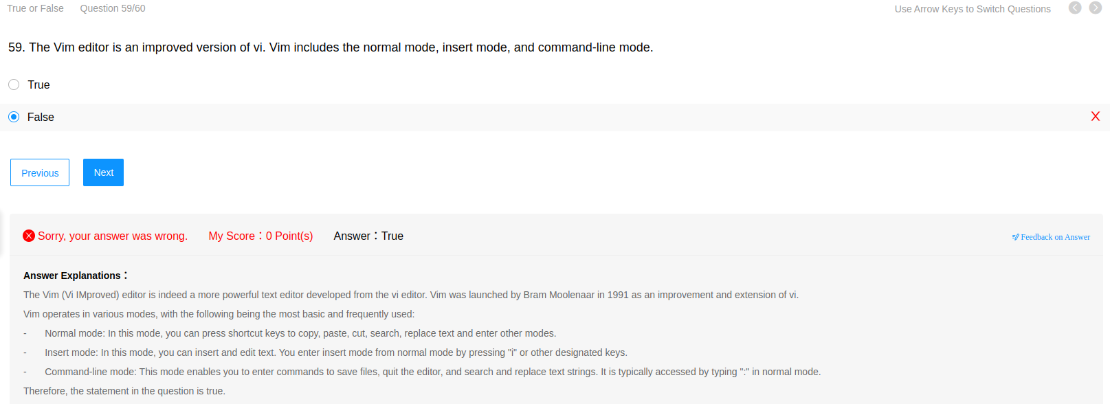

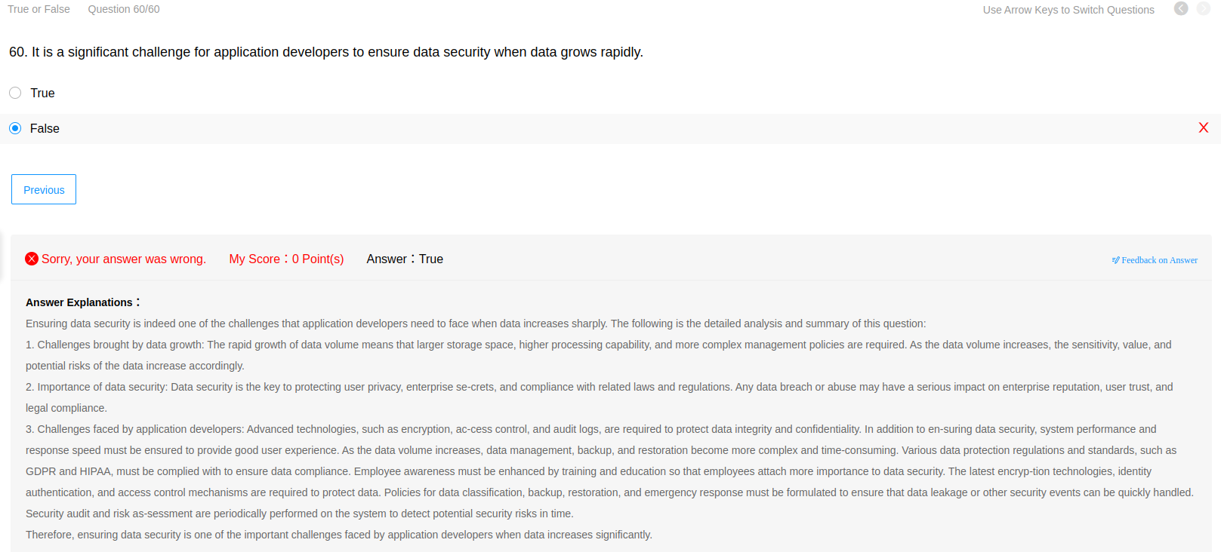

**PROVA FASE NACIONAL - HCIP**

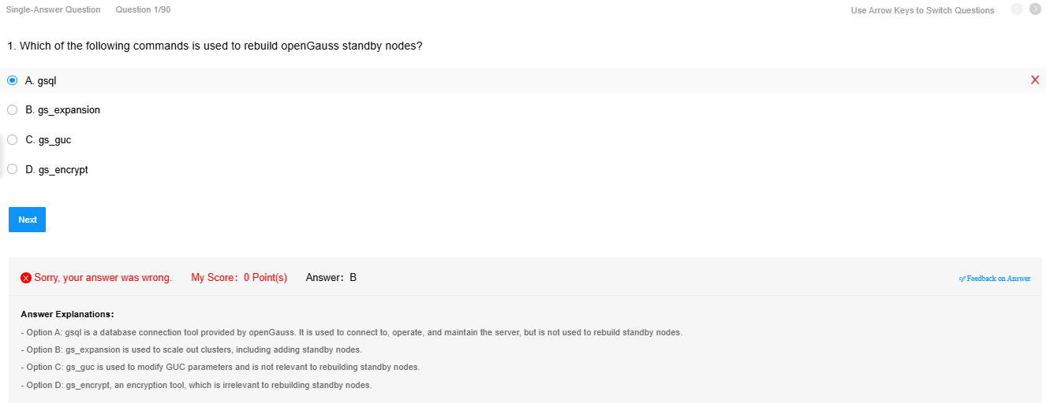

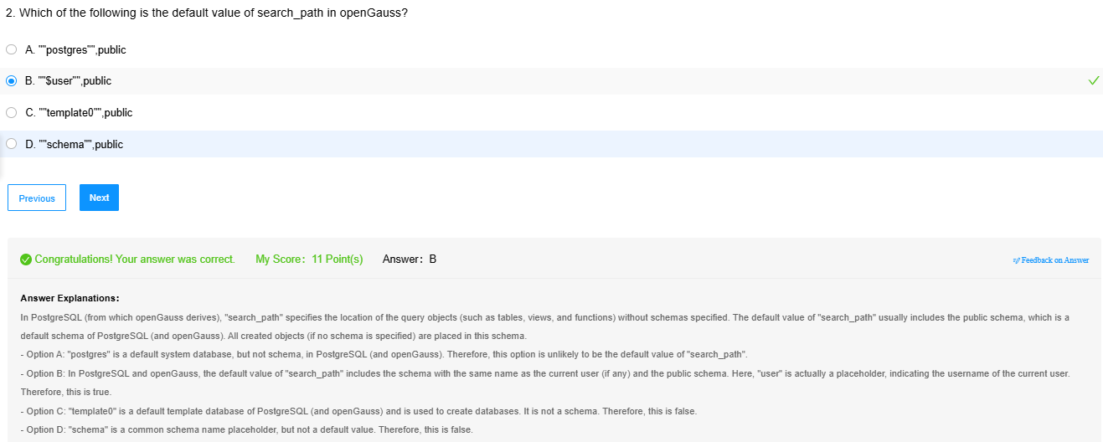

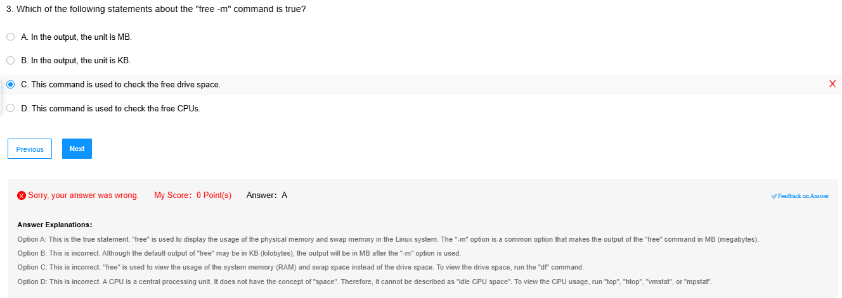

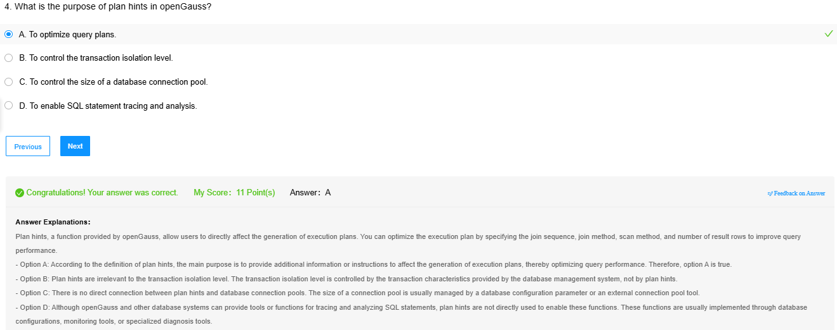

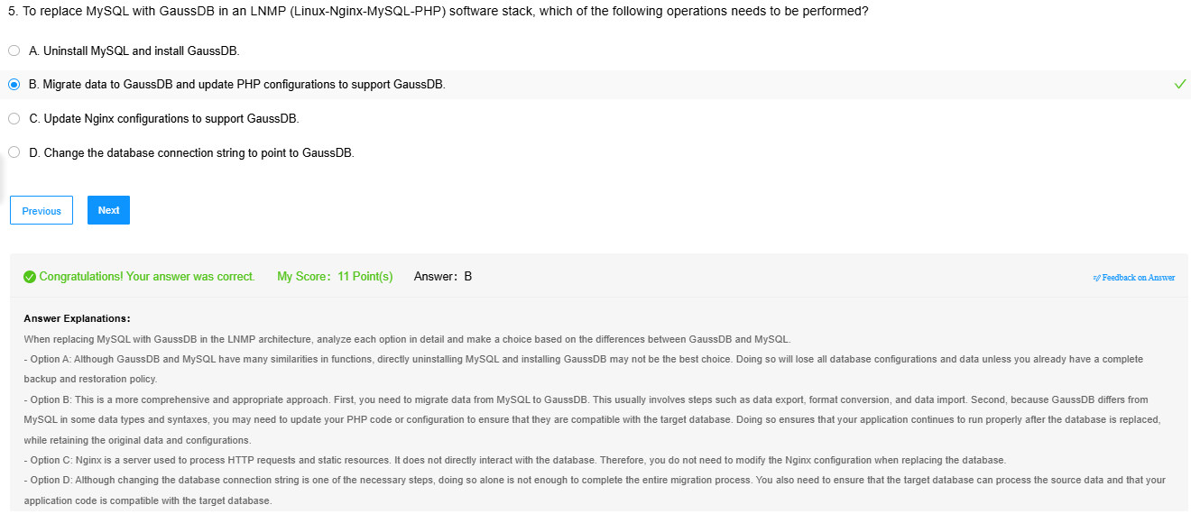

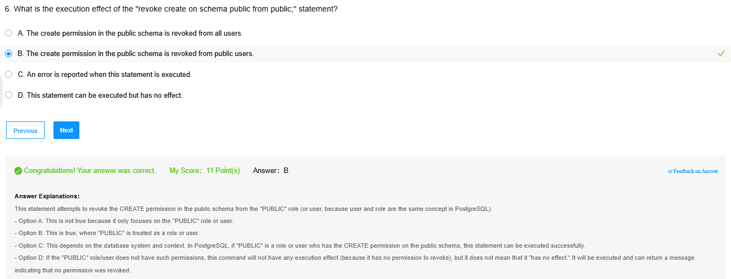

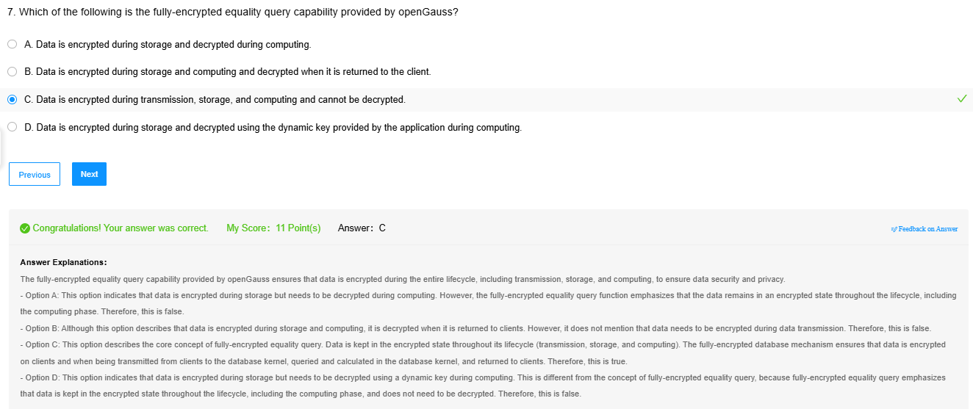

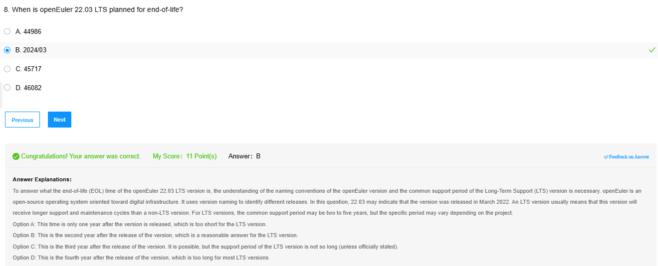

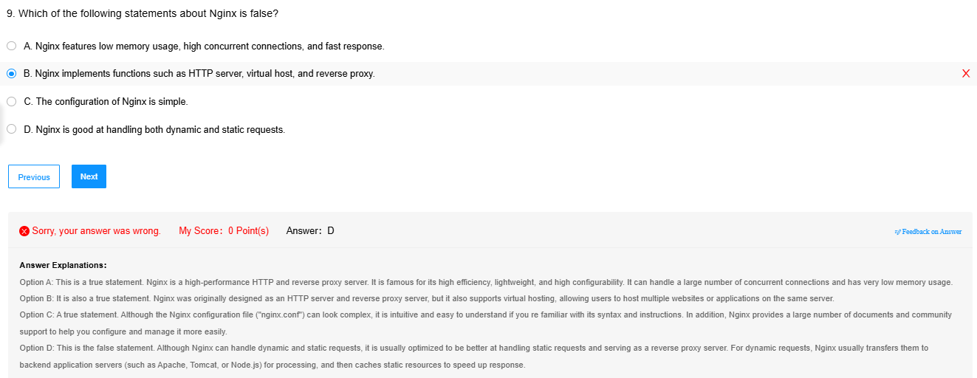

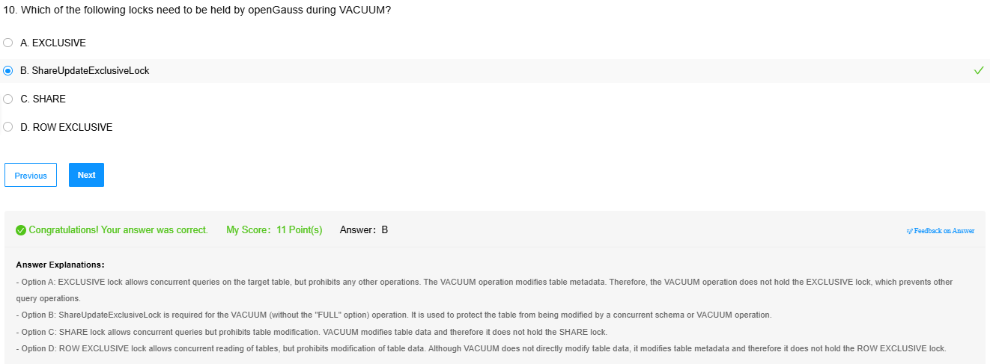

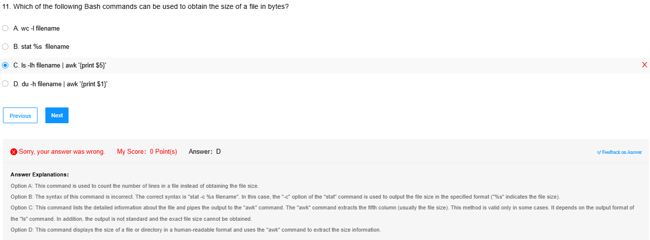

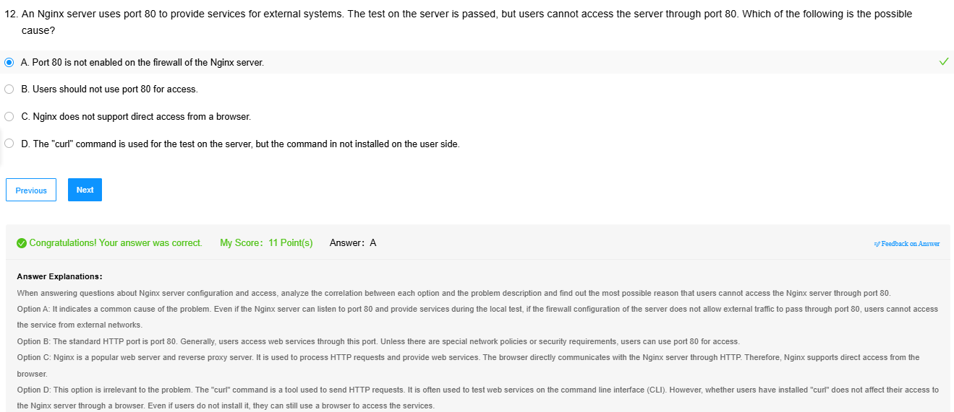

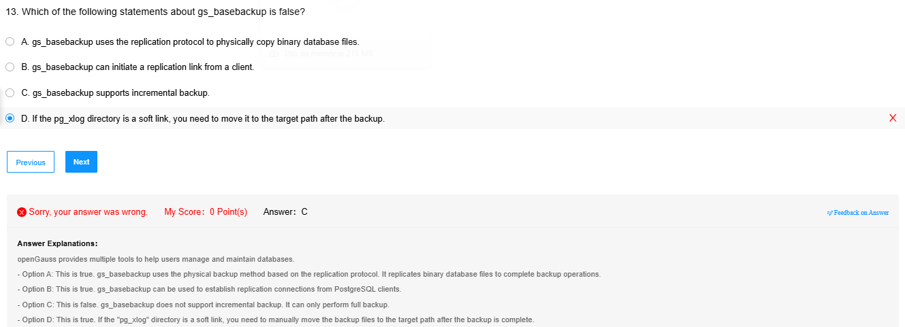

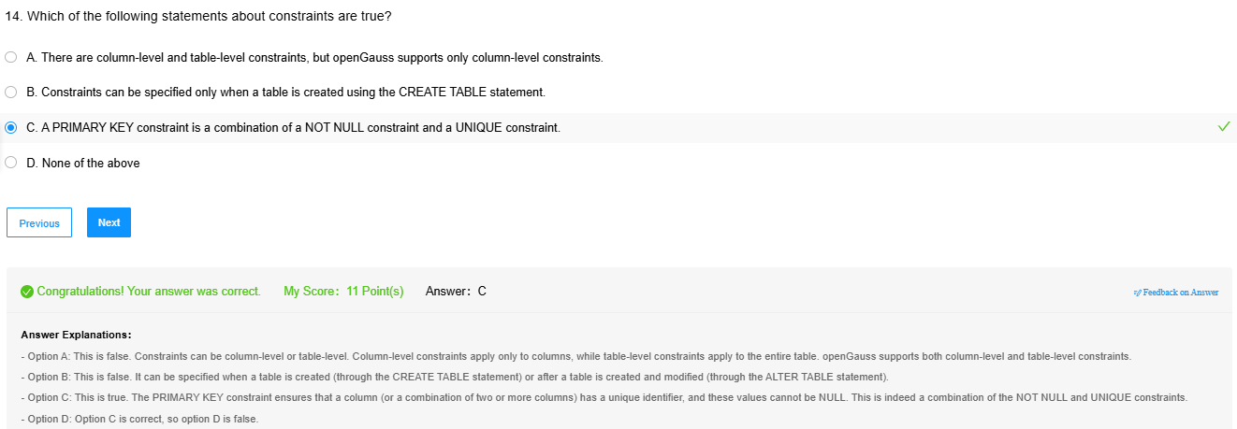

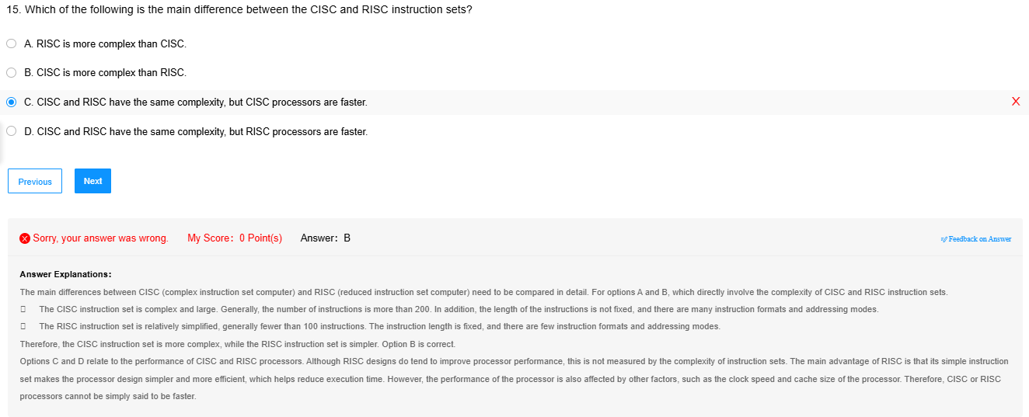

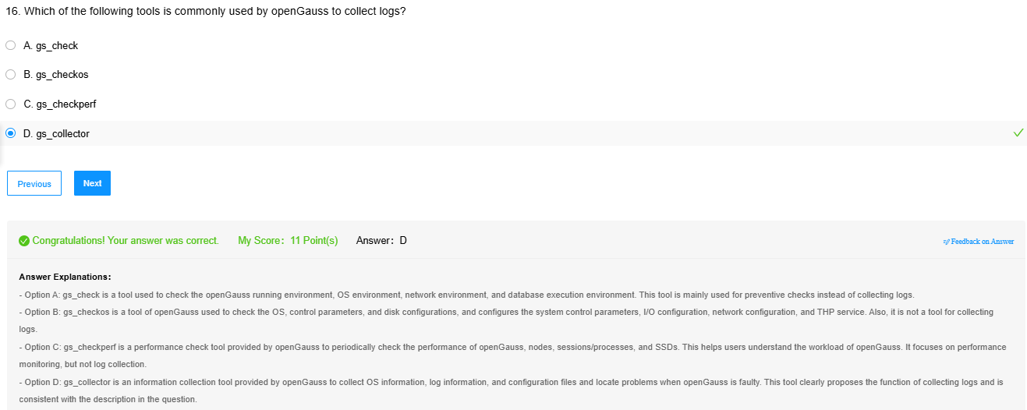

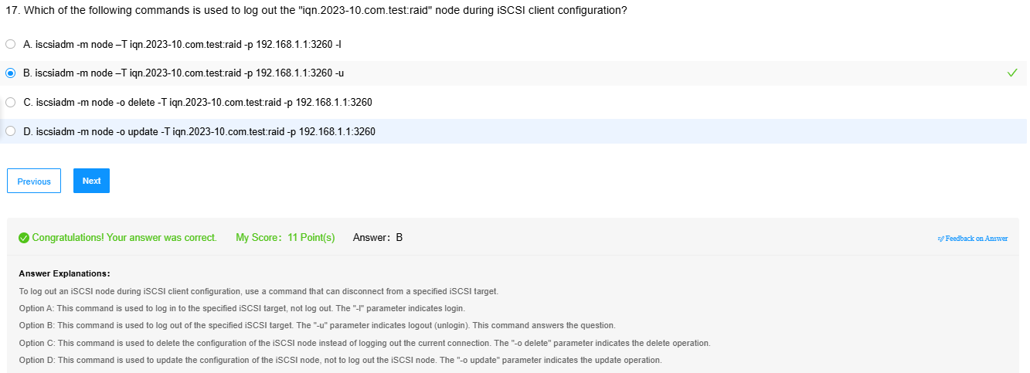

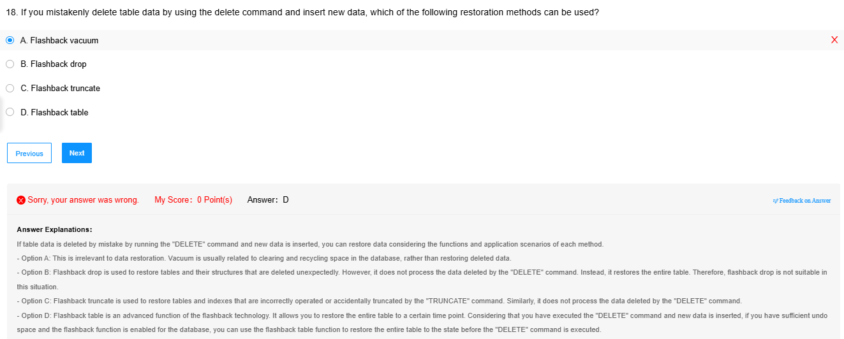

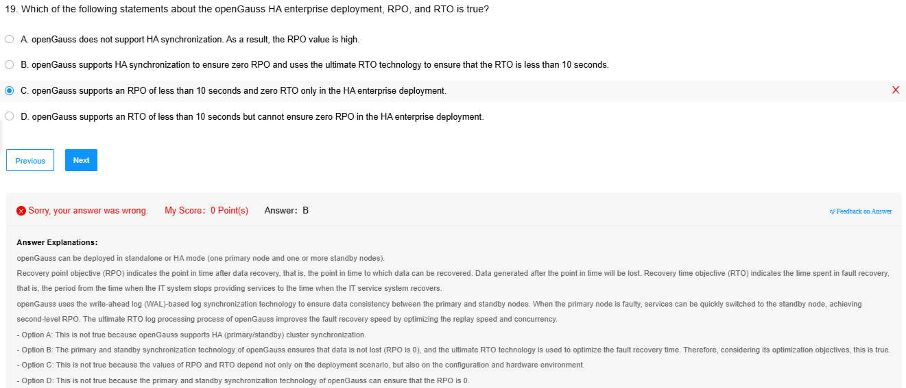

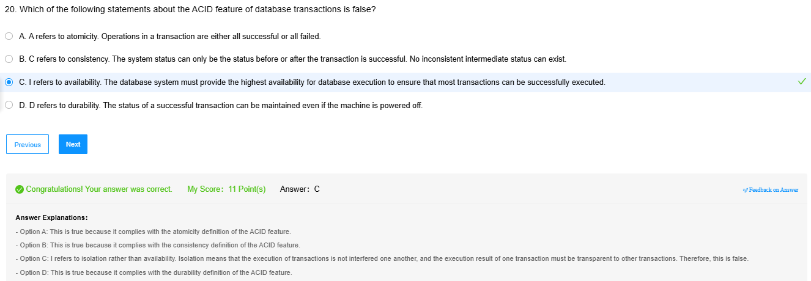

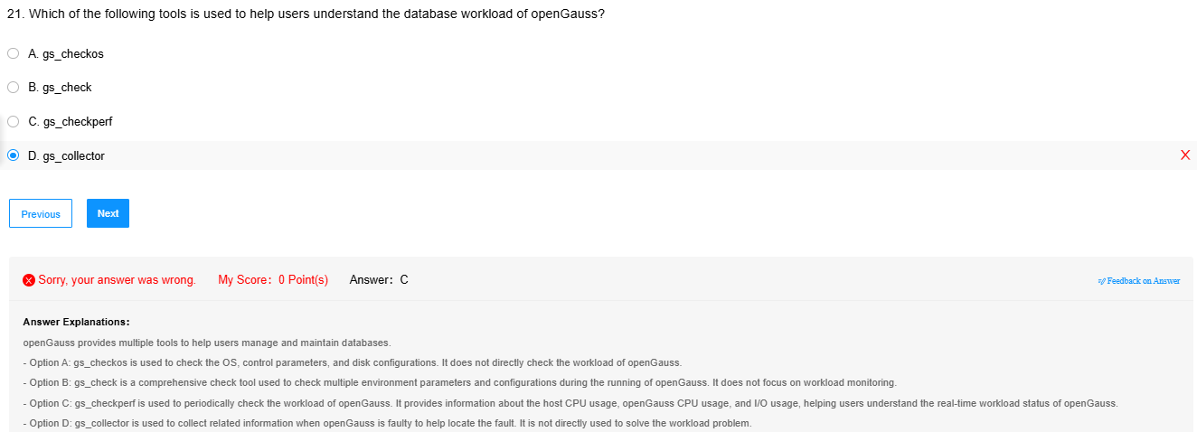

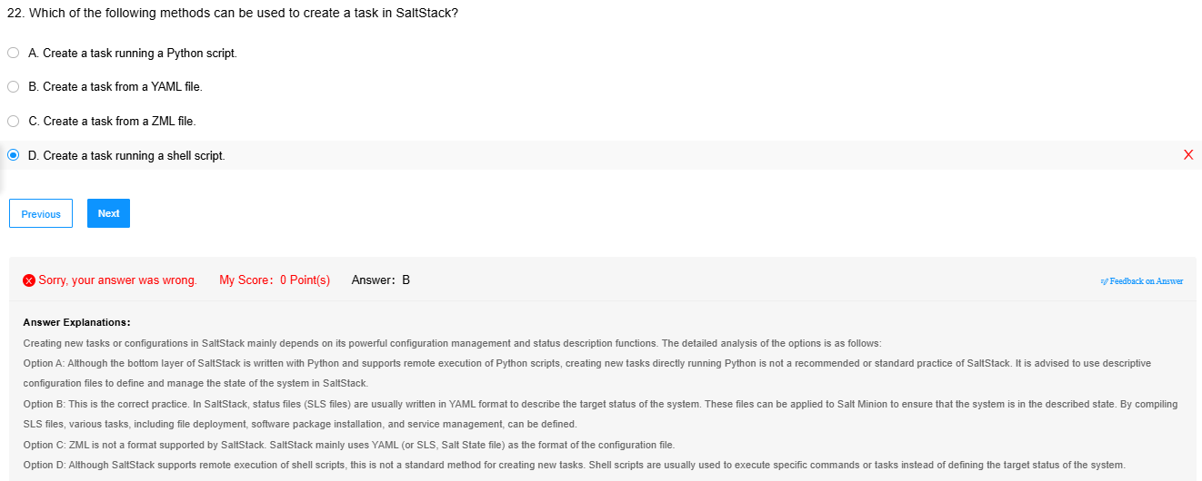

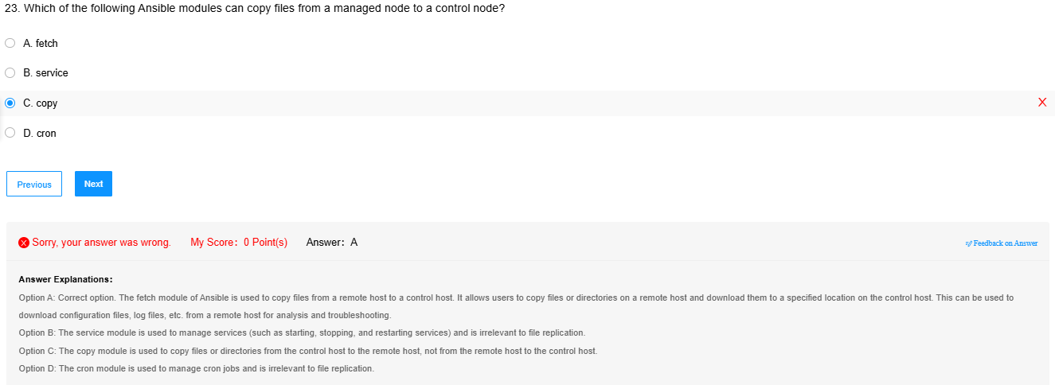

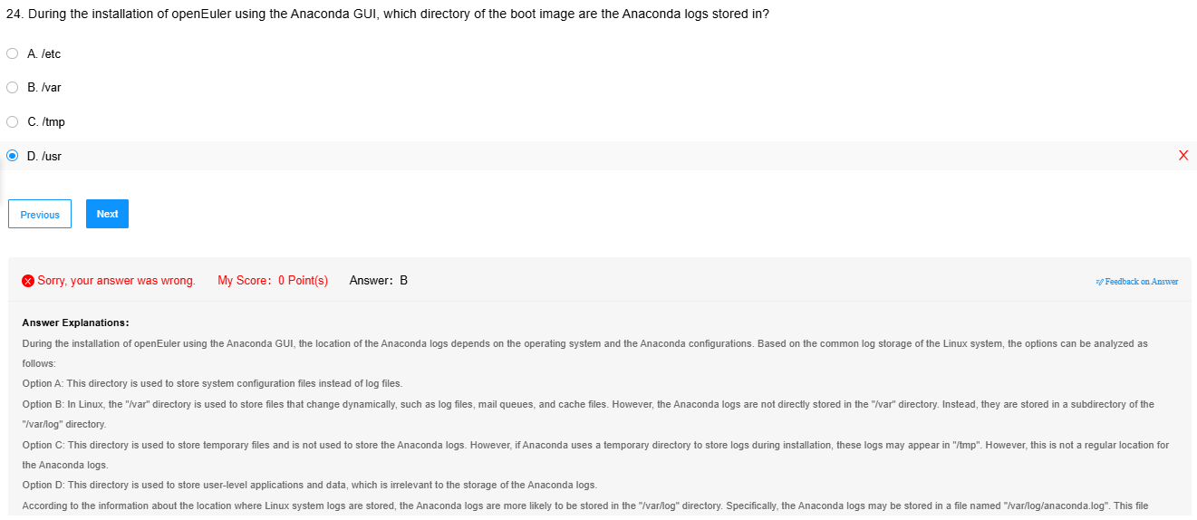

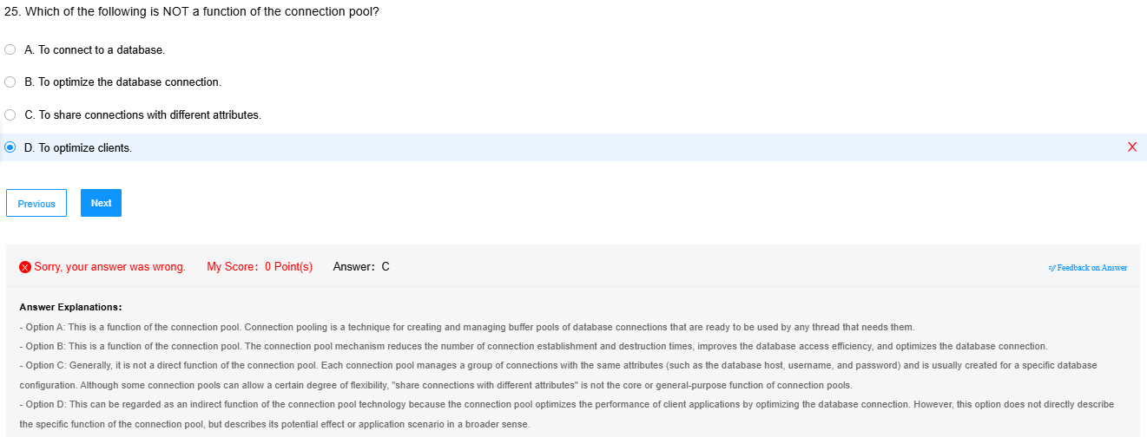

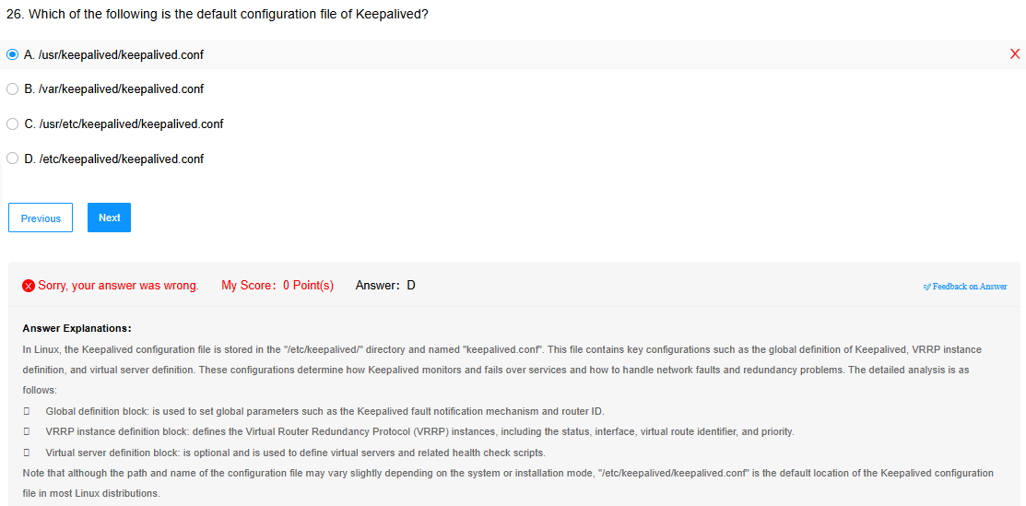

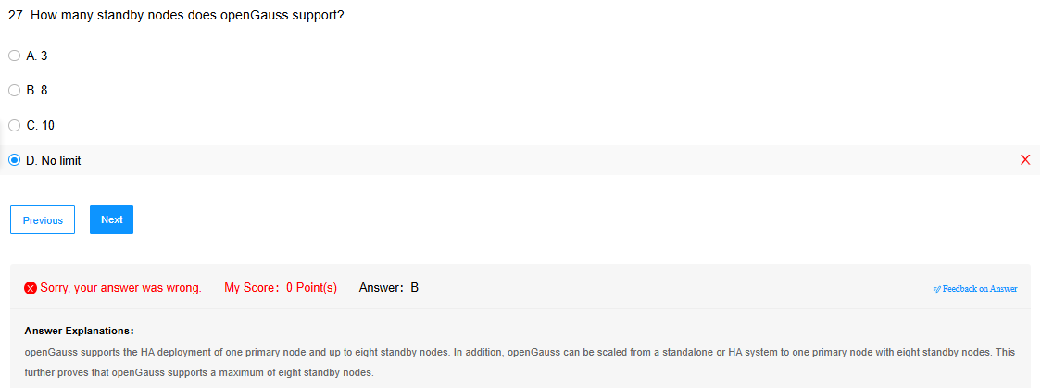

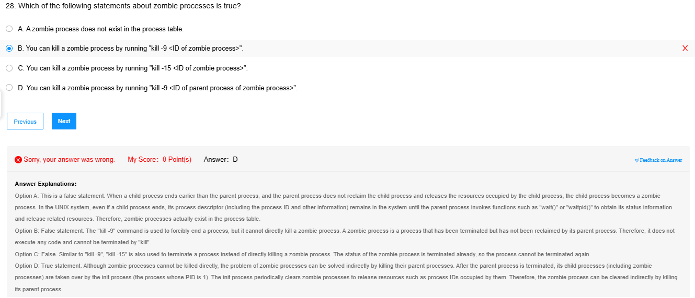

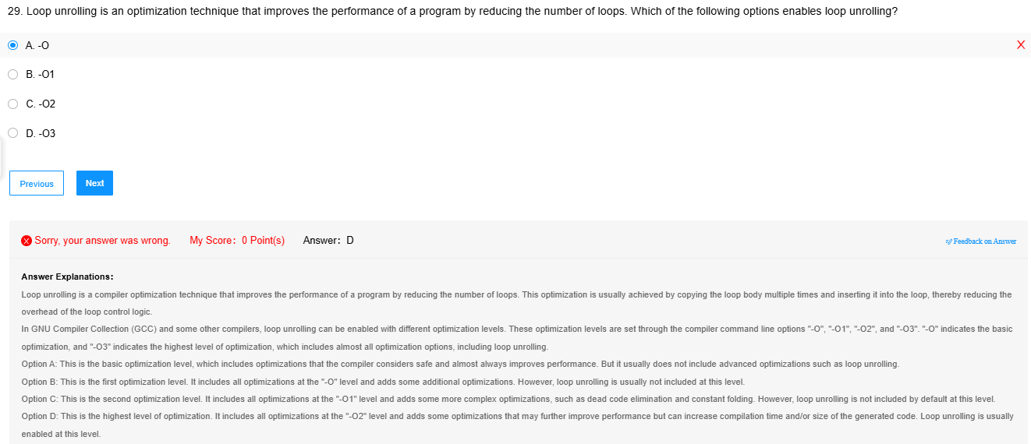

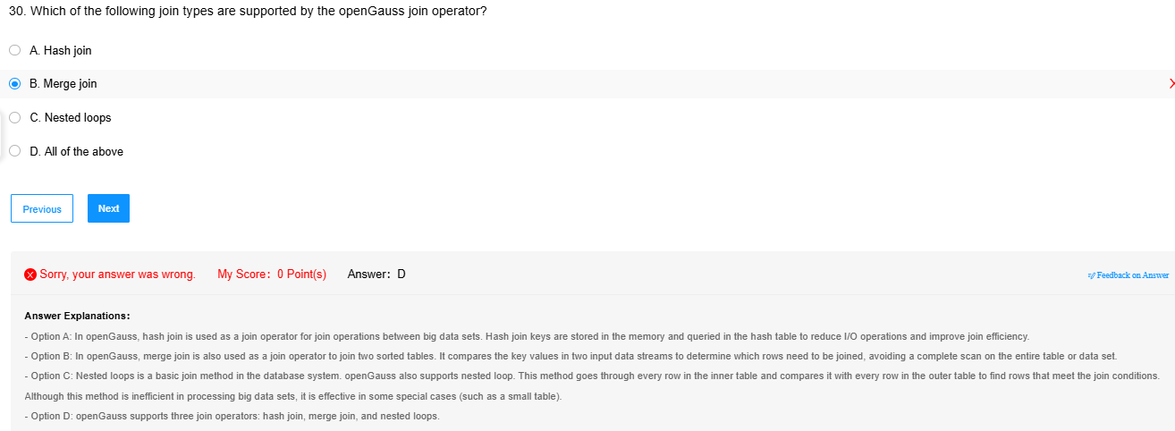

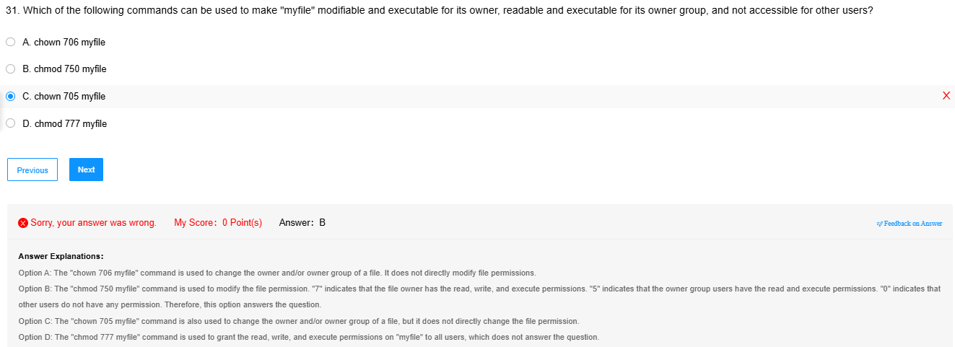

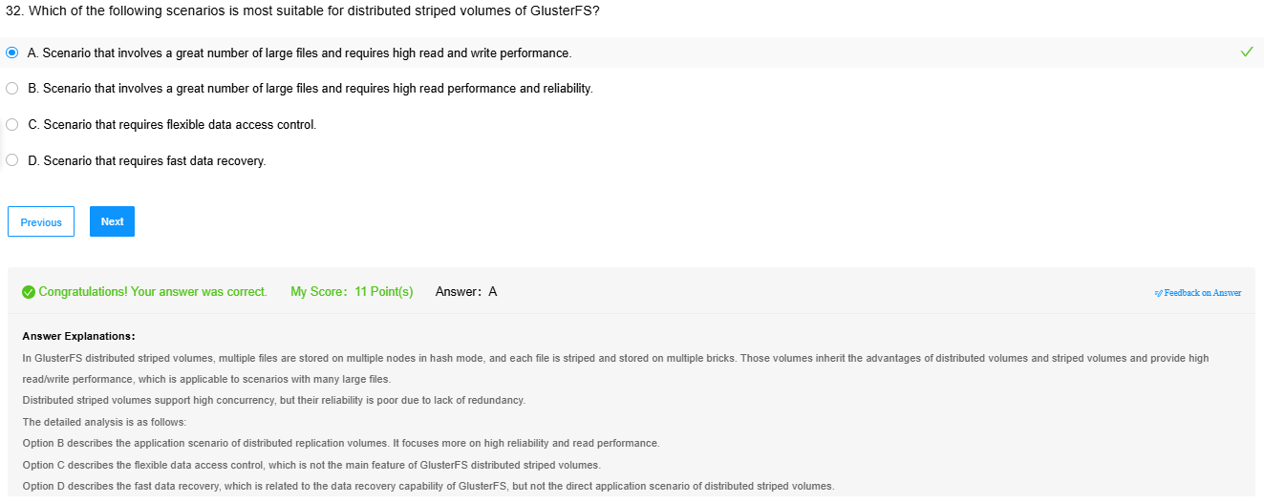

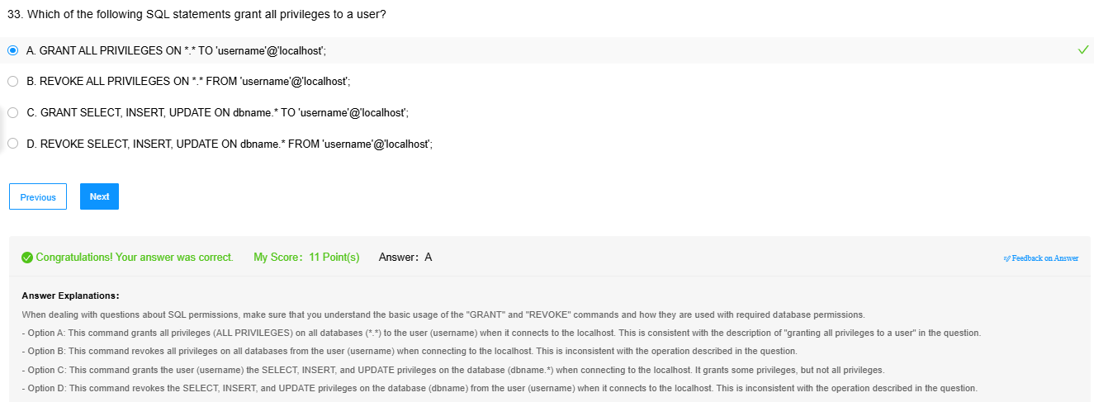

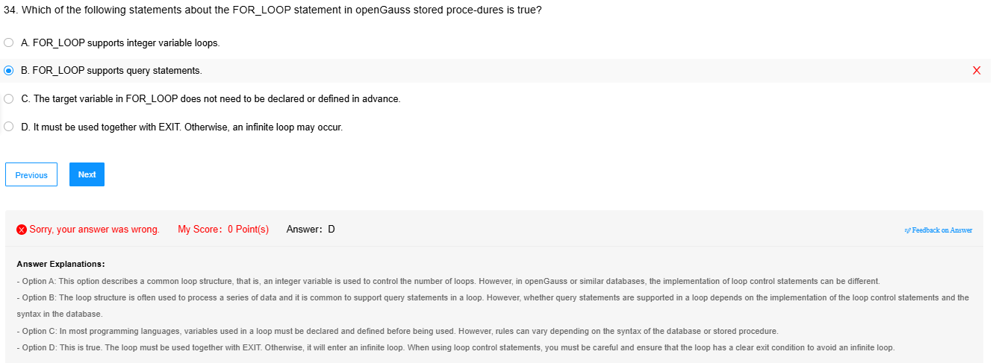

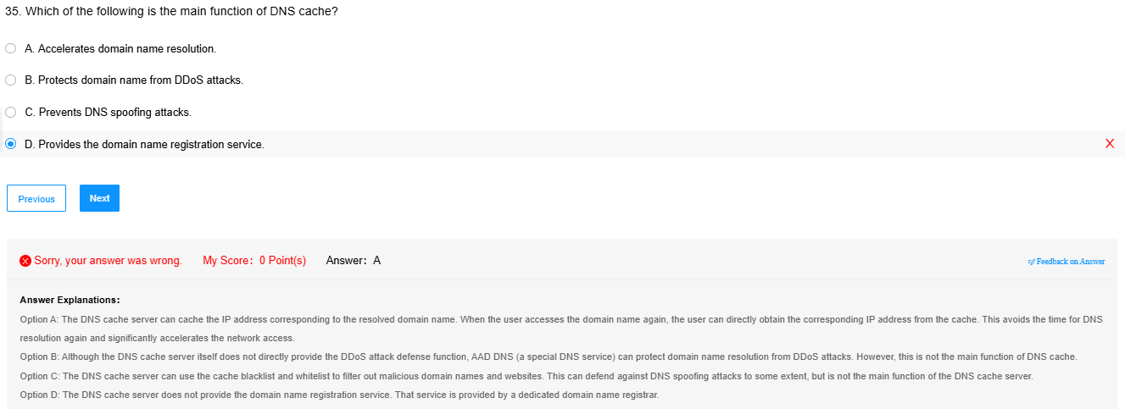

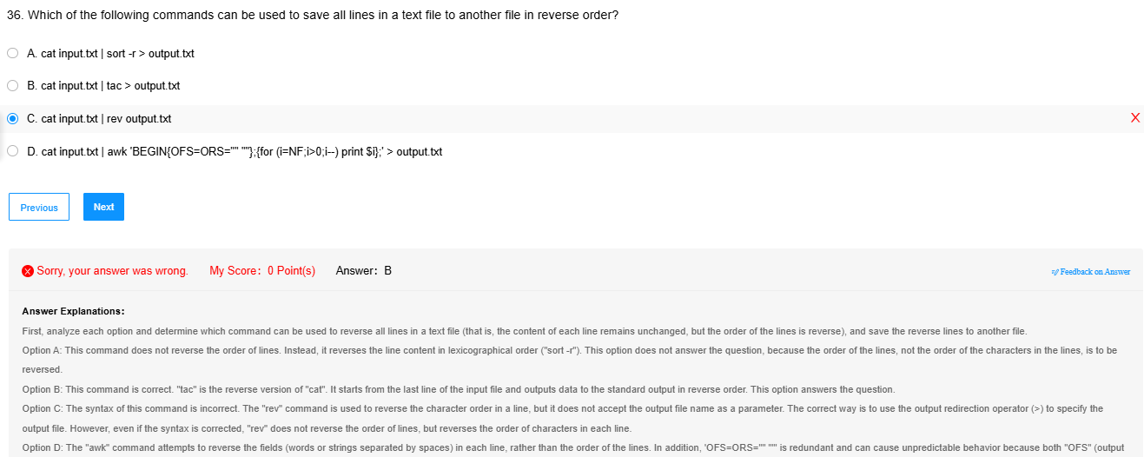

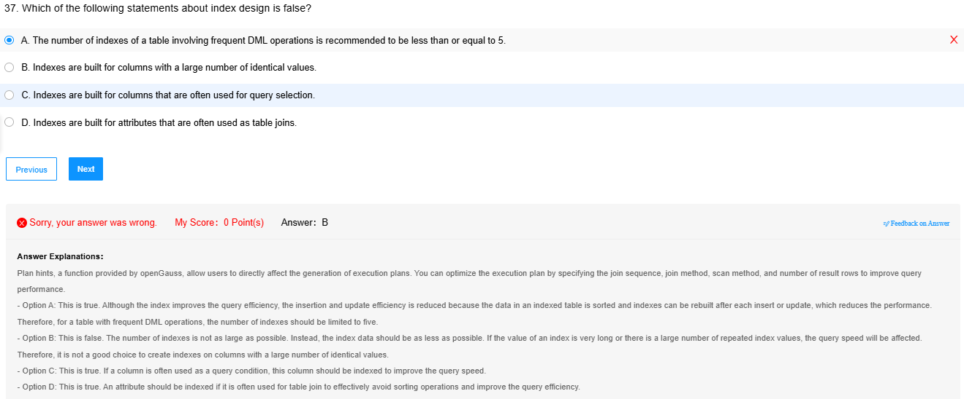

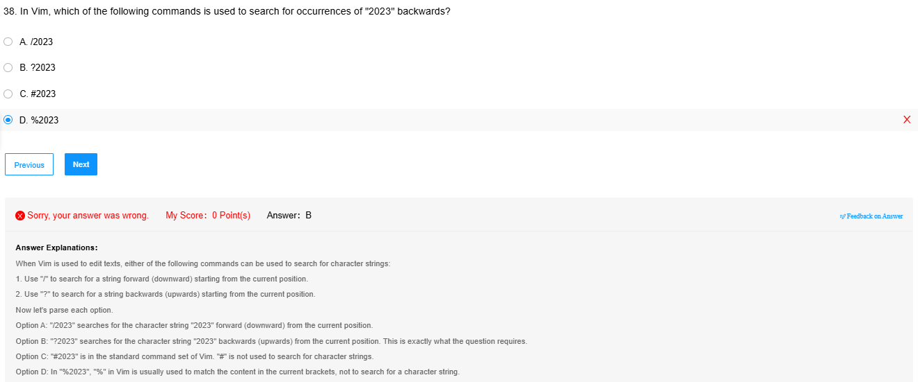

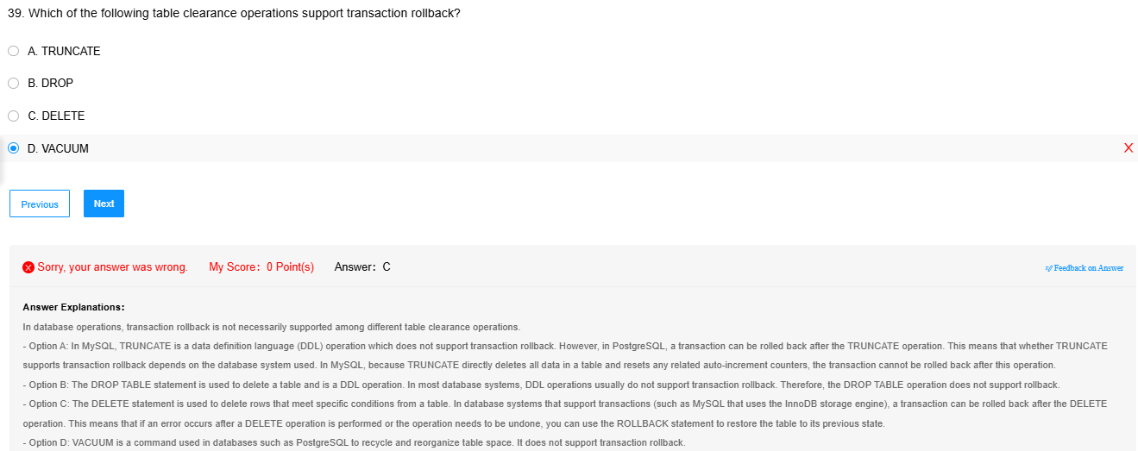

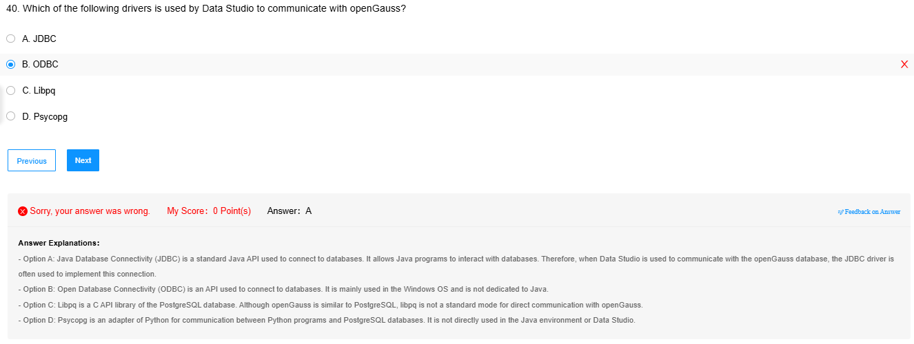

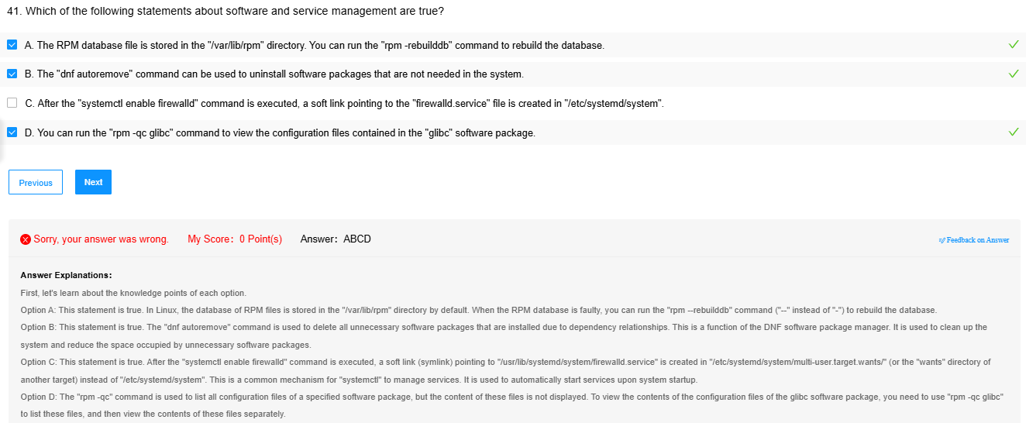

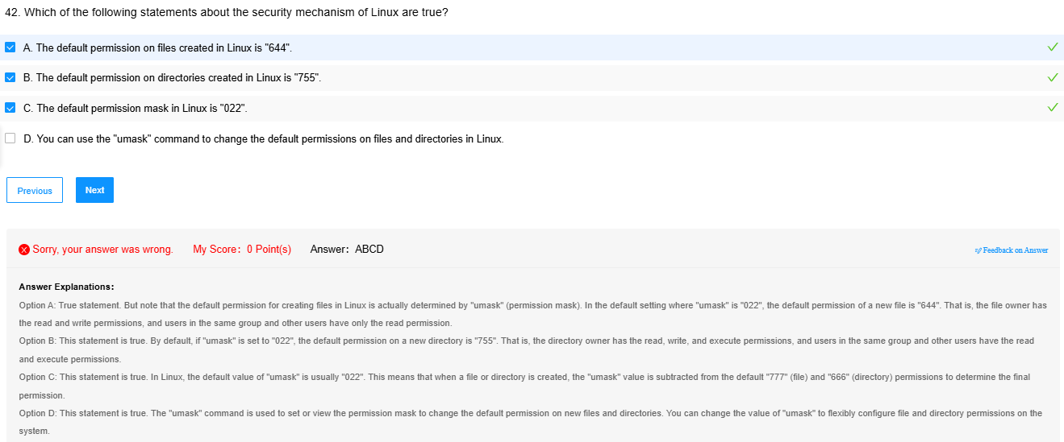

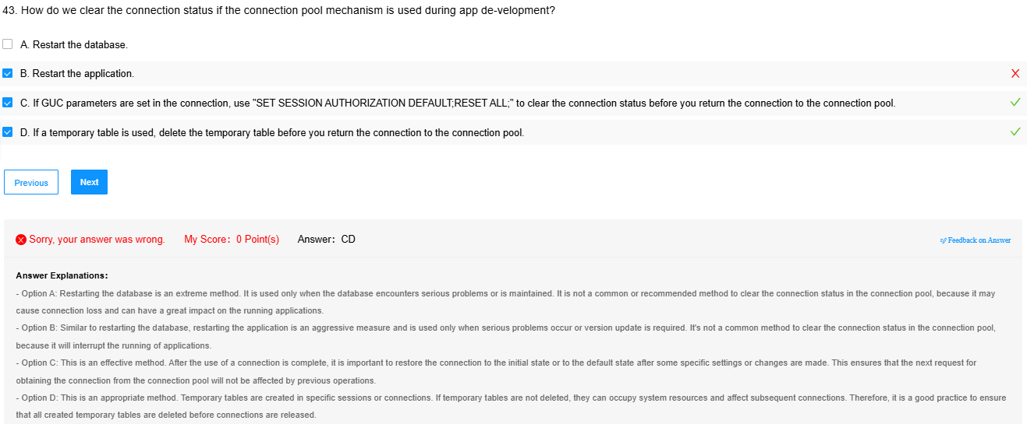

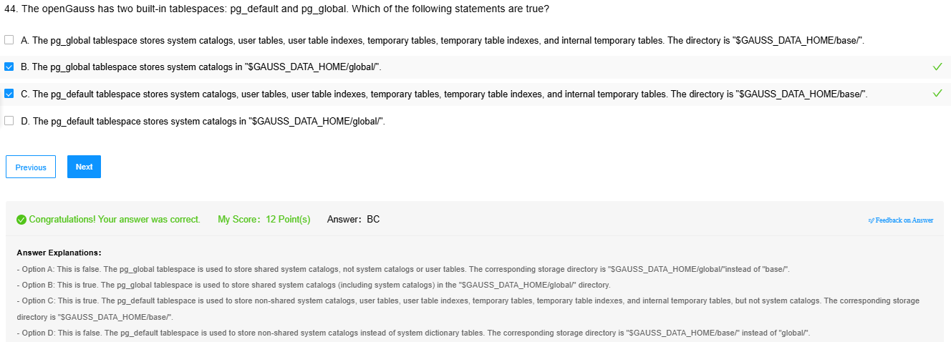

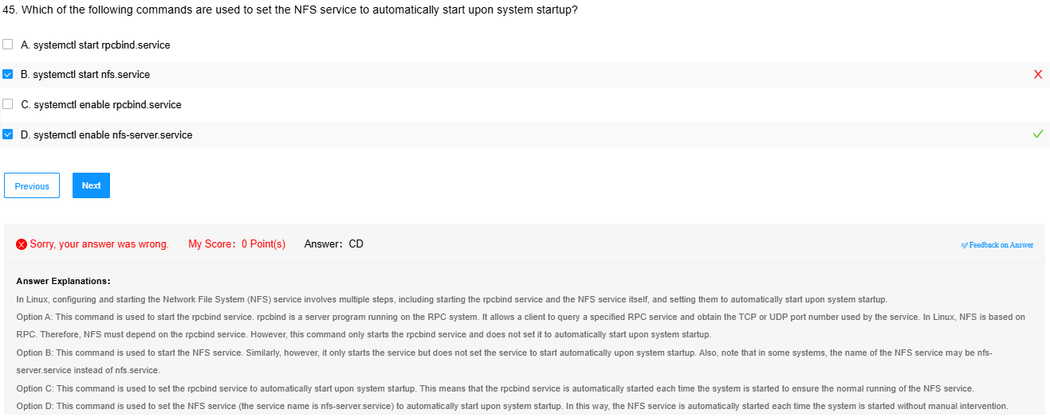

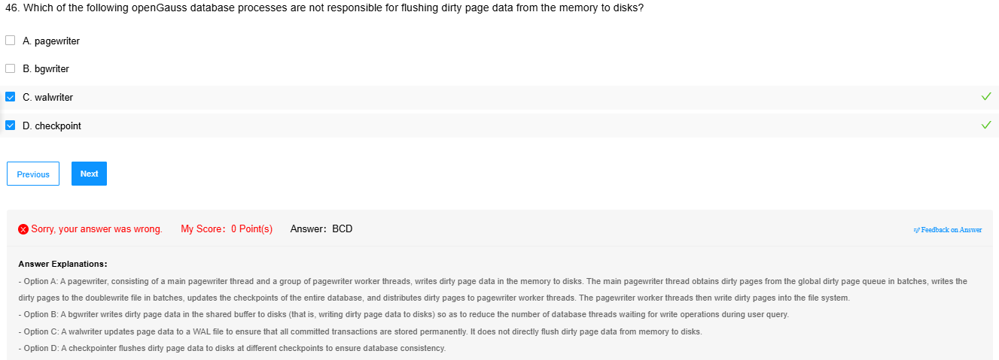

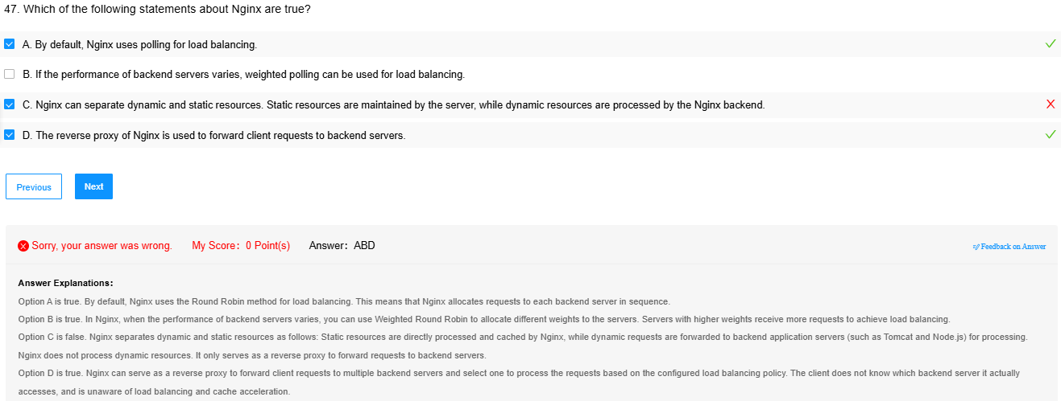

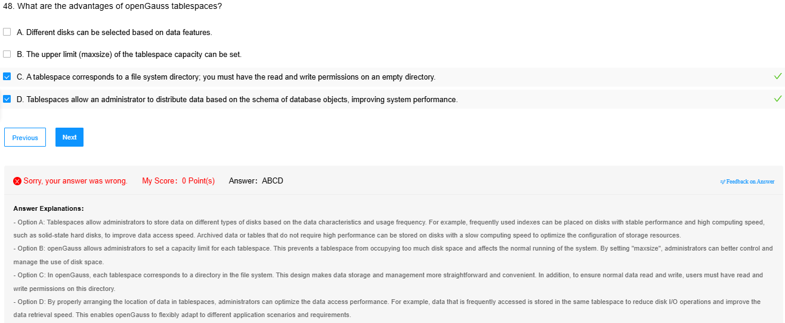

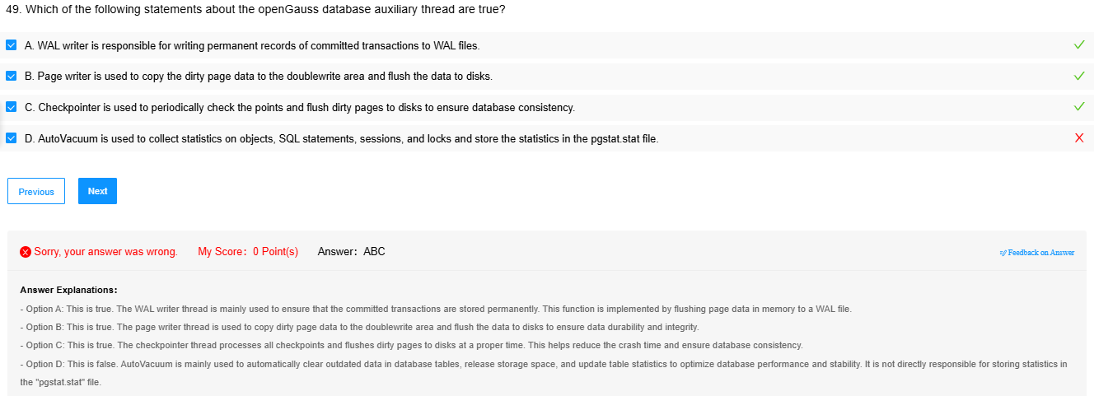

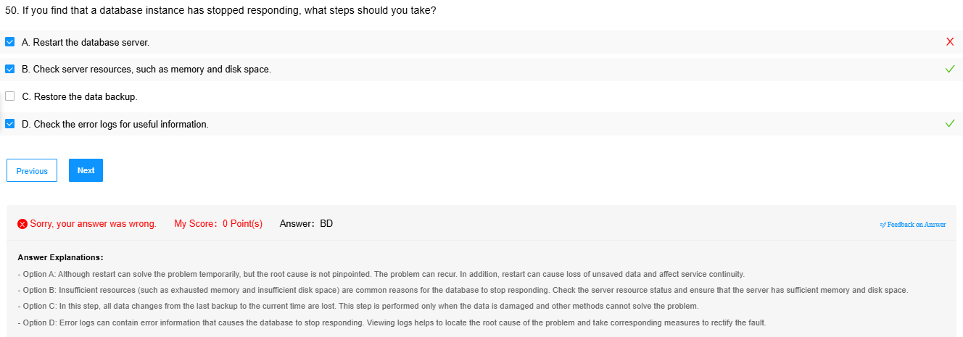

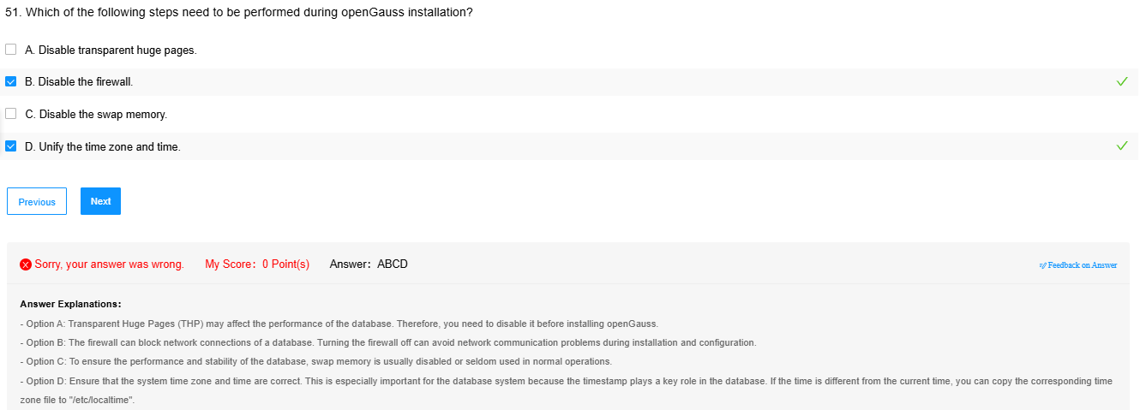

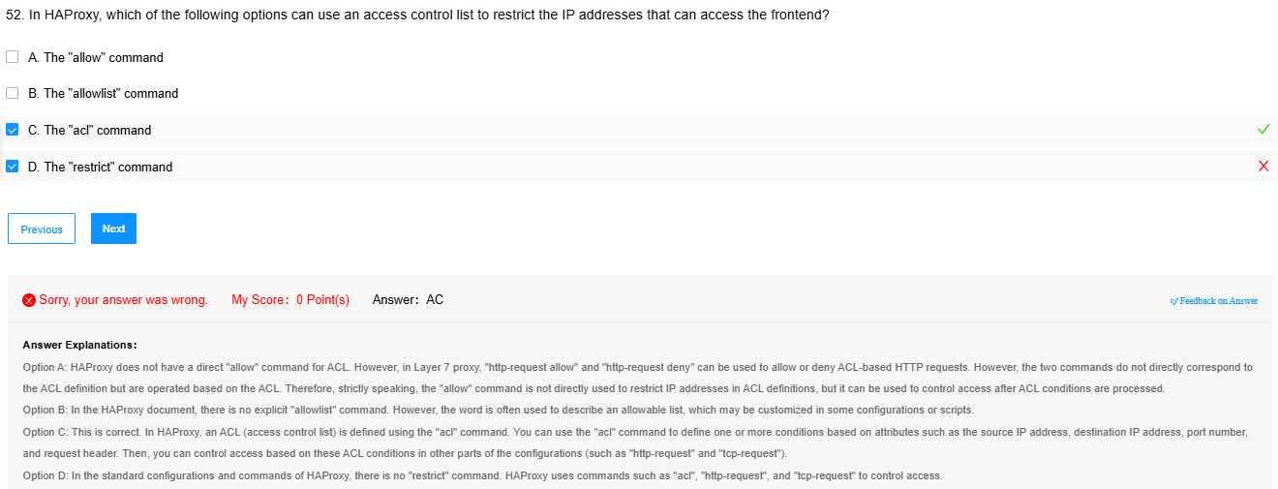

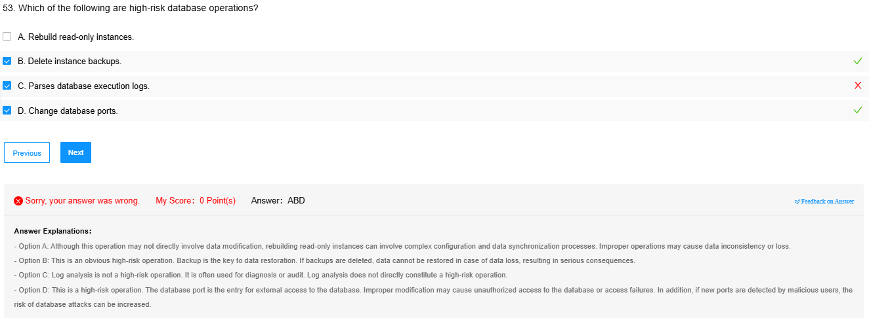

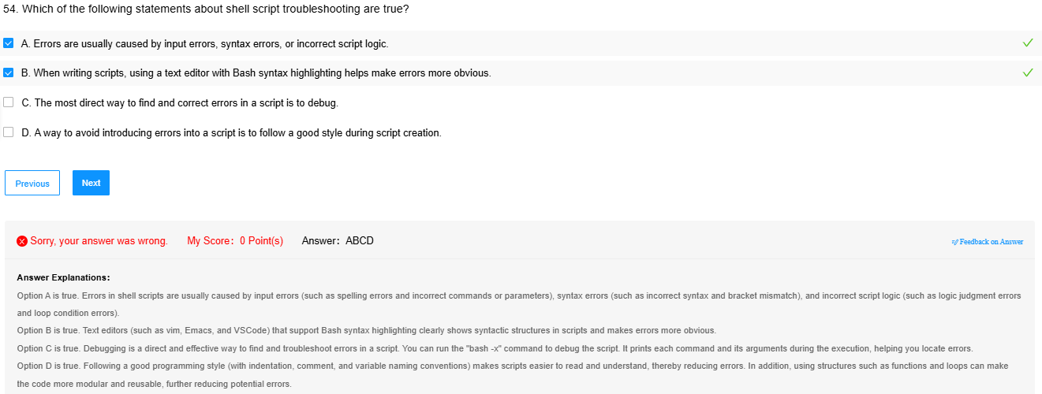

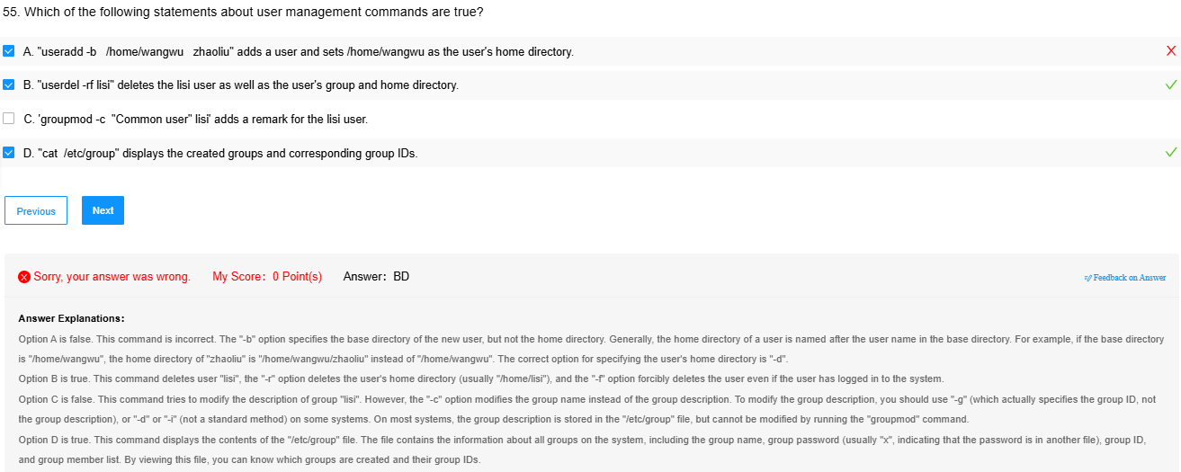

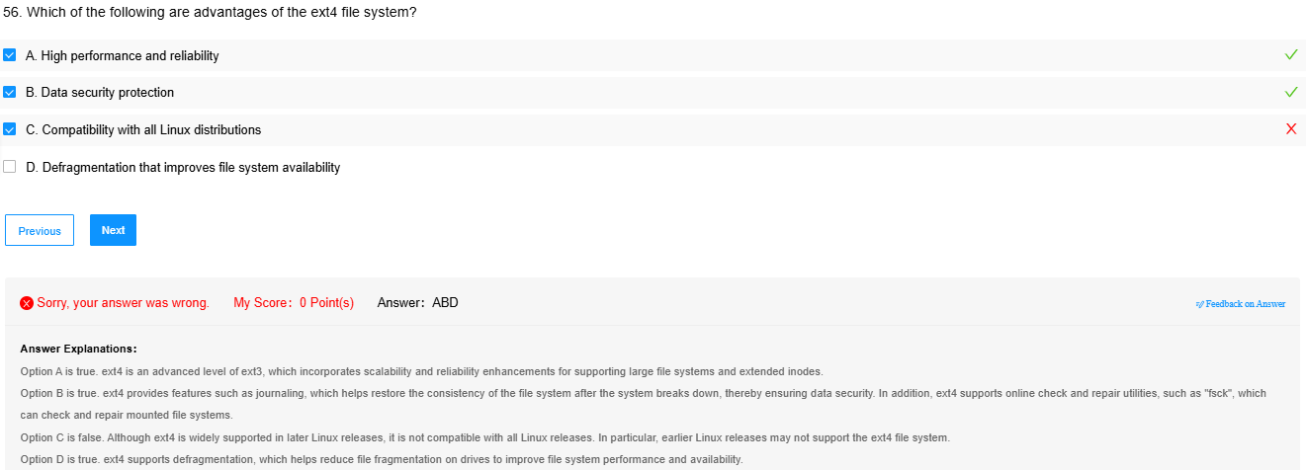

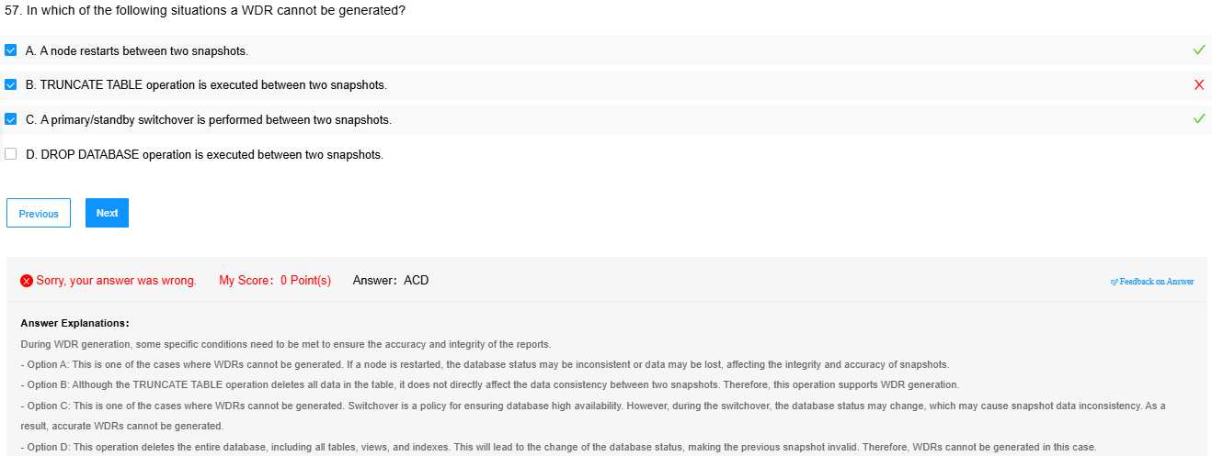

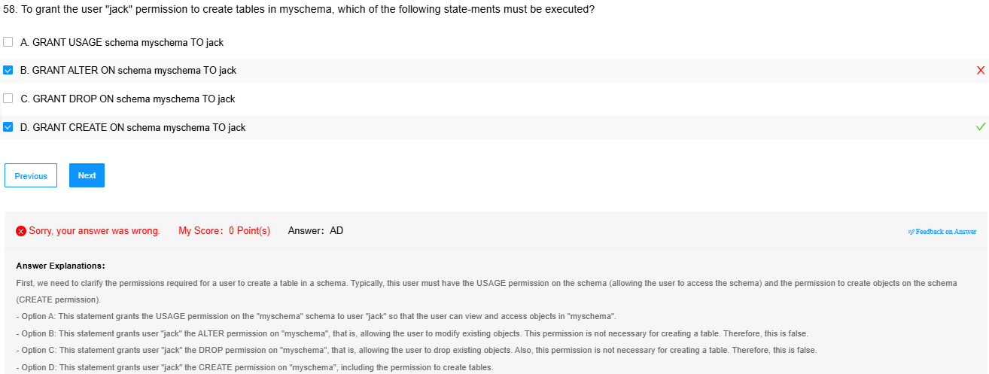

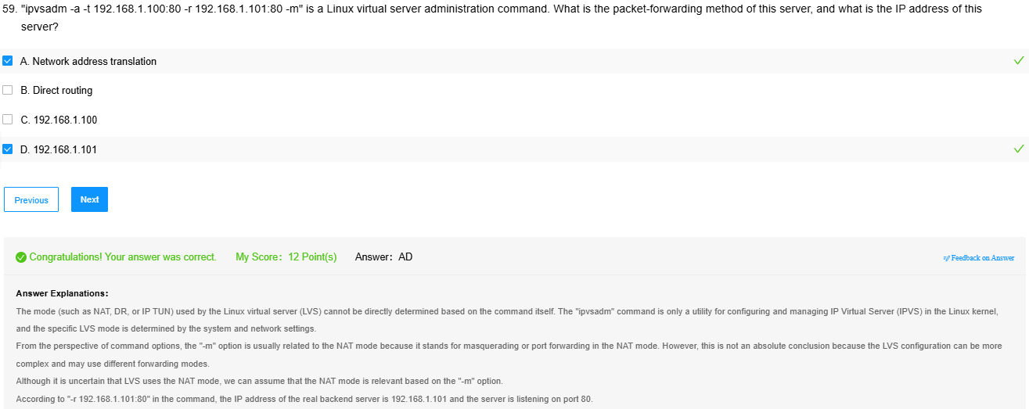



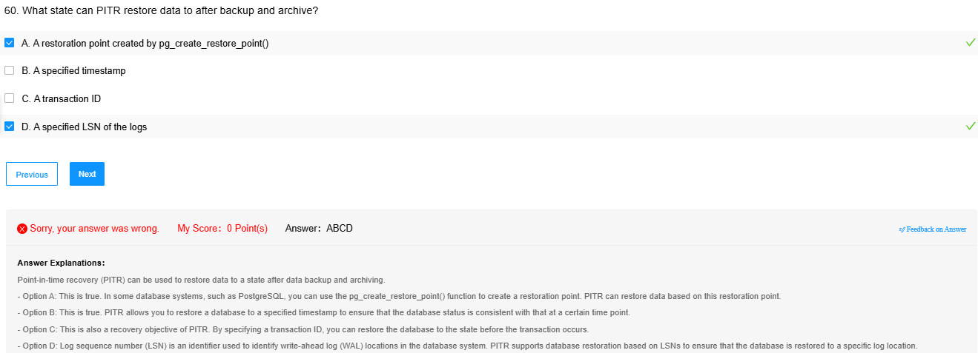

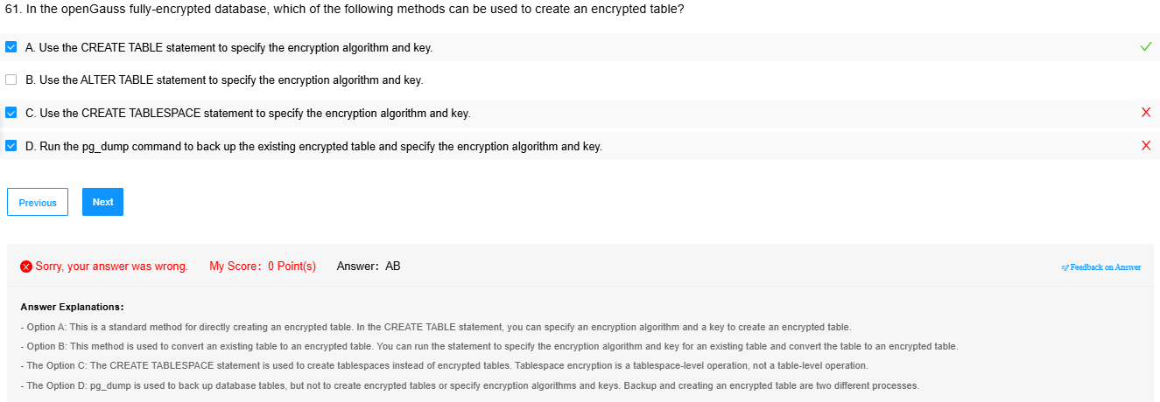

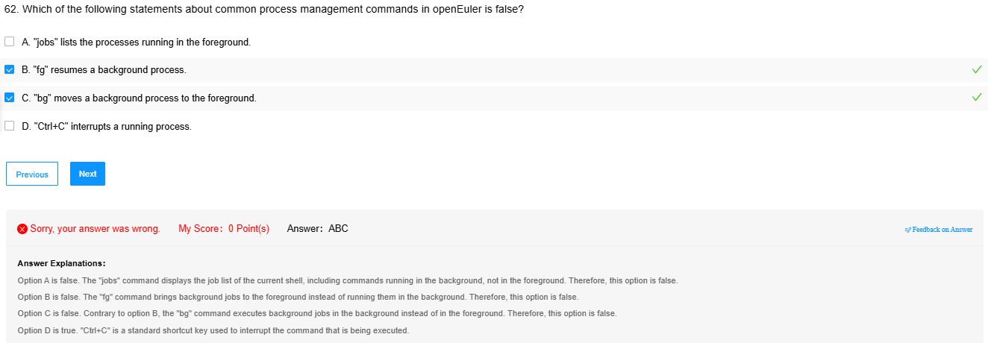

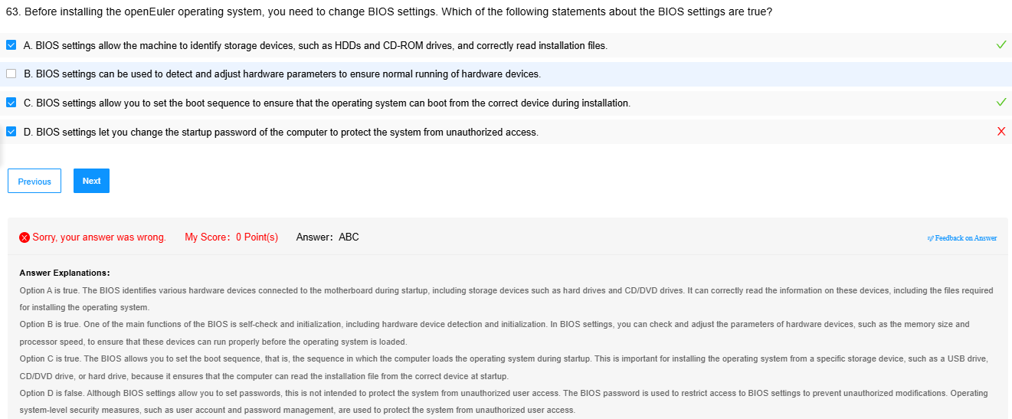

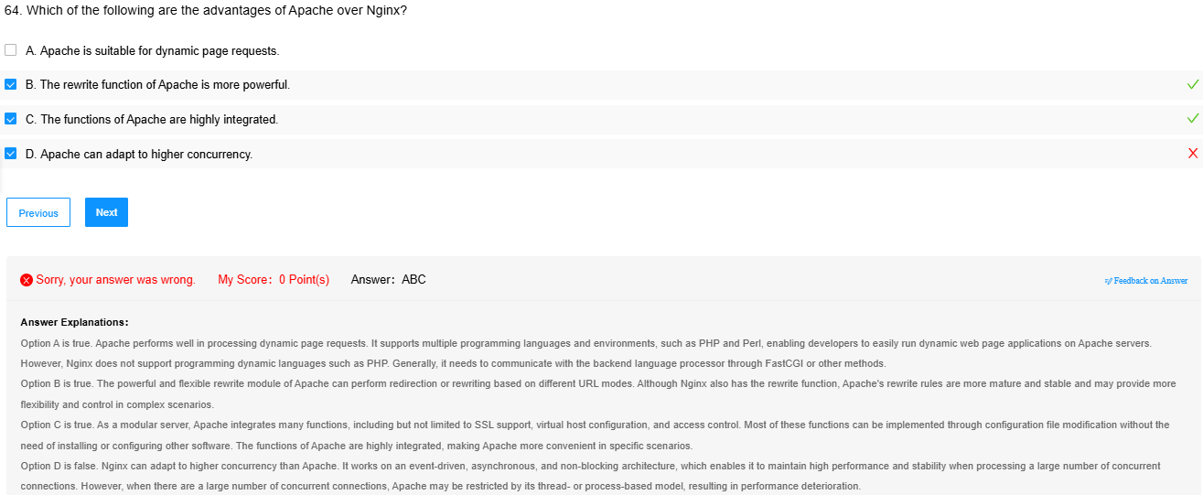

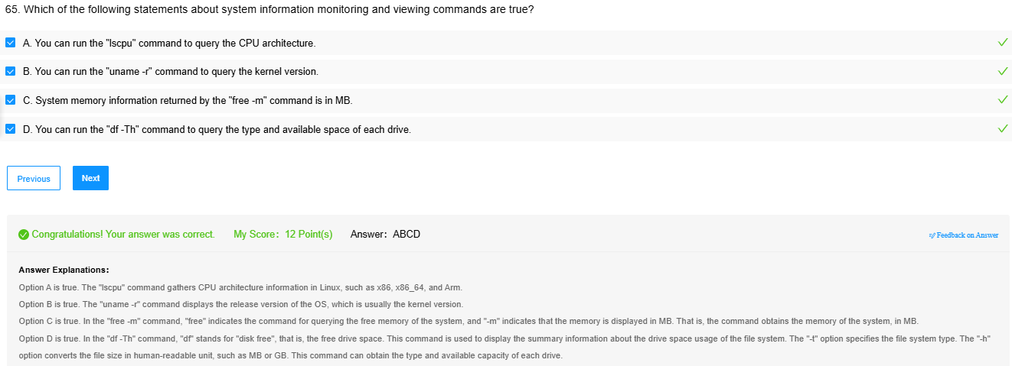

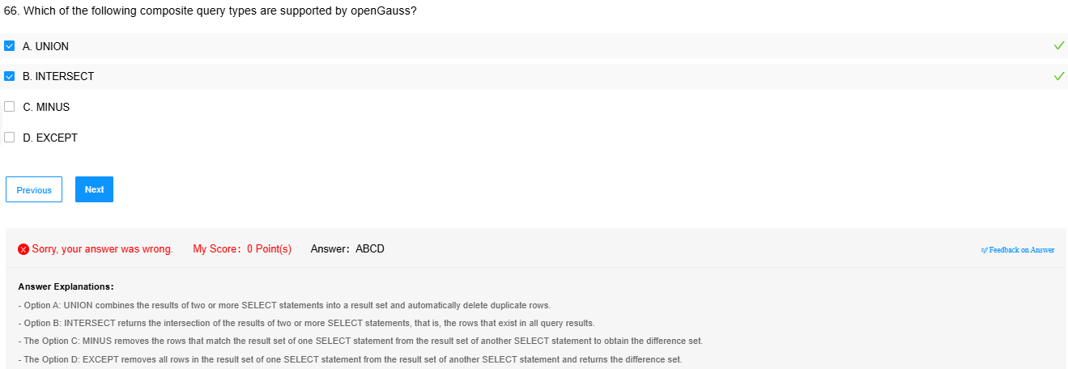

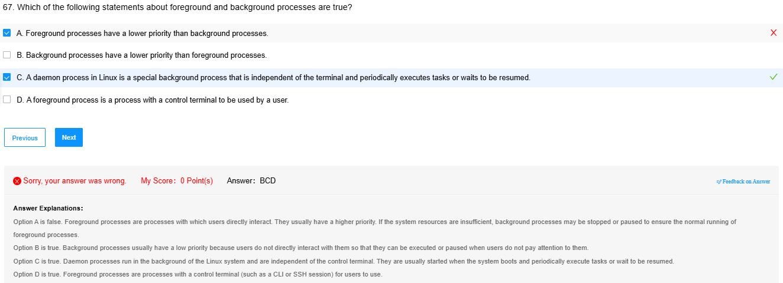

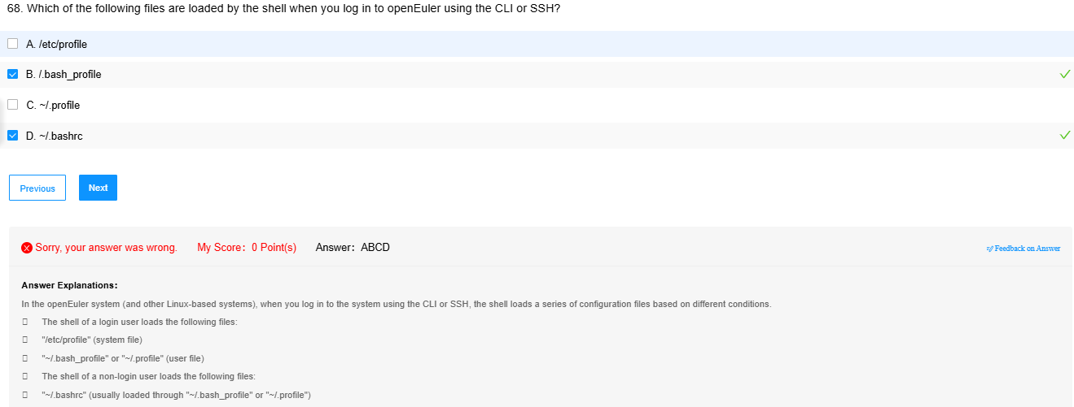

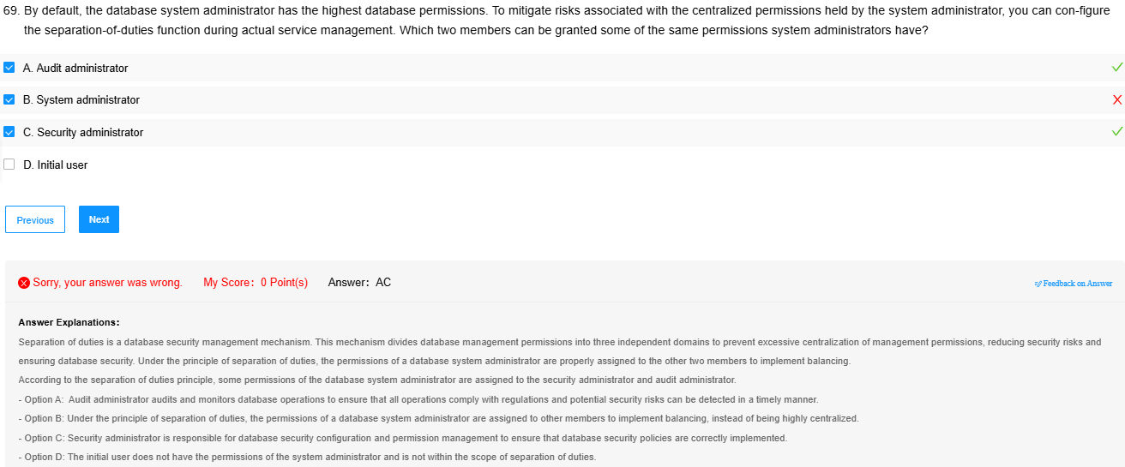

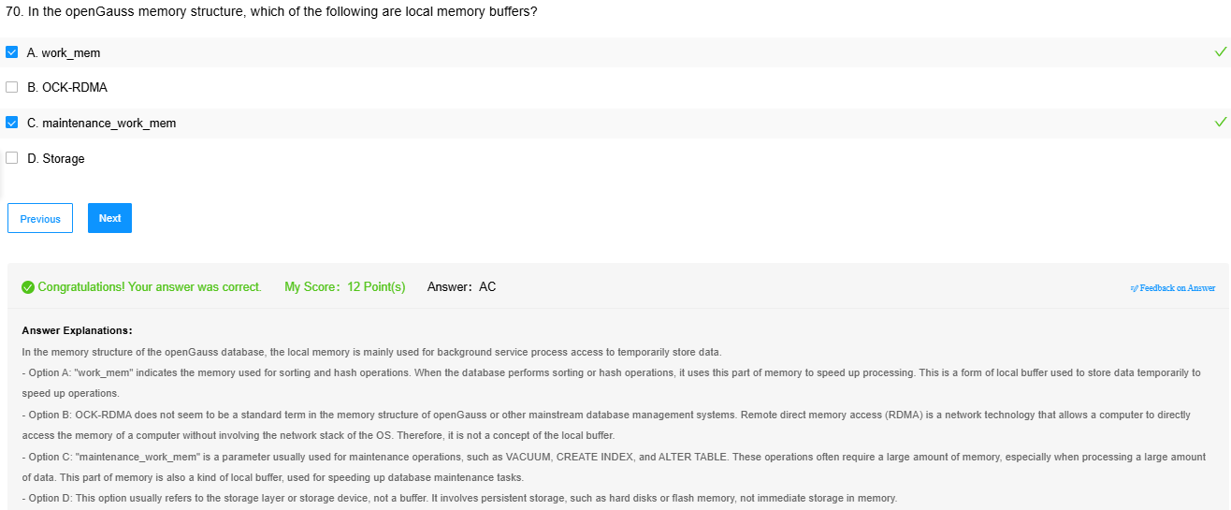

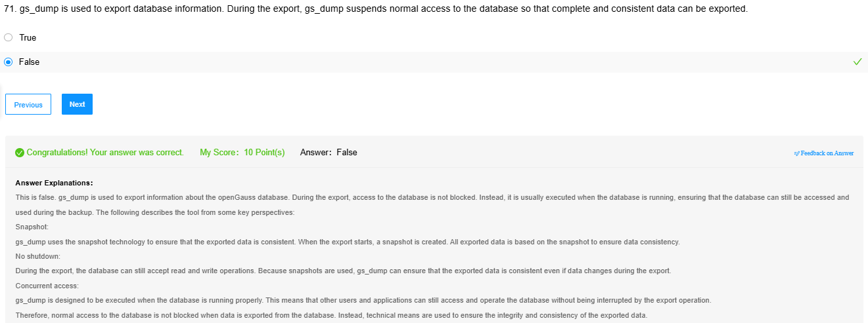

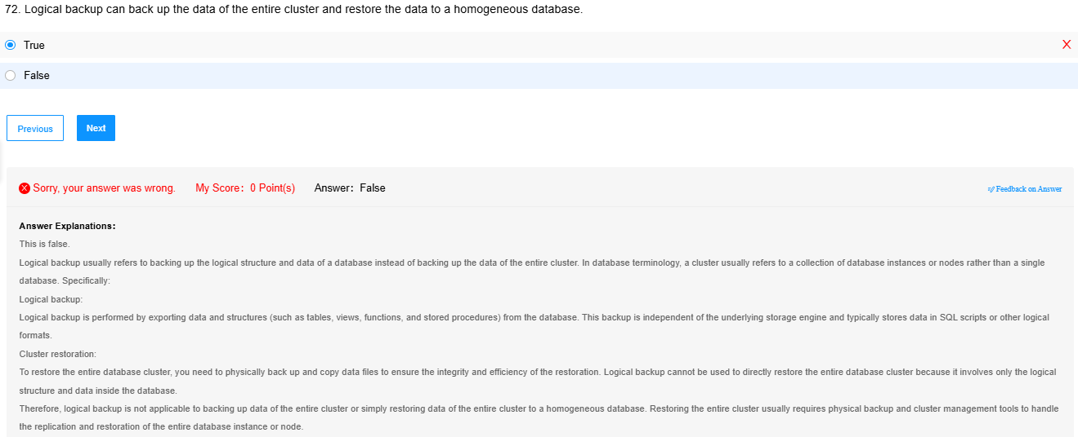

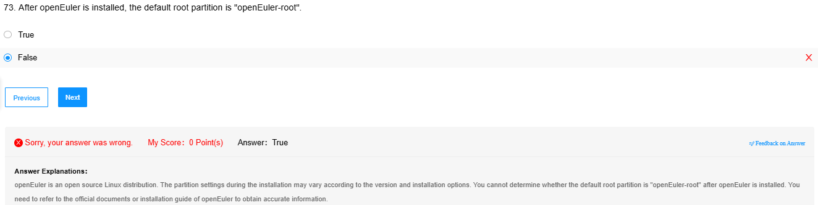

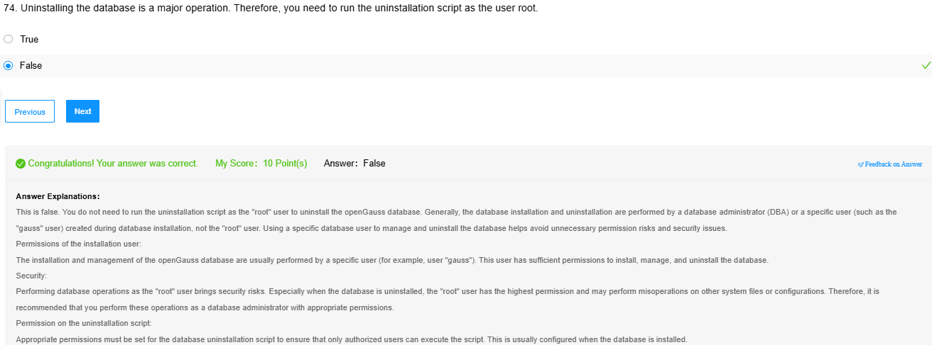

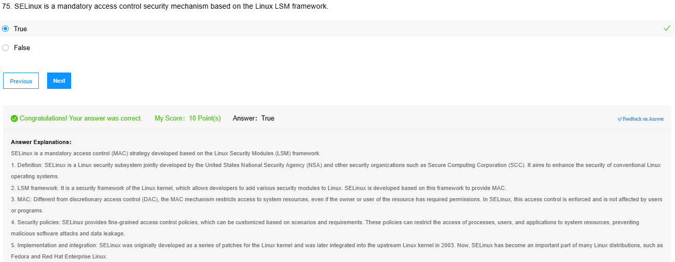

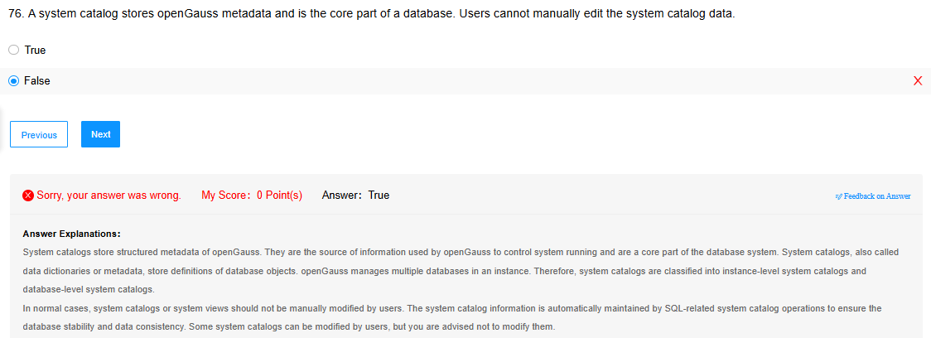

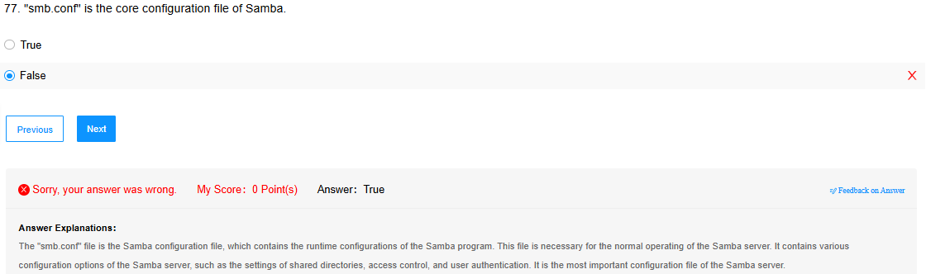

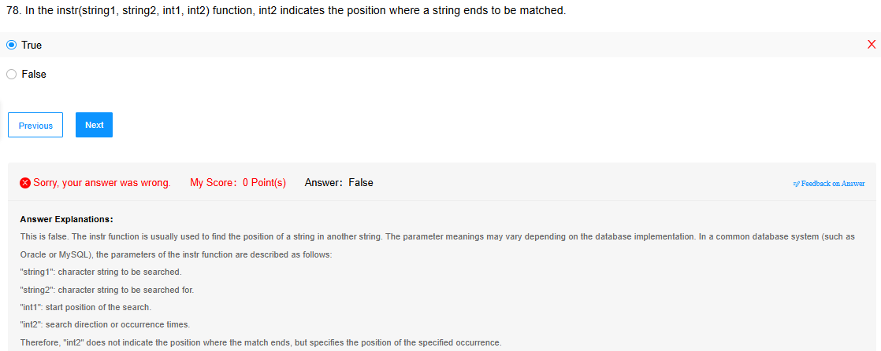

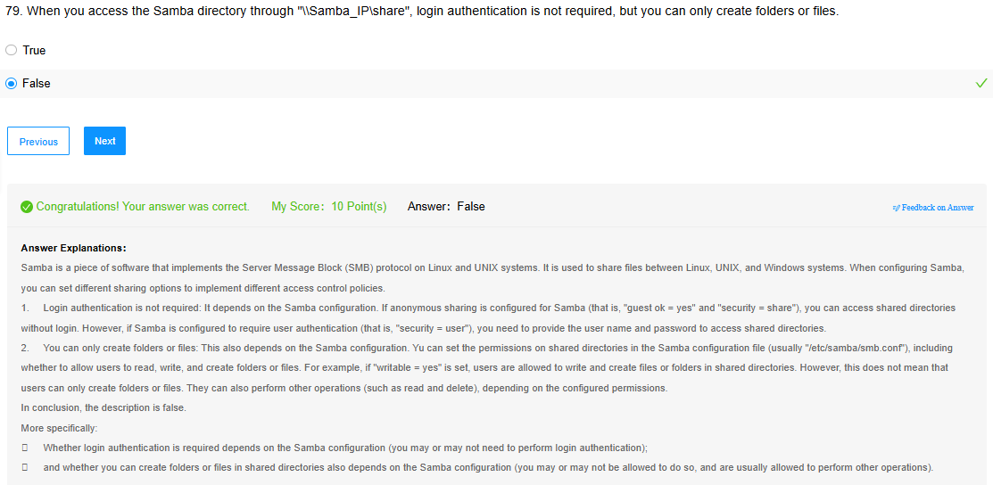

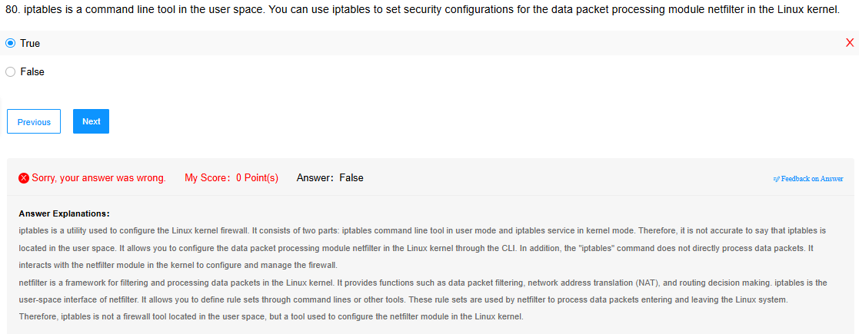

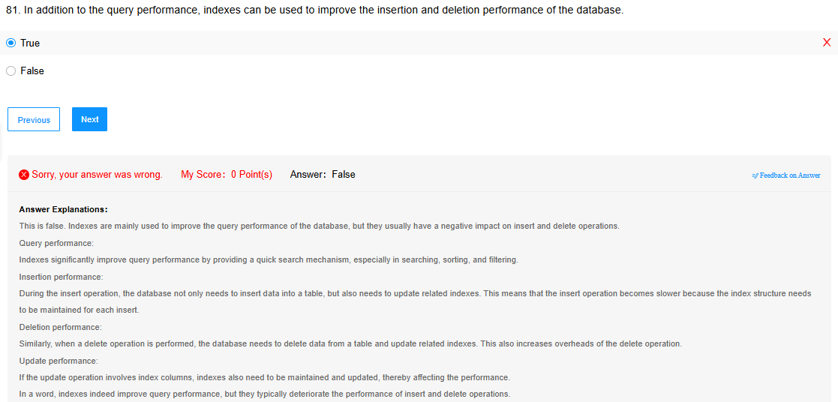

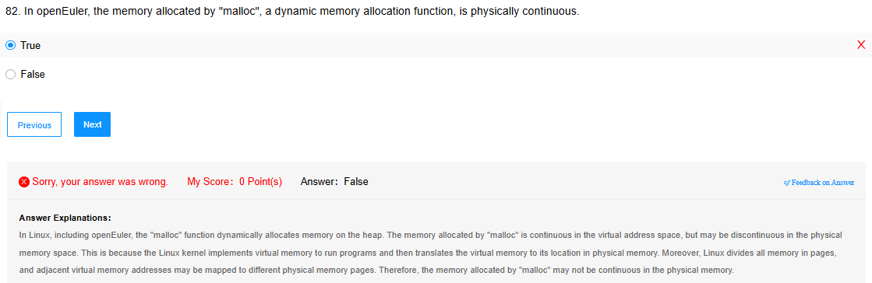

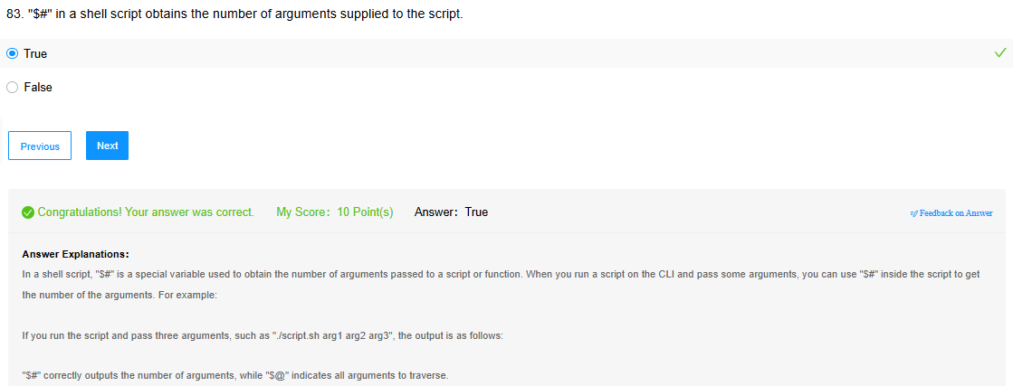

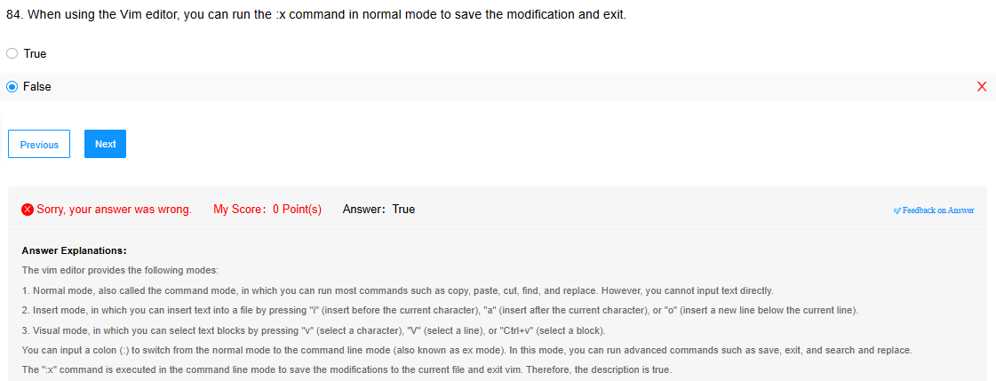

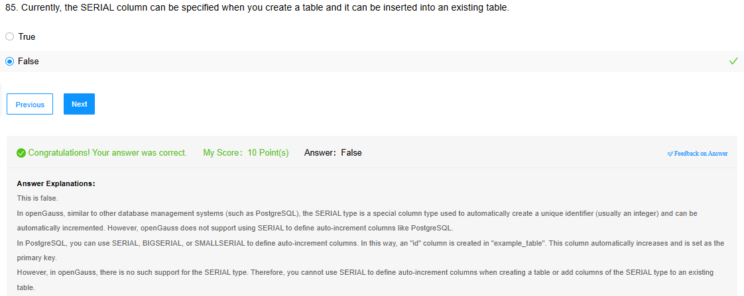

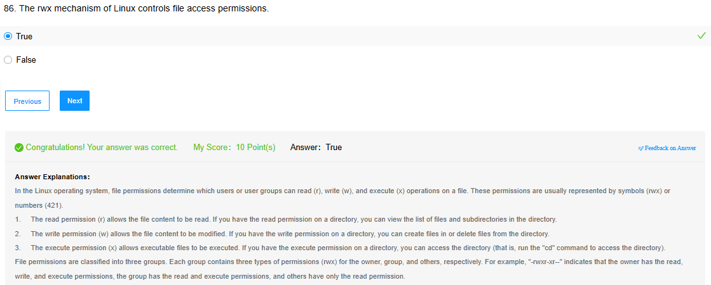

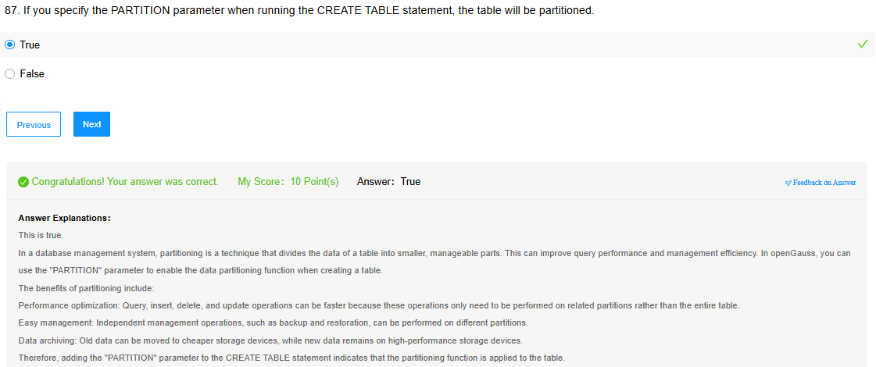

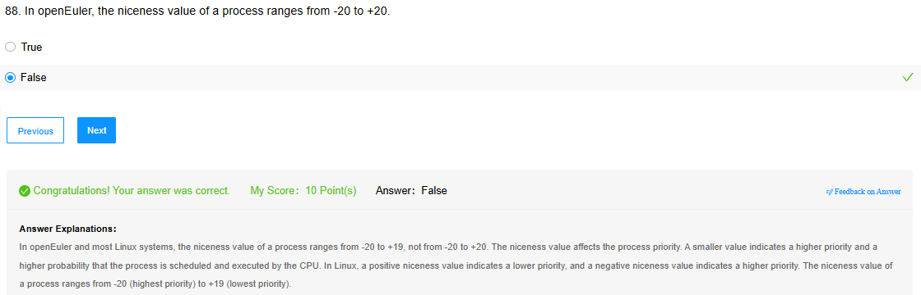

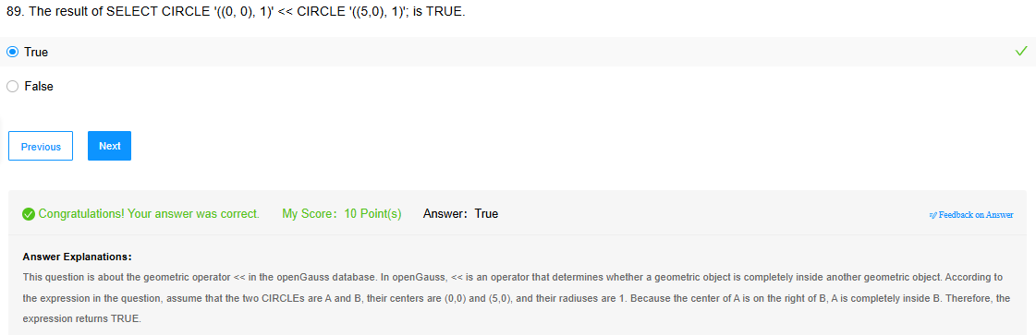

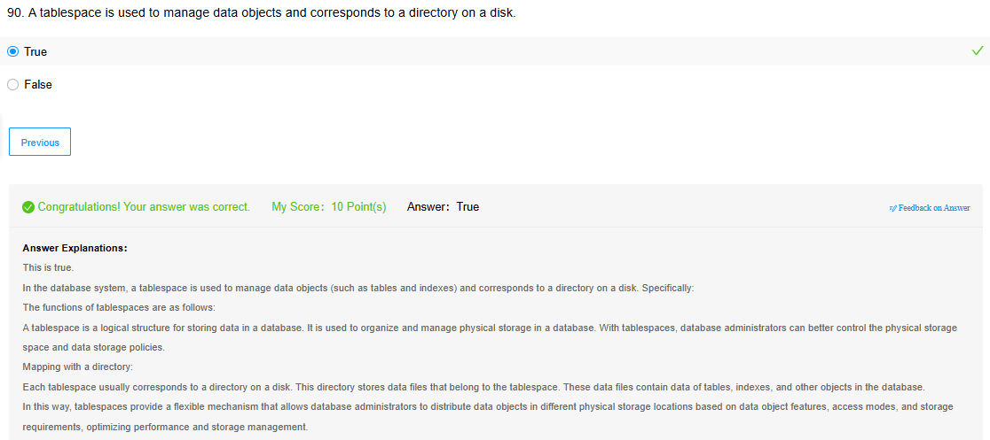

**HCIA-OpenEuler**

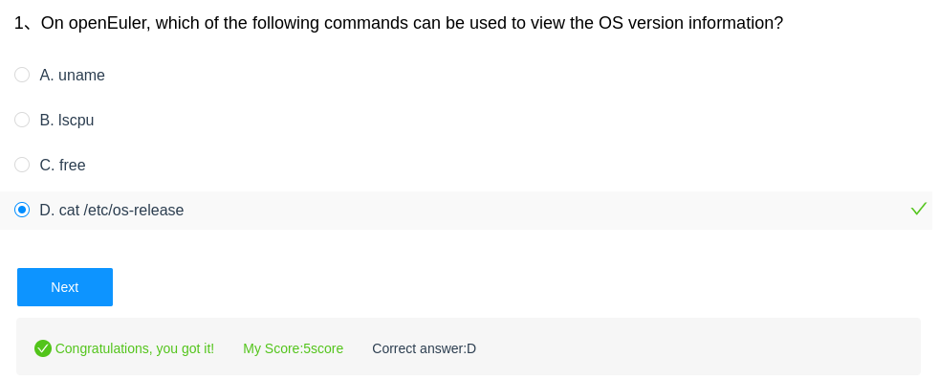

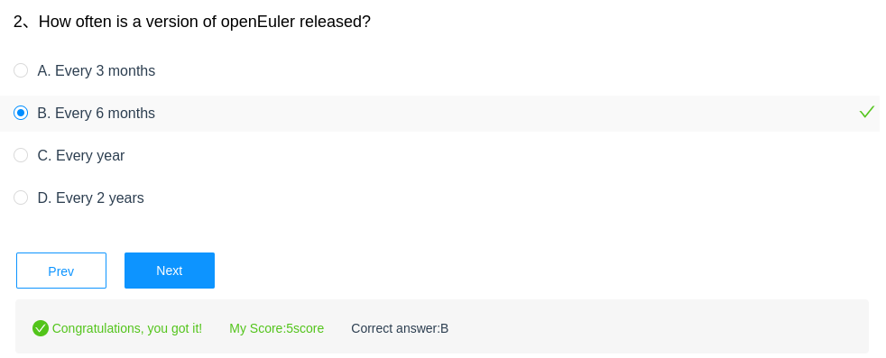

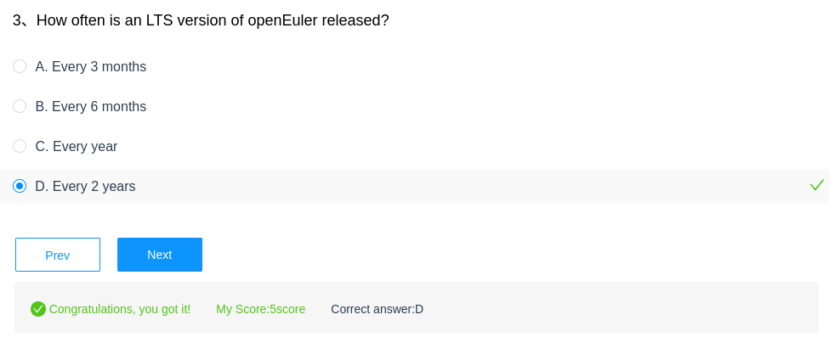

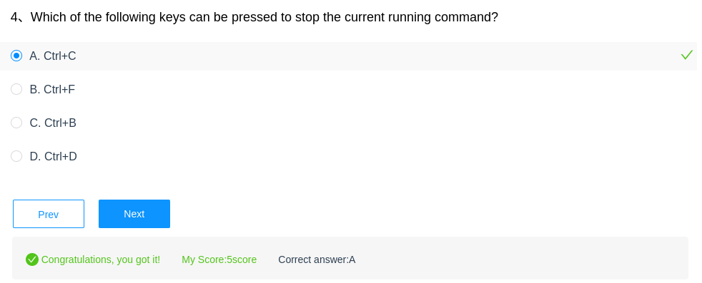

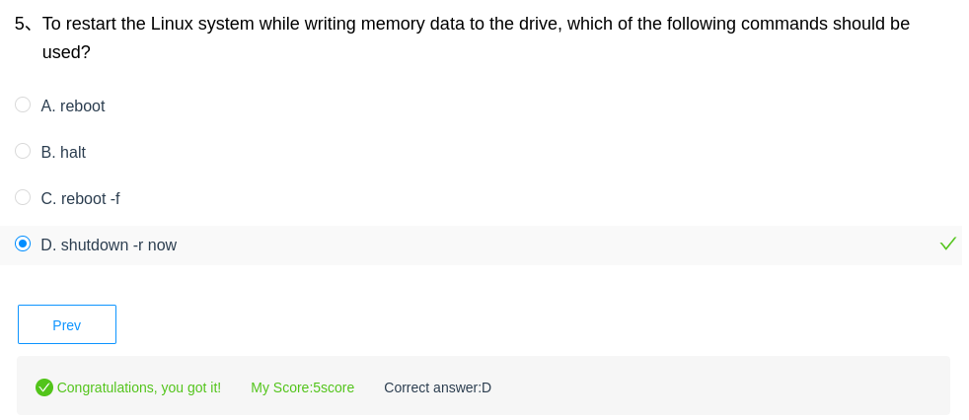

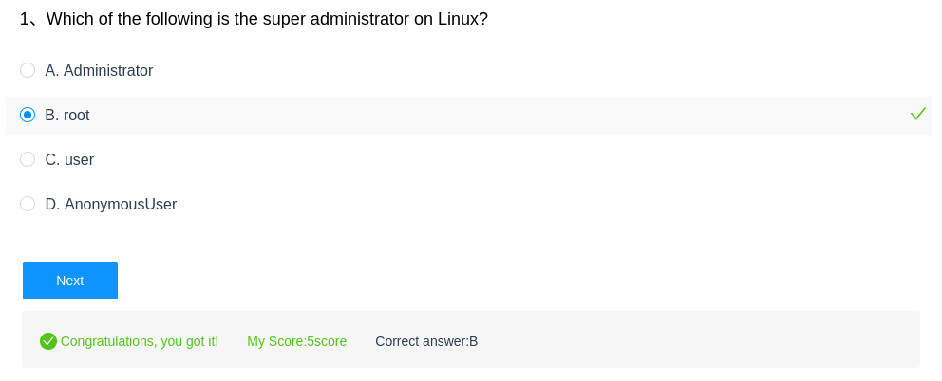

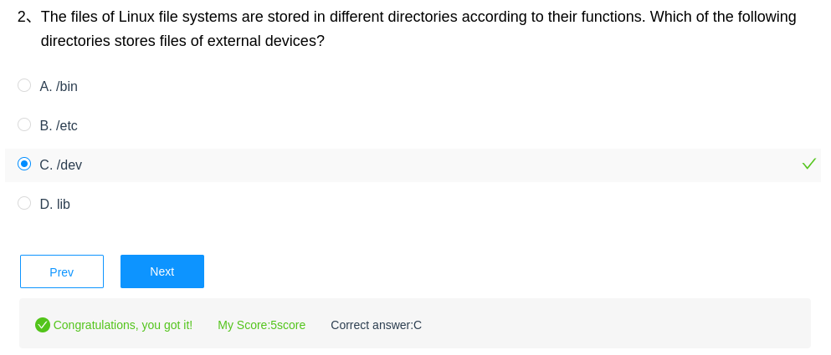

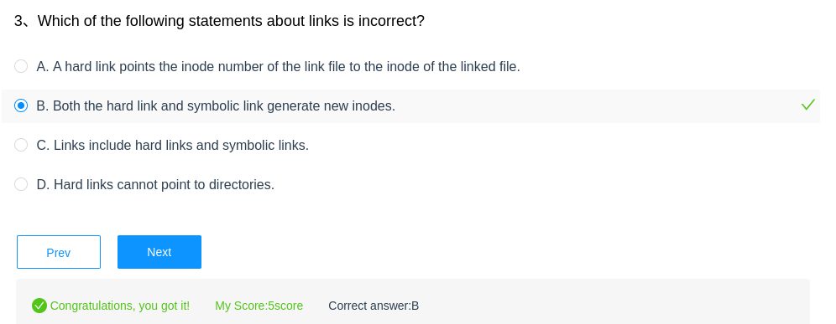

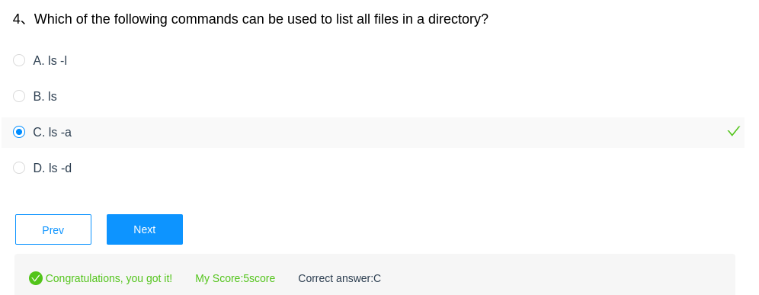

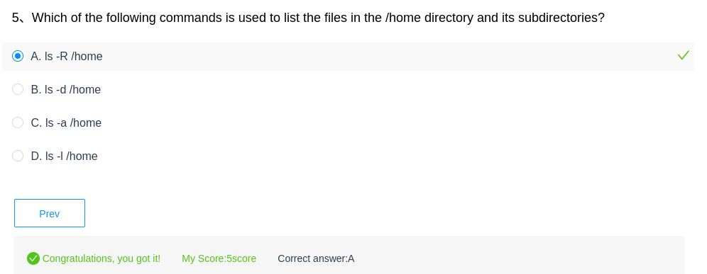

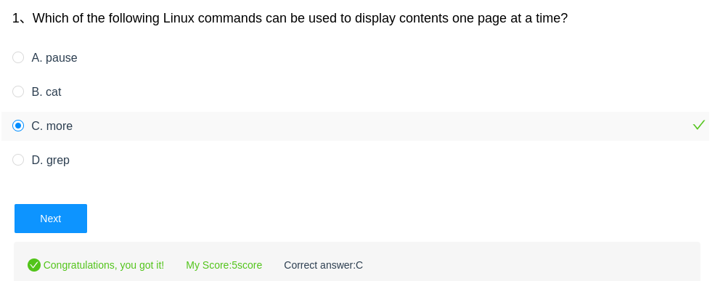

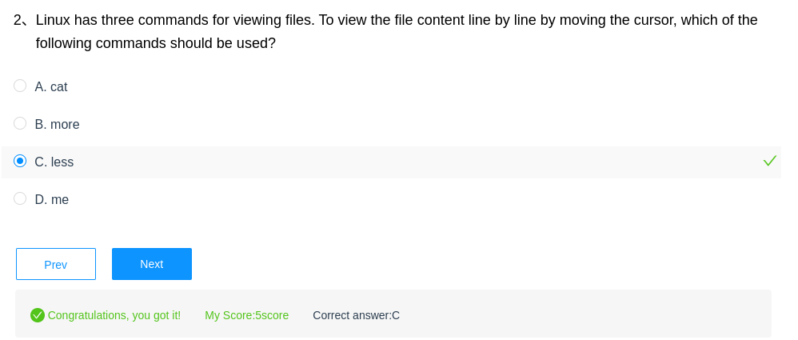

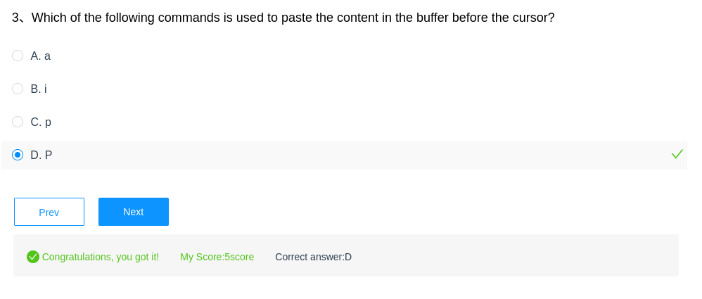

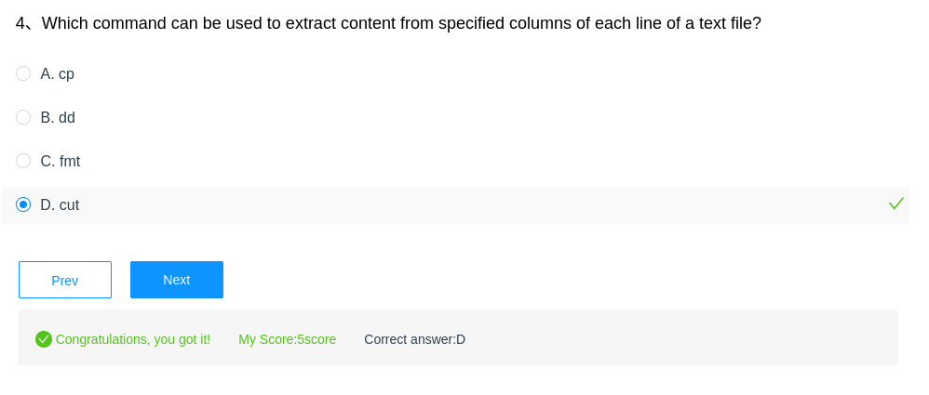

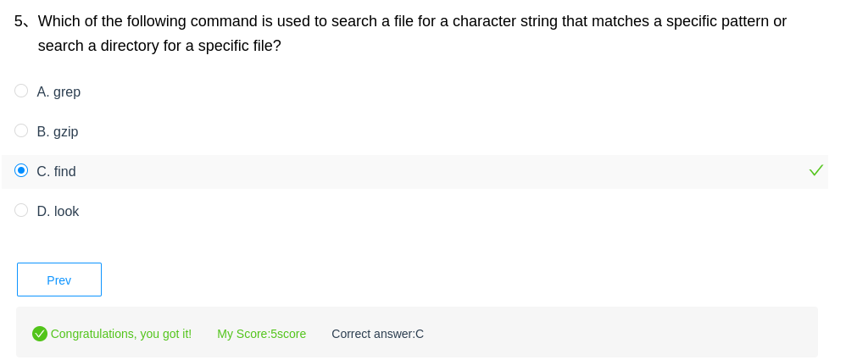

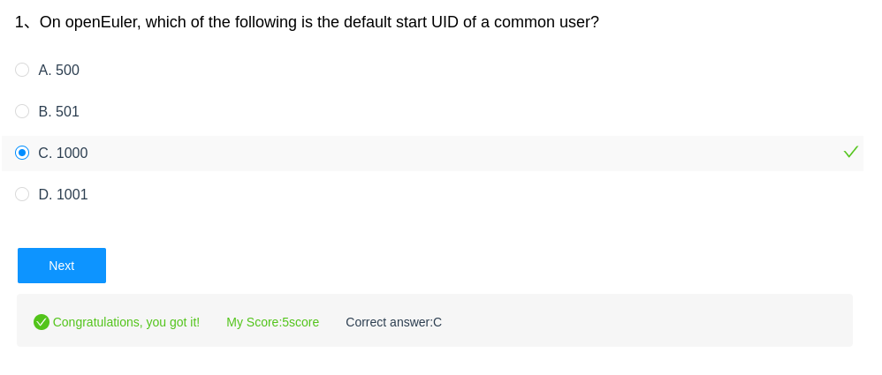

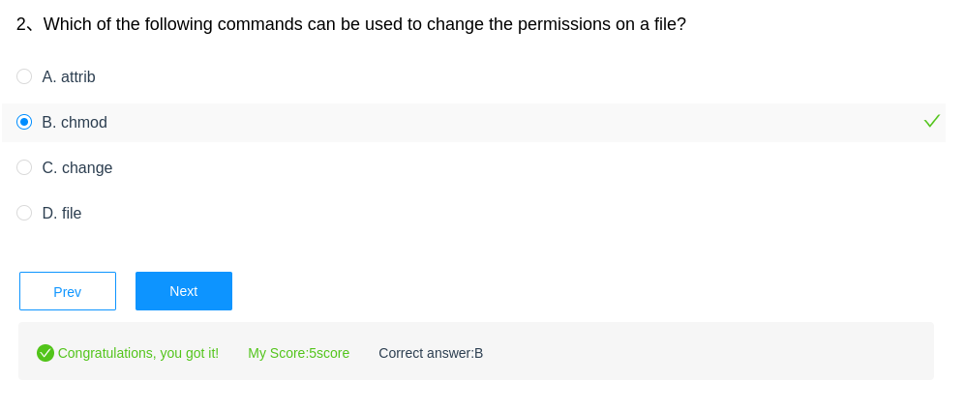

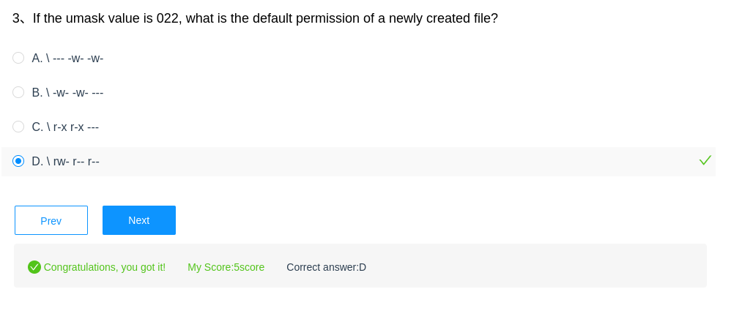

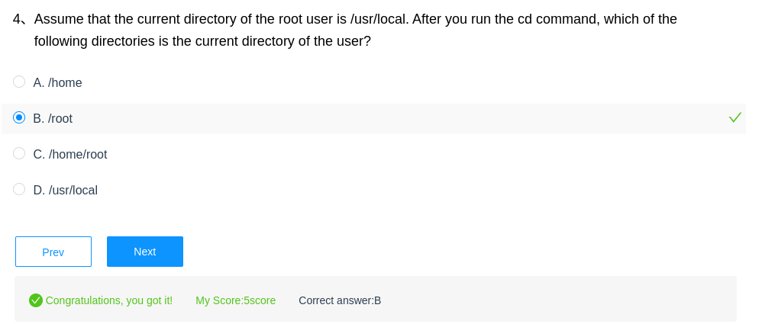

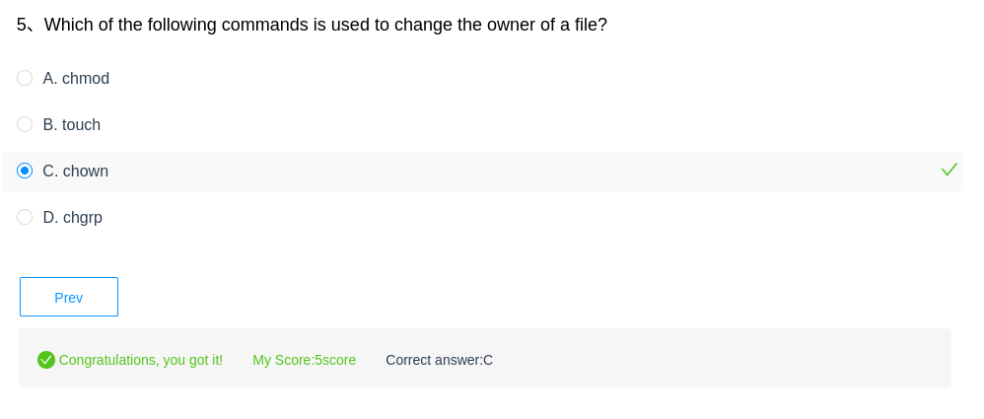

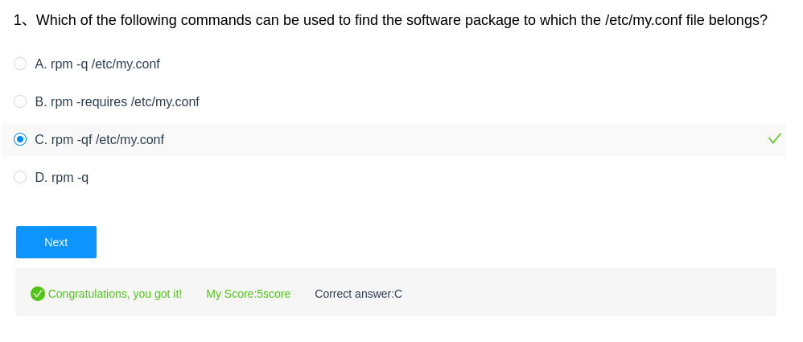

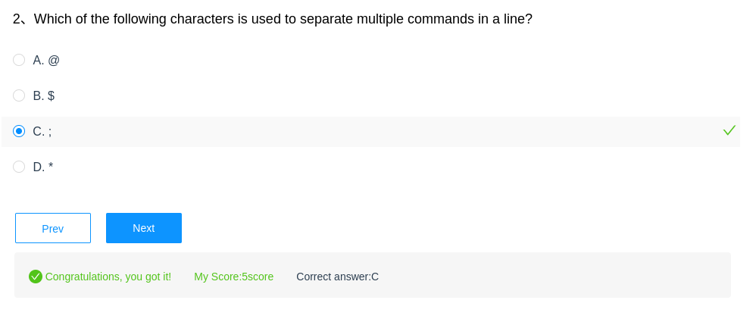

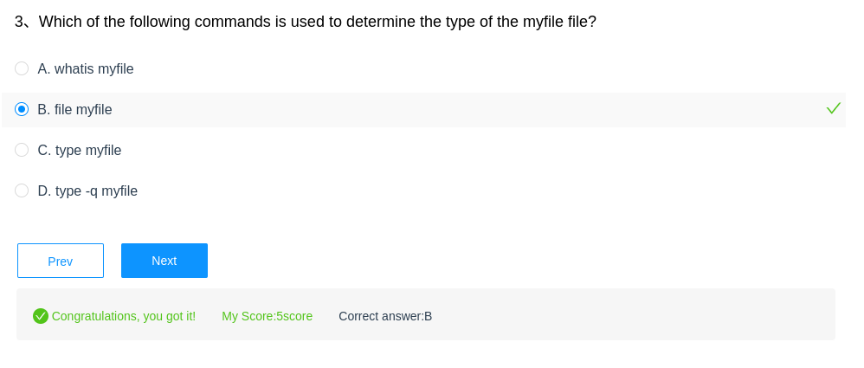

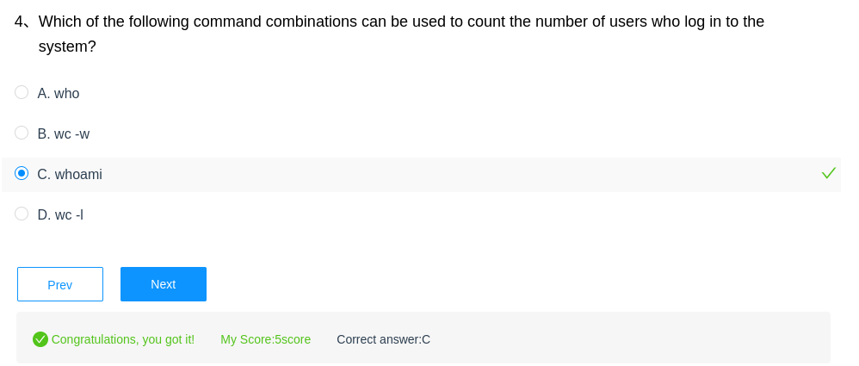

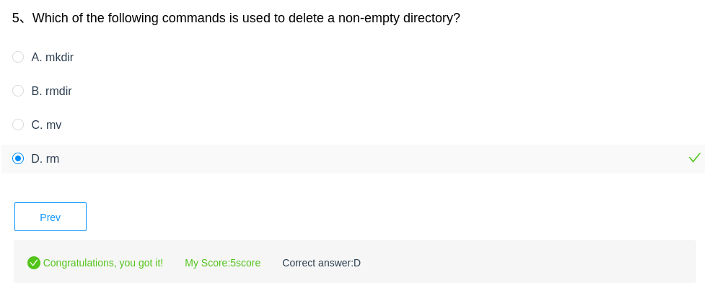

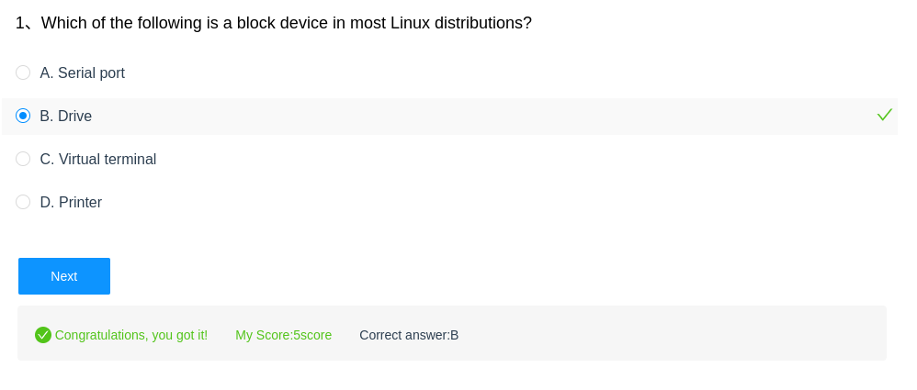

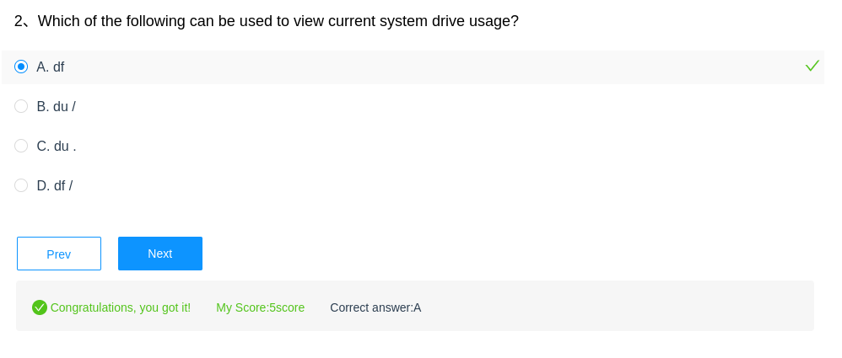

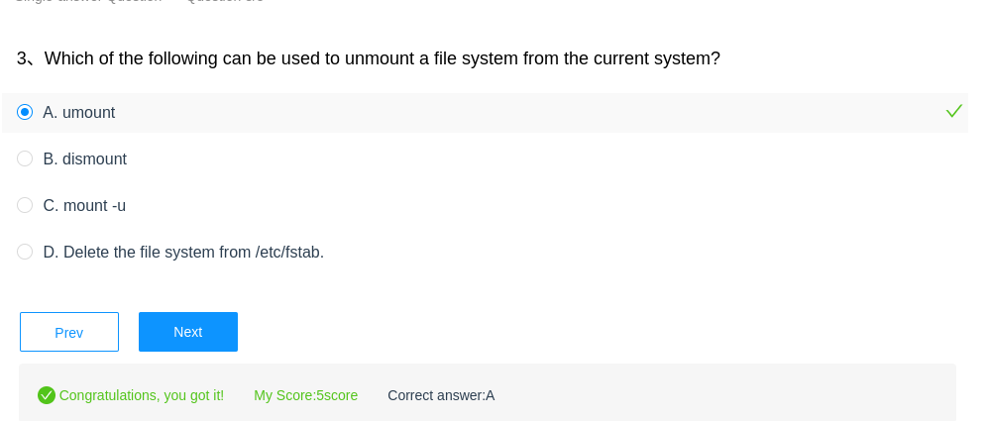

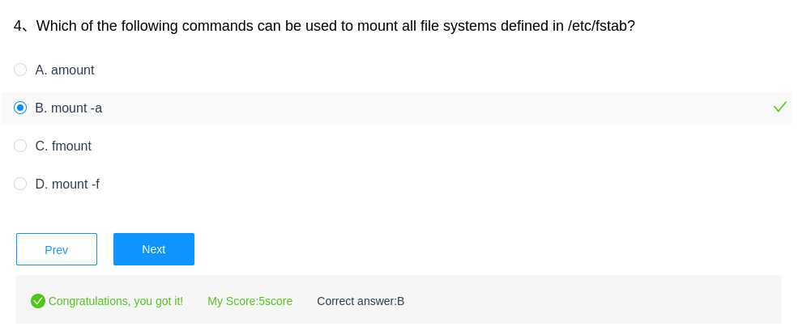

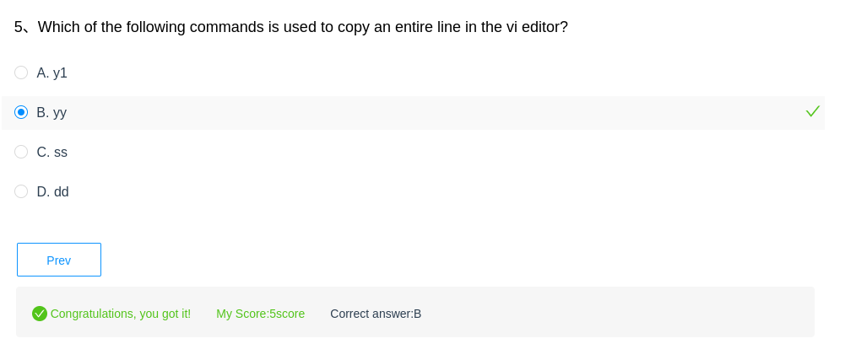

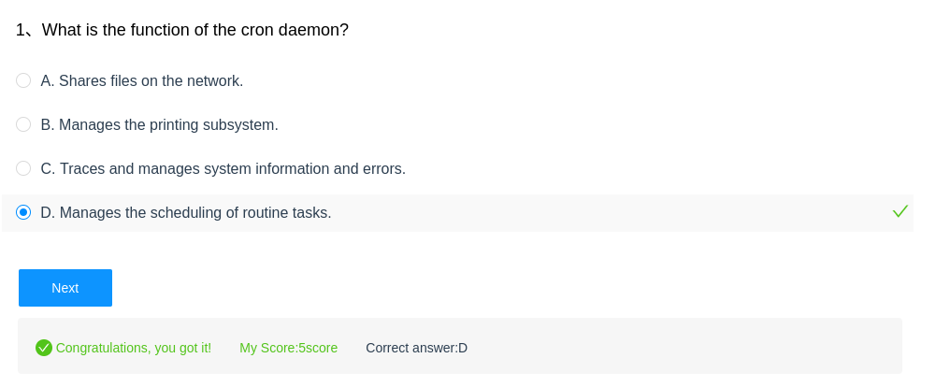

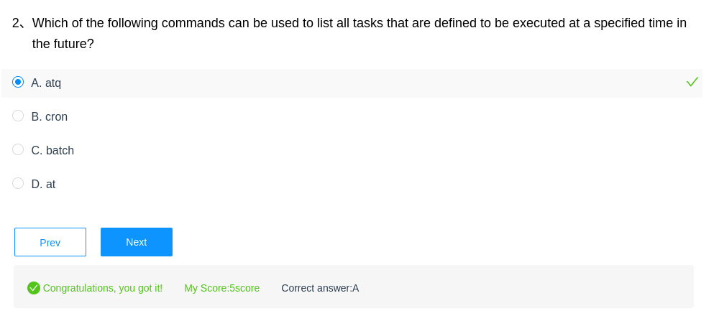

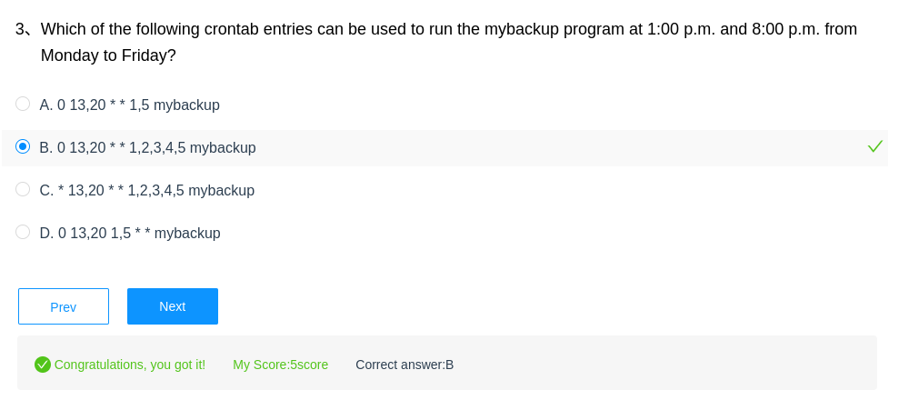

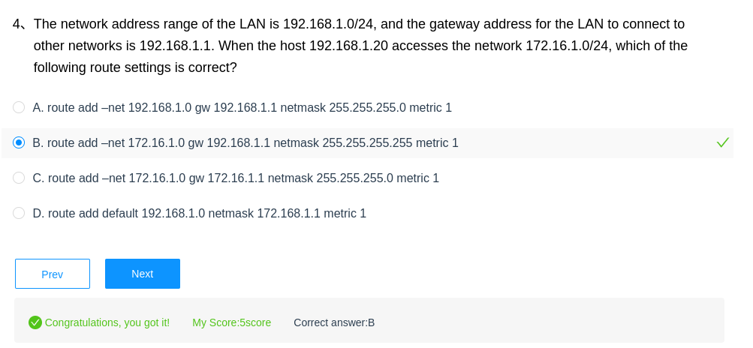

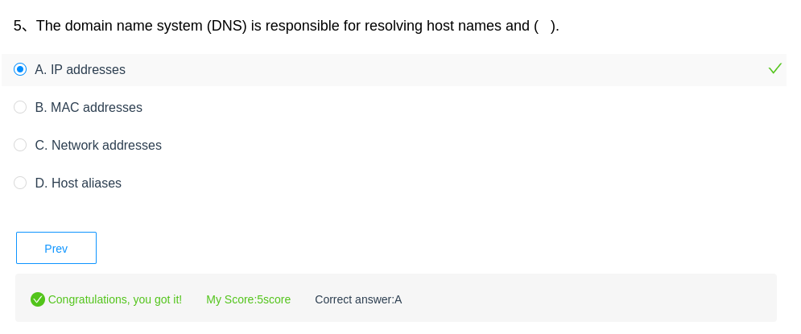

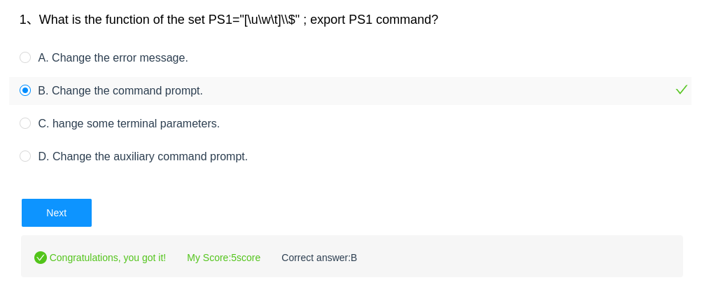

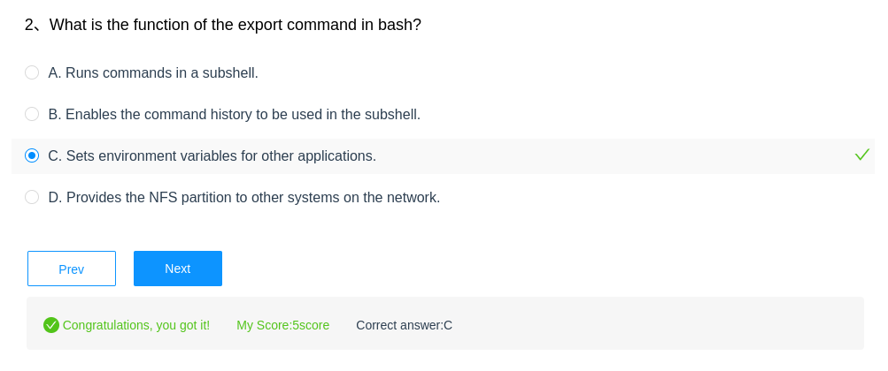

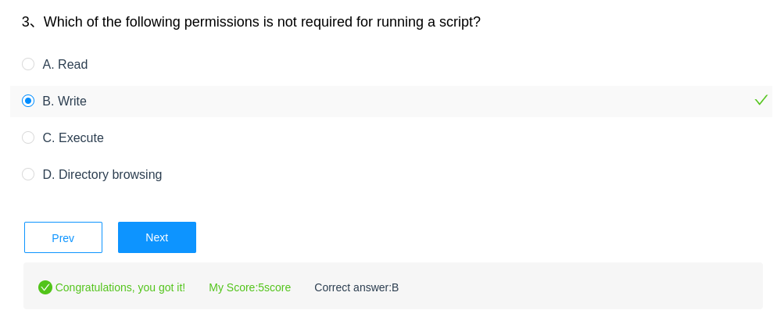

**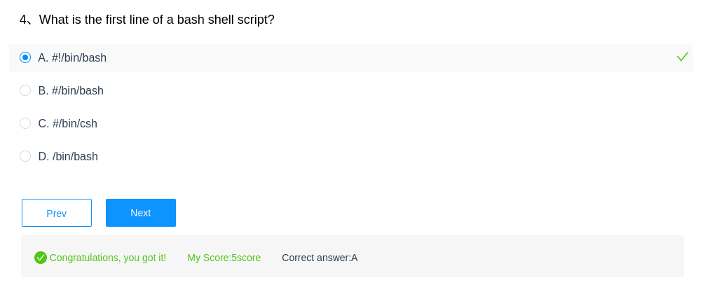  
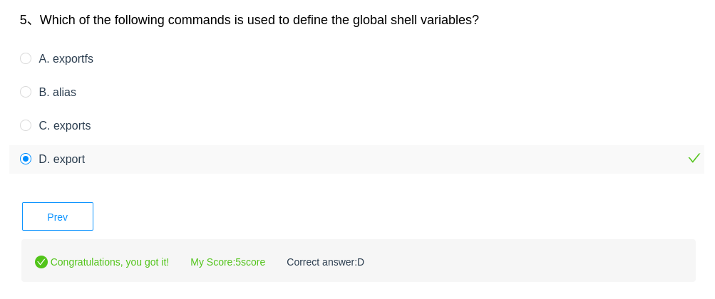**

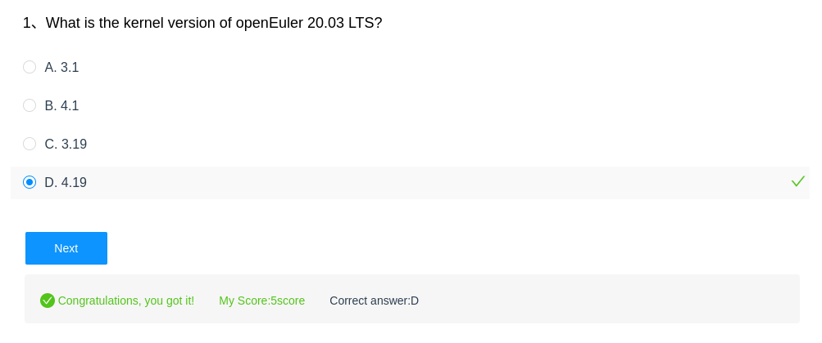

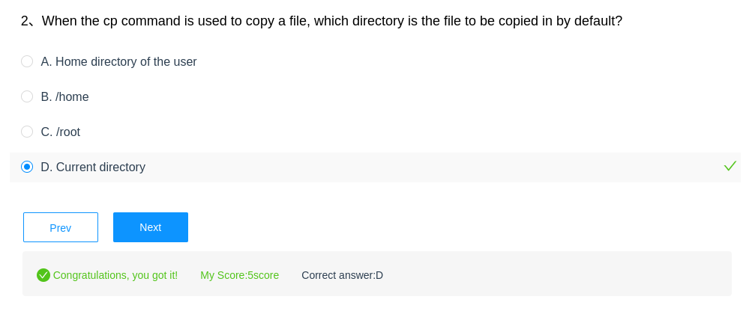

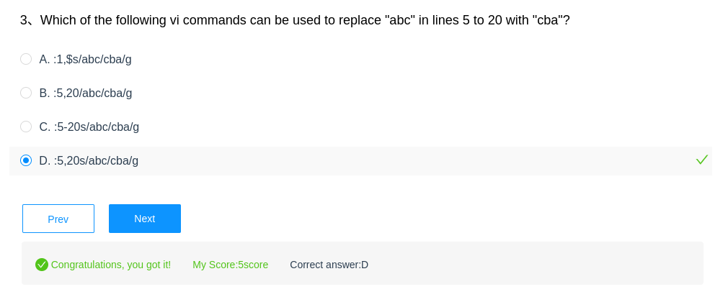

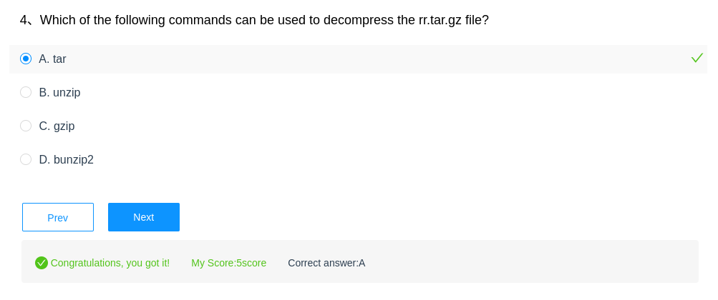

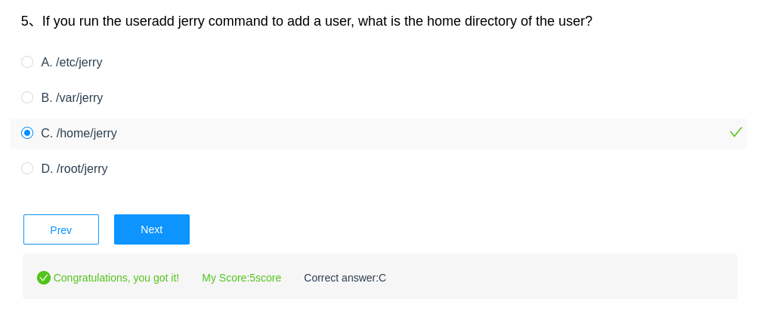

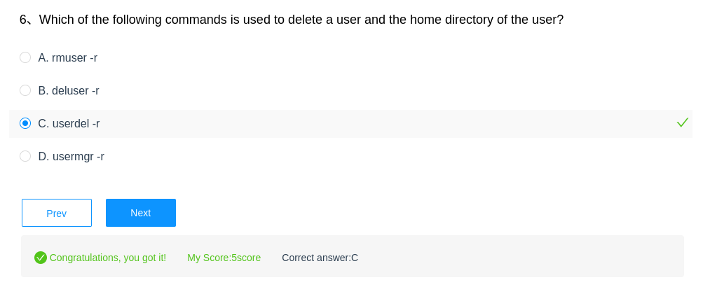

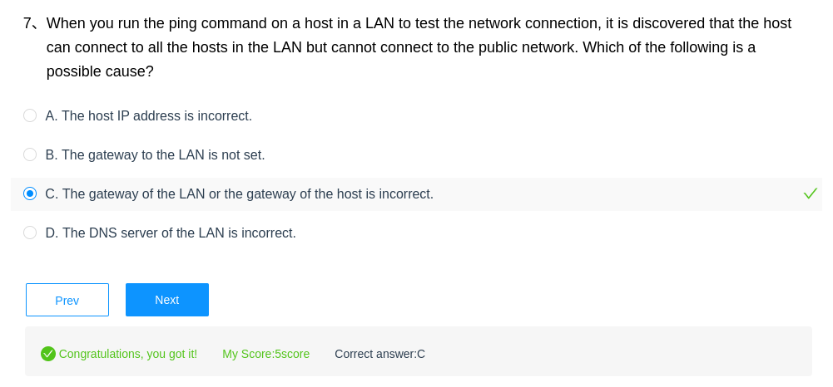

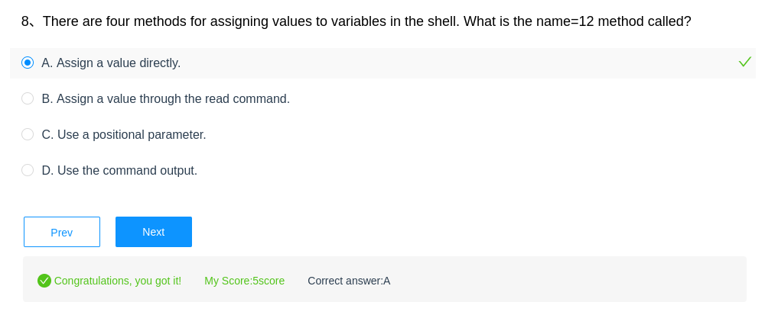

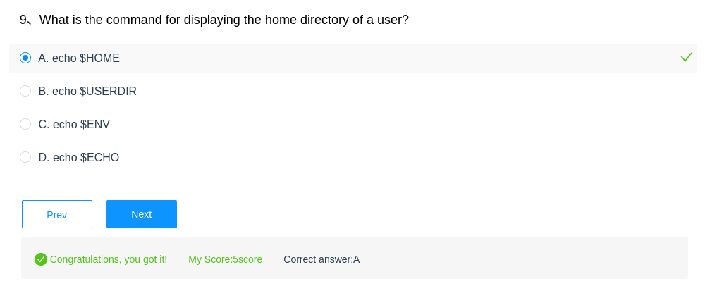

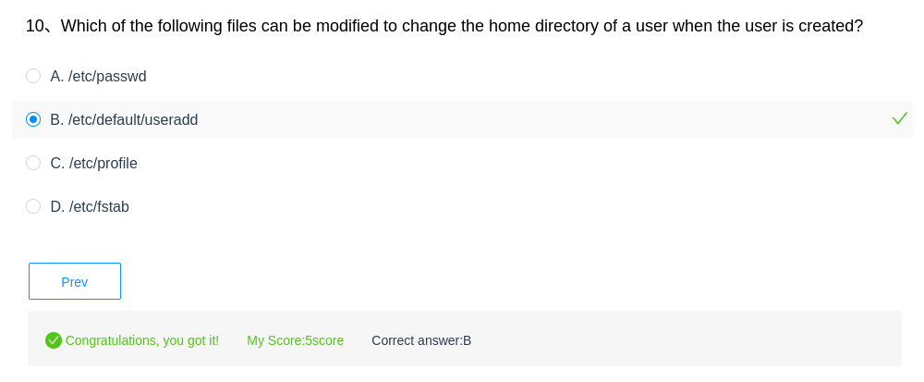

**HCIA-Kunpeng  
  
(Multiple-answer question) Which of the following are Huawei Kunpeng computing products?**

**A. Kunpeng processors**

**B. TaiShan servers**

**C. Huawei Cloud Kunpeng services**

Resposta:

Todos os itens (A, B e C) são produtos de computação Huawei Kunpeng.

* Kunpeng Processors: São processadores baseados na arquitetura ARM, projetados para alto desempenho e eficiência energética.
* TaiShan servers: São servidores que utilizam os processadores Kunpeng, oferecendo alta capacidade de computação e armazenamento para diversas aplicações.
* Huawei Cloud Kunpeng services: São serviços em nuvem que utilizam a tecnologia Kunpeng, oferecendo soluções de computação, armazenamento e outras funcionalidades baseadas em ARM.

**(Multiple-answer question) Which of the following support does Huawei provide for the Kunpeng computing industry?**

**A. Toolchains**

**B. Cloud services**

**C. Community services**

**D. Professional services**

Todos os itens (A, B, C e D) são suportes que a Huawei oferece para a indústria de computação Kunpeng.

* Toolchains: Ferramentas de desenvolvimento de software otimizadas para a arquitetura Kunpeng, facilitando a criação de aplicativos e soluções.
* Cloud services: Serviços em nuvem baseados na tecnologia Kunpeng, oferecendo infraestrutura, plataformas e software como serviço (IaaS, PaaS e SaaS).
* Community services: Suporte e recursos para desenvolvedores, incluindo fóruns, documentação, exemplos de código e programas de parceria.
* Professional services: Serviços de consultoria, implementação, suporte técnico e treinamento para empresas que utilizam a tecnologia Kunpeng.

**(Multiple-answer question) Which of the following statements about the Huawei Kunpeng 920 CPU are true? ()**

**A. It adopts 7 nm manufacturing.**

**B. It supports the 8-channel DDR4 controller.**

**C. It supports the PCle 4.0 interface and is compatible with PCIe 3.0/2.0/1.0.**

**D. It supports multiple accelerators.**

Todas as afirmações (A, B, C e D) são verdadeiras sobre a CPU Huawei Kunpeng 920.

* Fabricação de 7 nm: A Kunpeng 920 é fabricada utilizando a tecnologia de 7 nanômetros, o que garante maior densidade de transistores e melhor eficiência energética.
* Controlador DDR4 de 8 canais: A CPU suporta memória DDR4 com 8 canais, permitindo maior largura de banda e desempenho para aplicações que exigem alta capacidade de memória.
* Interface PCIe 4.0: A Kunpeng 920 suporta a interface PCIe 4.0, que oferece o dobro da velocidade da PCIe 3.0, permitindo a utilização de dispositivos de alta performance, como GPUs e SSDs NVMe.
* Múltiplos aceleradores: A CPU soporta múltiplos aceleradores, como motores de aceleração criptográfica e de compressão, que podem ser utilizados para otimizar o desempenho de tarefas específicas.

**(Multiple-answer question) Which of the following descriptions about the Huawei Kunpeng 920 CPU accelerators are true? ()**

**A. SSL acceleration engine**

**B. Encryption/Decryption acceleration engine**

**C. Compression/Decompression acceleration engine**

Todas as descrições (A, B e C) são verdadeiras sobre os aceleradores da CPU Huawei Kunpeng 920.

* Motor de aceleração SSL: A CPU possui um motor de aceleração SSL integrado, que permite realizar operações de criptografia SSL de forma mais rápida e eficiente, otimizando o desempenho de servidores web e aplicações que utilizam HTTPS.
* Motor de aceleração de criptografia/descriptografia: A Kunpeng 920 possui um motor de aceleração dedicado para operações de criptografia e descriptografia, o que acelera o processamento de dados confidenciais e garante a segurança das informações.
* Motor de aceleração de compressão/descompressão: A CPU também possui um motor de aceleração para compressão e descompressão de dados, o que melhora o desempenho de aplicações que trabalham com grandes volumes de dados, como servidores de arquivos e bancos de dados.

**(Multiple-answer question) Which of the following are models of TaiShan 200 rack servers? ()**

**A. 2280**

**B. 5280**

**C. 2480**

**D. RH2288**

As opções A (2280), B (5280) e C (2480) são modelos de servidores de rack TaiShan 200.

* Os servidores TaiShan 200 são projetados para oferecer alta densidade de computação e armazenamento, ideal para aplicações de missão crítica, computação de alto desempenho (HPC) e inteligência artificial.
* Os modelos 2280, 5280 e 2480 variam em especificações como número de processadores, capacidade de memória, slots de expansão e opções de armazenamento, permitindo que os clientes escolham o modelo mais adequado para suas necessidades.
* A opção D (RH2288) refere-se a um modelo de servidor de rack da Huawei, mas não pertence à linha TaiShan 200.

**(Single-answer question) Which of the following four groups of SQL commands are DML commands? ()**

**A. CREATE, DROP, UPDATE**

**B. INSERT, UPDATE, DELETE**

**C. INSERT, DROP, ALTER**

**D. UPDATE, DELETE, ALTER**

A resposta correta é B. INSERT, UPDATE, DELETE

Explicação:

* DML (Data Manipulation Language): Comandos SQL que permitem manipular os dados armazenados em tabelas, como inserir, atualizar e excluir registros.  
  + INSERT: Adiciona novas linhas (registros) a uma tabela.
  + UPDATE: Modifica os dados existentes em uma ou mais linhas de uma tabela.
  + DELETE: Remove uma ou mais linhas de uma tabela.
* DDL (Data Definition Language): Comandos SQL que permitem definir e modificar a estrutura do banco de dados, como criar, alterar e excluir tabelas e outros objetos.  
  + CREATE: Cria um novo objeto (tabela, índice, etc.) no banco de dados.
  + DROP: Remove um objeto existente do banco de dados.
  + ALTER: Modifica a estrutura de um objeto existente.

Análise das outras opções:

* A. CREATE, DROP, UPDATE: CREATE e DROP são comandos DDL, não DML. UPDATE é um comando DML.
* C. INSERT, DROP, ALTER: INSERT é um comando DML. DROP e ALTER são comandos DDL.
* D. UPDATE, DELETE, ALTER: UPDATE e DELETE são comandos DML. ALTER é um comando DDL.

**(Multiple-answer question) Why does x86-based software need to be ported before it is used on the Kunpeng platform? ()**

**A. The instruction sets are different.**

**B. The source code can be executed only after it has been compiled or translated into instructions to the target instruction sets.**

**C. The representation of compilation options and macros in the x86 architecture differs from that in the Kunpeng architecture.**

**D. x86-based executable programs cannot be directly executed on the Kunpeng platform.**

Todas as opções (A, B, C e D) estão corretas.

Explicação:

* A. Os conjuntos de instruções são diferentes: A arquitetura x86 (utilizada em muitos computadores pessoais) e a arquitetura ARM (utilizada na plataforma Kunpeng) possuem conjuntos de instruções diferentes. Isso significa que os programas compilados para x86 não são diretamente compatíveis com ARM.
* B. O código fonte só pode ser executado depois de compilado ou traduzido em instruções para os conjuntos de instruções de destino: Para que um programa funcione em uma arquitetura diferente, seu código fonte precisa ser recompilado ou traduzido para o conjunto de instruções da arquitetura de destino (ARM, no caso da Kunpeng).
* C. A representação de opções de compilação e macros na arquitetura x86 difere daquela na arquitetura Kunpeng: As opções de compilação e macros utilizadas na arquitetura x86 podem não ser compatíveis com a arquitetura ARM. É necessário ajustar essas opções para garantir que o programa seja compilado corretamente para a plataforma Kunpeng.
* D. Programas executáveis baseados em x86 não podem ser executados diretamente na plataforma Kunpeng: Como os conjuntos de instruções são diferentes, os programas executáveis (arquivos binários) gerados para x86 não podem ser executados diretamente em plataformas ARM, como a Kunpeng.

**Why does x86-based software need to be ported before it is used on the Kunpeng platform? ()**

**A. The instruction sets are different.**

**B. The source code can be executed only after it has been compiled or translated into instructions to the target instruction sets.**

**C. The representation of compilation options and macros in the x86 architecture differs from that in the Kunpeng architecture.**

**D. x86-based executable programs cannot be directly executed on the Kunpeng platform.**

As respostas corretas são A, B, C, D. Aqui está o detalhamento:

A. Os conjuntos de instruções são diferentes.

Os processadores Kunpeng (baseados em ARM) usam o conjunto de instruções ARM, enquanto as plataformas x86 usam o conjunto de instruções x86/x64. O software compilado para x86 não pode ser executado diretamente em hardware baseado em ARM devido a instruções binárias incompatíveis.

B. O código-fonte só pode ser executado depois de ter sido compilado e traduzido em instruções para os conjuntos de instruções de destino.

O código-fonte (por exemplo, C/C++) deve ser recompilado especificamente para a plataforma Kunpeng gerar código de máquina compatível com ARM. Sem recompilação, o software não pode ser executado em processadores Kunpeng.

C. A representação das opções de compilação e macros na arquitetura x86 difere daquela na arquitetura Kunpeng.

Sinalizadores de compilação (por exemplo, -march=x86-64), macros específicas da arquitetura (por exemplo, #ifdef __x86_64__) e código assembly embutido são adaptados para x86. Eles devem ser modificados ou substituídos por equivalentes ARM/Kunpeng (por exemplo, -march=armv8-a, #ifdef __aarch64__) durante a portabilidade.

D. Programas executáveis ​​baseados em x86 não podem ser executados diretamente na plataforma Kunpeng.

Os binários x86 não são compatíveis com arquiteturas ARM como Kunpeng. Os executáveis ​​devem ser reconstruídos a partir do código-fonte da plataforma Kunpeng. Mesmo linguagens interpretadas (por exemplo, Python) podem exigir ajustes se contarem com bibliotecas compiladas específicas para x86.

**HCIA - Mock Exam**

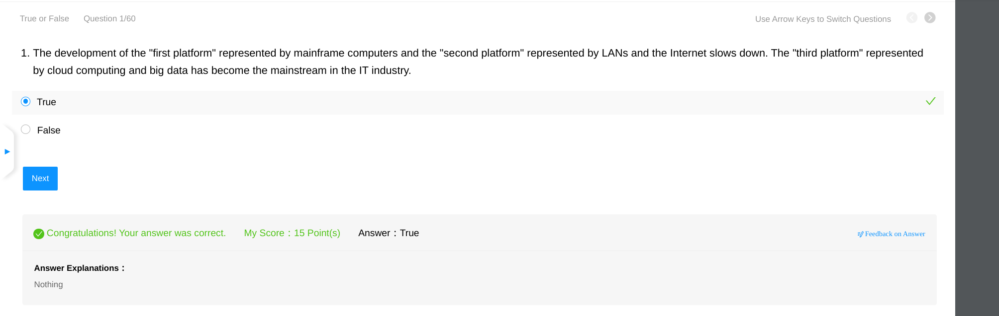

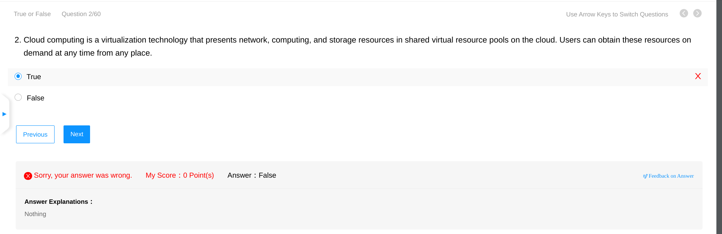

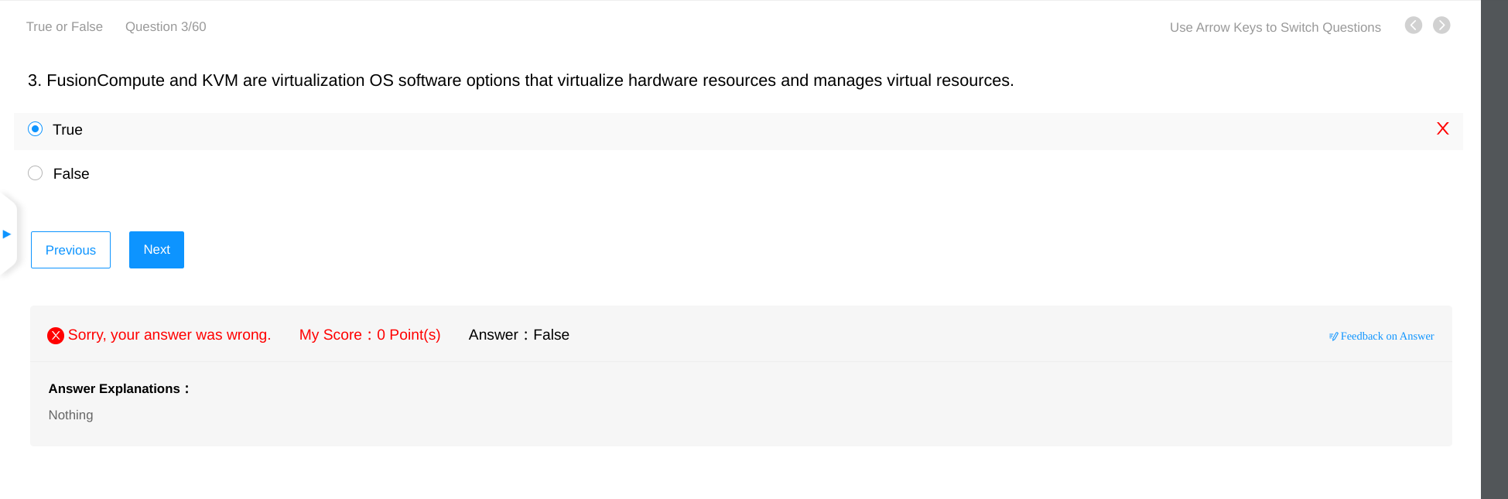

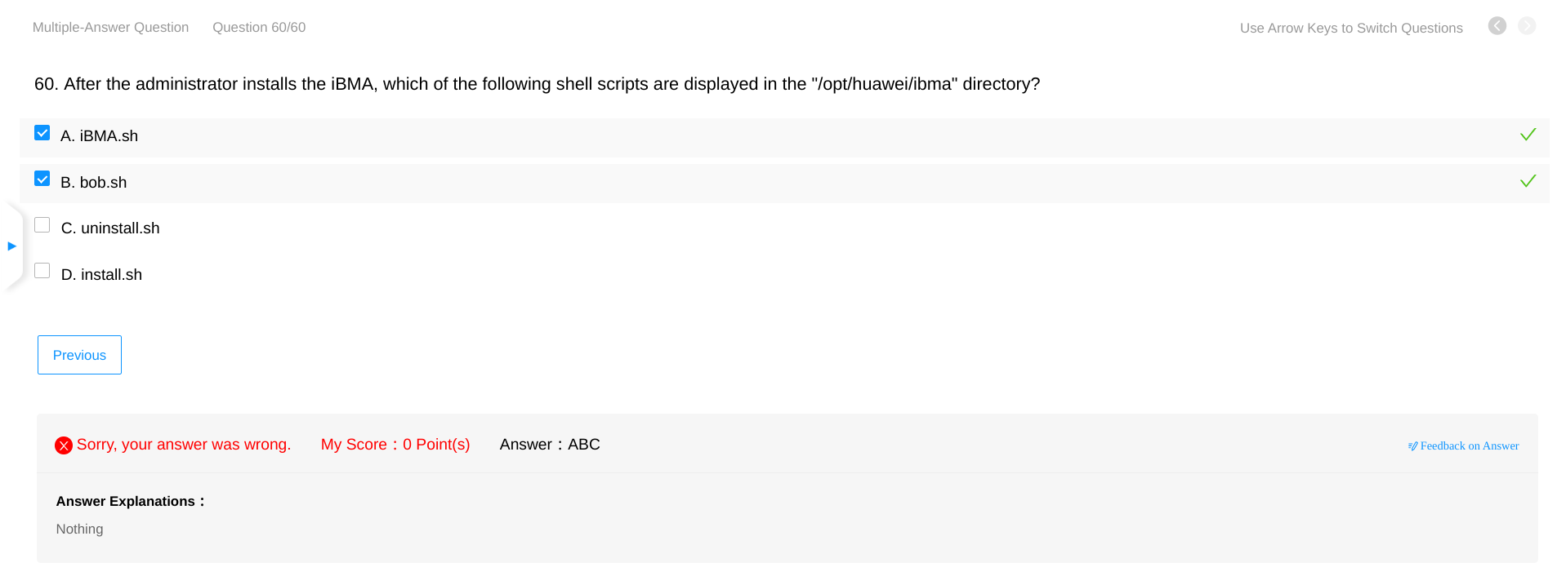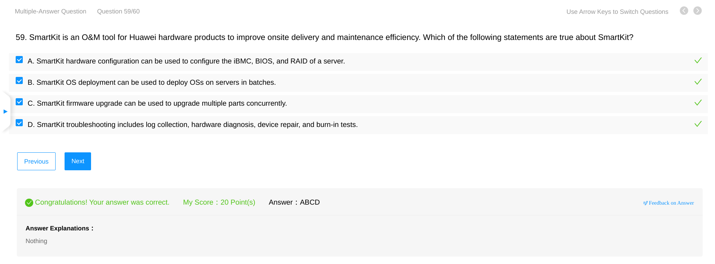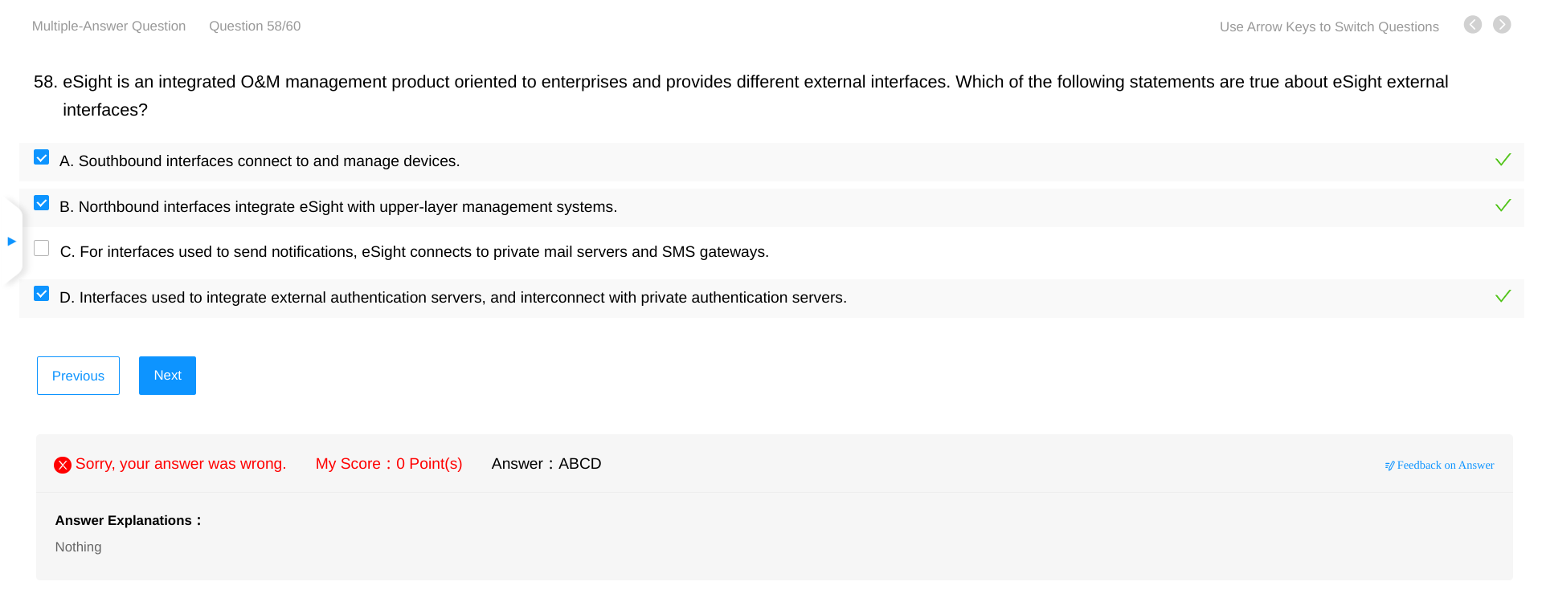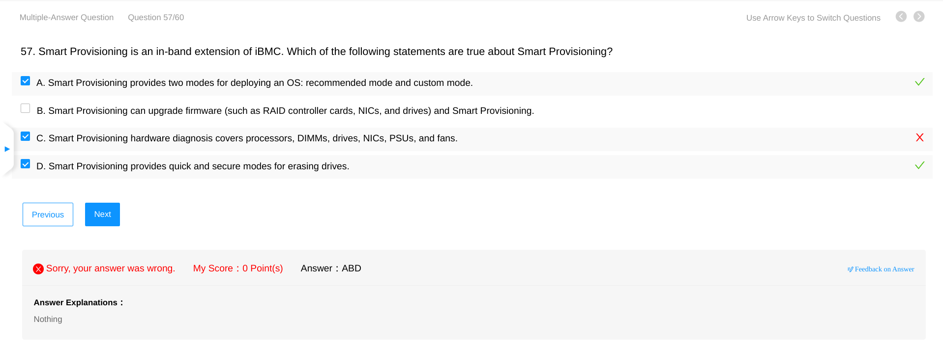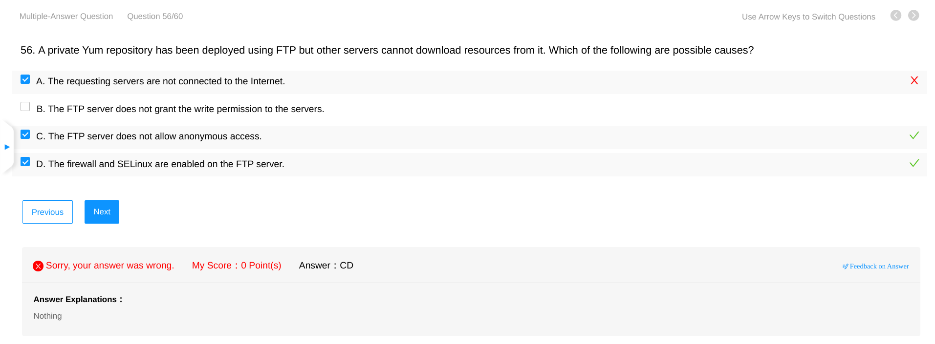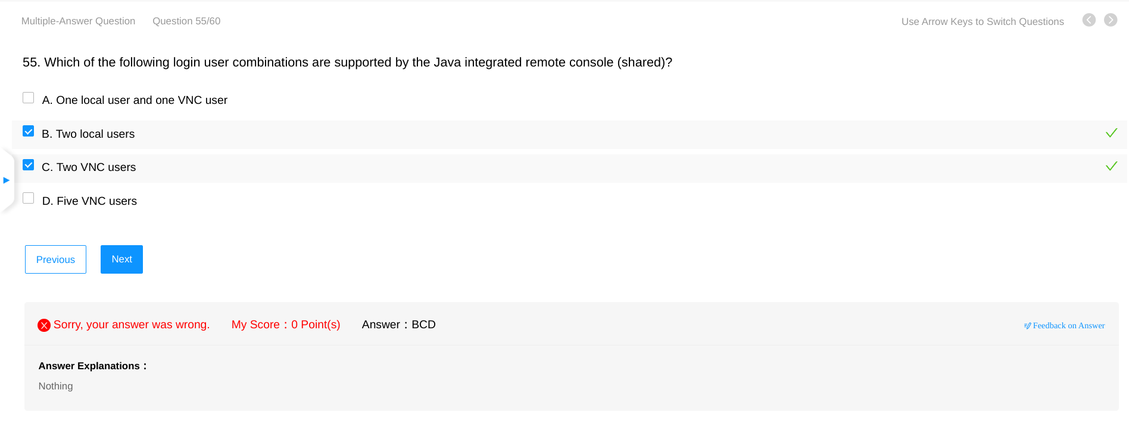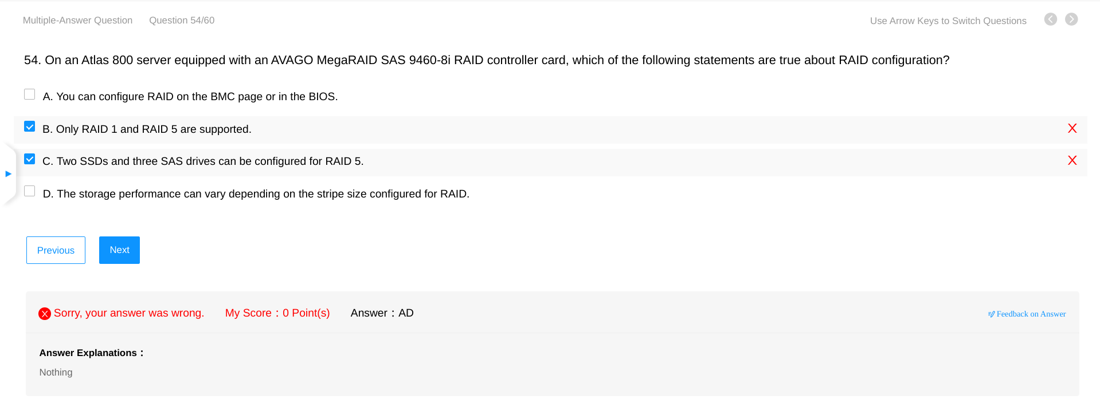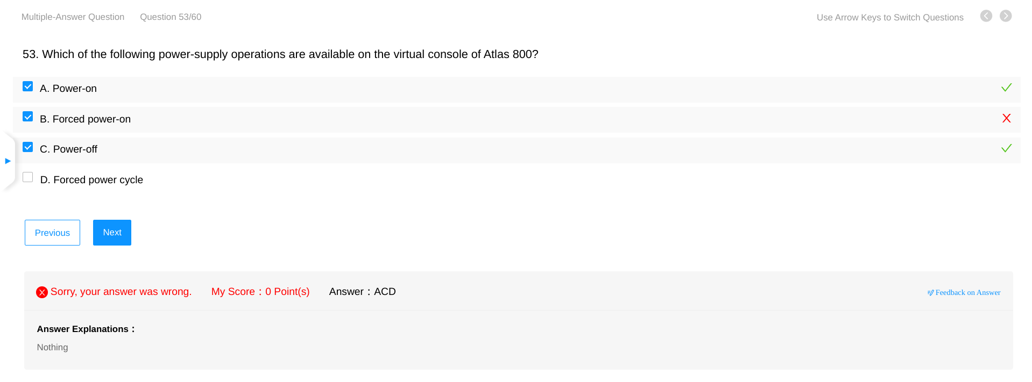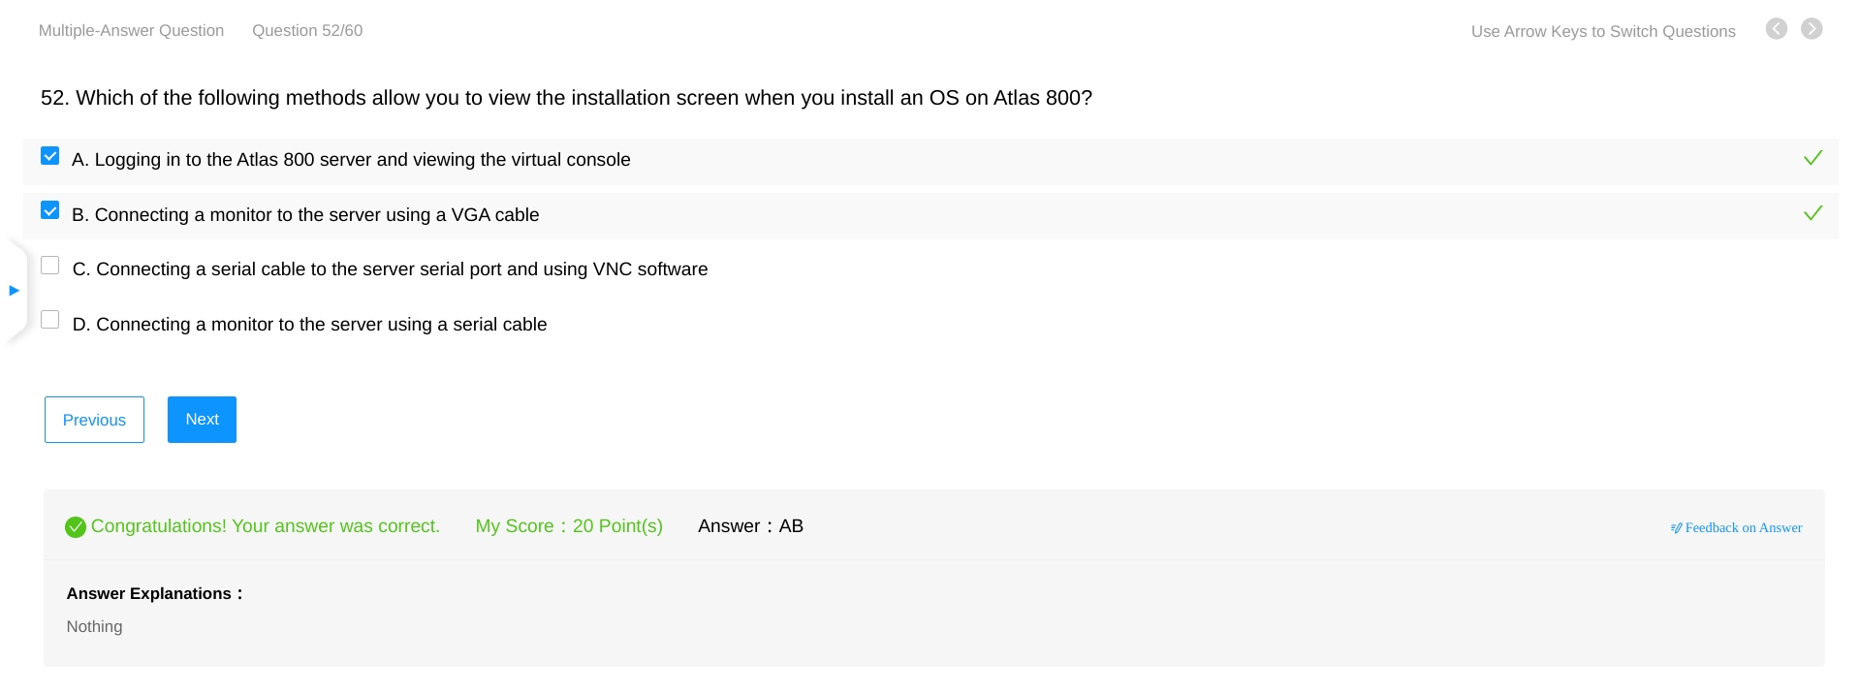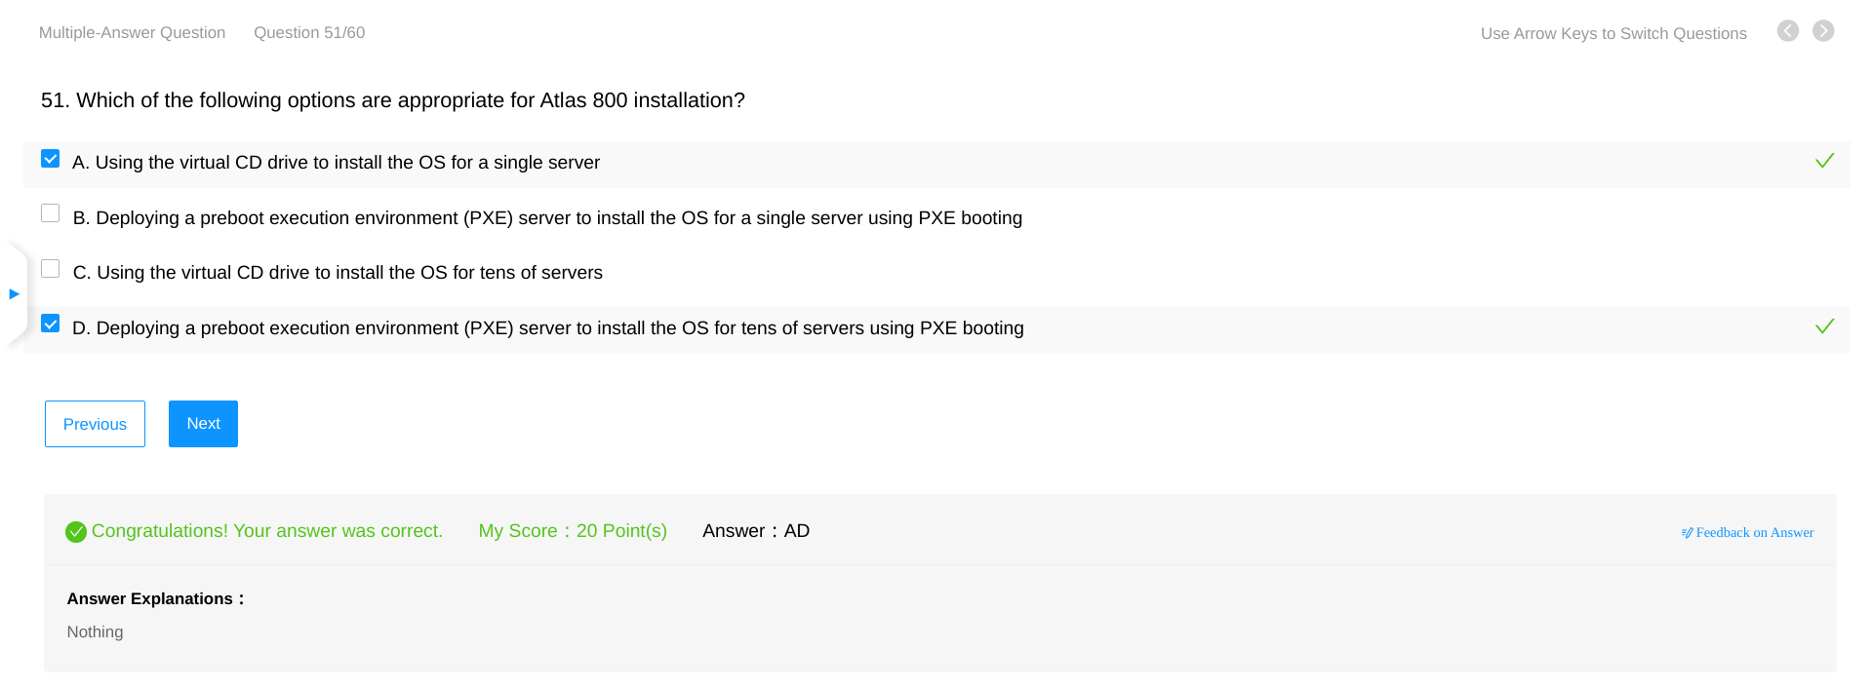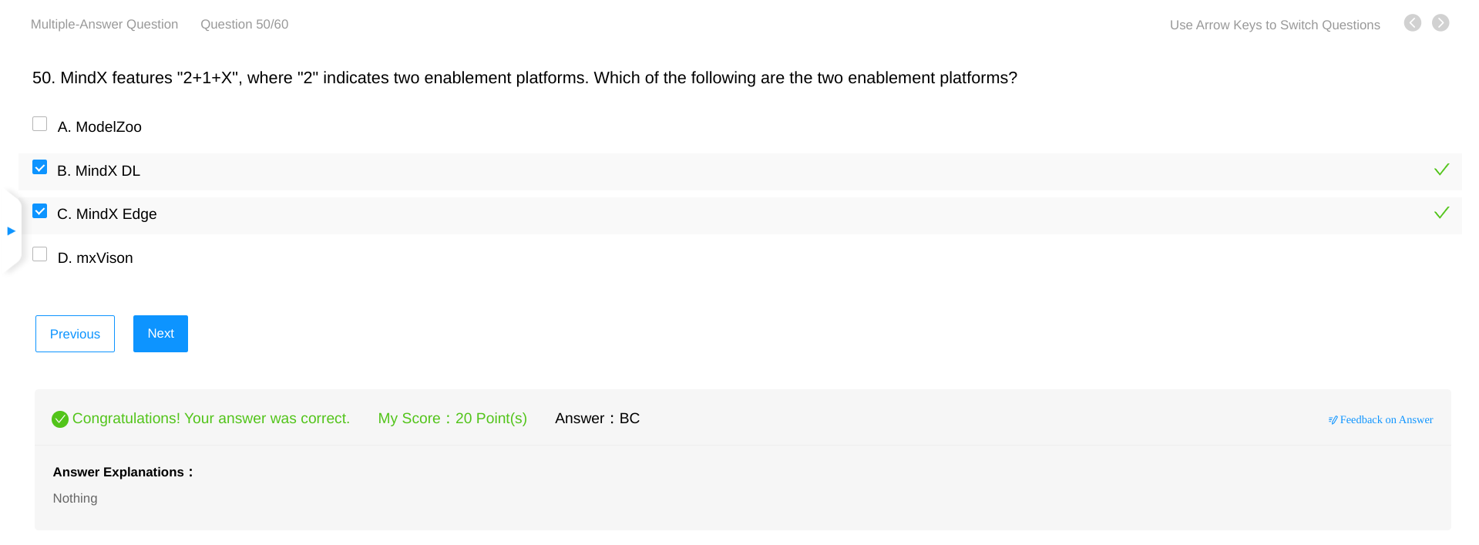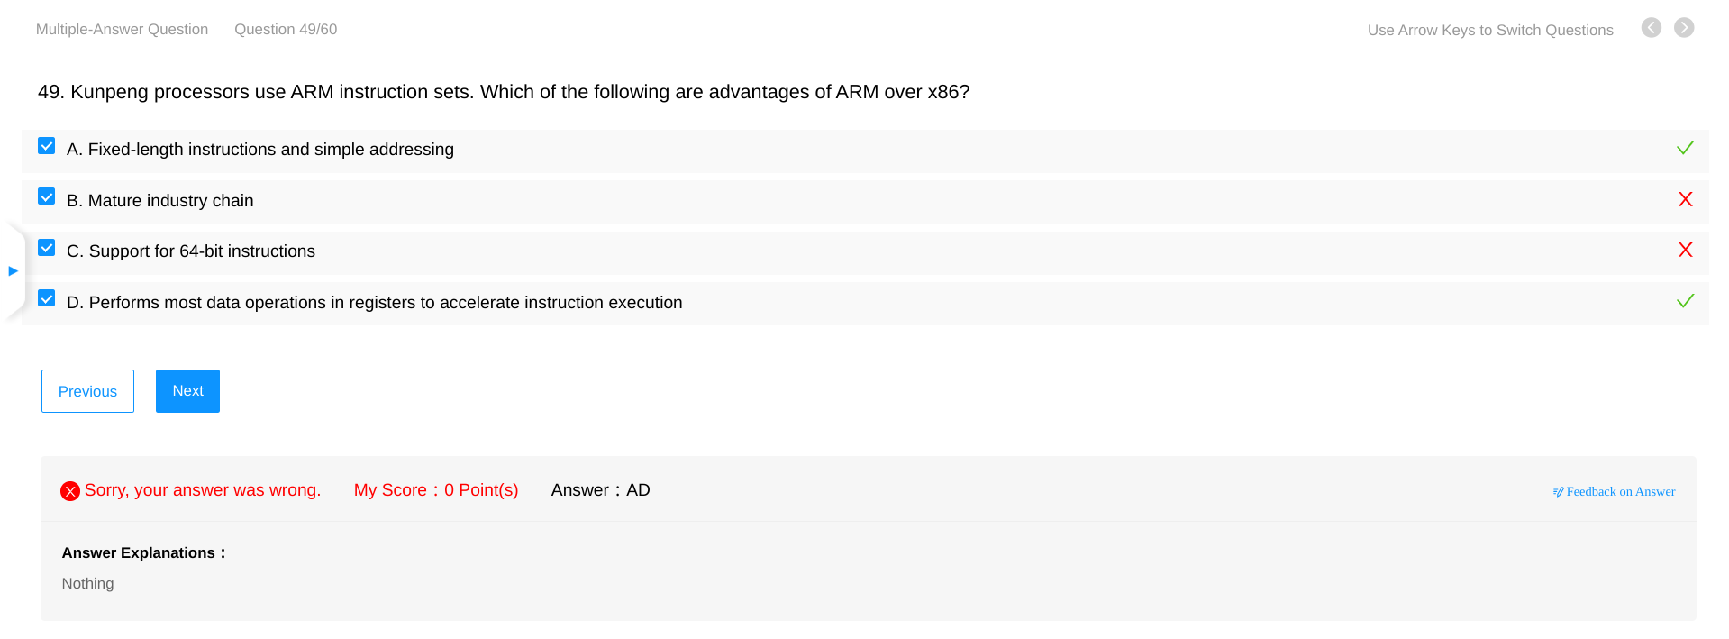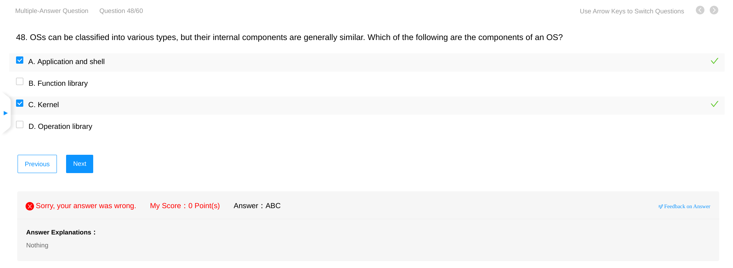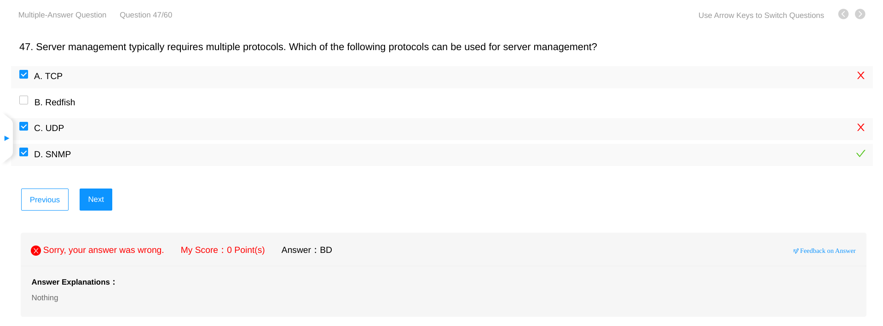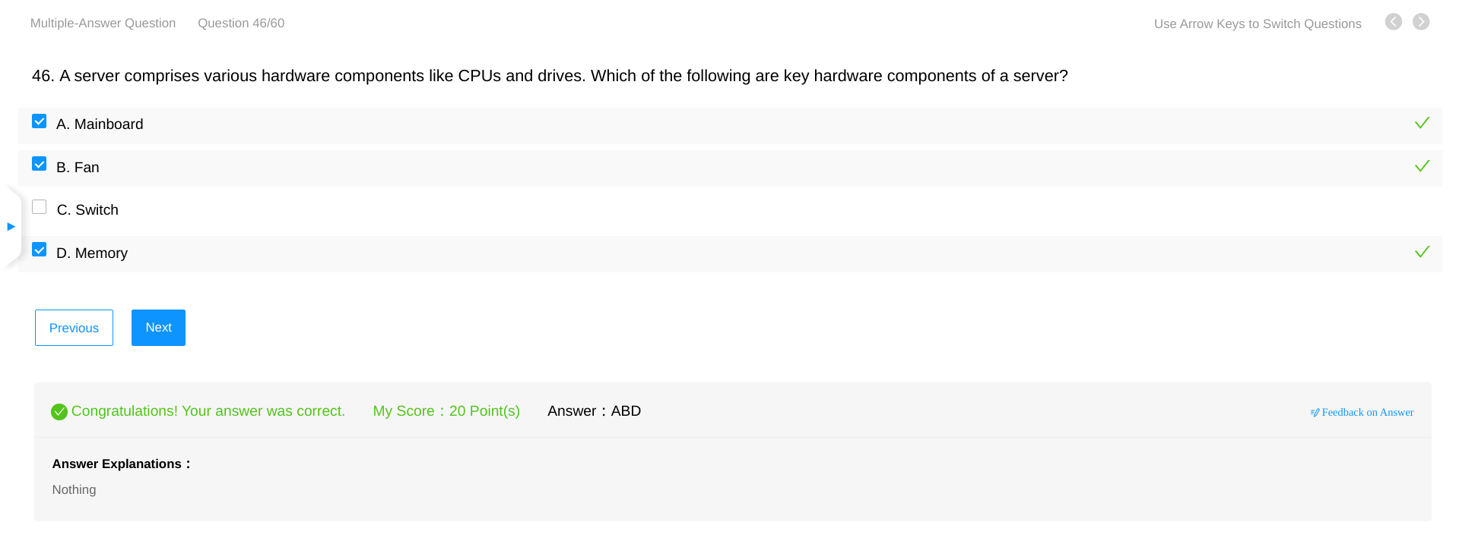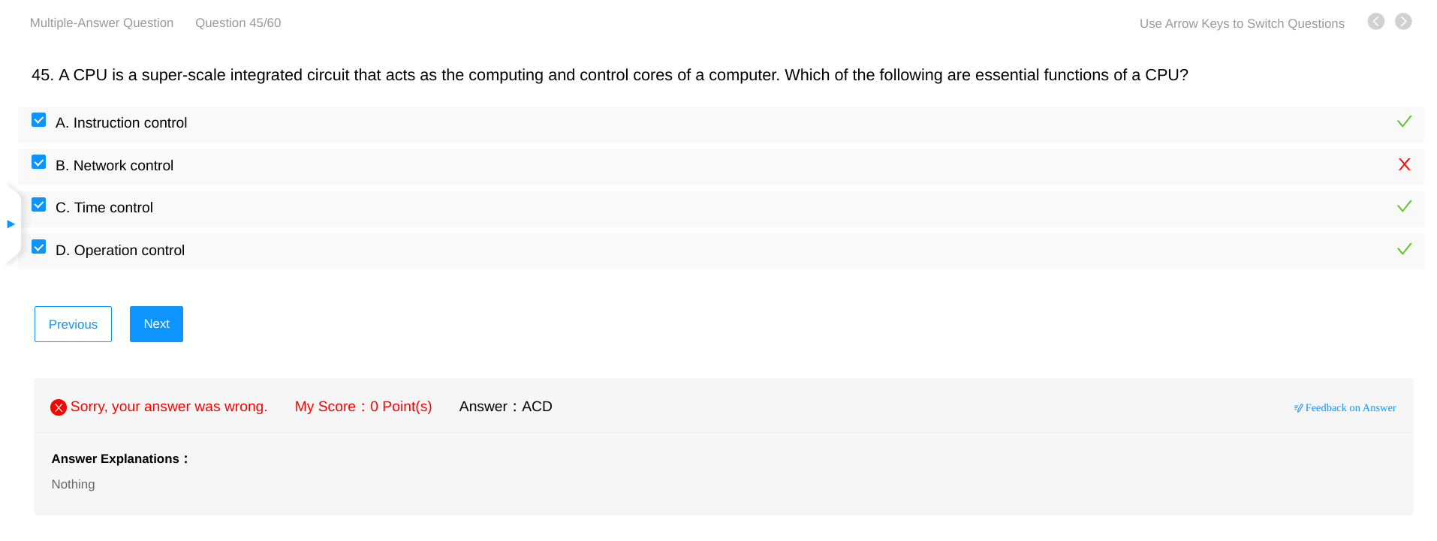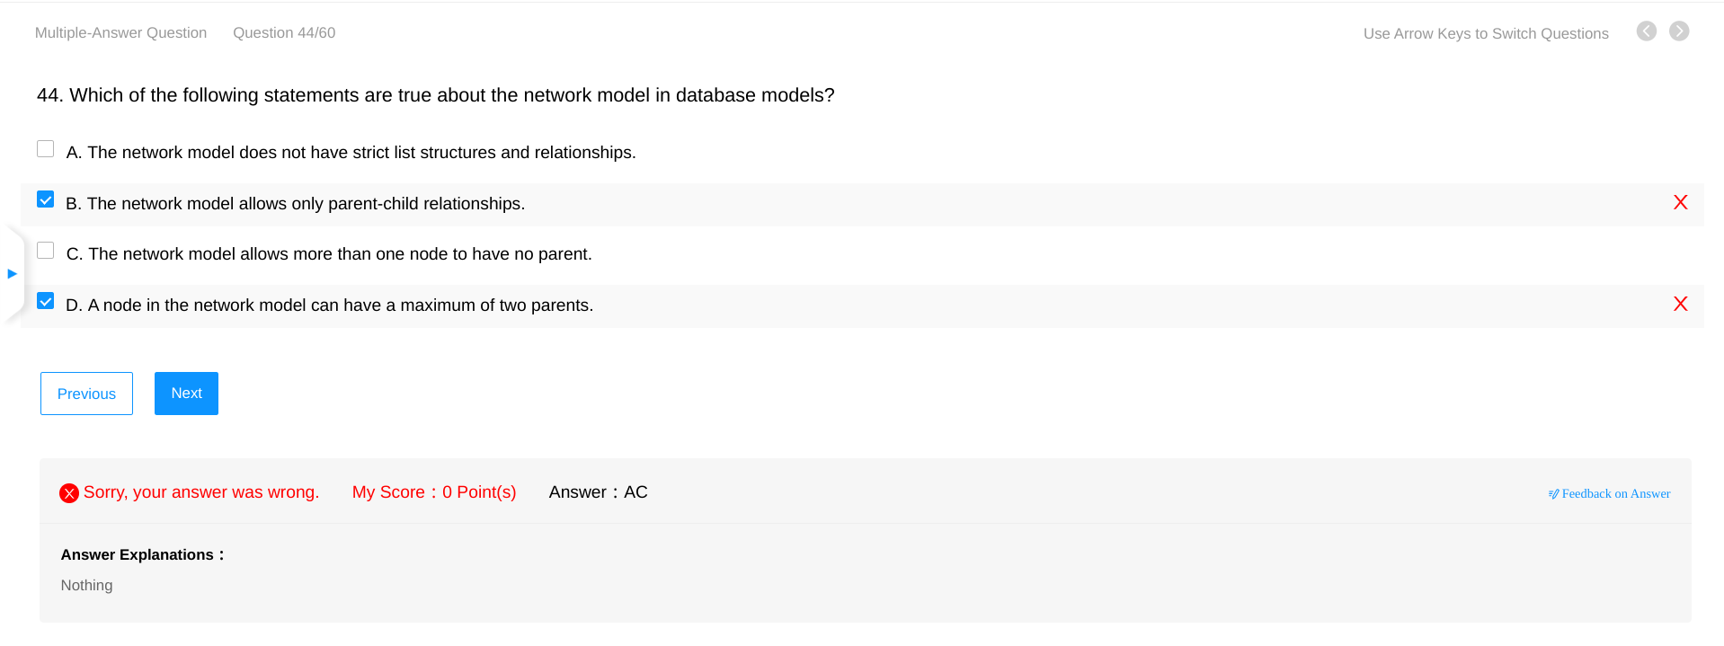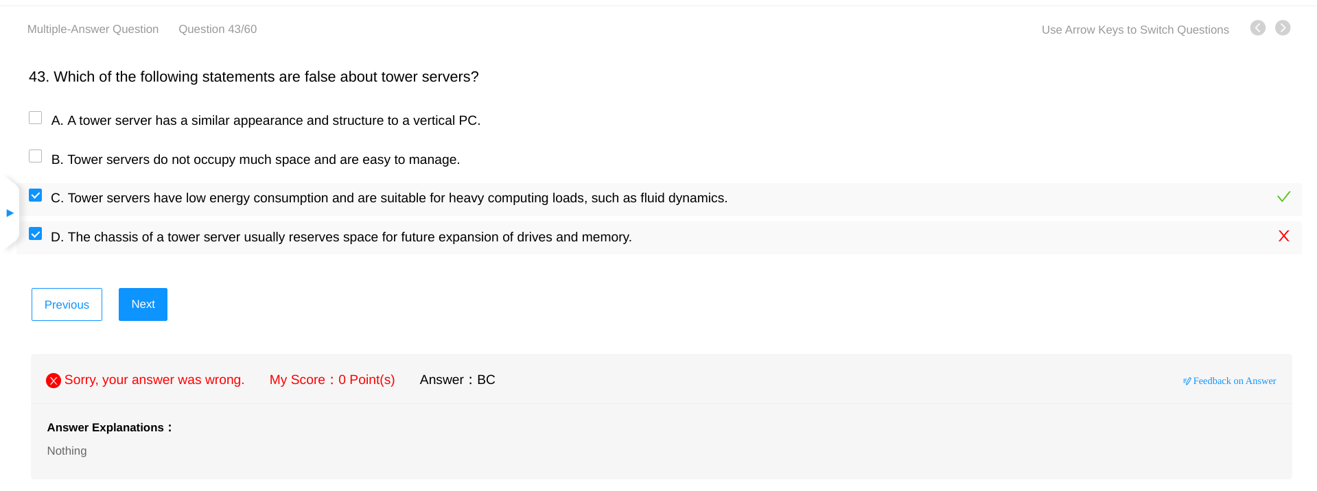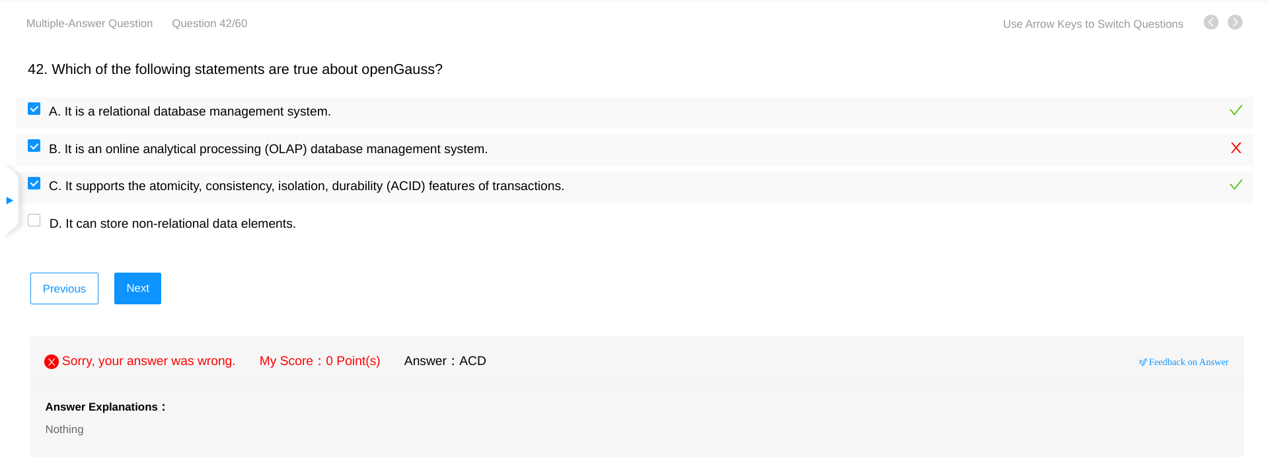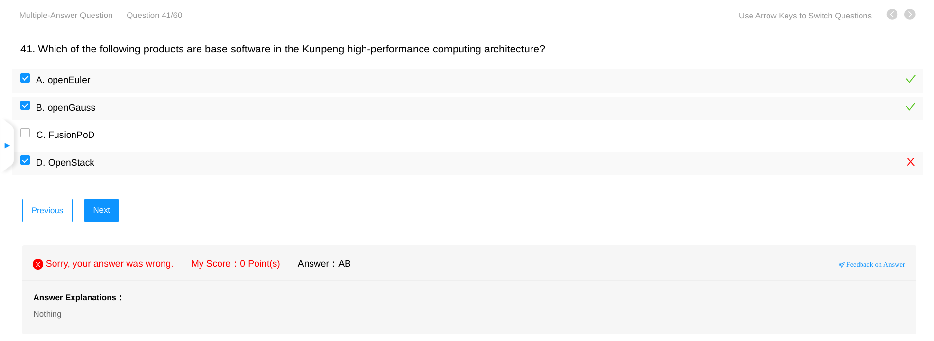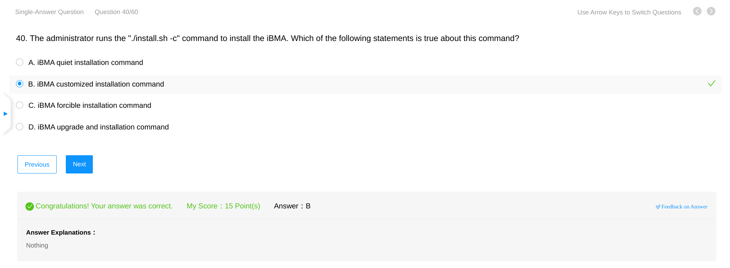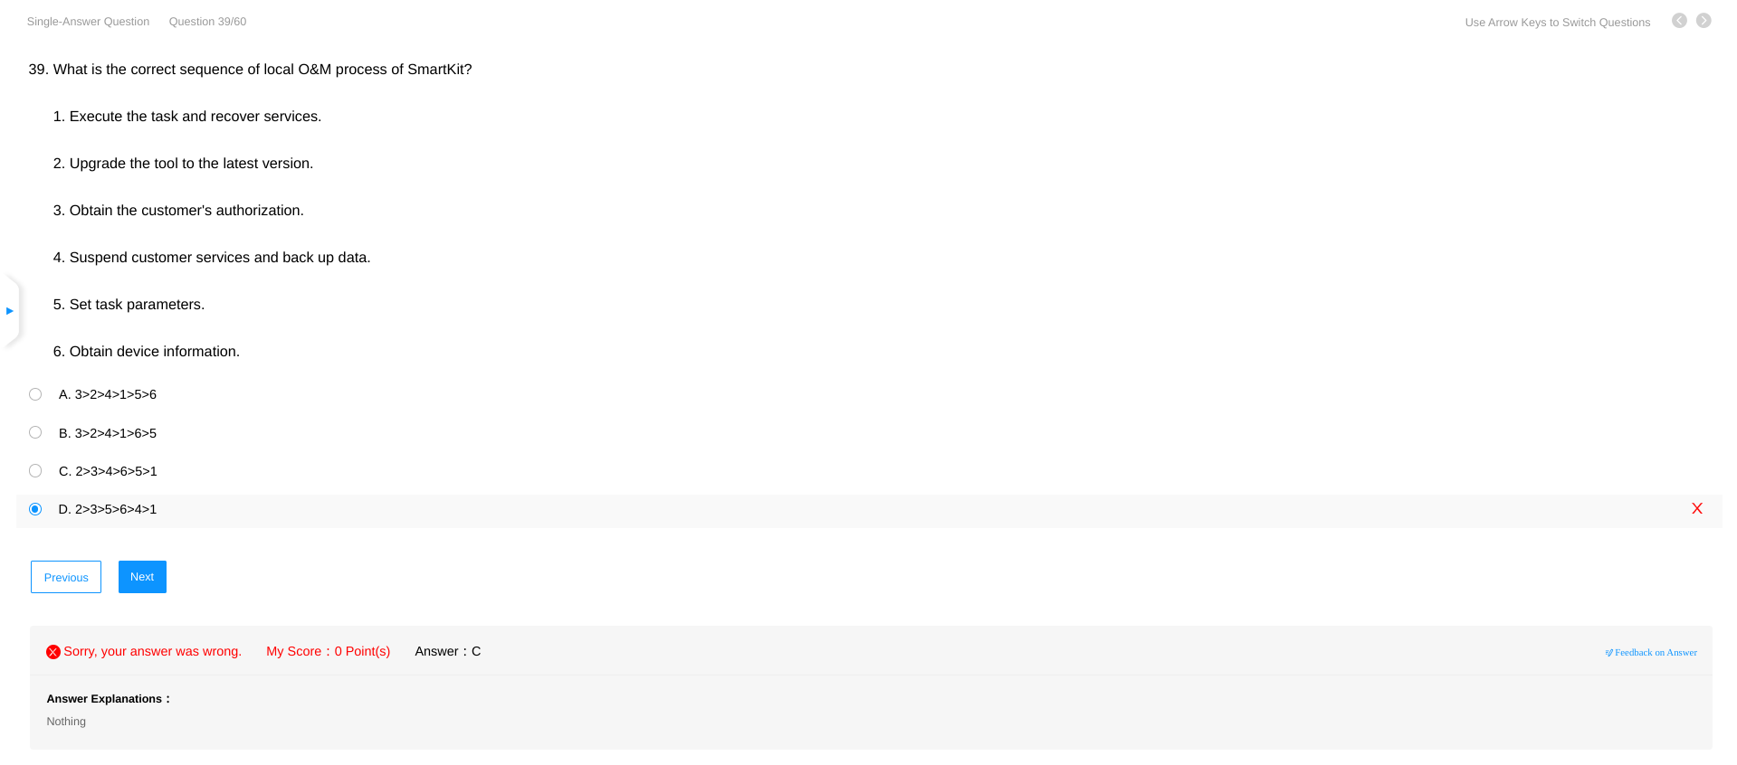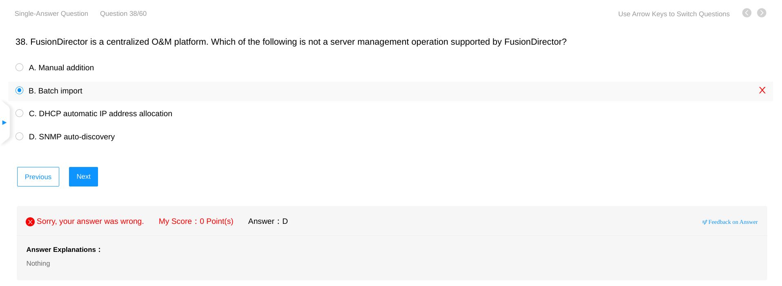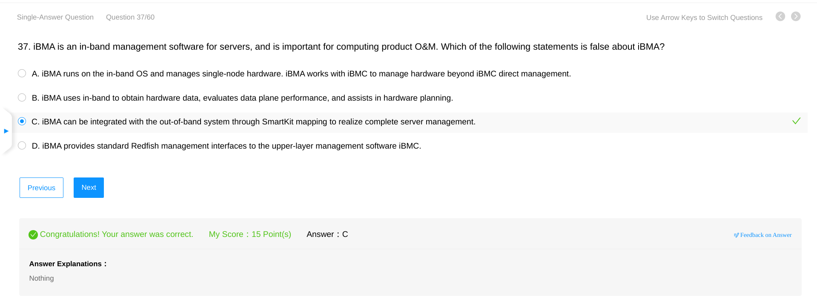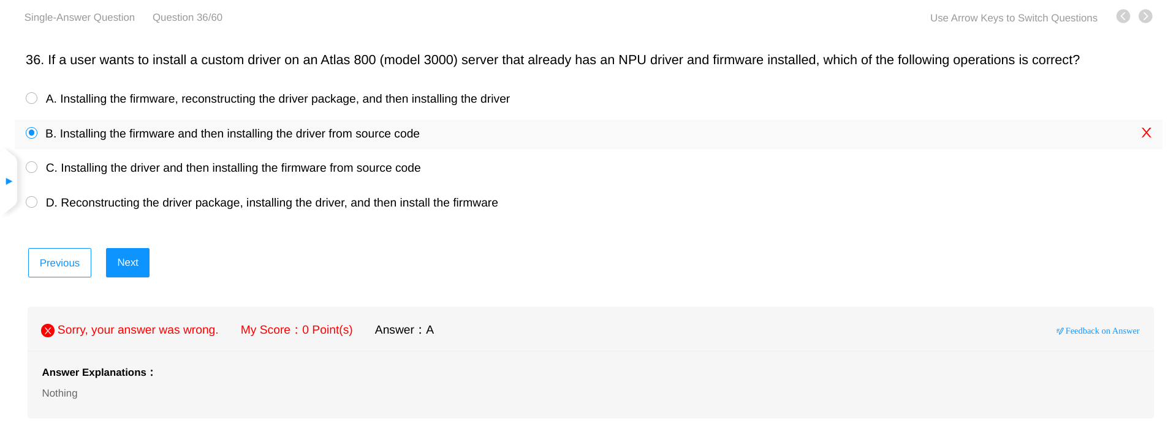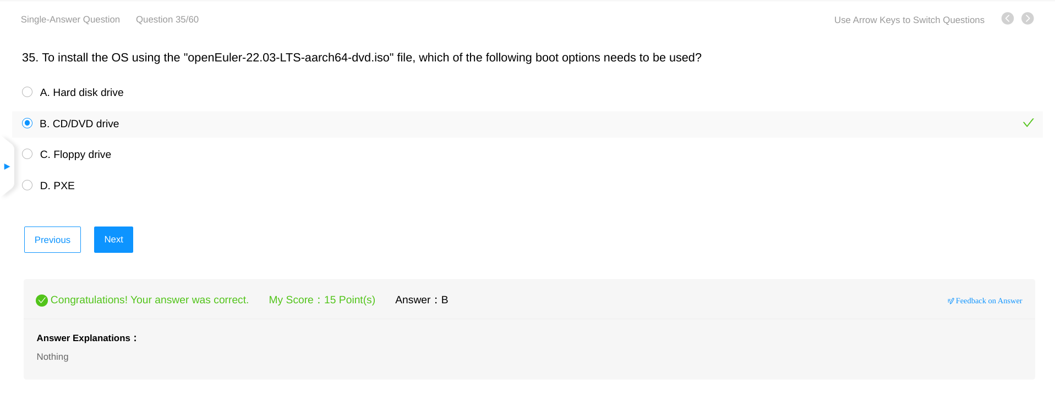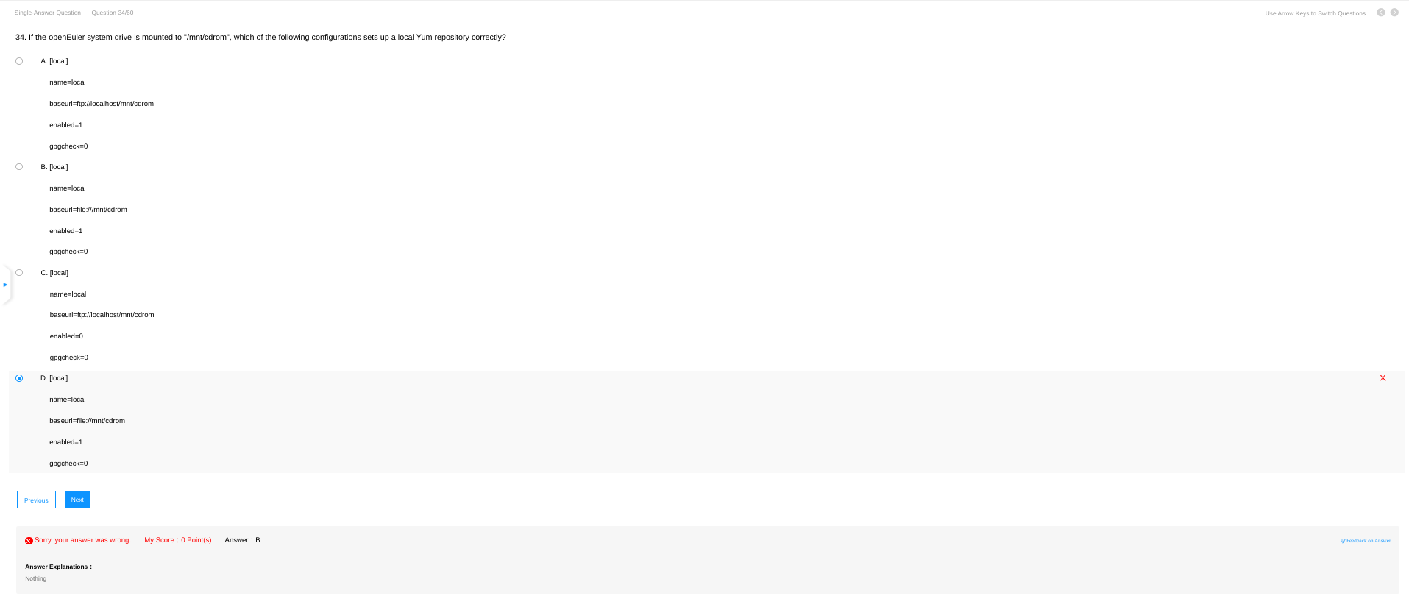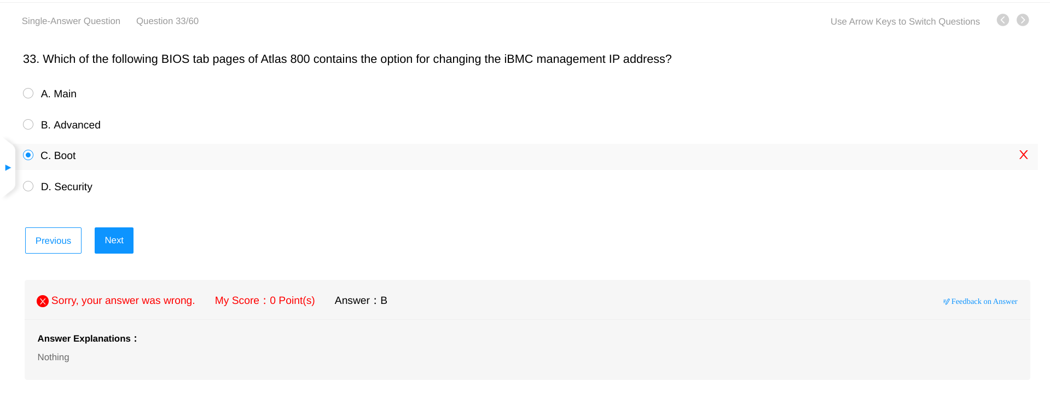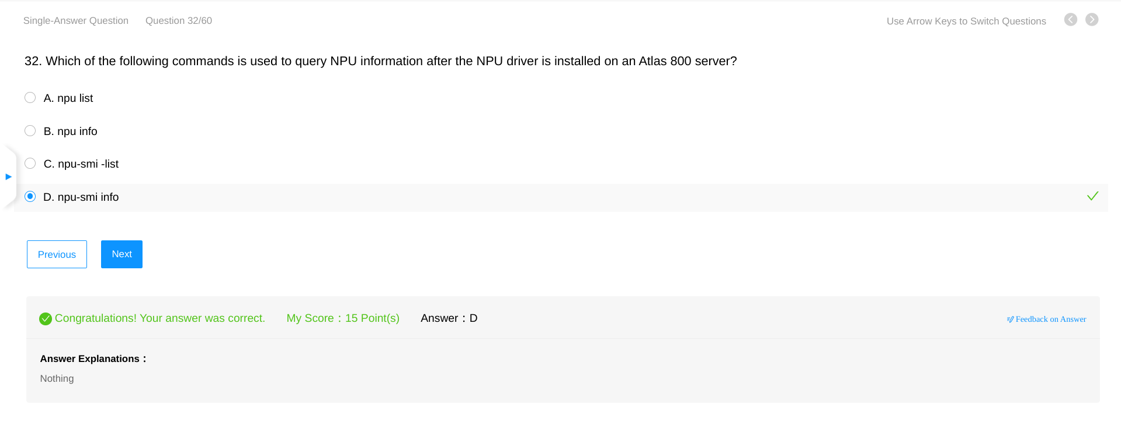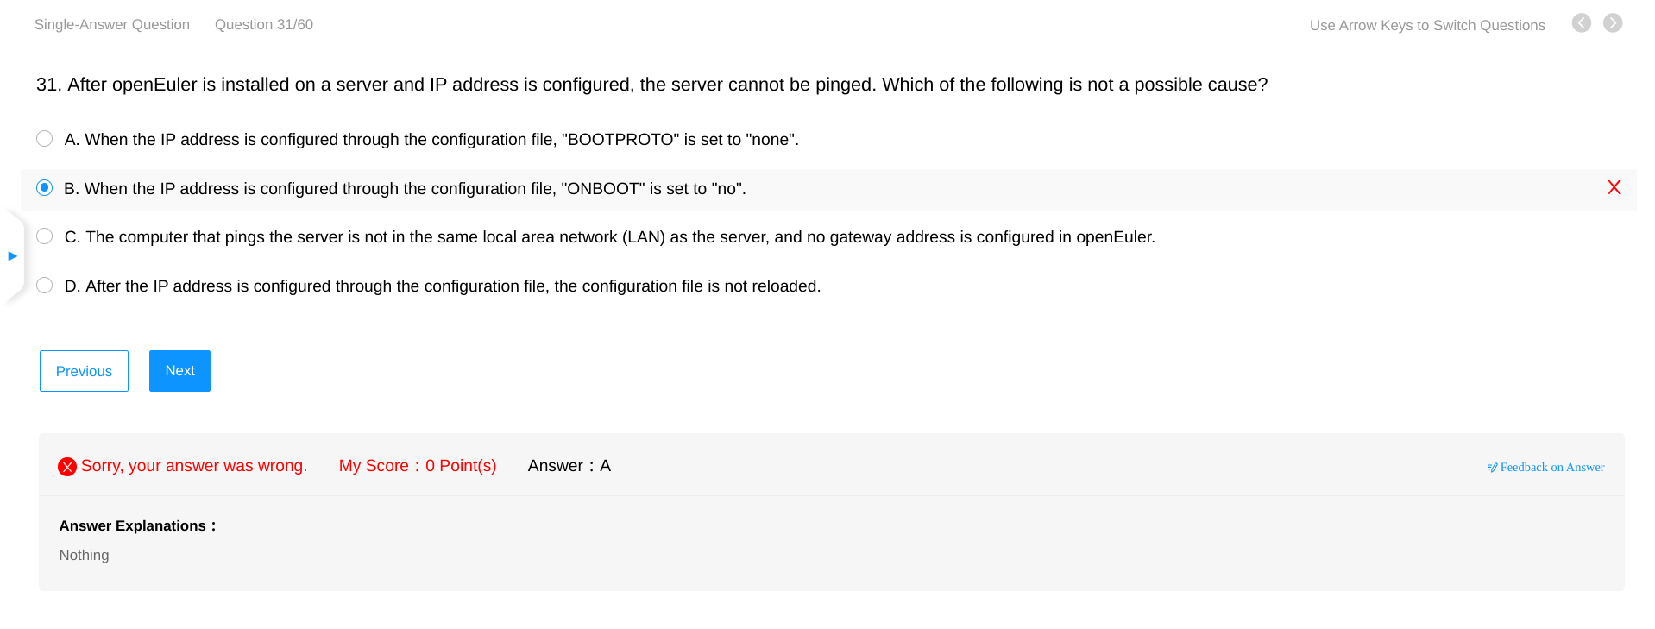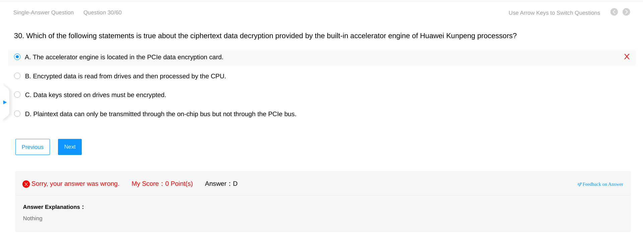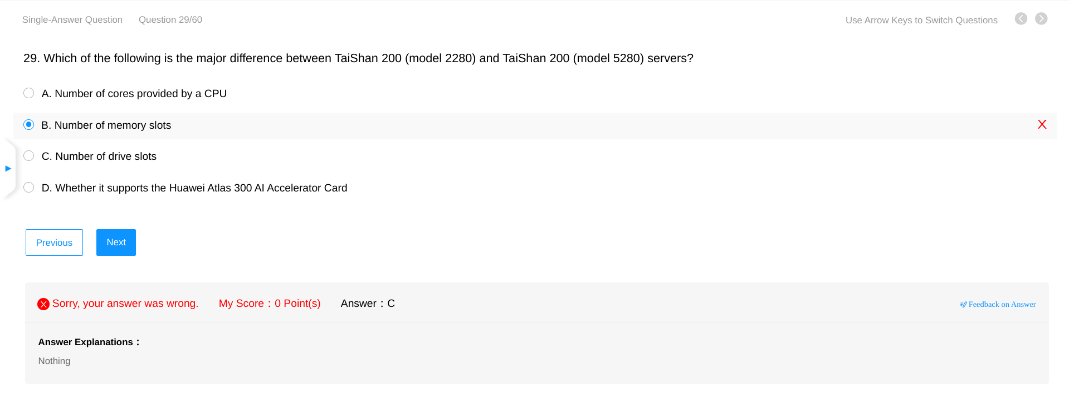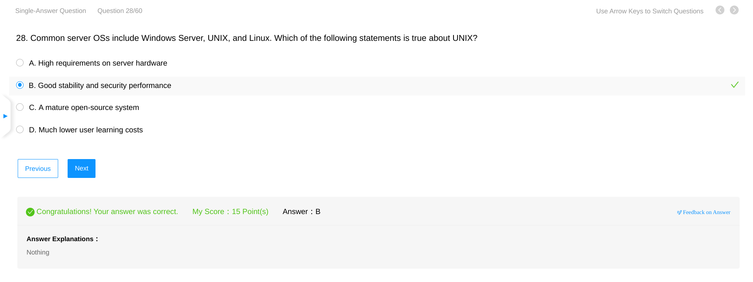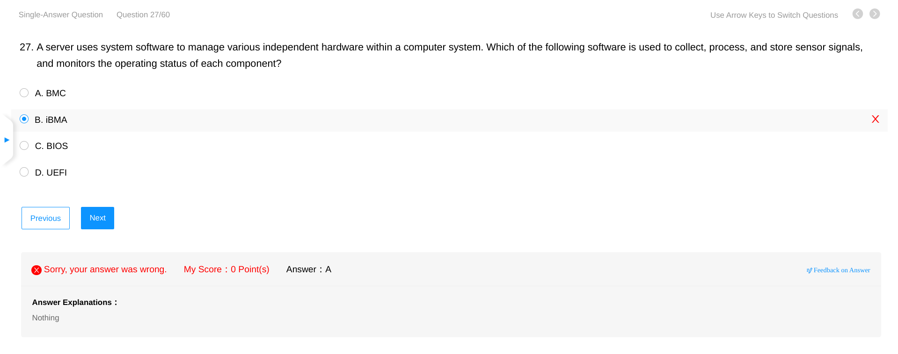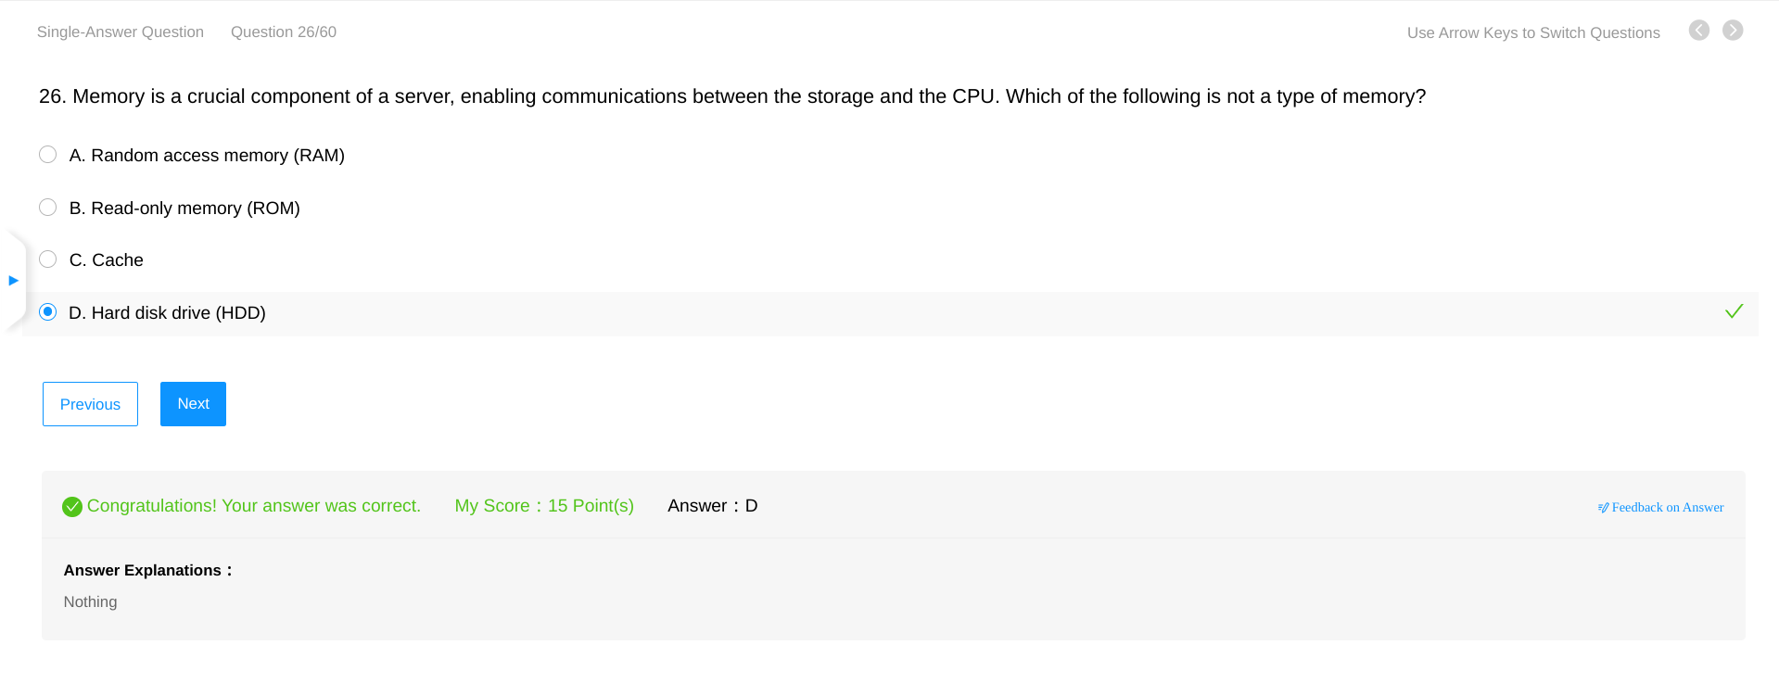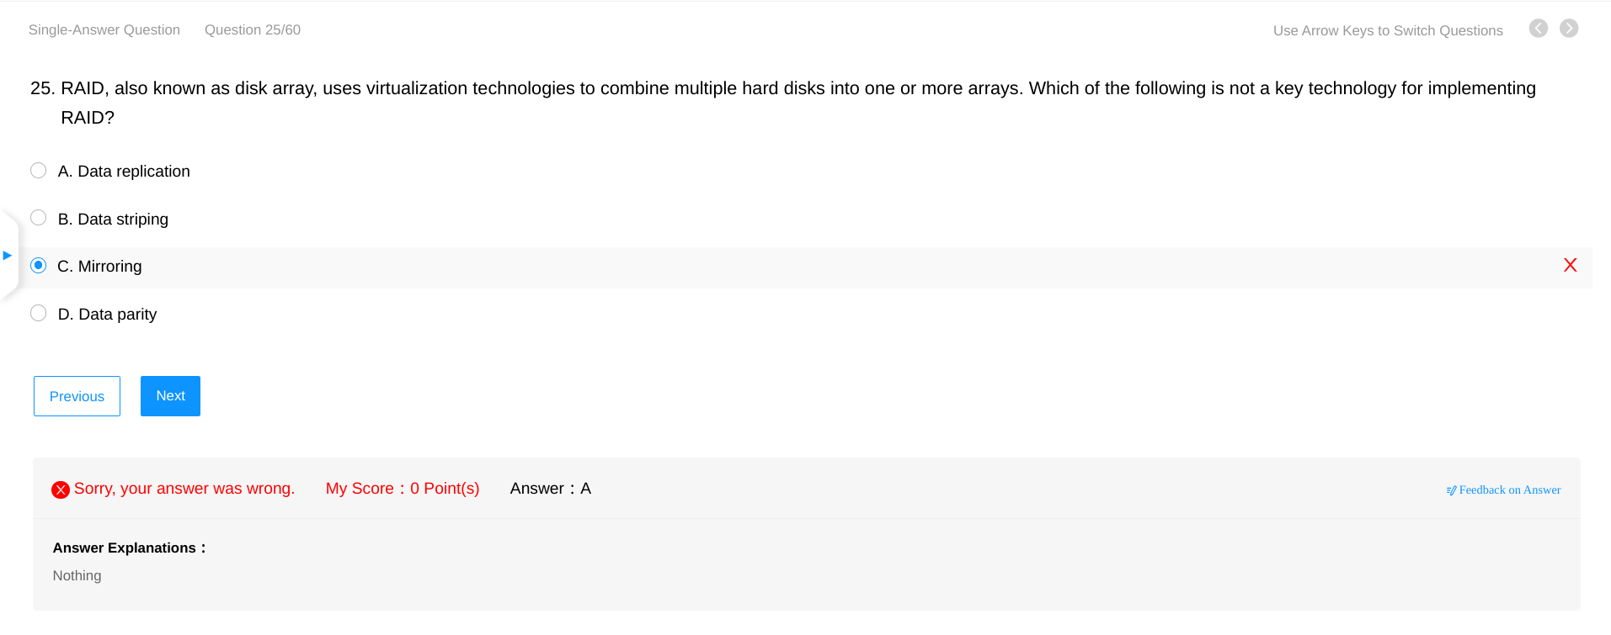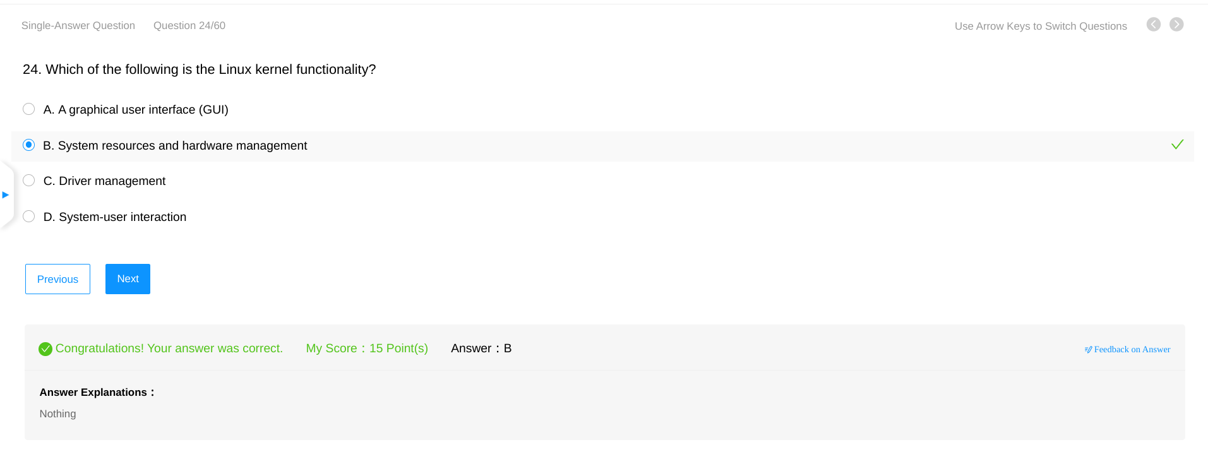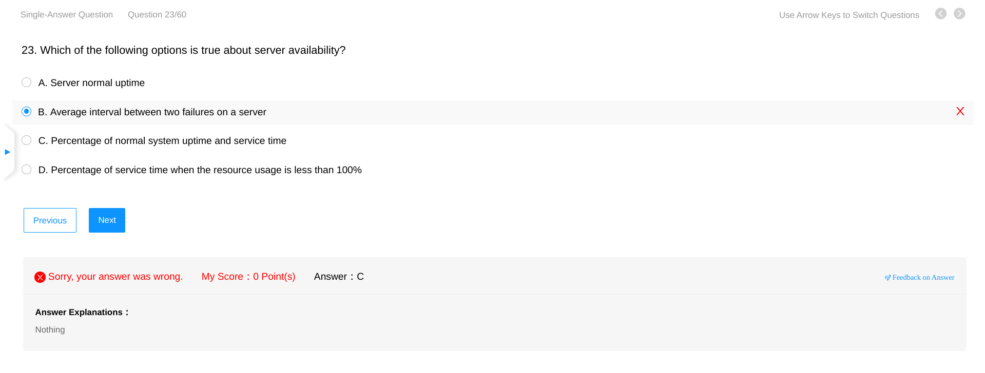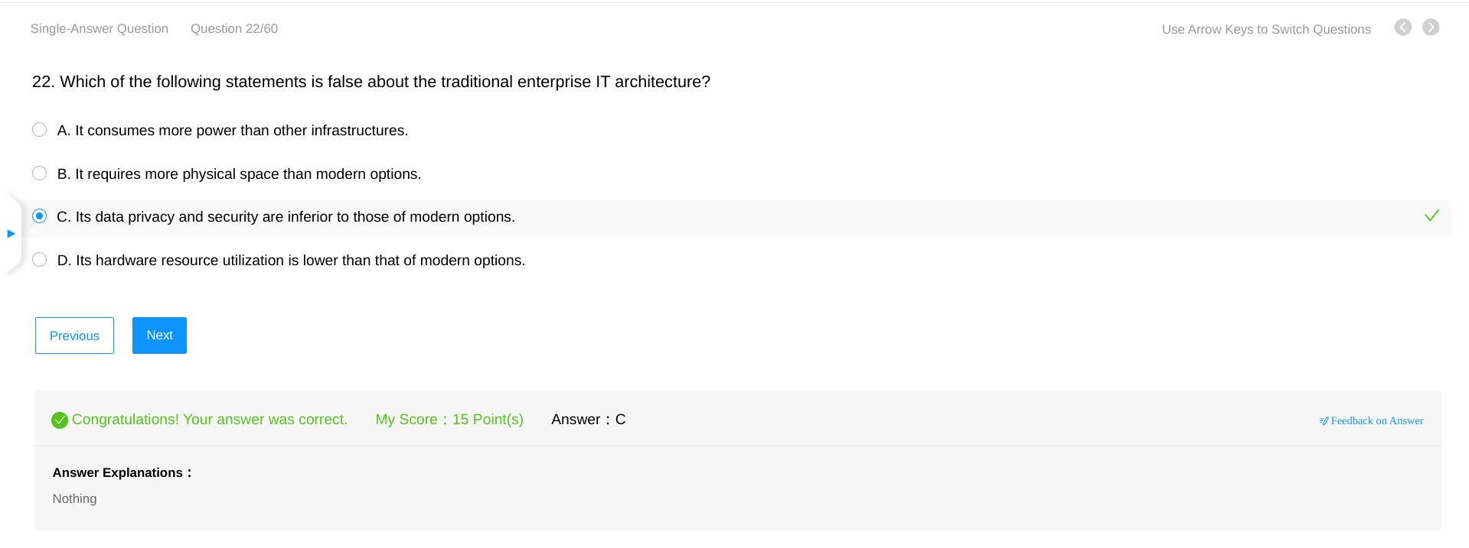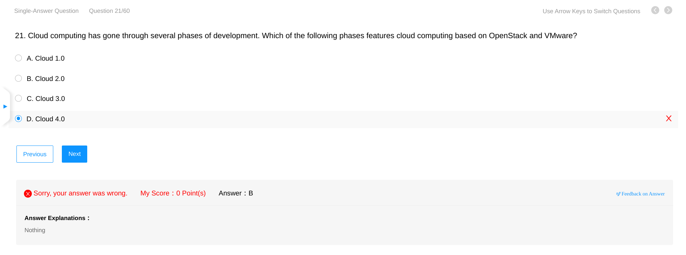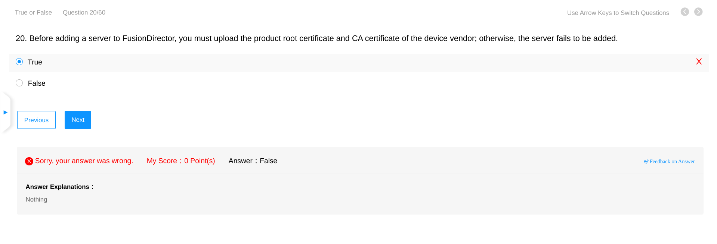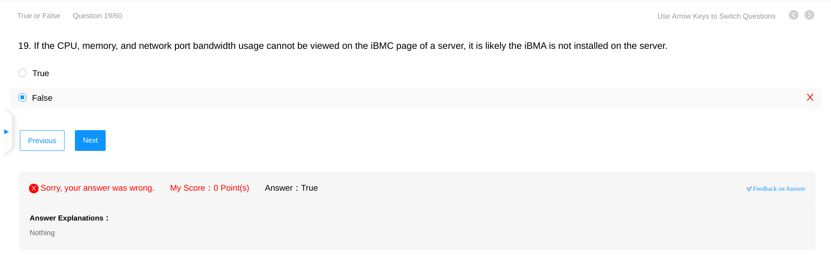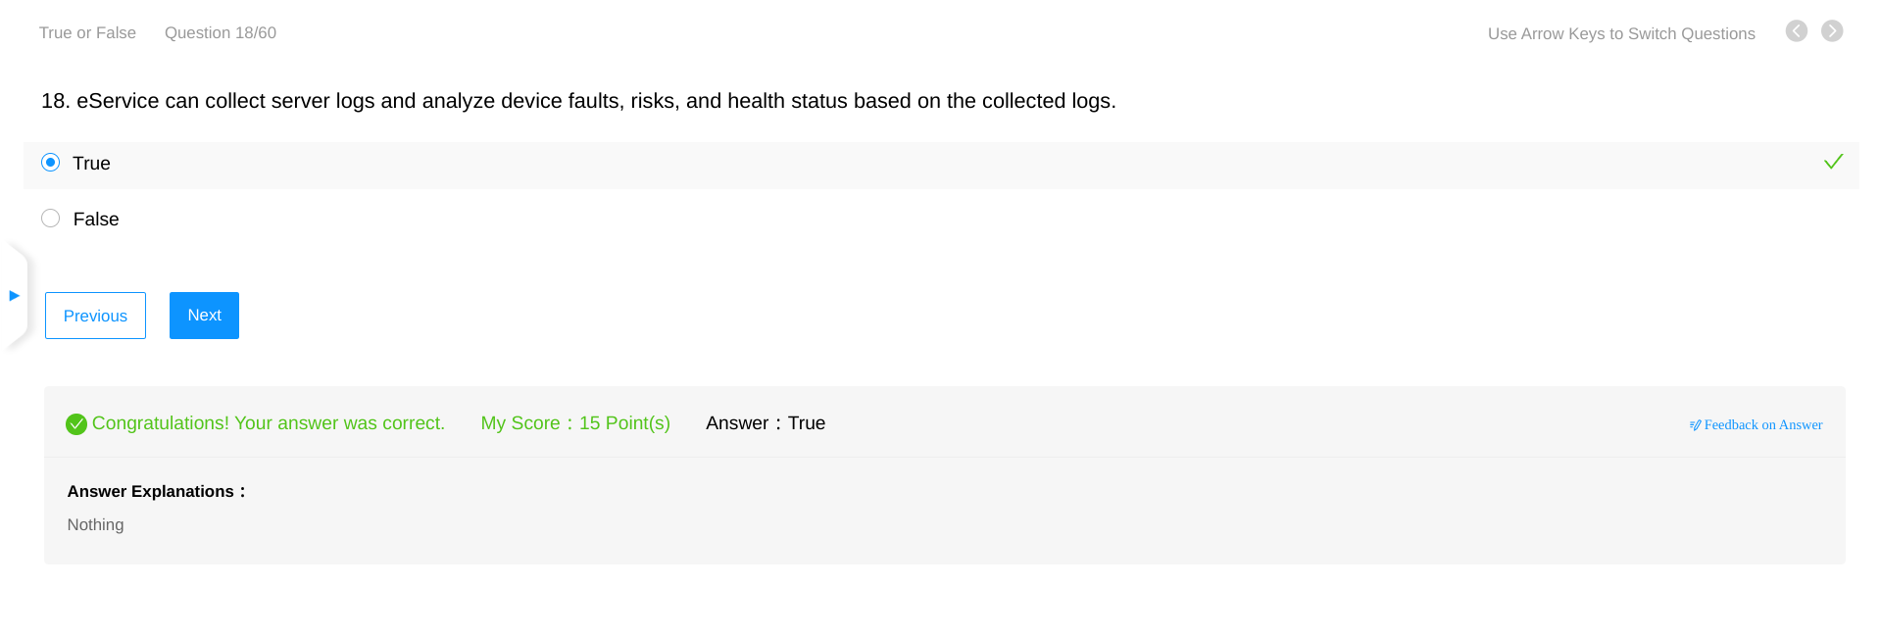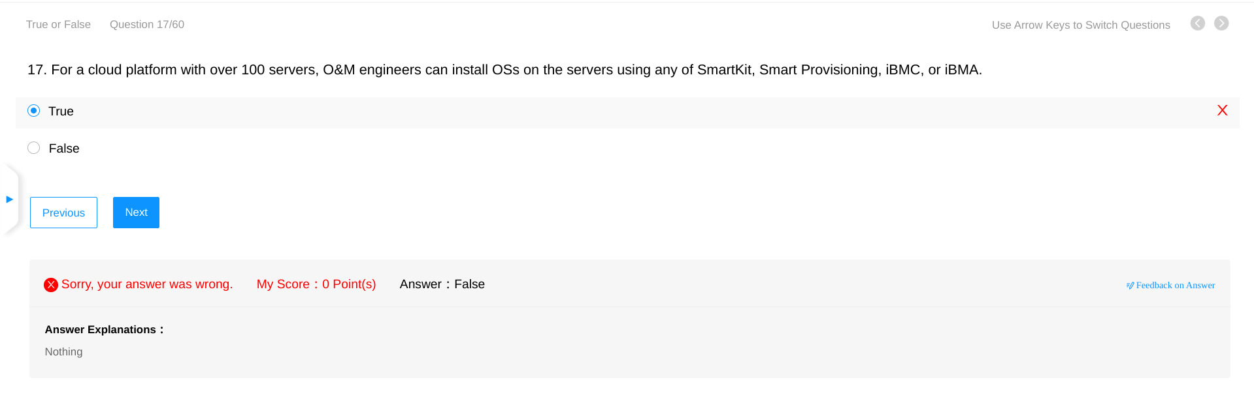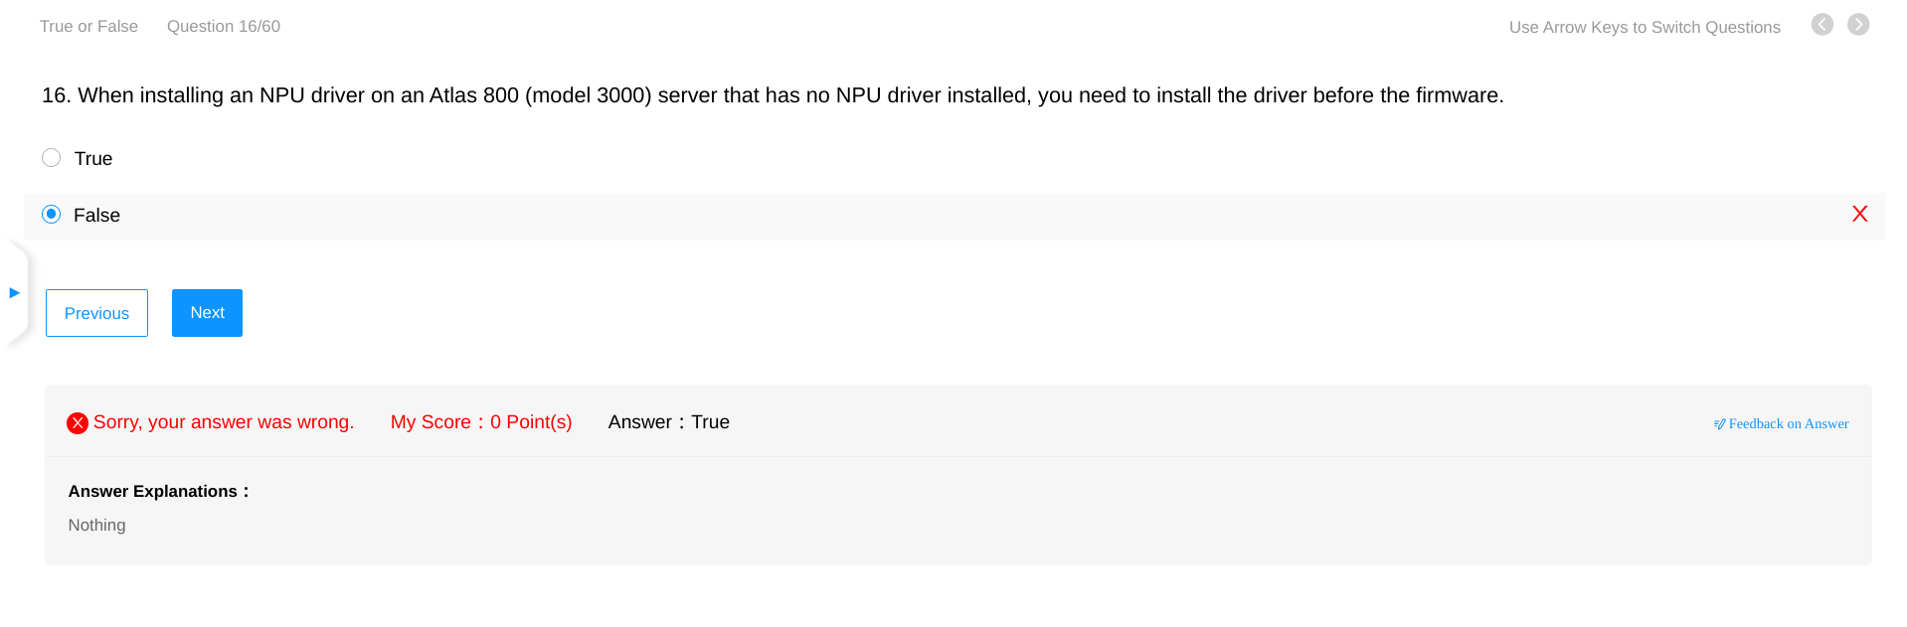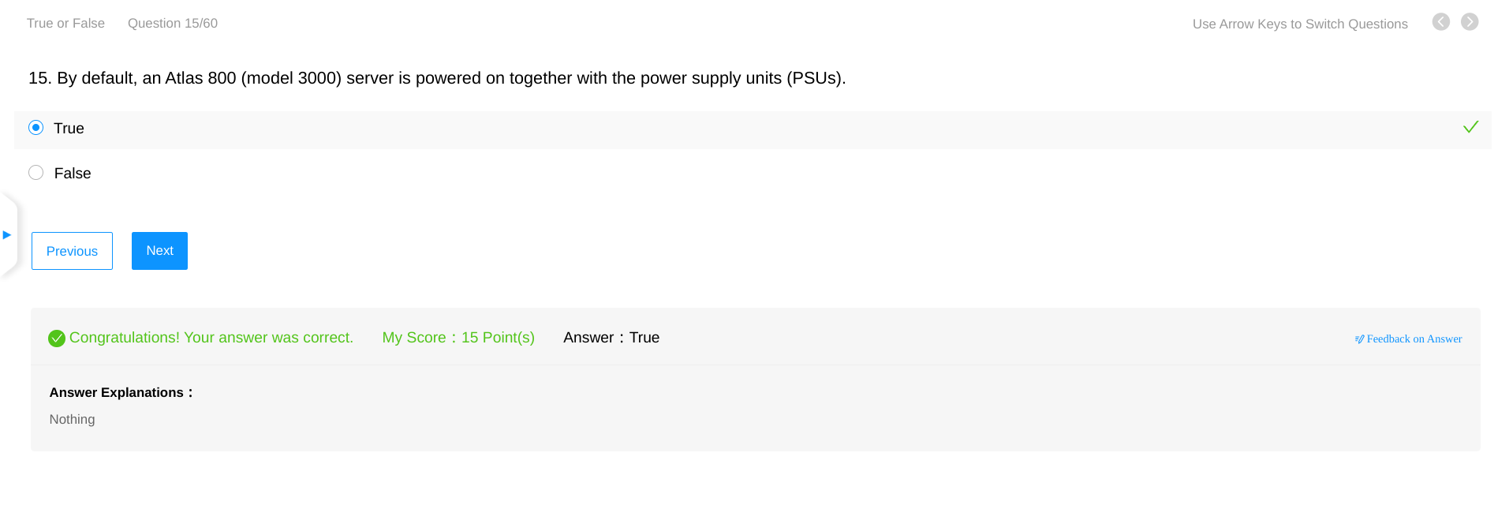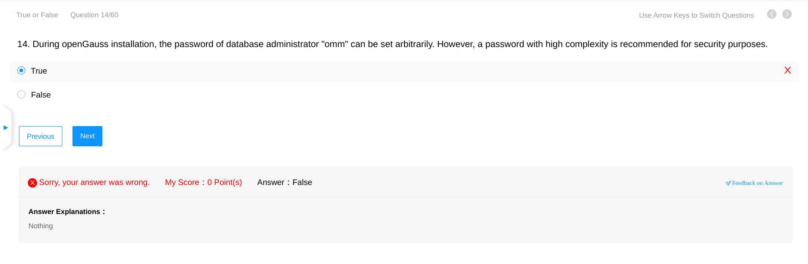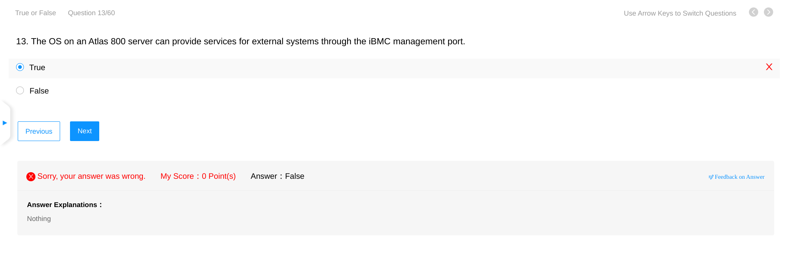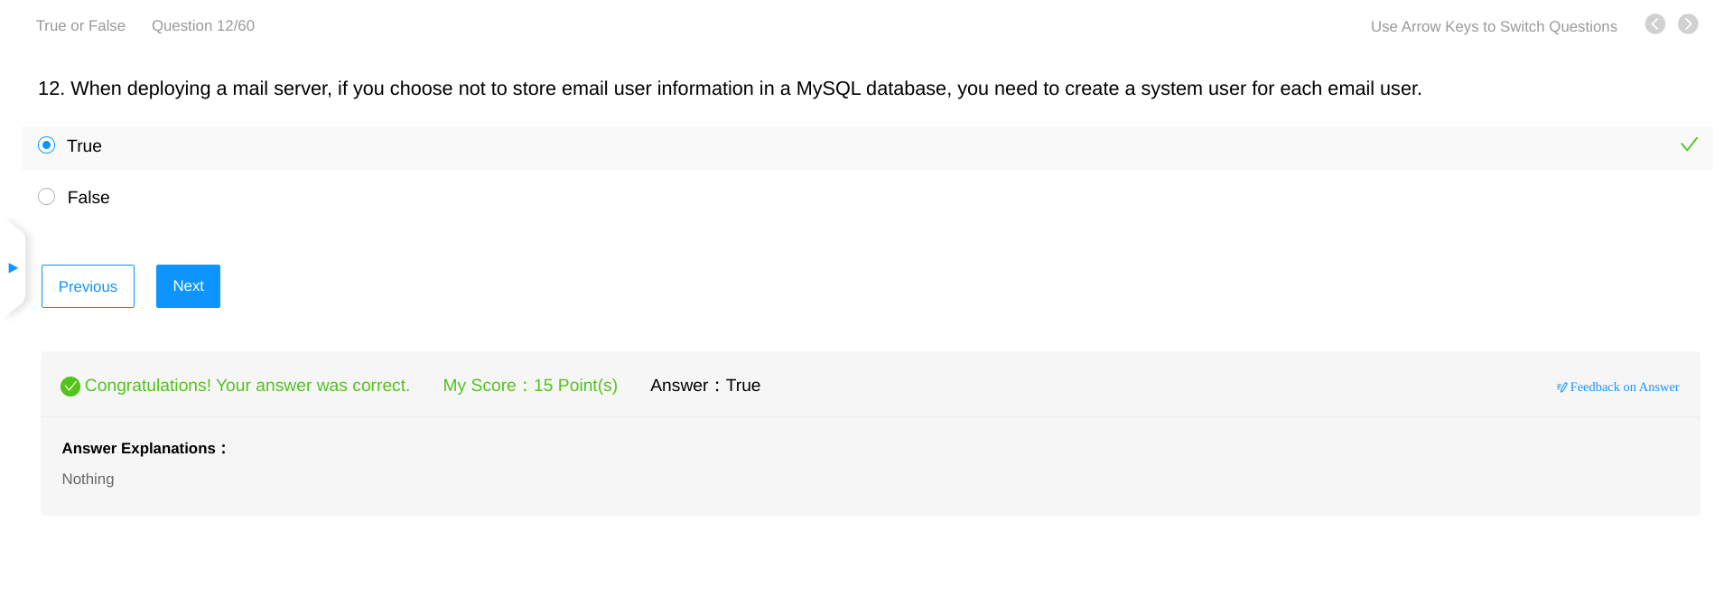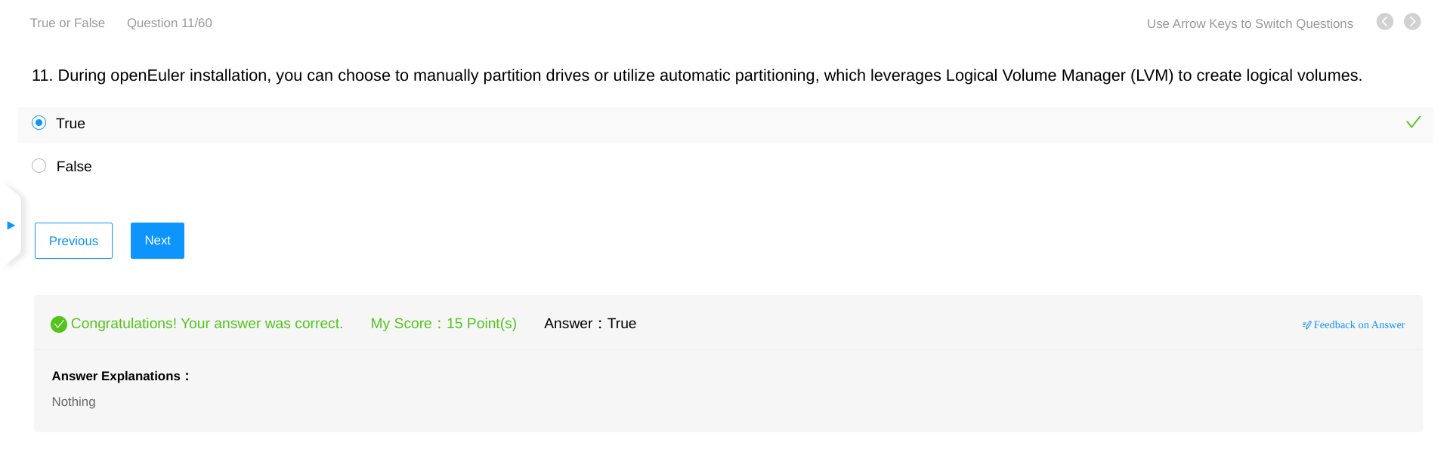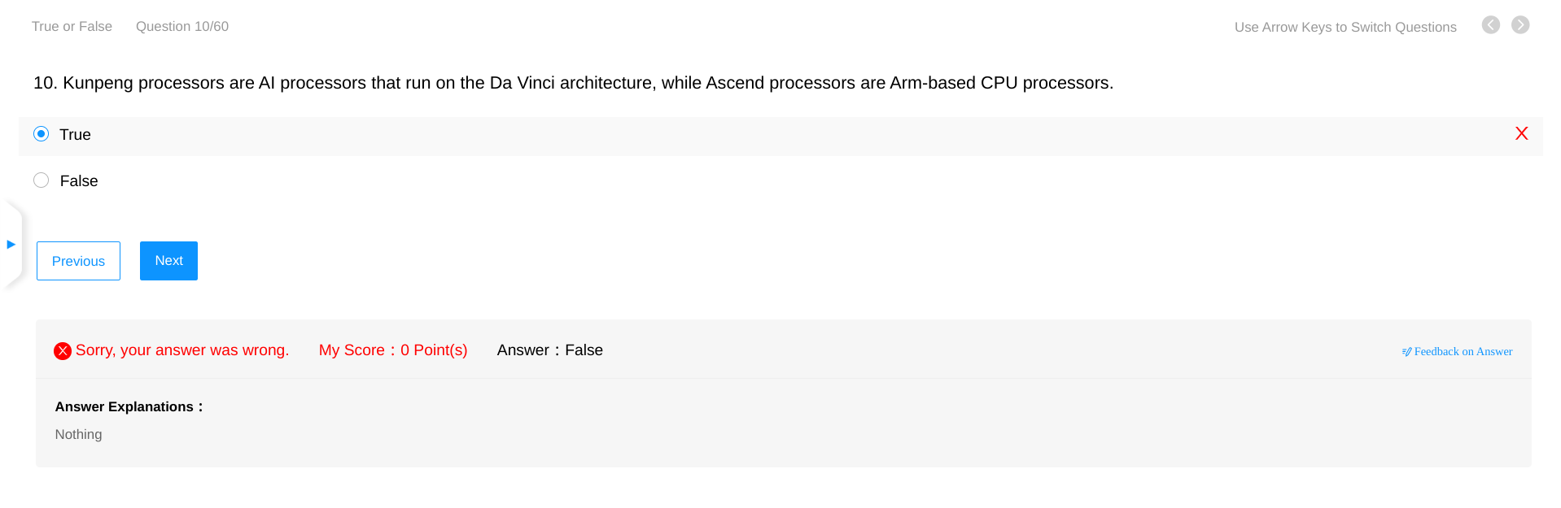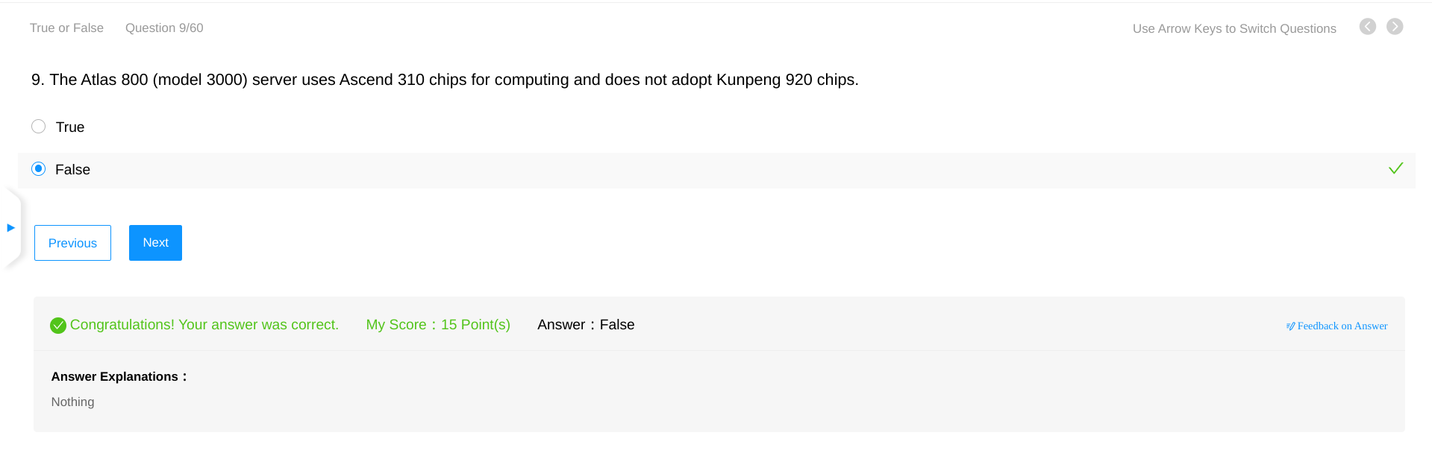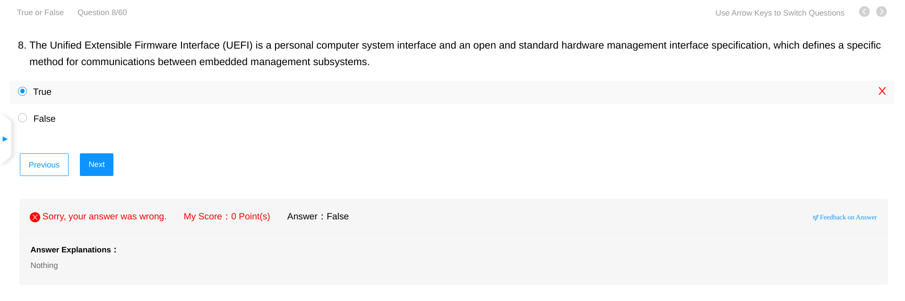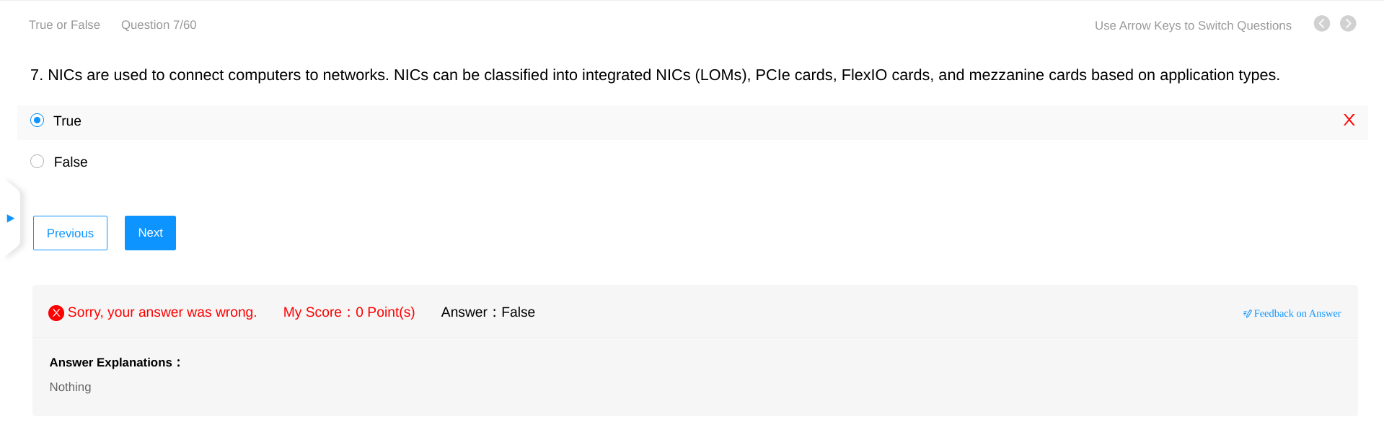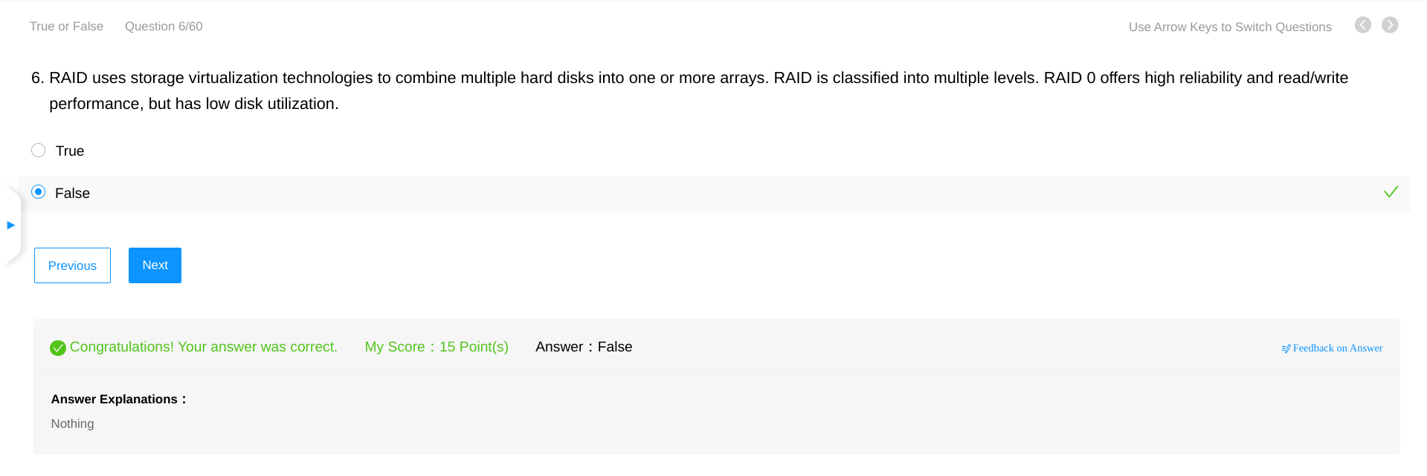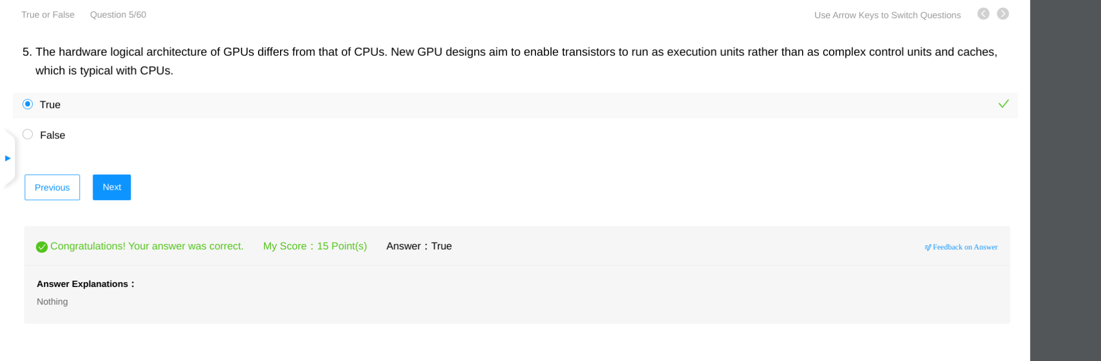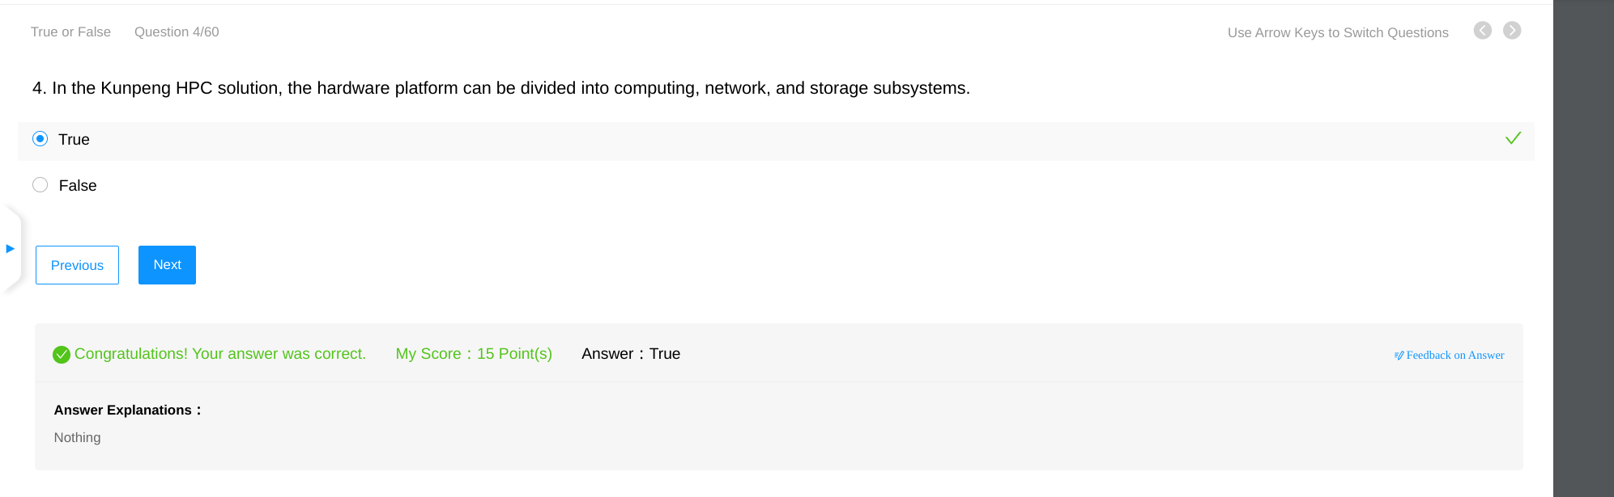

Regional Exam - HCIE

